

**WORKSHOP**

**SERVICE MANUAL**

**Suzuki DT2.2 Outboard**

**00221 DT2.2, 1997**

**Serial number 00221-861942**

**CONTENTS**

**1 GENERAL INFORMATION**

**AND BOATING SAFETY**

**2 TOOLS AND EQUIPMENT**

**3 MAINTENANCE**

**4 FUEL SYSTEM**

**5 IGNITION AND ELECTRICAL SYSTEMS**

**6 OIL INJECTION**

|  |  |
| --- | --- |
| HOW TO USE THIS MANUAL | 1.2 |
| BOATING SAFETY | 1-4 |
| SAFETY IN SERVICE | 1-12 |
| TOOLS AND EQUIPMENT | 2-2 |
| TOOLS | 2-5 |
| FASTENERS, MEASUREMENTS AND CONVERSIONS | 2-14 |
| ENGINE MAINTENANCE | 3-2 |
| BOAT MAINTENANCE | 3-8 |
| TUNE-UP | 3-12 |
| WINTER STORAGE CHECKLIST | 3-35 |
| SPRING COMMISSIONING CHECKLIST | 3-35 |
| FUEL AND COMBUSTION | 4-2 |
| FUEL SYSTEM | 4-3 |
| TROUBLESHOOTING | 4-7 |
| CARBURETOR SERVICE | 4.11 |
| REED VALVE SERVICE | 4-25 |
| FUEL PUMP SERVICE | 4-27 |
| ELECTRONIC FUEL INJECTION | 4-32 |
| UNDERSTANDING AND TROUBLESHOOTING |  |
| ELECTRICAL SYSTEMS | 5-2 |
| BREAKER POINTS IGNITION (MAGNETO IGNITION) | 5-7 |
| CAPACITOR DISCHARGE IGNITION (CDI) SYSTEM | 5-11 |
| ELECTRONIC IGNITION | 5-38 |
| CHARGING CIRCUIT | 5-39 |
| STARTING CIRCUIT | 5-45 |
| IGNITION AND ELECTRICAL WIRING DIAGRAMS | 5-52 |
| OIL INJECTION SYSTEM | 6-2 |
| COOLING SYSTEM | 6-11 |
| OIL INJECTION WARNING SYSTEMS | 6-14 |
| OVERHEAT WARNING SYSTEM | 6-17 |

**CONTENTS**

|  |  |
| --- | --- |
| ENGINE MECHANICAL POWERHEAD RECONDITIONING | 7-2  7-32 |
| LOWER UNIT | 8-2 |
| LOWER UNIT OVERHAUL | 8-6 |
| JET DRIVE | 8-51 |
| MANUAL TILT | 9-2 |
| GAS ASSISTED TILT | 9-2 |
| POWER TILT | 9-3 |
| POWER TRIM/TILT | 9-6 |
| REMOTE CONTROL BOX | 10-2 |
| TILLER HANDLE | 10-7 |
| HAND REWIND STARTER | 11-2 |
| OVERHEAD TYPE STARTER | 11-2 |
| BENDIX TYPE STARTER | 11.10 |
| GLOSSARY | 11-13 |
| INDEX | 11-17 |
| SUPPLEMENT: DT5Y AND ADDITIONAL INFORMATION | 12-2 |
| ON MOST OTHER MODELS, INCLUDING UPDATED |  |
| CARBURETOR AND IGNITION SPECIFICATIONS |  |

|  |  |
| --- | --- |
|  | **POWERHEAD 7** |
|  |  |
|  |  |

**LOWER UNIT 8**

**TRIM AND TILT 9**

**REMOTE CONTROL 10**

**HAND REWIND STARTER 11**

**GLOSSARY**

**ASTER INDEX**

**SUPPLEMENT**

**2-16** TOOLS AND EQUIPMENT

**CONVERSION FACTORS**

|  |  |  |  |  |
| --- | --- | --- | --- | --- |
| **LENGTH-DISTANCE** |  |  |  |  |
| Inches (in.) | x 25.4 | = Millimeters (mm) | x .0394 | = Inches |
| Feet (ft.) | x .305 | = Meters (m) | x 3.281 | = Feet |
| Miles | x 1.609 | = Kilometers (km) | x .0621 | = Miles |
| **VOLUME** |  |  |  |  |
| Cubic Inches (in3) | x 16.387 | = Cubic Centimeters | x .061 | = in3 |
| IMP Pints (IMP pt.) | x .568 | = Liters (L) | x 1.76 | = IMP pt. |
| IMP Quarts (IMP qt.) | x 1.137 | = Liters (L) | x .88 | = IMP qt. |
| IMP Gallons (IMP gal.) | x 4.546 | = Liters (L) | x .22 | = IMP gal. |
| IMP Quarts (IMP qt.) | x 1.201 | = US Quarts (US qt.) | x .833 | = IMP qt. |
| IMP Gallons (IMP gal.) | x 1.201 | = US Gallons (US gal.) | x .833 | = IMP gal. |
| Fl. Ounces | x 29.573 | = Milliliters | x .034 | = Ounces |
| US Pints (US pt.) | x .473 | = Liters (L) | x 2.113 | = Pints |
| US Quarts (US qt.) | x .946 | = Liters (L) | x 1.057 | = Quarts |
| US Gallons (US gal.) | x 3.785 | = Liters (L) | x .264 | = Gallons |
| **MASS-WEIGHT** |  |  |  |  |
| Ounces (oz.) | x 28.35 | = Grams (g) | x .035 | = Ounces |
| Pounds (lb.) | x .454 | = Kilograms (kg) | x 2.205 | = Pounds |
| **PRESSURE** |  |  |  |  |
| Pounds Per Sq. In. (psi) | x 6.895 | = Kilopascals (kPa) | x .145 | = psi |
| Inches of Mercury (Hg) | x .4912 | = psi | x 2.036 | = Hg |
| Inches of Mercury (Hg) | x 3.377 | = Kilopascals (kPa) | x .2961 | = Hg |
| Inches of Water (H20) | x .07355 | = Inches of Mercury | x 13.783 | = H2O |
| Inches of Water (H20) | x .03613 | = psi | x 27.684 | = H2O |
| Inches of Water (H20) | x .248 | = Kilopascals (kPa) | x 4.026 | = H2O |
| **TORQUE** |  |  |  |  |
| Pounds-Force Inches (in-lb) | x .113 | = Newton Meters (Nm) | x 8.85 | = in-lb |
| Pounds-Force Feet (ft-lb) | x 1.356 | = Newton Meters (Nm) | x .738 | = ft-lb |
| **VELOCITY** |  |  |  |  |
| Miles Per Hour (MPH) | x 1.609 | = Kilometers Per Hour (KPH) | x .621 | = MPH |
| **POWER** |  |  |  |  |
| Horsepower (Hp) | x .745 | = Kilowatts | x 1.34 | = Horsepower |
| **FUEL CONSUMPTION\*** |  |  |  |  |
| Miles Per Gallon IMP (MPG) | x .354 | = Kilometers Per Liter (Km/L) |  |  |
| Kilometers Per Liter (Km/L) | x 2.352 | = IMP MPG |  |  |
| Miles Per Gallon US (MPG) | x .425 | = Kilometers Per Liter (Km/L) |  |  |
| Kilometers Per Liter (Km/L) | x 2.352 | = US MPG |  |  |

*It is common to covert from miles per gallon (mpg) to liters/100 kilometers (1/100 km), where mpg (IMP) x 1/100 km = 282 and mpg (US) x 1/100 km = 235.

**TEMPERATURE**

Degree Fahrenheit (°F) = (°C x 1.8) + 32

Degree Celsius (°C) = (°F — 32) x .56

**ENGINE MAINTENANCE 3-2** SERIAL NUMBER IDENTIFICATION 3-2 2-STROKE OIL 3-2

OIL RECOMMENDATIONS 3-2 FILLING 3-2

LOWER UNIT 3-3

OIL RECOMMENDATIONS 3-3 DRAINING & FILLING 3-3 FUEL FILTER 3-4

RELIEVING FUEL SYSTEM PRESSURE 3-5

REMOVAL & INSTALLATION 3-5 FUEL/WATER SEPARATOR 3-6 TRIM/TILT & PIVOT POINTS 3-6

INSPECTION & LUBRICATION 3-6 PROPELLER 3-7

**BOAT MAINTENANCE 3-8** INSIDE THE BOAT 3-8

FIBERGLASS HULLS 3-8

TRIM TABS, ANODES AND LEAD WIRES 3-8

BATTERY 3-9

CLEANING 3-10

CHECKING SPECIFIC GRAVITY 3-10 BATTERY TERMINALS 3-11 BATTERY & CHARGING SAFETY PRECAUTIONS 3-11

BATTERY CHARGERS 3-11 REPLACING BATTERY CABLES 3-12 **TUNE-UP 3-12**

INTRODUCTION 3-12

TUNE-UP SEQUENCE 3-12 COMPRESSION CHECK 3-12

CHECKING COMPRESSION 3-12

LOW COMPRESSION 3-13 SPARK PLUGS 3-13

SPARK PLUG HEAT RANGE 3-13 SPARK PLUG SERVICE 3-14 REMOVAL & INSTALLATION 3-14 READING SPARK PLUGS 3-14 INSPECTION & GAPPING 3-15

SPARK PLUG WIRES 3-17 - TESTING 3-17

REMOVAL & INSTALLATION 3-17 IGNITION SYSTEM 3-17

TIMING AND SYNCHRONIZATION 3-17 TIMING 3-17

SYNCHRONIZATION 3-17 PREPARATION 3-17

DT2 AND DT2.2 3-18

IGNITION TIMING 3-18

IDLE SPEED 3-19

DT4 3-19

IGNITION TIMING 3-19

IDLE SPEED 3-19

DT6 AND DT8 3-19

IGNITION TIMING 3-19

IDLE SPEED 3-20

DT9.9 AND DT15 3-21

IGNITION TIMING 3-21

IDLE SPEED 3-21

DT20, DT25 AND DT30 3-22 IGNITION TIMING 3-22 THROTTLE LINKAGE

ADJUSTMENT 3-22 IDLE SPEED 3-22

DT35 AND DT40 3-23

IGNITION TIMING 3-23 IDLE SPEED 3-25

THROTTLE LINKAGE 3-26 DT55 AND DT65 3-26

IGNITION TIMING 3-26 IDLE SPEED 3-26

THROTTLE LINKAGE 3-27 DT75 AND DT85 3-29

IGNITION TIMING 3-29 CARBURETOR LINKAGE ADJUSTMENT 3-29 IDLE SPEED 3-29

DT90 AND DT100 3-30 IGNITION TIMING 3-30 CARBURETOR LINKAGE

ADJUSTMENT 3-30 IDLE SPEED 3-30

DT115 AND DT140 3-30 IGNITION TIMING 3-30 CARBURETOR LINKAGE 3-31 IDLE SPEED 3-32

DT150, DT175, DT200 3-32 IGNITION TIMING 3-32 CARBURETOR LINKAGE 3-32

IDLE SPEED 3-32

**WINTER STORAGE CHECKLIST 3-35 SPRING COMMISSIONING CHECKLIST 3-35**

**SPECIFICATIONS CHARTS** CAPACITIES 3-2

CARBURETOR IDLE AIR SCREW SPECIFICATION 3-33

TUNE UP SPECIFICATIONS CHARTS 3-34

GENERAL ENGINE

SPECIFICATIONS 3-38 SERIAL NUMBER

IDENTIFICATION 3-43



MAINTENANCE

ENGINE MAINTENANCE 3-2

BOAT MAINTENANCE 3-8

TUNE-UP 3-12

WINTER STORAGE CHECKLIST 3-35

SPRING COMMISSIONING

CHECKLIST 3-35

**3-2** MAINTENANCE

**ENGINE MAINTENANCE**

Serial Number Identification

Suzuki uses engine serial numbers and models numbers for identification purposes. These numbers are stamped on plates riveted to the port side transom bracket or to the starboard side of the support plate.

This information identifies the specific engine and will indicate to the owner or service technician if there are any unique parts or if any changes have been made to that particular model during its production run. The serial and models number should be used any time you order replacement parts.

For more information, refer to the "Serial Number Identification" and the "General Engine Specifications" charts at the end of this section.

2-Stroke Oil

OIL RECOMMENDATIONS

See Figures 1 and 2

Use only Suzuki CCI oil or NMMA (National Marine Manufacturers Association) certified 2-stroke lubricants. These oils are proprietary lubricants designed to ensure optimal engine performance and to minimize combustion

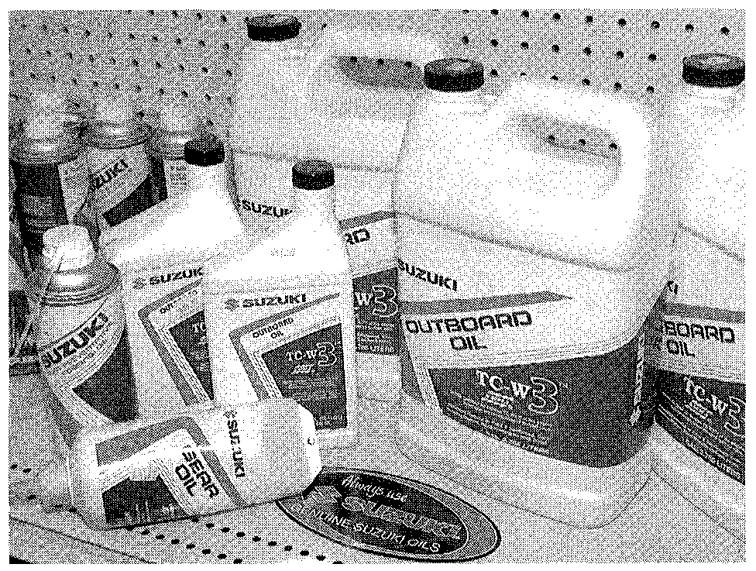

Fig. 1 2-Stroke outboard oils are proprietary lubricants designed to ensure optimal engine performance and to minimize combustion chamber deposits, avoid detonation and prolong spark plug life

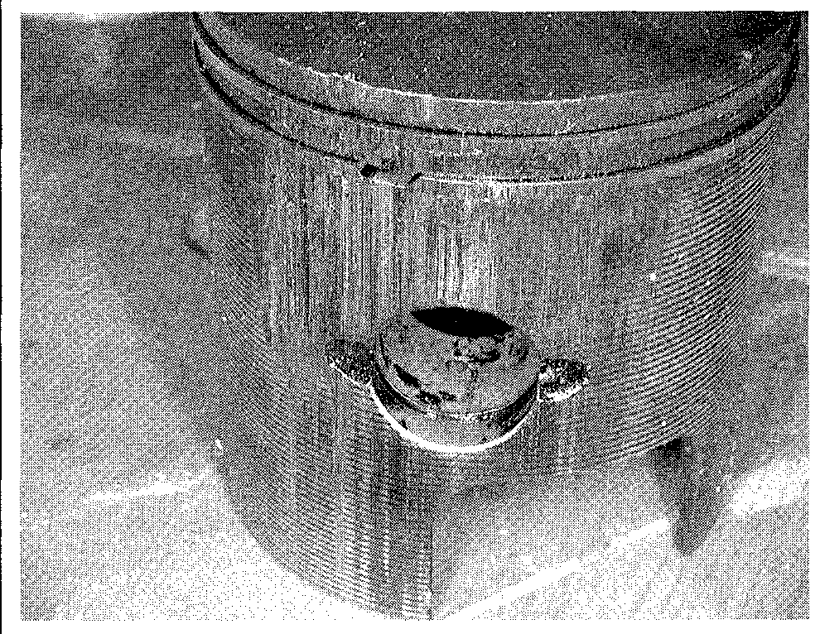

Fig. 2 This scuffed piston is an example of what can happen when the proper 2-stroke oil is not used. The outboard required a complete overhaul

chamber deposits, avoid detonation and prolong spark plug life. If Suzuki CCI oil or a NMMA certified lubricant is unavailable, use only 2-stroke outboard oil.

Remember, it is this oil, mixed with the gasoline that lubricates the

internal parts of the engine. Lack of lubrication due to the wrong mix or improper type of oil can cause catastrophic powerhead failure.

FILLING

There are two methods of adding 2-stroke oil to an outboard. The first is the pre-mix method used on outboards up to 6 horsepower and on some commercial models. The second is the automatic oil injection method which automatically injects the correct quantity of oil into the engine for all operating conditions.

Pre-Mix

Mixing the engine lubricant with gasoline before pouring it into the tank is by far the simplest method of lubrication for 2-stroke outboards. However, this method is the most messy and causes the most amount of harm to our environment.

The most important part of filling a pre-mix system is to determine the proper fuel/oil ratio. Most manufacturers use a 50:1 ratio (that is 50 parts of fuel to 1 part of oil) or a 100:1 ratio. Consult your owners manual to determine what the appropriate ratio should be for your engine.

The procedure itself is uncomplicated. Simply add the correct amount of lubricant to your fuel tank and then fill the tank with gasoline. The order in which you do this is important because as the gasoline is poured into the fuel tank it will mix with and agitate the oil for a complete blending.

If you are attempting to top off your tank, here is a general guideline to determine how much oil to add. For three gallons of fuel you would add 4 ounces of oil to obtain a 100:1 ratio; 8 ounces of oil to obtain a 50:1 ratio and 16 ounces of oil to obtain a 25:1 ratio.

Oil Injection

Most outboard manufacturers use a mechanically driven oil pump mounted on the engine block that is connected to the throttle by way of a linkage arm.

**Capacities**

|  |  |  |  |
| --- | --- | --- | --- |
| **Injection Oil**  **Model Quart (Liter)** | | **Lower Unit Fuel Tank**  **Oz. (ml) Gal. (Liter)** | |
| **DT2** | **PreMix** | **2.4(70)** | **0.3(1.2)** |
| **DT2.2** | **PreMix** | **2.4(70)** | **0.3(1.2)** |
| **DT4** | **PreMix** | **6.4(190)** | **0.7(2.6)** |
| **DT5Y** | **Premix** | **6.4(190)** | **0.7(2.8)** |
| **DT6** | **PreMix** | **11.5(240)** | **6.3(24)** |
| **DT8** | **PreMix** | **11.5(240)** | **6.3(24)** |
| **DT9.9** | **2.3(2.1)** | **5.7(170)** | **6.3(24)** |
| **DT15** | **2.3(2.1)** | **5.7(170)** | **6.3(24)** |
| **DT20** | **2.3(2.1)** | **10.1(300)** | **6.3(24)** |
| **DT25** | **2.1(2.0)** | **7.8(230)** | **6.3(24)** |
| **DT30** | **2.1(2.0)** | **7.8(230)** | **6.3(24)** |
| **DT35** | **2.1(2.0)** | **20.6(610)** | **6.3(24)** |
| **DT40** | **2.1(2.0)-** | **20.6(610)** | **6.3(24)** |
| **DT55** | **3.2(3.0)** | **22(650)** | **6.3(24)** |
| **DT65** | **3.2(3.0)** | **22(650)** | **6.3(24)** |
| **DT75** | **2.4(2.3)** | **23.7(700)** | **6.3(24)** |
| **DT85** | **2.4(2.3)** | **23.7(700)** | **6.3(24)** |
| **DT90** | **4.8(4.5)** | **18.9(560)** | **6.3(24)** |
| **DT100** | **4.8(4.5)** | **18.9(560)** | **6.3(24)** |
| **DT115** | **6.3(6.0)** | **37.2(1100)** | **6.3(24)** |
| **DT140** | **6.3(6.0)** | **37.2(1100)** | **6.3(24)** |
| **DT150** | **9.5(9.0)** | **35.5(1050)** | **6.3(24)** |
| **DT175** | **9.5(9.0)** | **35.5(1050)** | **6.3(24)** |
| **DT200** | **9.5(9.0)** | **35.5(1050)** | **6.3(24)** |
| **DT225** | **9.0(8.5)** | **35.5(1050)** | **-** |

MAINTENANCE **3-3**

The system is powered by the crankshaft which drives a gear in the pump, cre­ating oil pressure. As the throttle lever is advanced to increase engine speed, the linkage arm also moves, opening a valve that allows more oil to flow into the oil pump.

Most mechanical-injection systems incorporate low-oil warning alarms that are also connected to an engine overheating sensor. Also, these systems may have a built-in speed limiter. This sub-system is designed to reduce engine speed automatically when oil problems occur. This important feature goes a long way toward preventing severe engine damage in the event of an oil injec­tion problem.

The procedure for filling these systems is simple. On each powerhead there is an auxiliary oil reservoir which holds the 2-stroke oil. Simply fill the oil take to the proper capacity.

It is highly advisable to carry several spare bottles of 2-stroke oil with you onboard.

For more information on the oil injection system refer to the "Lubrication and Cooling" section of this manual.

**Lower Unit**

See Figures 3 and 4

Regular maintenance and inspection of the lower unit is critical for proper operation and reliability. A lower unit can quickly fail if it becomes heavily cont­aminated with water, or excessively low on oil. The most common cause of a lower unit failure is water contamination.

Water in the lower unit is usually caused by fishing line, or other foreign mate­rial, becoming entangled around the propeller shaft and damaging the seal. If the line is not removed, it will eventually cut the propeller shaft seal and allow water to enter the lower unit. Fishing line has also been known to cut a groove in the pro­peller shaft if left neglected over time. This area should be checked frequently.

OIL RECOMMENDATIONS

Use only Suzuki Outboard Motor Gear Oil or and equivalent high quality SAE 90 hypoid gear oil. These oils are proprietary lubricants designed to ensure optimal performance and to minimize corrosion in the lower unit.

Remember, it is this lower unit lubricant that prevents corrosion and lubricates the internal parts of the drive gears. Lack of lubrication due to water contamination or the improper type of oil can cause cata­strophic lower unit failure.

DRAINING & FILLING

See accompanying illustrations

**CAUTION**

The EPA warns that prolonged contact with used engine oil may cause a number of skin disorders, including cancer! You should make every effort to minimize your exposure to used engine oil. Protective gloves should be worn when changing the oil. Wash your hands and any other exposed skin areas as soon as possible after exposure to used engine oil. Soap and water, or waterless hand cleaner should be used.

1. Place a suitable container under the lower unit.
2. Loosen the oil level plug on the lower unit. This step is important! If the oil level plug cannot be loosened or removed, the complete lower unit lubricant service cannot be performed.

Never remove the vent or filler plugs when the lower unit is hot. Expanded lubricant will be released through the plug hole.

1. Remove the fill plug from the lower end of the gear housing followed by the oil level plug.
2. Allow the lubricant to completely drain from the lower unit.

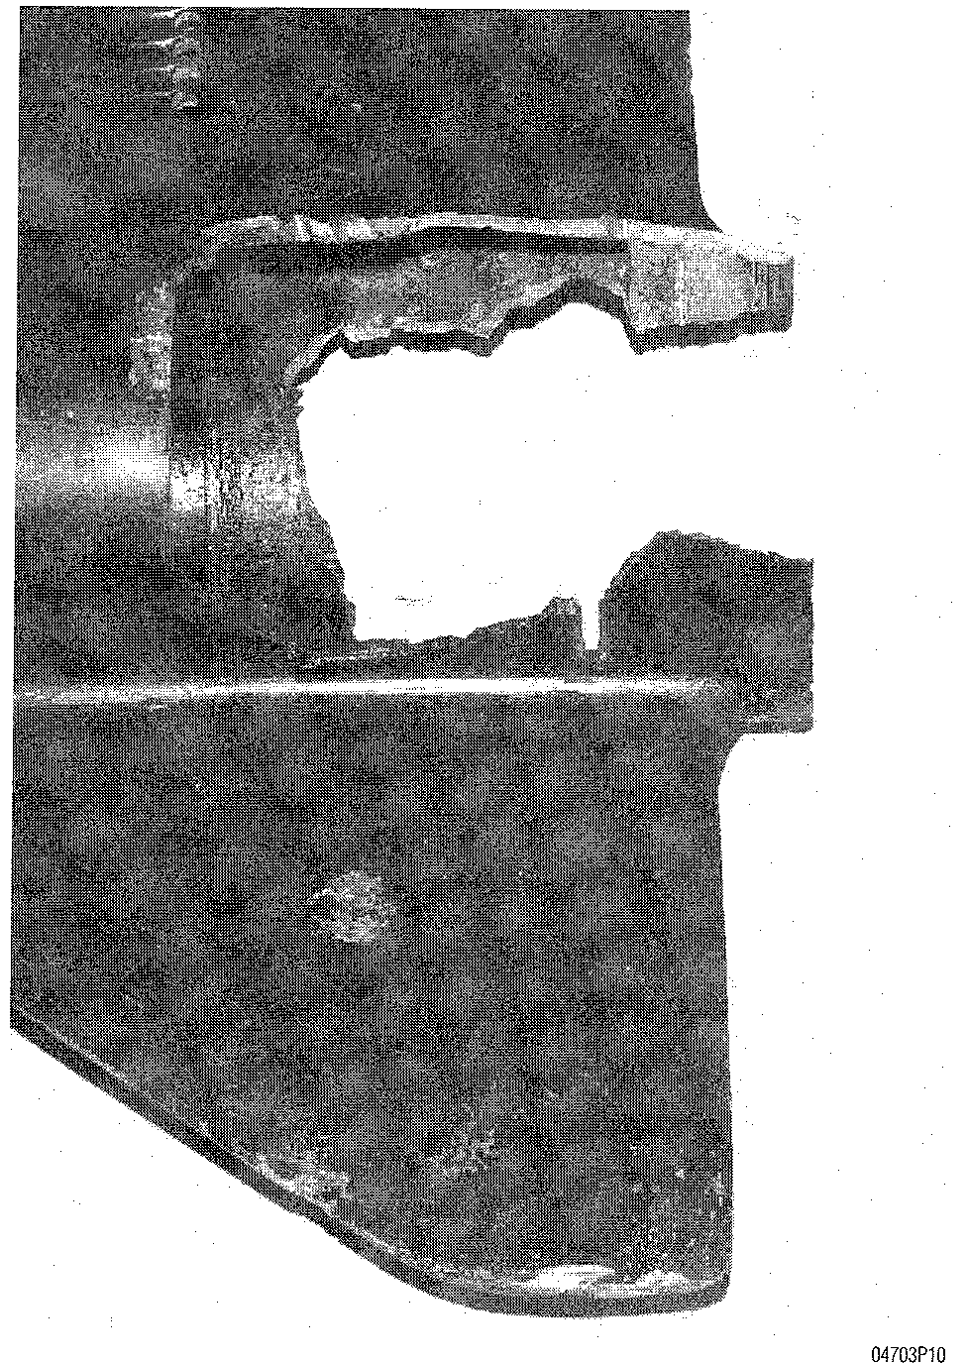

Fig. 3 This lower unit was destroyed because the bearing carrier was frozen due to lack of lubrication

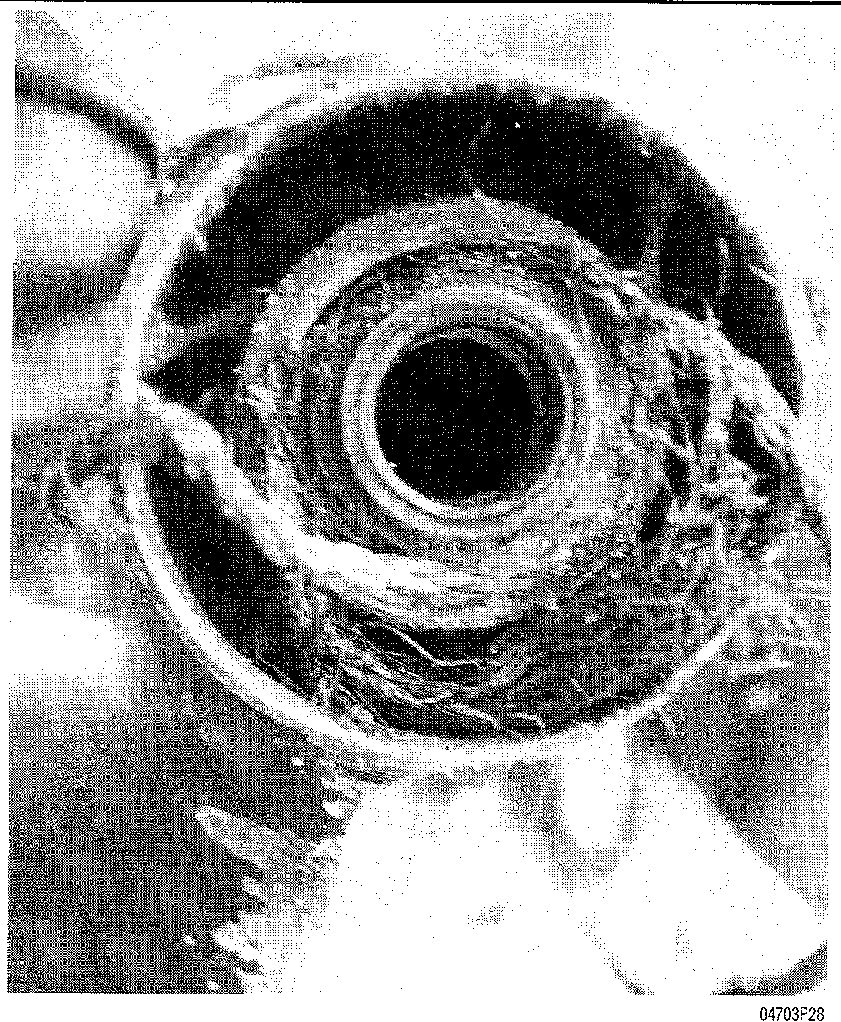

Fig. 4 Excellent view of rope and fishing line entangled behind the propeller. Entangled fishing line can actually cut through the seal, allowing water to enter the lower unit and lubricant to escape

**3-4** MAINTENANCE

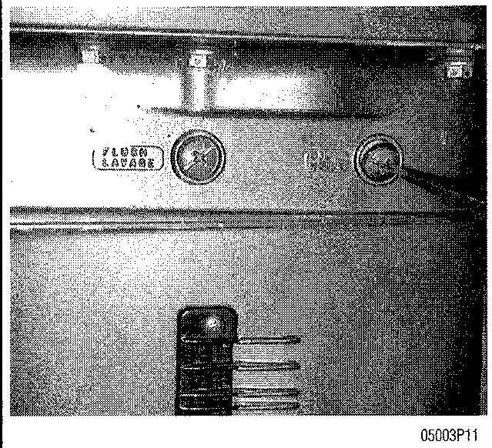

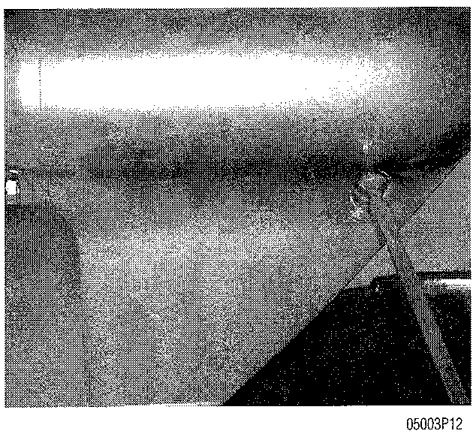

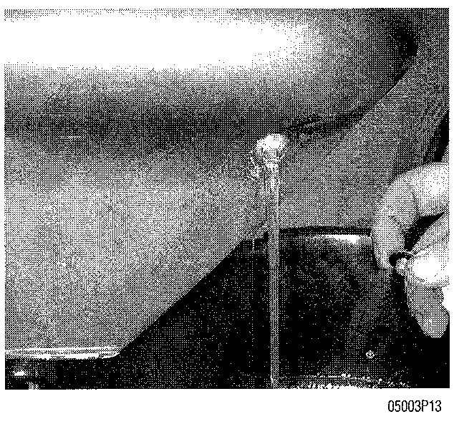

Step 2

Step 3

Step 4

If applicable, check the magnet end of the drain screw for metal particles. Some normal wear is to be expected, but if there are signs of metal chips or excessive metal particles, the gear case needs to be dis­assembled and inspected.

1. Inspect the lubricant for the presence of a milky white substance, water or metallic particles. If any of these conditions are present, the lower unit should be serviced immediately.
2. Place the outboard in the proper position for filling the lower unit. The lower unit should not list to either port or starboard, and should be completely vertical.
3. On smaller outboards, insert the lubricant tube into the oil drain hole at the bottom of the lower unit, and squeeze lubricant until the excess begins to come out the oil level hole.
4. On larger outboards, oil should be injected, to fill the gear case through the drain plug.

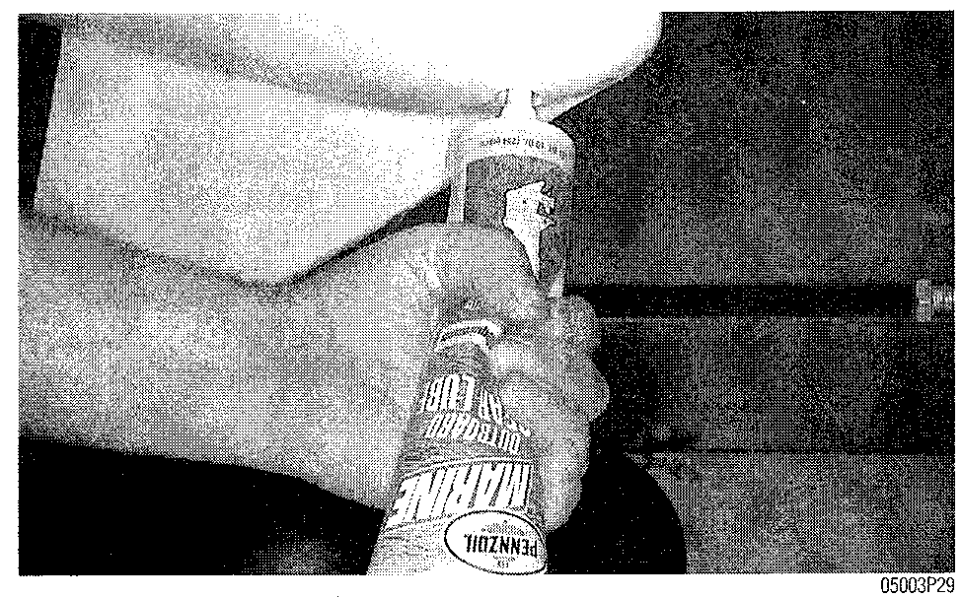

Step 7

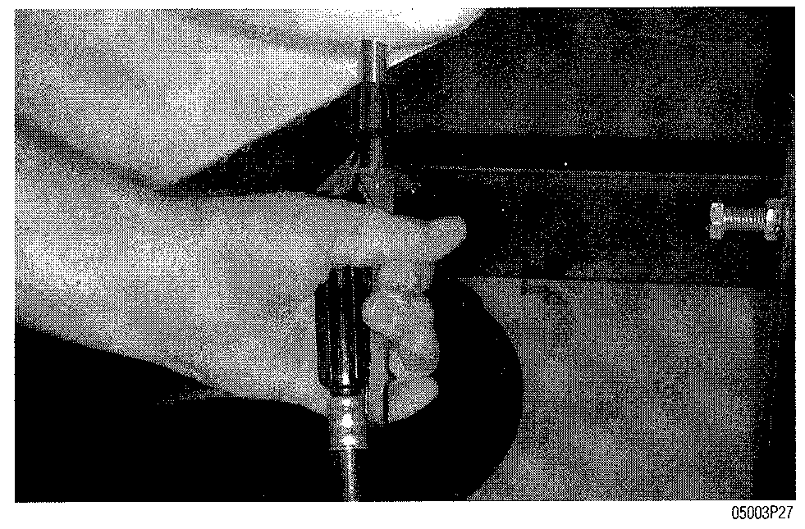

**Step 8**

1. Pump kits are available from marine manufacturers such as Rapiar®.
2. Using new gaskets, (washers) install the oil level and vent plugs (if applicable) first, then install the oil fill plug.
3. Place the used lubricant in a suitable container for transportation to an authorized recycling station.

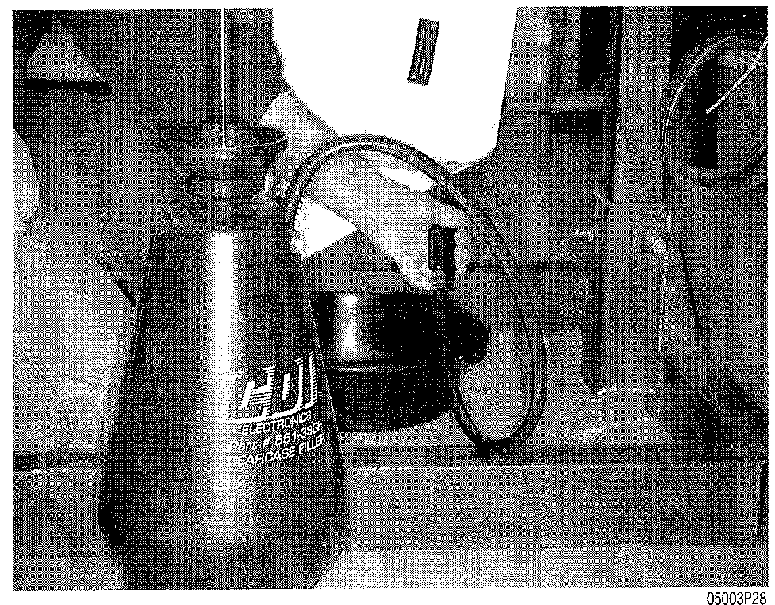

**Step 9**

**Fuel Filter**

**0 See Figures 5 and 6**

The fuel filter is designed to keep particles of dirt and debris from entering the carburetor(s) and clogging the internal passages. A small speck of dirt or sand can drastically affect the ability of the carburetor(s) to deliver the proper amount of air and fuel to enter the engine. If a filter becomes clogged, the flow of gasoline will be impeded. This could cause lean fuel mixtures, hesitation and stumbling, and idle problems.

Regular replacement of the fuel filter will decrease the risk of blocking the flow of fuel to the engine, which could leave you stranded on the water. Fuel fil­ters are usually inexpensive, and replacement is a simple task. Change your fuel filter on a regular basis to avoid fuel delivery problems to the carburetor.

In addition to the fuel filter mounted on the engine, a filter is usually found inside or near the fuel tank (with the exception of DT2 and DT2.2 ). Because of the large variety of differences in both portable and fixed fuel tanks, it is impossible to give a detailed procedure for removal and installation. Most in-tank filters are sim­ply a screen on the pick-up line inside the fuel tank. Filters of this type usually only need to be cleaned and returned to service. Fuel filters on the outside of the tank are typically of the inline type, and are replaced by simply removing the clamps, disconnecting the hoses, and installing a new filter. When installing the new filter, make sure the arrow on the filter points in the direction of fuel flow.

MAINTENANCE **3-5**

RELIEVING FUEL SYSTEM PRESSURE

On fuel injected engines, always relieve system pressure prior to disconnect­ing any fuel system component, fitting or fuel line.

**CAUTION**

**Exercise extreme caution whenever relieving fuel system pressure to avoid fuel spray and potential serious bodily injury. Please be advised that fuel under pressure may penetrate the skin or any part of the body it contacts.**

To avoid the possibility of fire and personal injury, always disconnect the negative battery cable.

Always place a shop towel or cloth around the fitting or connection prior to loosening to absorb any excess fuel due to spillage. Ensure that all fuel spillage is removed from engine surfaces. Ensure that all fuel soaked clothes or towels in suitable waste container.

1. Remove the engine cover.
2. Place a wrench on both the service check bolt and fitting nut to prevent the fitting from twisting and breaking off.
3. Holding the service check bolt and fuel pressure check nut with both wrenches, place a shop towel or equivalent material over the service check bolt.
4. Loosen the service check bolt approximately one turn slowly to relieve the fuel pressure.
5. After relieving the fuel pressure, remove the service check bolt and replace the 6mm sealing washer with a new one. Tighten the service check bolt to 9 ft. lbs. (12 Nm).

REMOVAL & INSTALLATION

**I See Figures 7 and 8**

**\*\* CAUTION**

**Observe all applicable safety precautions when working around fuel. Whenever servicing the fuel system, always work in a well-ventilated area. Do not allow fuel spray or vapors to come in con­tact with a spark or open flame. Do not smoke while working around gasoline. Keep a dry chemical fire extinguisher near the work area. Always keep fuel in a container specifically designed for fuel stor­age; also, always properly seal fuel containers to avoid the possi­bility of fire or explosion.**

1. Remove the engine cover.
2. Locate the fuel filter in the engine pan.
3. Lift the fuel filter from the engine pan, and place a pan or clean rag underneath it to absorb any spilled fuel.
4. Slide the hose retaining clips off the filter nipple with a pair of pliers and disconnect the hoses from the filter.
5. Reinstall the hoses on the filter nipples of the new filter. Make sure the embossed arrow on the filter points in the direction of fuel flow.
6. Slide the clips on each hose over the filter nipples.
7. Check the fuel filter installation for leakage by priming the fuel system with the fuel line primer bulb.
8. Once it is confirmed that there is no leakage from the connections, place the filter back to its proper position in the engine pan.
9. Replace the engine cover.

**Fig. 6 A clogged fuel filter resulted in a lean fuel mixture at speed and caused the burn hole in the top of the piston. This powerhead required a complete overhaul**

**Fig. 5 Typical fuel filter mounting location**

**Fig. 8 Be sure to mount the filter in the proper direction. The arrow on the filter (circled) indicates the direction of the flow of fuel**

**Fig. 7 Thoroughly clean the filter element in solvent**

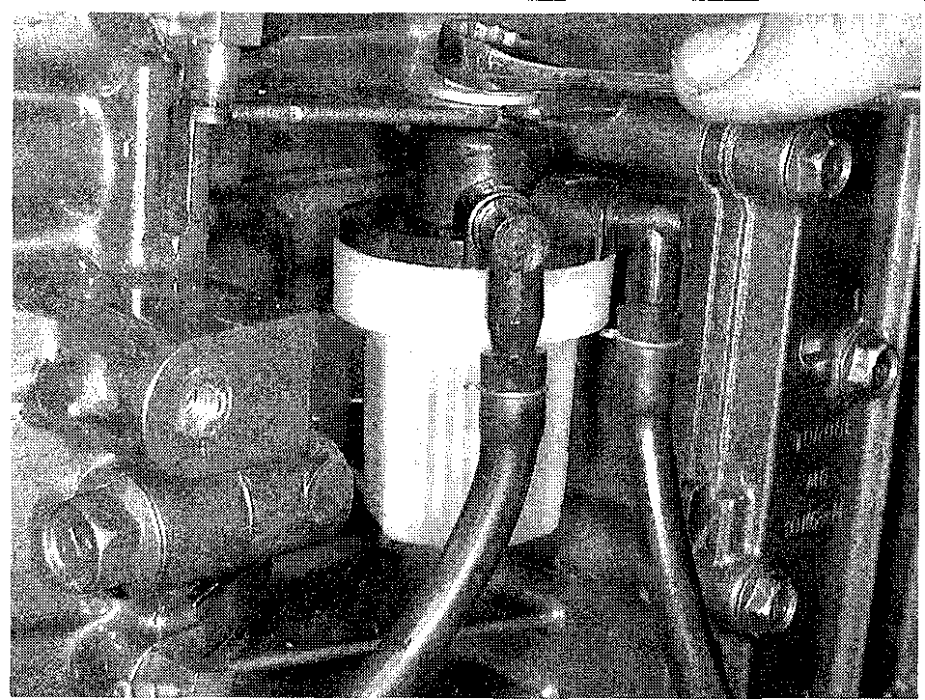

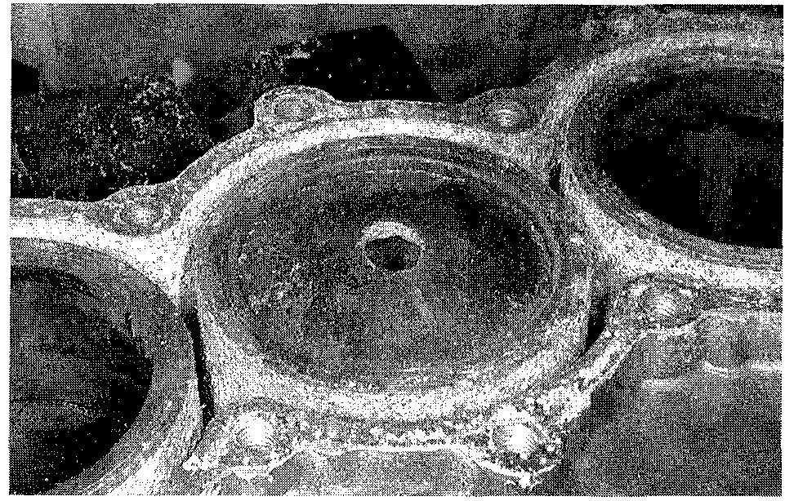

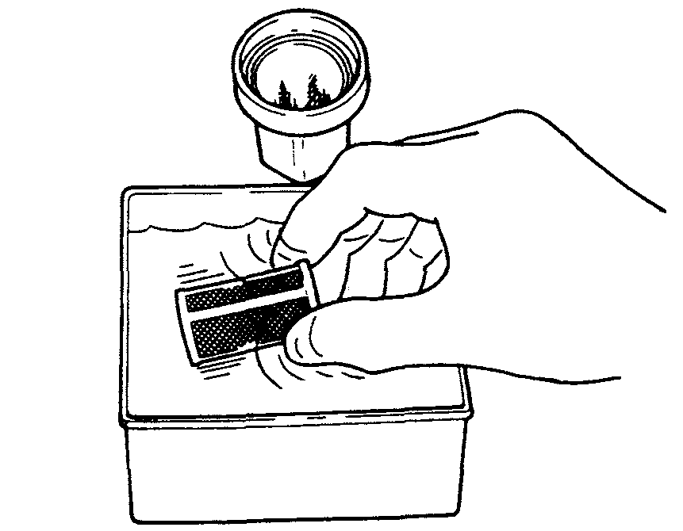

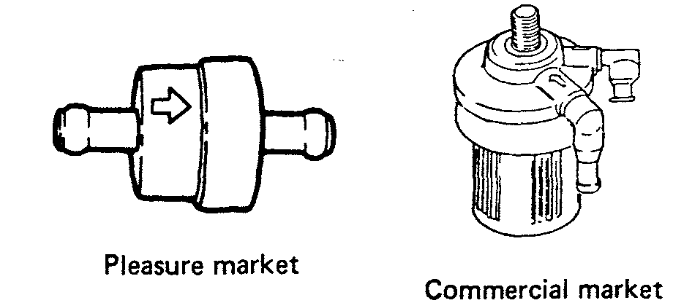

**3-6** MAINTENANCE

**Fuel/Water Separator**

See Figures 9 and 10

In addition to the engine and inline fuel filters, there is usually another filter located in the fuel supply line. This is the fuel/water separator. It is used to remove water particles from the fuel prior to entering the engine or inline filter. Water can enter the fuel supply from a variety of sources and can lead to poor engine performance and ultimately, serious engine damage.

Because of the large variety of differences in both portable and fixed fuel tanks, it is impossible to give a single procedure to cover all applications.

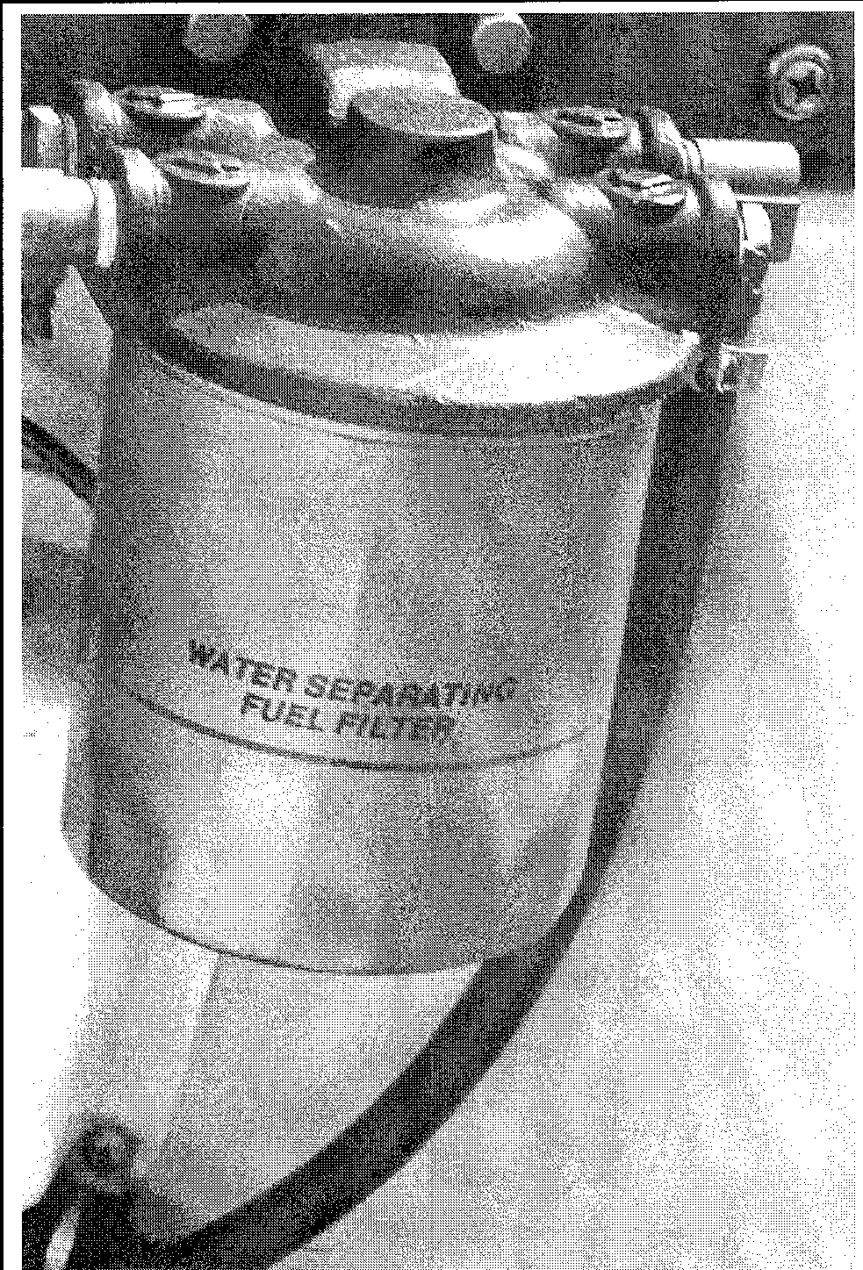

Fig. 9 A water separating fuel filter installed inside the boat on the transom

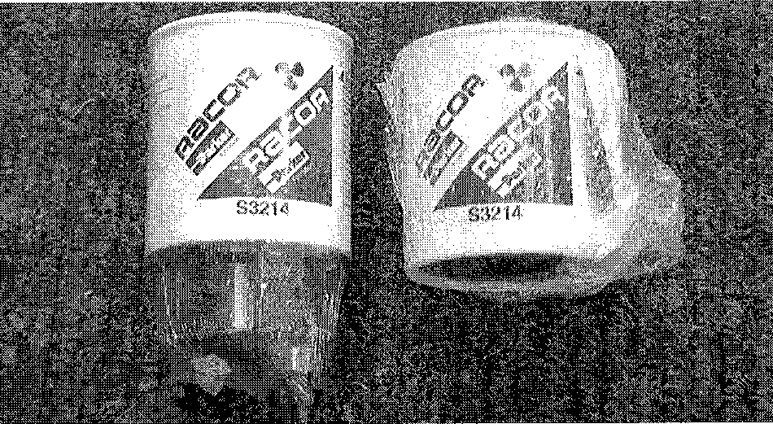

Fig. 10 A typical water separating fuel filter assembly ready to be installed on the boat

Check with the boat manufacturer or the marina who rigged the boat to get the specifics of your particular fuel filtration system.

**Trim/Tilt & Pivot Points**

INSPECTION & LUBRICATION

I See Figures 11, 12 and 13

The steering head and other pivot points of the outboard-to-engine mounting components need periodic lubrication with marine grade grease to provide smooth operation and prevent corrosion. Usually, these pivot points are easily lubricated by simply attaching a grease gun to the fittings.

If the engine is used in salt water, the frequency of applying lubricant is usu­ally doubled in comparison to operation in fresh water. Due to the very corrosive nature of salt water, an anti-seize thread compound should be used on all exposed fasteners outside of the cowling to reduce the chance of them seizing

in place and breaking off when you try to remove them.

.Rinsing off the engine after each use is a very good habit to get into, not only does it help preserve the appearance of the engine, it virtually eliminates the corrosive effects of operating in salt water.

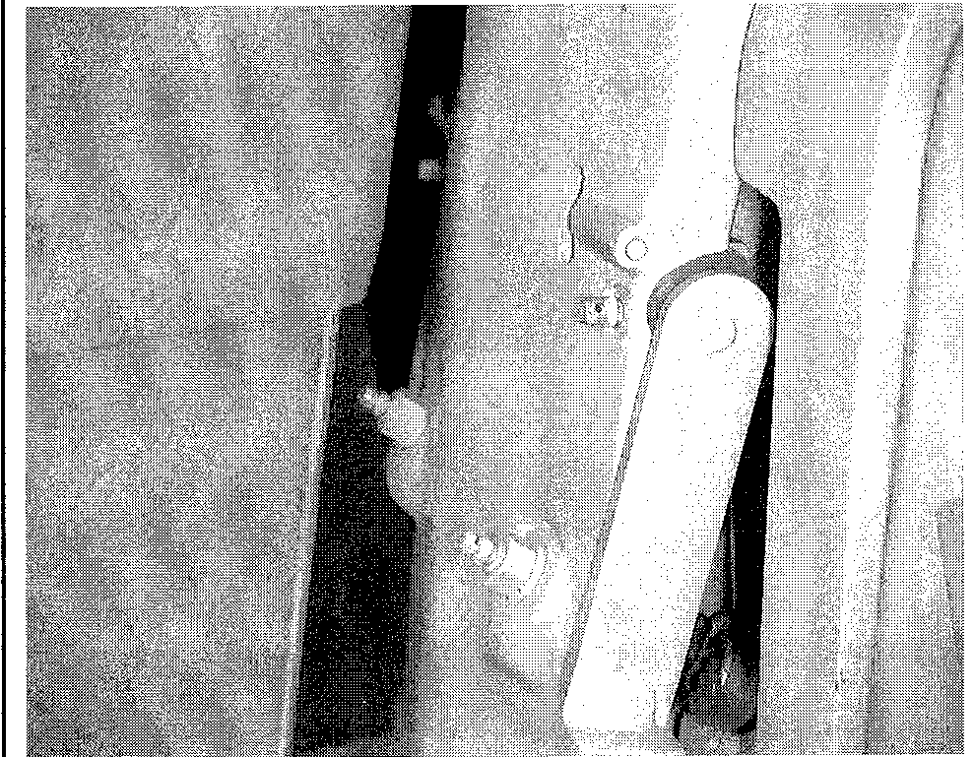

Fig. 11 The steering head . .

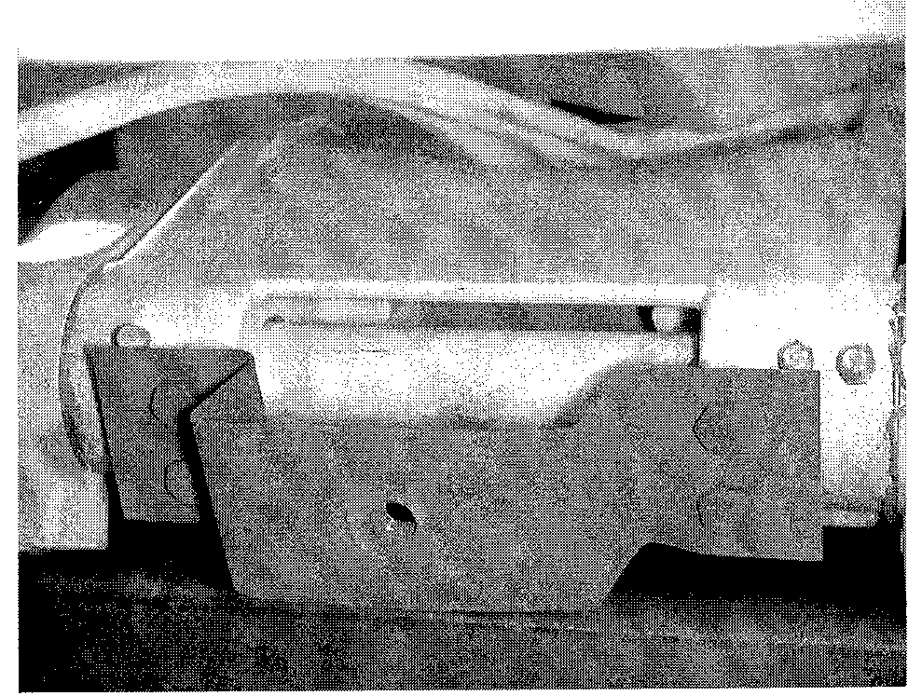

Fig. 12 . . . and steering tube both contain grease fittings which should be lubricated regularly

MAINTENANCE **3**-7

Fig. 13 Due to the very corrosive nature of salt water, some sort of anti-seize type thread compound should be used on all exposed fas­teners outside of the cowling to reduce the chance of them seizing in place

Fig. 15 A block of wood inserted between the propeller and the anti-cavitation plate will prevent the propeller from turning while the nut is being removed or installed

vibrations in the motor. Remove and inspect the propeller. Use a file to trim nicks and burrs. Take care not to remove any more material than is absolutely necessary.

Also, check the rubber and splines inside the propeller hub for damage. If there is damage to either of these, take the propeller to your local marine dealer or a "prop shop". They can evaluate the damaged propeller and determine if it can be saved by rehubbing.

Additionally, the propeller should be removed each time the boat is hauled from the water at the end of an outing. Any material entangled behind the pro­peller should be removed before any damage to the shaft and seals can occur. This may seem like a waste of time, but the small amount of time involved in removing the propeller is returned many times by reduced maintenance and repair, including the replacement of expensive parts.

Propeller

I See Figures 14, 15 and 16

The propeller should be inspected regularly to be sure the blades are in good condition. If any of the blades become bent or nicked, this condition will set up

Fig. 14 An application of anti-seize on the propeller shaft splines will prevent the propeller from seizing on the shaft and facilitate easier removal for the next service

Fig. 16 Once the propeller nut and washer is removed, the propeller can be removed by sliding it off the shaft

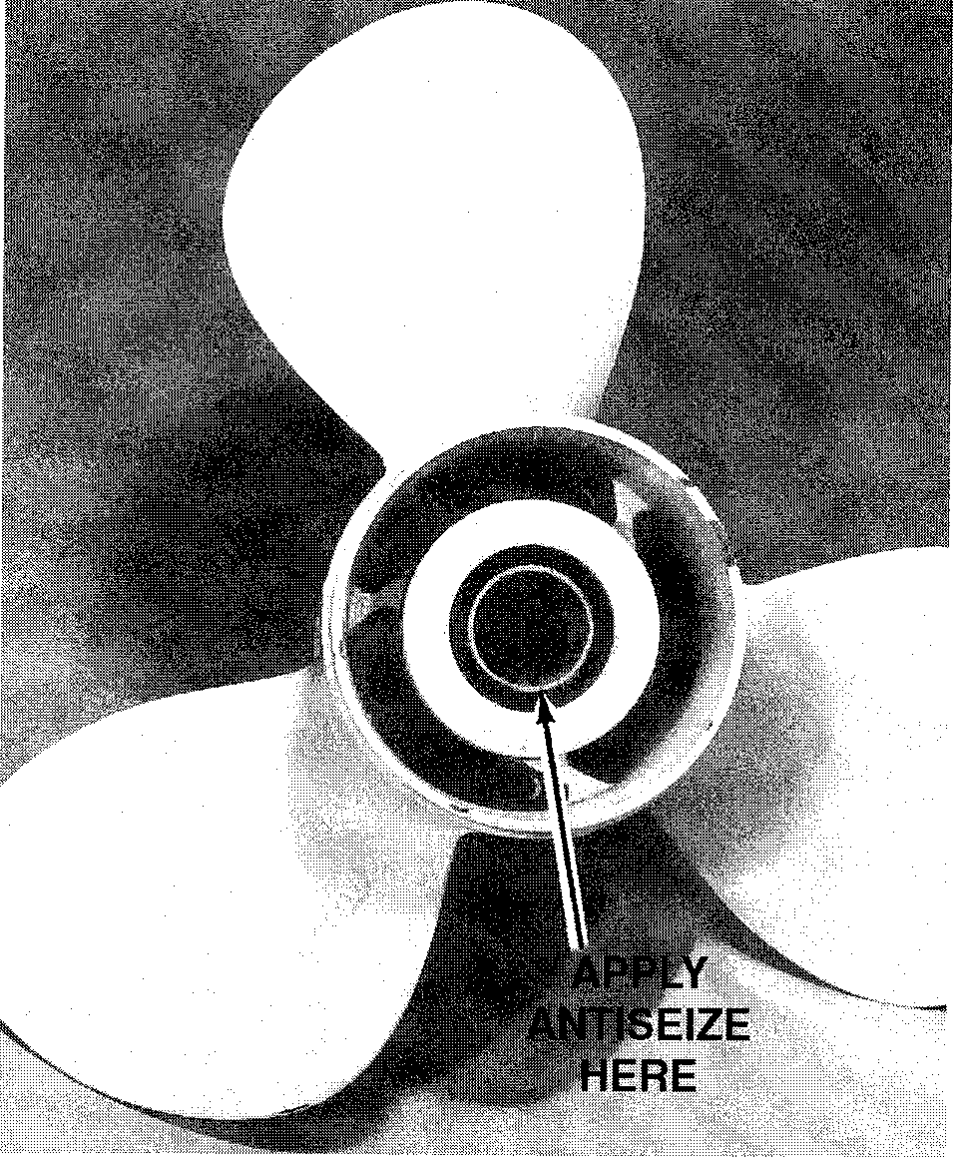

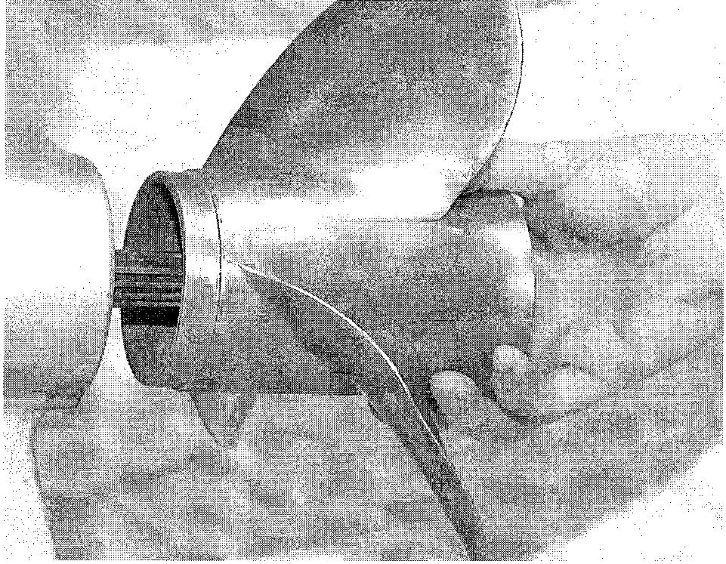

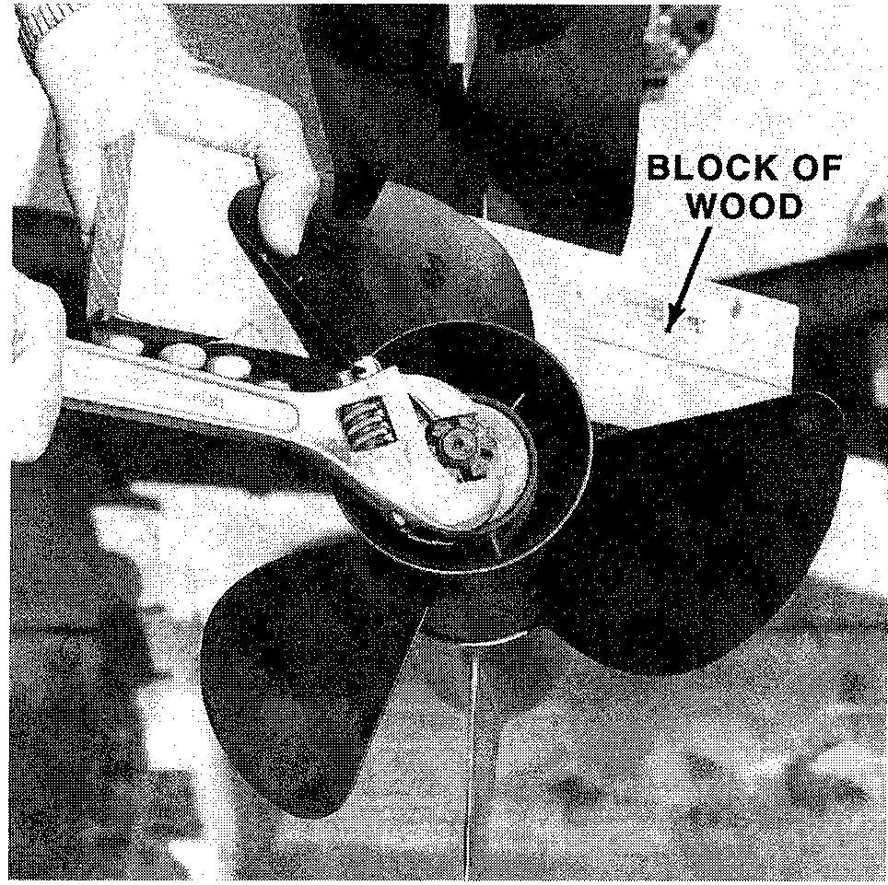

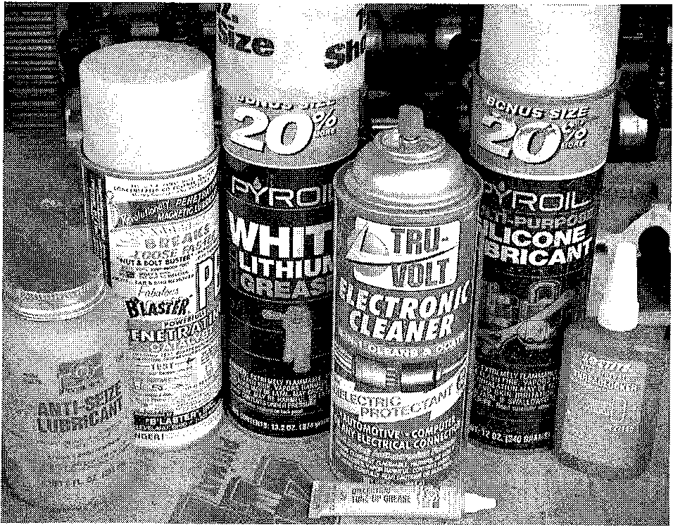

**3-8** MAINTENANCE

**BOAT MAINTENANCE**

**Inside The Boat**

**See Figure 17**

The following points may be lubricated with an all purpose marine lubricant:

* Remote control cable ends next to the hand nut. DO NOT over-lubricate the cable
* Steering arm pivot socket
* Exposed shaft of the cable passing through the cable guide tube
* Steering link rod to steering cable

**Fiberglass Hulls**

► **See Figures 18, 19 and 20**

Fiberglass reinforced plastic hulls are tough, durable, and highly resistant to impact. However, like any other material they can be damaged. One of the advantages of this type of construction is the relative ease with which it may be repaired. Because of its break characteristics, and the simple techniques used in restoration, these hulls have gained popularity throughout the world. From the most congested urban marina, to isolated lakes in wilderness areas, to the severe cold of far off northern seas, and in sunny tropic remote rivers of primi­tive islands or continents, fiberglass boats can be found performing their daily task with a minimum of maintenance.

A fiberglass hull has almost no internal stresses. Therefore, when the hull is broken or stove-in, it retains its true form. It will not dent to take an out-of-shape

set. When the hull sustains a severe blow, the impact will be either absorbed by deflection of the laminated panel or the blow will result in a definite, localized break. In addition to hull damage, bulkheads, stringers, and other stiffening structures attached to the hull may also be affected and therefore, should be checked. Repairs are usually confined to the general area of the rupture.

**The best way to care for a fiberglass hull is to wash it thoroughly, immediately after hauling the boat while the hull is still wet.**

A fouled bottom can seriously affect boat performance. This is one reason why racers, large and small, both powerboat and sail, are constantly giving attention to the condition of the hull below the waterline.

In areas where marine growth is prevalent, a coating of vinyl, anti-fouling bottom paint should be applied. If growth has developed on the bottom, it can be removed with a solution of Muriatic acid applied with a brush or swab and then rinsed with clear water. Always use rubber gloves when working with Muri­atic acid and take extra care to keep it away from your face and hands. The fumes are toxic. Therefore, work in a well-ventilated area, or if outside, keep your face on the windward side of the work.

Barnacles have a nasty habit of making their home on the bottom of boats which have not been treated with anti-fouling paint. Actually they will not harm the fiberglass hull, but can develop into a major nuisance.

If barnacles or other crustaceans have attached themselves to the hull, extra work will be required to bring the bottom back to a satisfactory condition. First, if practical, put the boat into a body of fresh water and allow it to remain for a few days. A large percentage of the growth can be removed in this manner. If this remedy is not possible, wash the bottom thoroughly with a high-pressure fresh water source and use a scraper. Small particles of hard shell may still hold fast. These can be removed with sandpaper.

**Trim Tabs, Anodes and Lead Wires**

**See Figures 21 thru 28**

Check the trim tabs and the anodes (zinc). Replace them, if necessary. The trim tab must make a good ground inside the lower unit. Therefore, the trim tab and the cavity must not be painted. In addition to trimming the boat, the trim tab acts as a zinc electrode to prevent electrolysis from acting on more expensive parts. It is normal for the tab to show signs of erosion. The tabs are inexpensive and should be replaced frequently.

Clean the exterior surface of the unit thoroughly. Inspect the finish for dam­age or corrosion. Clean any damaged or corroded areas, and then apply primer and matching paint.

Check the entire unit for loose, damaged, or missing parts.

An anode is attached across both clamp brackets. It also serves as protec­tion for the coil of hydraulic hoses beneath the trim/tilt unit between the brack­ets.

Lead wires provide good electrical continuity between various brackets which might be isolated from the trim tab by a coating of lubricant between moving parts.

**Fig. 17 Use only a good quality marine grade grease for lubrication**

**Fig. 18 In areas where marine growth is a problem, a coating of anti-foul bottom paint should be applied**

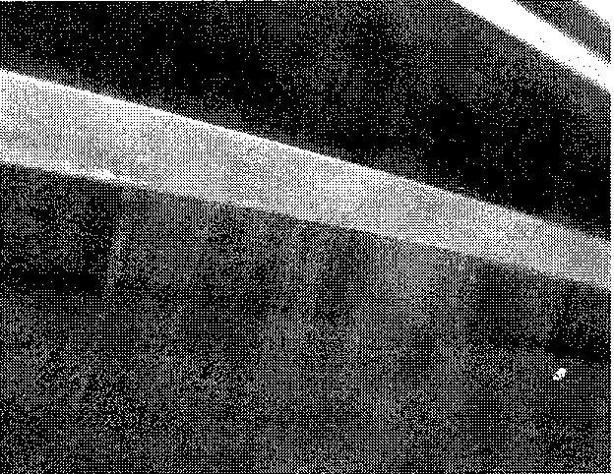

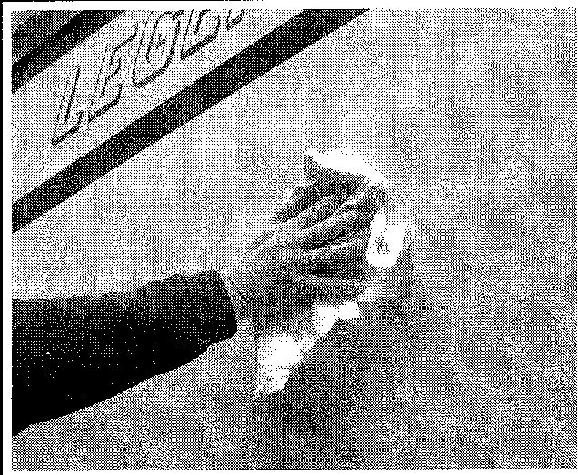

**Fig. 19 The best way to care for a fiber­glass hull is to wash it thoroughly**

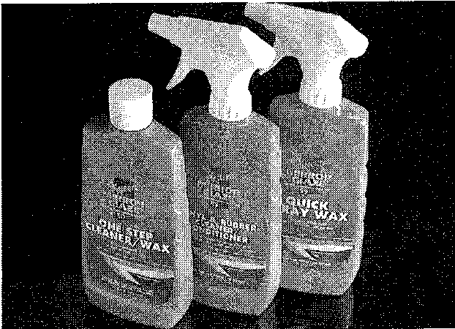

**Fig. 20 Fiberglass, vinyl and rubber care products, such as those available from Meguiar's are available to protect every part of your boat**

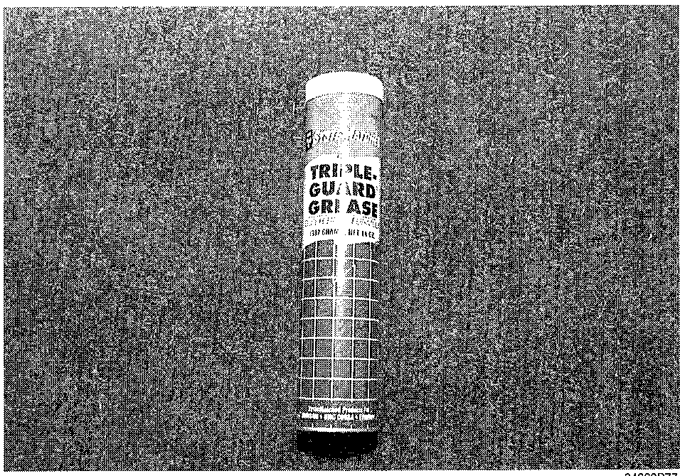

MAINTENANCE **3-9**

|  |  |
| --- | --- |
| **Battery** | complete check up of the electrical system in your boat at the beginning of the boating season is a wise move. Continued regular maintenance of the battery  will ensure trouble free starting on the water.  A complete battery service procedure is included in the "Maintenance" sec­tion of this manual. The following are a list of basic electrical system service procedures that should be performed as part of any tune-up.   * Check the battery for solid cable connections * Check the battery and cables for signs of corrosion damage * Check the battery case for damage or electrolyte leakage * Check the electrolyte level in each cell |
| Difficulty in starting accounts for almost half of the service required on boats each year. A survey by Champion Spark Plug Company indicated that roughly one third of all boat owners experienced a "won't start" condition in a given year. When an engine won't start, most people blame the battery when, in fact, it may be that the battery has run down in a futile attempt to start an engine with other problems.  Maintaining your battery in peak condition may be though of as either tune-up or maintenance material. Most wise boaters will consider it to be both. A |

Fig. 28 One of the many lead wires used to connect bracketed parts. Lead wires are used as an assist in reducing corrosion

Fig. 27 Most anodes are easily removed by loosening and removing their attaching fasteners

Fig. 25 ... and this one on the lower unit

Fig. 24 . . . other types of anodes are also used throughout the outboard, like this one on the stern bracket . .

Fig. 23 Although many outboards use the trim tab as an anode .. .

Fig. 22 Such extensive erosion of a trim tab compared with a new tab suggests an electrolysis problem or complete disregard for peri- odic maintenance

Fig. 21 What a trim tab should look like when it's in good condition

Fig. 26 Anodes installed in the water jacket of a powerhead provide added pro­tection against corrosion

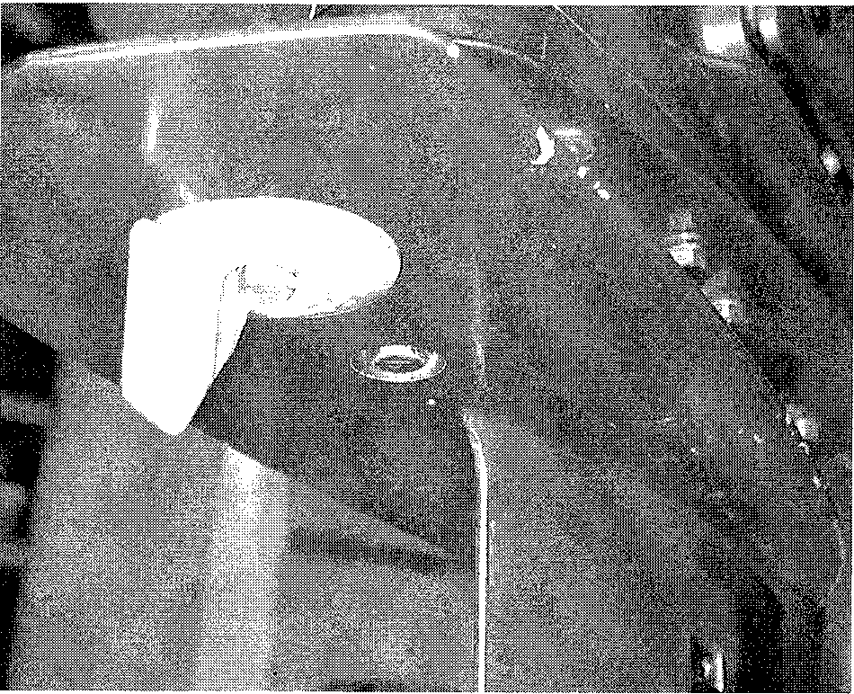

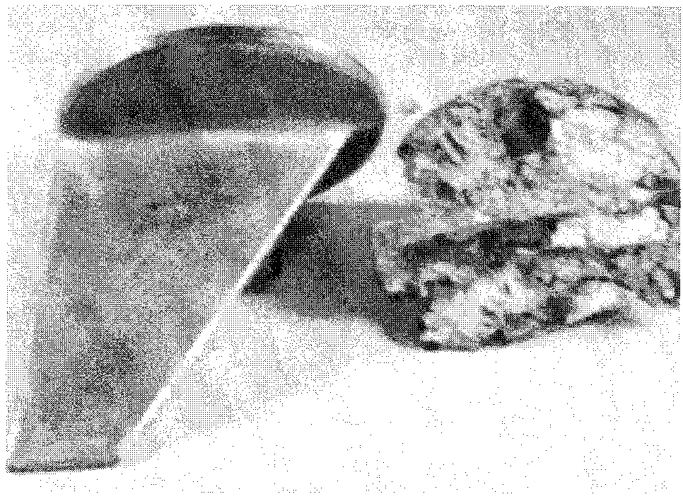

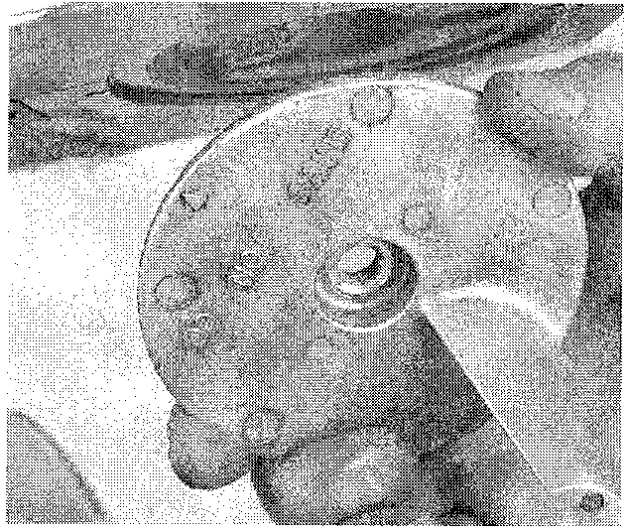

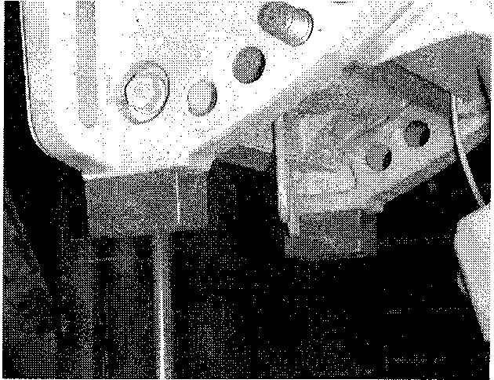

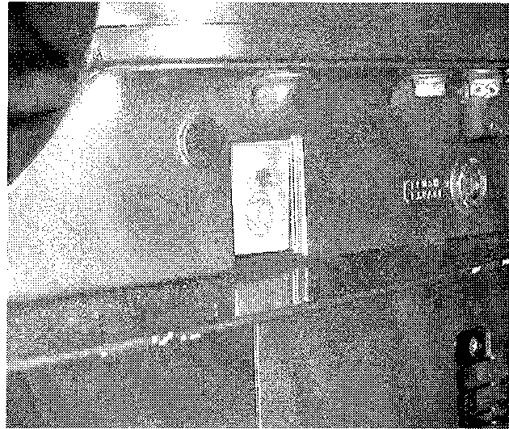

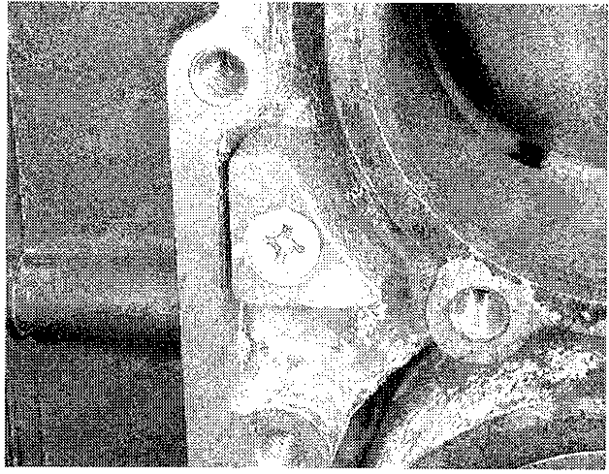

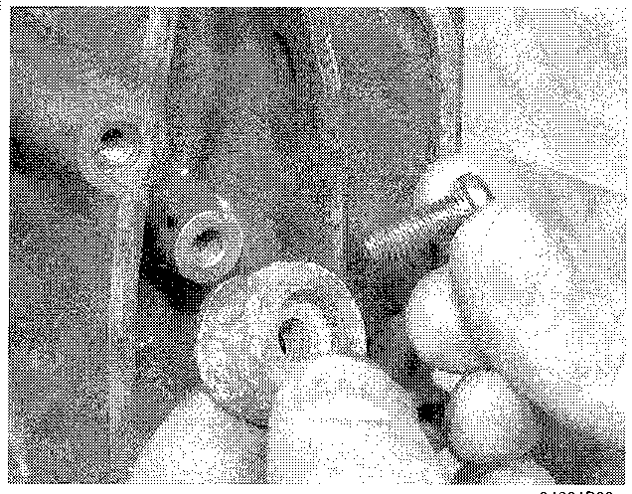

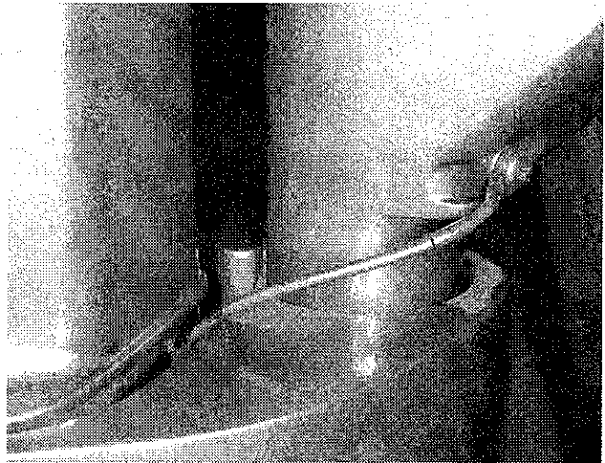

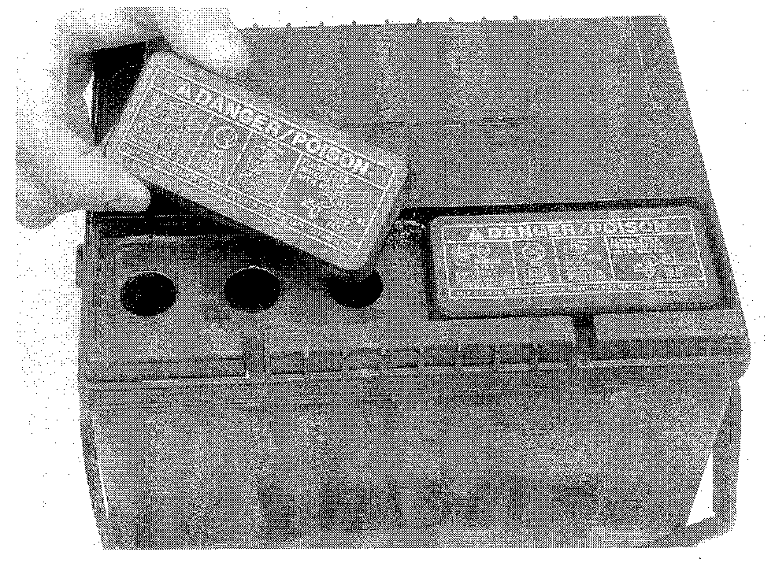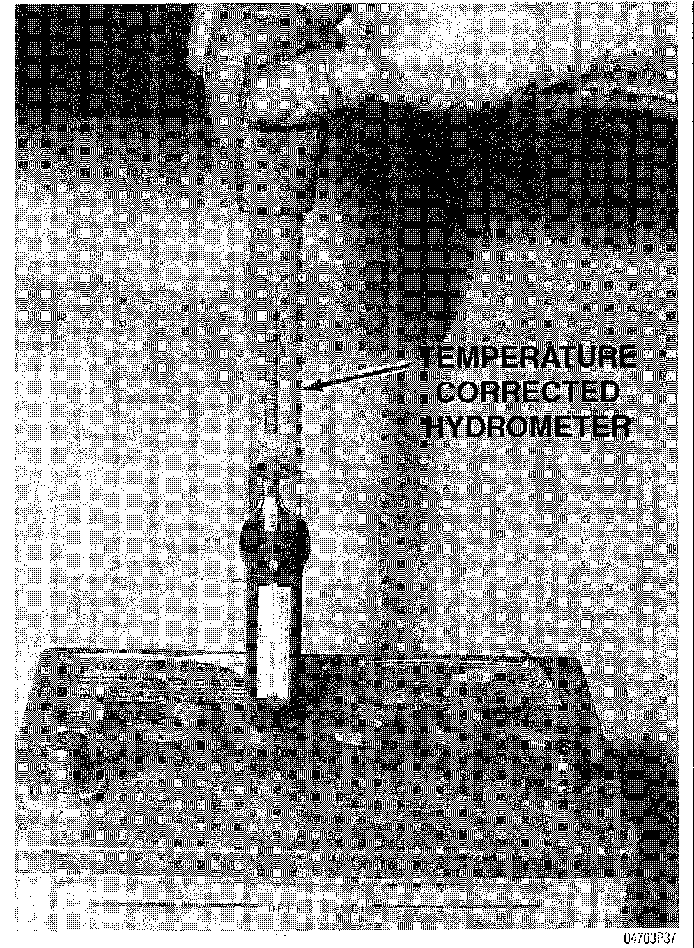

* Check to be sure the battery is fastened securely in position
* Check the battery's state of charge and charge as necessary
* Check battery voltage while cranking the starter. Voltage should remain above 9.5 volts
* Clean the battery, terminals and cables
* Coat the battery terminals with dielectric grease or terminal protector

Batteries which are not maintained on a regular basis can fall victim to para­sitic loads (small current drains which are constantly drawing current from the battery). Normal parasitic loads may drain a battery on boat that is in storage and not used frequently. Boats that have additional accessories with increased parasitic load may discharge a battery sooner. Storing a boat with the negative battery cable disconnected or battery switch turned off will minimize discharge due to parasitic loads.

CLEANING

Keep the battery clean, as a film of dirt can help discharge a battery that is
  
not used for long periods. A solution of baking soda and water mixed into a
  
paste may be used for cleaning, but be careful to flush this off with clear water.

Do not let any of the solution into the filler holes on non-sealed bat­teries. Baking soda neutralizes battery acid and will de-activate a bat­tery cell.

CHECKING SPECIFIC GRAVITY

The electrolyte fluid (sulfuric acid solution) contained in the battery cells will tell you many things about the condition of the battery. Because the cell plates must be kept submerged below the fluid level in order to operate, maintaining the fluid level is extremely important. In addition, because the specific gravity of the acid is an indication of electrical charge, testing the fluid can be an aid in determining if the battery must be replaced. A battery in a boat with a properly operating charging system should require little maintenance, but careful, peri­odic inspection should reveal problems before they leave you stranded.

**\*\* CAUTION**

Battery electrolyte contains sulfuric acid. If you should splash any on your skin or in your eyes, flush the affected area with plenty of clear water. If it lands in your eyes, get medical help immediately.

As stated earlier, the specific gravity of a battery's electrolyte level can be used as an indication of battery charge. At least once a year, check the specific gravity of the battery. It should be between 1.20 and 1.26 on the gravity scale. Most parts stores carry a variety of inexpensive battery testing hydrometers. These can be used on any non-sealed battery to test the specific gravity in each cell.

**Conventional Battery**

**See Figures 29 and 30**

A hydrometer is required to check the specific gravity on all batteries that are not maintenance-free. The hydrometer has a squeeze bulb at one end and a noz­zle at the other. Battery electrolyte is sucked into the hydrometer until the float or pointer is lifted from its seat. The specific gravity is then read by noting the position of the float/pointer. If gravity is low in one or more cells, the battery should be slowly charged and checked again to see if the gravity has come up. Generally, if after charging, the specific gravity of any two cells varies more than 50 points (0.50), the battery should be replaced, as it can no longer produce sufficient voltage to guarantee proper operation.

Check the battery electrolyte level at least once a month, or more often in hot weather or during periods of extended operation. Electrolyte level can be checked either through the case on translucent batteries or by removing the cell caps on opaque-case types. The electrolyte level in each cell should be kept filled to the split ring inside each cell, or the line marked on the outside of the case.

If the level is low, add only distilled water through the opening until the level is correct. Each cell is separate from the others, so each must be checked and filled individually. Distilled water should be used, because the chemicals and minerals found in most drinking water are harmful to the battery and could sig­nificantly shorten its life.

If water is added in freezing weather, the battery should be warmed to allow the water to mix with the electrolyte. Otherwise, the battery could freeze.

3-10 MAINTENANCE

Fig. 29 On non-maintenance free batteries with translucent cases, the electrolyte level can be seen through the case; on other types (such as the one shown), the cell cap must be removed

Fig. 30 The best way to determine the condition of a battery is to test the specific gravity of the electrolyte with a battery tester

Maintenance-Free Batteries I See Figure 31

Although some maintenance-free batteries have removable cell caps for access to the electrolyte, the electrolyte condition and level is usually checked using the built-in hydrometer "eye". The exact type of eye varies between battery manufacturers, but most apply a sticker to the battery itself explaining the pos-

MAINTENANCE **3-11**

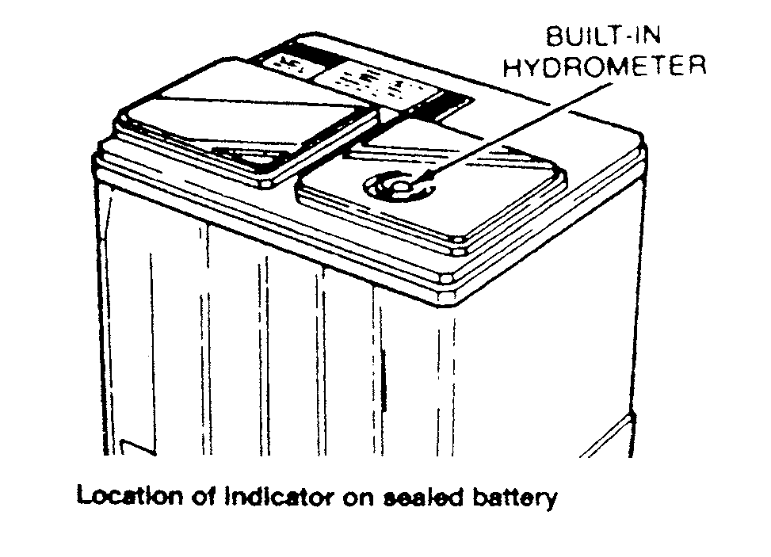

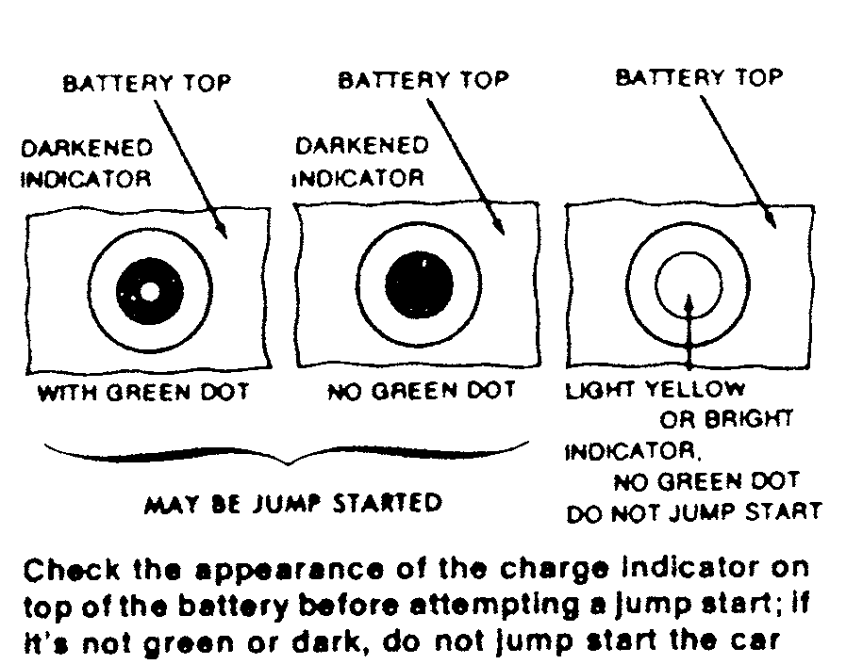

Fig. 31 A typical sealed (maintenance-free) battery with a built-in hydrometer—note that the hydrometer eye may vary between manufacturers; always refer to the battery's label

sible readings. When in doubt, refer to the battery manufacturer's instructions to interpret battery condition using the built-in hydrometer.

The readings from built-in hydrometers may vary, however a green eye usu­ally indicates a properly charged battery with sufficient fluid level. A dark eye is normally an indicator of a battery with sufficient fluid, but one that may be low in charge. In addition, a light or yellow eye is usually an indication that elec­trolyte supply has dropped below the necessary level for battery (and hydrome­ter) operation. In this last case, sealed batteries with an insufficient electrolyte level must usually be discarded.

BATTERY TERMINALS

At least once a season, the battery terminals and cable clamps should be cleaned. Loosen the clamps and remove the cables, negative cable first. On bat­teries with top mounted posts, the use of a puller specially made for this pur­pose is recommended. These are inexpensive and available from most auto parts stores.

Clean the cable clamps and the battery terminal with a wire brush, until all corrosion, grease, etc., is removed and the metal is shiny. It is especially impor­tant to clean the inside of the clamp thoroughly (a wire brush is useful here), since a small deposit of foreign material or oxidation there will prevent a sound electrical connection and inhibit either starting or charging. It is also a good idea to apply some dielectric grease to the terminal, as this will aid in the pre­vention of corrosion.

After the clamps and terminals are clean, reinstall the cables, negative cable last; Do not hammer the clamps onto battery posts. Tighten the clamps securely, but do not distort them. Give the clamps and terminals a thin external coating of grease after installation, to retard corrosion.

Check the cables at the same time that the terminals are cleaned. If the insu­lation is cracked or broken, or if its end is frayed, that cable should be replaced with a new one of the same length and gauge.

BATTERY & CHARGING SAFETY PRECAUTIONS

Always follow these safety precautions when charging or handling a battery.

1. Wear eye protection when working around batteries. Batteries contain corrosive acid and produce explosive gas a byproduct of their operation. Acid on the skin should be neutralized with a solution of baking soda and water made into a paste. In case acid contacts the eyes, flush with clear water and seek medical attention immediately.
2. Avoid flame or sparks that could ignite the hydrogen gas produced by the battery and cause an explosion. Connection and disconnection of cables to bat­tery terminals is one of the most common causes of sparks.
3. Always turn a battery charger OFF, before connecting or disconnecting the leads. When connecting the leads, connect the positive lead first, then the negative lead, to avoid sparks.
4. When lifting a battery, use a battery carrier or lift at opposite corners of the base.
5. Ensure there is good ventilation in a room where the battery is being charged.
6. Do not attempt to charge or load-test a maintenance-free battery when the charge indicator dot is indicating insufficient electrolyte.
7. Disconnect the negative battery cable if the battery is to remain in the boat during the charging process.
8. Be sure the ignition switch is OFF before connecting or turning the charger ON. Sudden power surges can destroy electronic components.
9. Use proper adapters to connect charger leads to batteries with non-con­ventional terminals.

BATTERY CHARGERS

See Figure 32

Before using any battery charger, consult the manufacturer's instructions for its use. Battery chargers are electrical devices that change Alternating Current (AC) to a lower voltage of Direct Current (DC) that can be used to charge a marine battery. There are two types of battery chargers—manual and auto­matic.

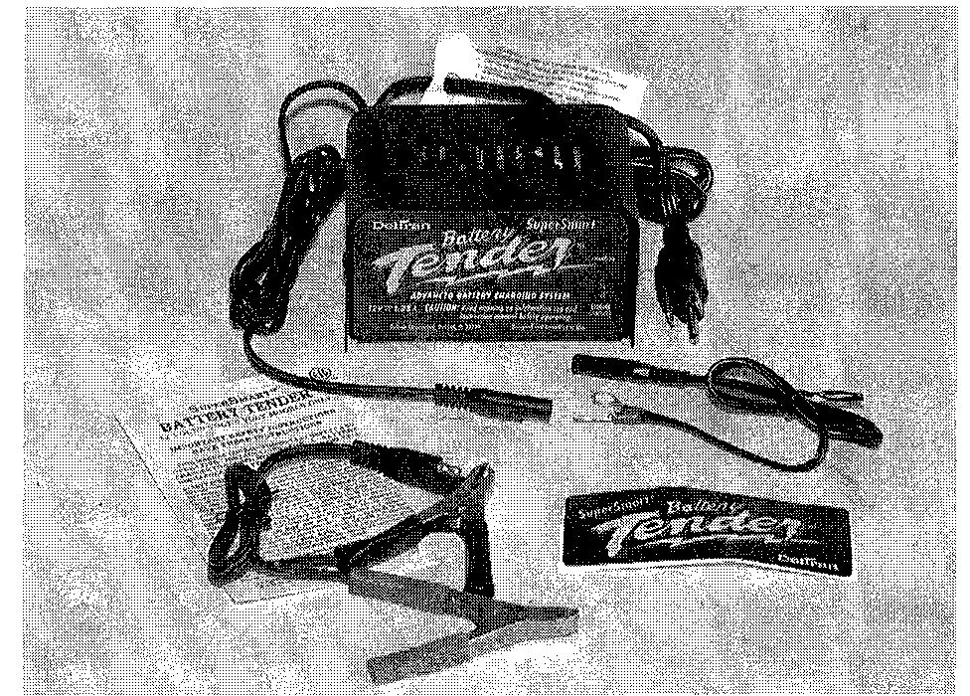

Fig. 32 Automatic battery chargers, like the Battery Tender® from Deltran, have an important advantage—they can stay connected to your battery for extended periods without the possibility of over­charging

**3-12** MAINTENANCE

A manual battery charger must be physically disconnected when the battery has come to a full charge. If not, the battery can be overcharged, and possibly fail. Excess charging current at the end of the charging cycle will heat the elec­trolyte, resulting in loss of water and active material, substantially reducing bat­tery life.

As a rule, on manual chargers, when the ammeter on the charger reg­isters half the rated amperage of the charger, the battery is fully charged. This can vary, and it is recommended to use a hydrometer to accurately measure state of charge.

Automatic battery chargers have an important advantage—they can be left connected (for instance, overnight) without the possibility of overcharging the battery. Automatic chargers are equipped with a sensing device to allow the bat­tery charge to taper off to near zero as the battery becomes fully charged. When charging a low or completely discharged battery, the meter will read close to full rated output. If only partially discharged, the initial reading may be less than full rated output, as the charger responds to the condition of the battery. As the bat­tery continues to charge, the sensing device monitors the state of charge and reduces the charging rate. As the rate of charge tapers to zero amps, the charger will continue to supply-a few milliamps of current—just enough to maintain a charged condition.

REPLACING BATTERY CABLES

Battery cables don't go bad very often, but like anything else, they can wear out. If the cables on your boat are cracked, frayed or broken, they should be replaced.

When working on any electrical component, it is always a good idea to dis­connect the negative (-) battery cable. This will prevent potential damage to many sensitive electrical components

Always replace the battery cables with one of the same length, or you will increase resistance and possibly cause hard starting. Coat the battery posts with a light film of dielectric grease, or a battery terminal protectant spray once you've installed the new cables. If you replace the cables one at a time, you won't mix them up.

.Any time you disconnect the battery cables, it is recommended that you disconnect the negative (-) battery cable first. This will prevent you from accidentally grounding the positive (+) terminal when disconnect­ing it, thereby preventing damage to the electrical system.

Before you disconnect the cable(s), first turn the ignition to the OFF position. This will prevent a draw on the battery which could cause arcing. When the bat­tery cable(s) are reconnected (negative cable last), be sure to check all electrical accessories are all working correctly.

**TUNE-UP**

**Introduction**

A proper tune-up is the key to long and trouble-free engine life, and the work can yield its own rewards. Studies have shown that a properly tuned and main­tained engine can achieve better fuel mileage than an out-of-tune engine. As a conscientious boater, set aside a Saturday morning, say once a month, to check or replace items which could cause major problems later. Keep your own personal log to jot down which services you performed, how much the parts cost you, the date, and the number of hours on the engine at the time. Keep all receipts for such items as engine oil and filters, so that they may be referred to in case of related problems or to determine operating expenses. As a do-it-yourselfer, these receipts are the only proof you have that the required maintenance was performed. In the event of a warranty problem, these receipts will be invaluable.

The efficiency, reliability, fuel economy and enjoyment available from engine performance are all directly dependent on having your outboard tuned properly. The importance of performing service work in the proper sequence cannot be over emphasized. Before making any adjustments, check the specifications. Never rely on memory when making critical adjustments.

Before beginning to tune any engine, ensure the engine has satisfactory compression. An engine with worn or broken piston rings, burned pistons, or scored cylinder walls, will not perform properly no matter how much time and expense is spent on the tune-up. Poor compression must be corrected or the tune-up will not give the desired results.

A practical maintenance program that is followed throughout the year, is one of the best methods of ensuring the engine will give satisfactory performance. As they say, you can spend a little time now or a lot of time later.

The extent of the engine tune-up is usually dependent on the time lapse since the last service. A complete tune-up of the entire engine would entail almost all of the work outlined in this manual. However, this is usually not nec­essary in most cases.

In this section, a logical sequence of tune-up steps will be presented in gen­eral terms. If additional information or detailed service work is required, refer to the section containing the appropriate instructions.

Each year higher compression ratios are built into modern outboard engines and the electrical systems become more complex. Therefore, the need for reli­able, authoritative, and detailed instructions becomes more critical. The infor­mation in this section will fulfill that requirement.

**Tune-Up Sequence**

During a major tune-up, a definite sequence of service work should be fol­lowed to return the engine its maximum performance level. This type of work should not be confused with troubleshooting (attempting to locate a problem when the engine is not performing satisfactorily). In many cases, these two areas will overlap, because many times a minor or major tune-up will correct the malfunction and return the system to normal operation.

The following list is a suggested sequence of tasks to perform during a tune-

up.

* Perform a compression check of each cylinder.
* Inspect the spark plugs to determine their condition. Test for adequate spark at the plug.
* Start the engine in a body of water and check the water flow through the engine.
* Check the gear oil in the lower unit.
* Check the carburetor adjustments and the need for an overhaul.
* Check the fuel pump for adequate performance and delivery.
* Make a general inspection of the ignition system.
* Test the starter motor and the solenoid, if so equipped.
* Check the internal wiring.
* Check the timing and synchronization.

**Compression Check**

Cylinder compression test results are extremely valuable indicators of inter­nal engine condition. The best marine mechanics automatically check an engine's compression as the first step in a comprehensive tune-up. Obviously, it is useless to try to tune an engine with extremely low or erratic compression readings, since a simple tune-up will not cure the problem.

The pressure created in the combustion chamber may be measured with a gauge that remains at the highest reading it measures during the action of a one-way valve. This gauge is inserted into the spark plug hole. A compression test will uncover many mechanical problems that can cause rough running or poor performance.

If the powerhead shows any indication of overheating, such as discolored or scorched paint, inspect the cylinders visually through the transfer ports for pos­sible scoring. It is possible for a cylinder with satisfactory compression to be scored slightly. Also, check the water pump. A faulty water pump may cause the overheating condition.

CHECKING COMPRESSION

► See Figures 33, 34 and 35

Prepare the engine for a compression test as follows:

1. Run the engine until it reaches operating temperature. If the test is per­formed on a cold engine, the readings will be considerably lower than normal, even if the engine is in perfect mechanical condition.
2. Label and disconnect the spark plug wires. Always grasp the molded cap and pull it loose with a twisting motion to prevent damage to the connection.
3. Clean all dirt and foreign material from around the spark plugs, and then remove all the plugs. Keep them in order by cylinder for later evaluation.
4. Ground the spark plug leads to the engine to render the ignition system inoperative while performing the compression check.

MAINTENANCE **3-13**

**Fig. 33 Removing the high tension lead. Always use a twist and pull motion on the boot to prevent damage to the wire**

Fig. 34 All spark plugs should be grounded while making compression tests. this action will prevent placing an extra load on the ignition coil

Fig. 35 Crank the engine with the starter through at least 4 complete strokes with the throttle at the wide-open position, to obtain the highest possible reading

Fig. 36 Damaged spark plugs. Notice the broken electrode on the left plug. The electrode must be found and retrieved prior to return­ing the powerhead to service

1. Insert a compression gauge into the No. 1, top, spark plug opening.
2. Crank the engine with the starter through at least 4 complete strokes with the throttle at the wide-open position, to obtain the highest possible reading. Then record the reading.
3. Repeat the test and record the compression for each cylinder.
4. A variation between cylinders is far more important than the actual read­ings. A variation of more than 15 psi (103 kPa), between cylinders indicates the lower compression cylinder is defective. Not all engines will exhibit the same compression readings. In fact, two identical engines may not have the same compression. Generally, the rule of thumb is that the lowest cylinder should be within 25% of the highest (difference between the two readings).
5. If compression is low in one or more cylinders, the problem may be worn, broken, or sticking piston rings, scored pistons or worn cylinders.

LOW COMPRESSION

Compression readings that are generally low indicate worn, broken, or stick­ing piston rings, scored pistons or worn cylinders, and usually indicate an engine that has a lot of hours on it. Low compression in two adjacent cylinders (with normal compression in the other cylinders) indicates a blown head gasket between the low-reading cylinders. Other problems are possible (broken ring, hole burned in a piston), but a blown head gasket is most likely.

A conventional compression check will only show secondary compression readings and not primary crankcase compression. If there is an air leak in the crankcase, this will cause insufficient fuel to be brought into the crankcase and cylinder for normal operation. If it is a small leak, the powerhead will run poorly, because the fuel mixture will be too lean, and cylinder temperatures will be hot­ter than normal.

Air leaks are possible around any seal, 0-ring, cylinder block mating surface, or gasket surface. Always replace 0-rings, gaskets and seals when service work has been preformed. If the powerhead is running poorly, spray soapy water on the suspected sealing surface and look for bubbles to form, indicating an air leak. The base of the powerhead and the lower crankshaft seal are impossible to check in this manner, and will need to be checked by another method, a crankcase pressure test

To pressure test the crankcase, make up adapters to fit the carburetor mount­ing studs. Into one adapter fit an air fitting, which will accept a hand pump, which is used for testing the lower unit. With the powerhead on the bench, place some rubber gasket material over the exhaust, leaving the water passages open. Using the hand pump, pressurize the crankcase to 5 psi.

Spray soapy water around the lower crankcase seal area and other seals and gasket sealing surfaces looking for telltale bubbles. Also, if possible, pull a vac­uum in the crankcase to check the seals in the opposite direction and watch for a pressure drop.

Spark Plugs

See Figure 36

Spark plug life and efficiency depend upon the condition of the engine and the combustion chamber temperatures to which the plug is exposed. These tem­peratures are affected by many factors, such as compression ratio of the engine, air/fuel mixtures and the type of normally placed on your engine.

Factory installed plugs are, in a way, compromise plugs, since the factory has no way of knowing what typical loads your engine will see. However, most people never have reason to change their plugs

SPARK PLUG HEAT RANGE See Figure 37

Spark plug heat range is the ability of the plug to dissipate heat. The longer the insulator (or the farther it extends into the engine), the hotter the plug will operate; the shorter the insulator (the closer the electrode is to the block's cool­ing passages) the cooler it will operate. A plug that absorbs little heat and remains too cool will quickly accumulate deposits of oil and carbon since it is not hot enough to burn them off. This leads to plug fouling and consequently to misfiring. A plug that absorbs too much heat will have no deposits but, due to the excessive heat, the electrodes will burn away quickly and might possibly

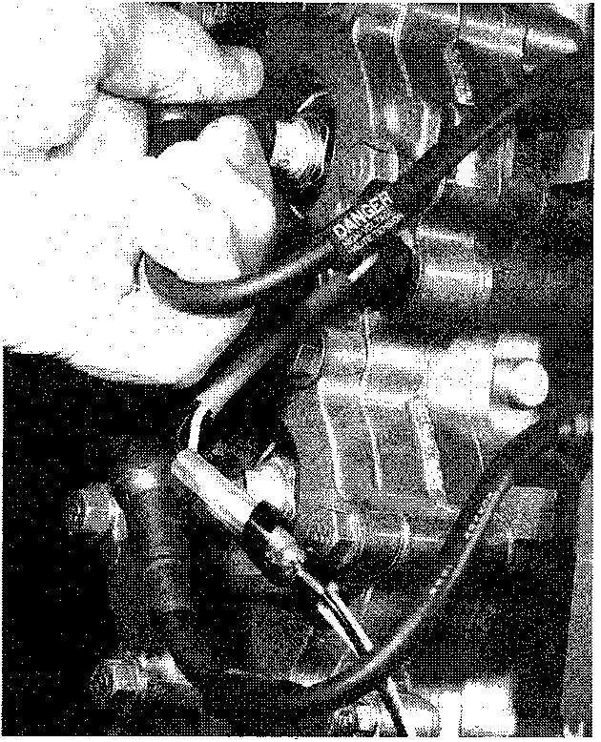

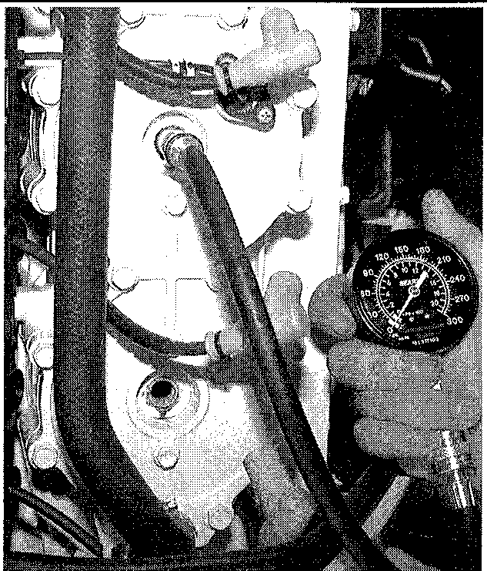

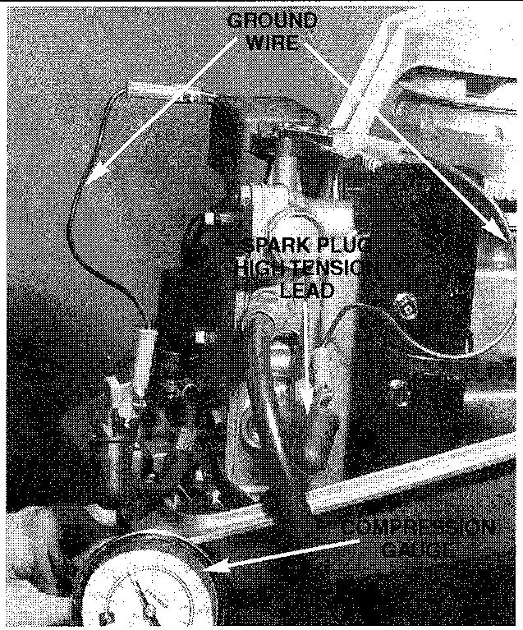

**3-14** MAINTENANCE

**lead to pre-ignition or other ignition problems. Pre-ignition takes place when plug tips get so hot that they glow sufficiently to ignite the air/fuel mixture before the actual spark occurs. This early ignition will usually cause a pinging during heavy loads.**

SPARK PLUG SERVICE

**•New technologies in spark plug and ignition system design have pushed the recommended replacement interval to every 100 hours of operation (6 months). However, this depends on usage and conditions. This holds true unless internal engine wear or damage cause plug foul­ing. If you suspect this, you may wish to remove and inspect the plugs before the recommended time.**

**Spark plugs should only require replacement once a season. The electrode on a new spark plug has a sharp edge, but with use, this edge becomes rounded by wear, causing the plug gap to increase. As the gap increases, the plug's voltage requirement also increases. It requires a greater voltage to jump the wider gap and about two to three times as much voltage to fire a plug at high speeds than at idle.**

**Tools needed for spark plug replacement include: a ratchet, short extension, spark plug socket (there are two types; either 13/46 inch or 5/8 inch, depending upon the type of plug), a combination spark plug gauge and gapping tool, and a can of penetrating oil or anti-seize type grease for engines with aluminum heads.**

**When removing spark plugs, work on one at a time. Don't start by remov­ing the plug wires all at once, because unless you number them, they may become mixed up. Take a minute before you begin and number the wires with tape.**

REMOVAL & INSTALLATION

1. **Disconnect the negative battery cable, and if the engine has been run recently, allow the engine to thoroughly cool. Attempting to remove plugs from a hot cylinder head could cause the plugs to seize and damage the threads in the cylinder head. Especially on aluminum heads!**
2. **Carefully twist the spark plug wire boot to loosen it, then pull the boot using a twisting motion and remove it from the plug. Be sure to pull on the boot and not on the wire, otherwise the connector located inside the boot may become separated.**

**A spark plug wire removal tool is recommended as it will make removal easier and help prevent damage to the boot and wire assem­bly.**

1. **Using compressed air (and safety glasses), blow debris from the spark plug well to assure that no harmful contaminants are allowed to enter the com­bustion chamber when the spark plug is removed. If compressed air is not available, use a rag or a brush to clean the area. Compressed air is available from both an air compressor or from compressed air in cans available at pho­tography stores.**

**Remove the spark plugs when the engine is cold, if possible, to pre­vent damage to the threads. If plug removal is difficult, apply a few drops of penetrating oil to the area around the base of the plug, and allow it a few minutes to work.**

1. **Using a spark plug socket that is equipped with a rubber insert to prop­erly hold the plug, turn the spark plug counterclockwise to loosen and remove the spark plug from the bore.**

**\*\*WARNING**

**Avoid the use of a flexible extension on the socket. Use of a flexible extension may allow a shear force to be applied to the plug. A shear force could break the plug off in the cylinder head, leading to costly and frustrating repairs. In addition, be sure to support the ratchet with your other hand—this will also help prevent the socket from damaging the plug.**

**Evaluate each cylinder's performance by comparing the spark condition. Check each spark plug to be sure they are all of the same manufacturer and have the same heat range rating. Inspect the threads in the spark plug opening of the block, and clean the threads before installing the plug.**

**When purchasing new spark plugs, always ask the dealer if there has been a spark plug change for the engine being serviced.**

**Crank the engine through several revolutions to blow out any material which might have become dislodged during cleaning. Always use a new gas­ket (if applicable). The gasket must be fully compressed on clean seats to complete the heat transfer process and to provide a gas tight seal in the cylin­der.**

1. **Inspect the spark plug boot for tears or damage. If a damaged boot is found, the spark plug boot and possible the entire wire will need replace­ment.**
2. **Apply a thin coating of anti-seize on the thread of the plug. This is extremely important on aluminum head engines.**
3. **Carefully thread the plug into the bore by hand. If resistance is felt before the plug completely bottomed, back the plug out and begin threading again.**

**\*\*WARNING**

**Do not use the spark plug socket to thread the plugs. Always care­fully thread the plug -by hand or using an old plug wire to prevent the possibility of crossthreading and damaging the cylinder head bore.**

1. **Carefully tighten the spark plug. If the plug you are installing is equipped with a crush washer, seat the plug, then tighten to 10-15 ft. lbs. (14-20 Nm) or about 14 turn to crush the washer. Whenever possible, spark plugs should be tightened to the factory torque specification.**
2. **Apply a small amount of silicone dielectric compound to the end of the spark plug lead or inside the spark plug boot to prevent sticking, then install the boot to the spark plug and push until it clicks into place. The click may be felt or heard. Gently pull back on the boot to assure proper contact.**

READING SPARK PLUGS

**See Figures 38 thru 44**

**Your spark plugs are the single most valuable indicator of your engine's inter­nal condition. Study your spark plugs carefully every time you remove them. Compare them to illustrations shown to identify the most common plug condi­tions.**

**Fig. 37 Spark Plug heat range**

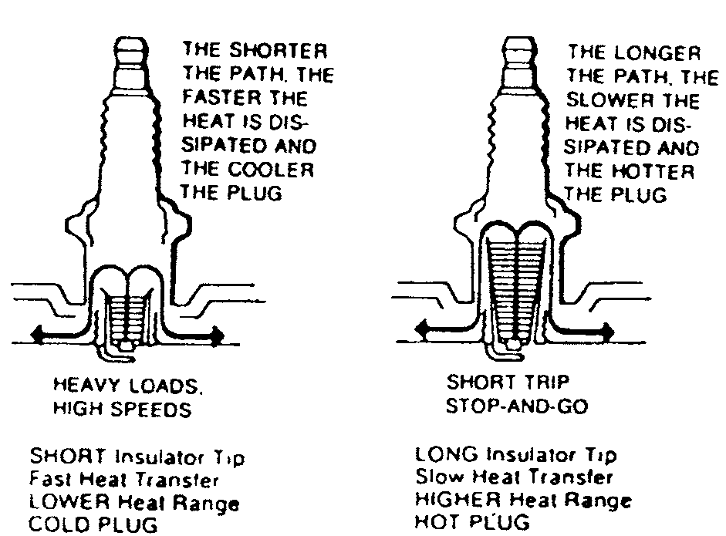

MAINTENANCE **3-15**

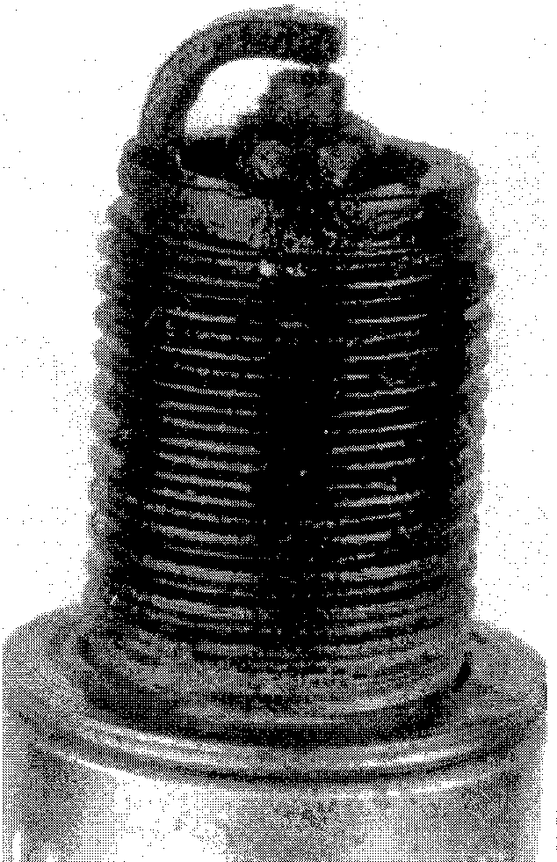

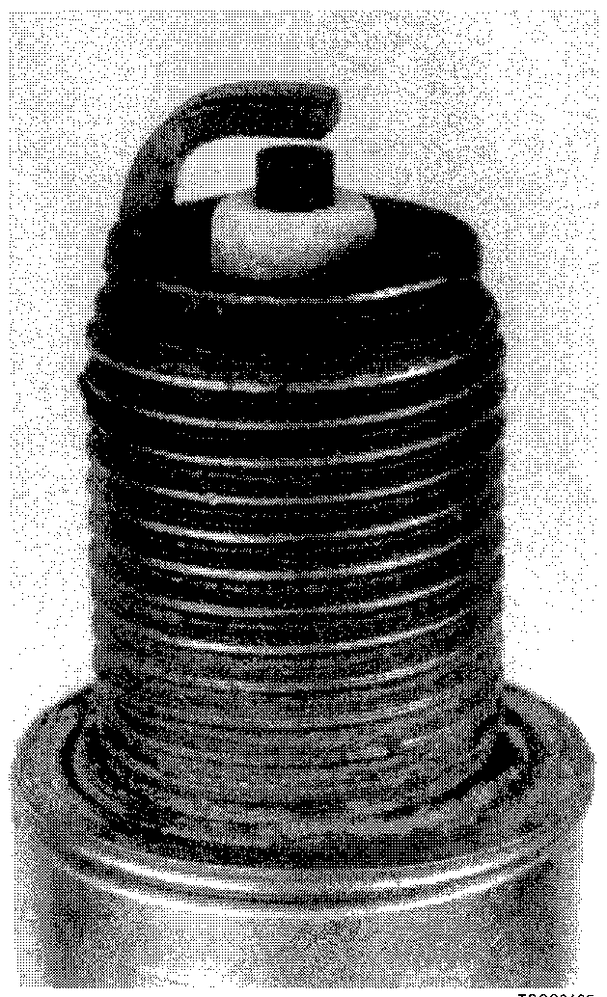

Fig. 38 A normally worn spark plug should have light tan or gray deposits on the fir­ing tip (electrode)

Fig. 41 An oil-fouled spark plug indicates an engine with worn piston rings and/or bad valve seals allowing excessive oil to enter the combustion chamber

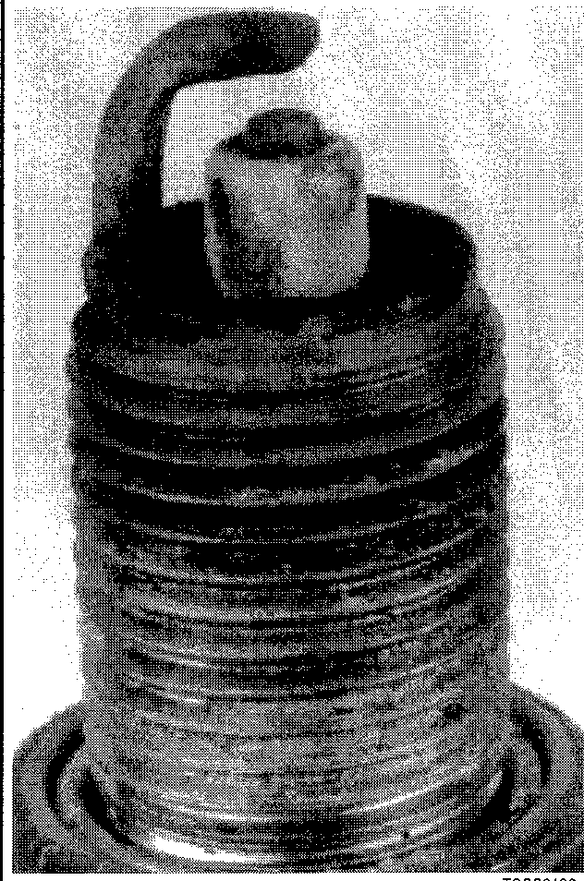

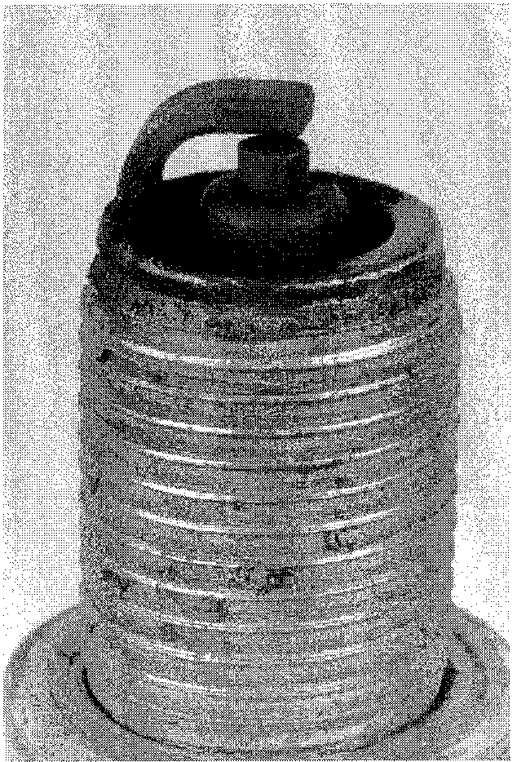

Fig. 39 A carbon-fouled plug, identified by soft, sooty black deposits, may indicate an improperly tuned vehicle. Check the air cleaner, ignition components and the engine control system.

Fig. 42 This spark plug has been left in the engine too long, as evidenced by the extreme gap—Plugs with such an extreme gap can cause misfiring and stumbling accompanied by a noticeable lack of power

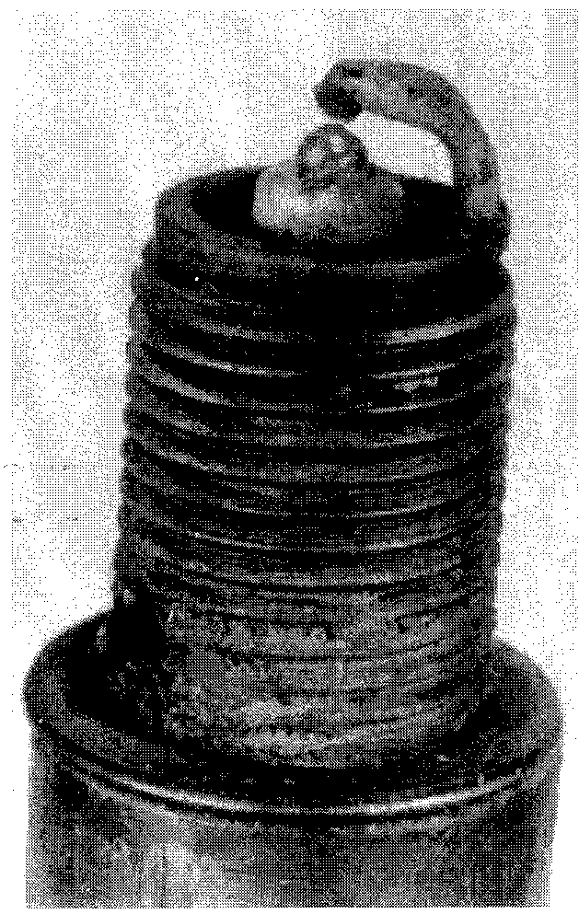

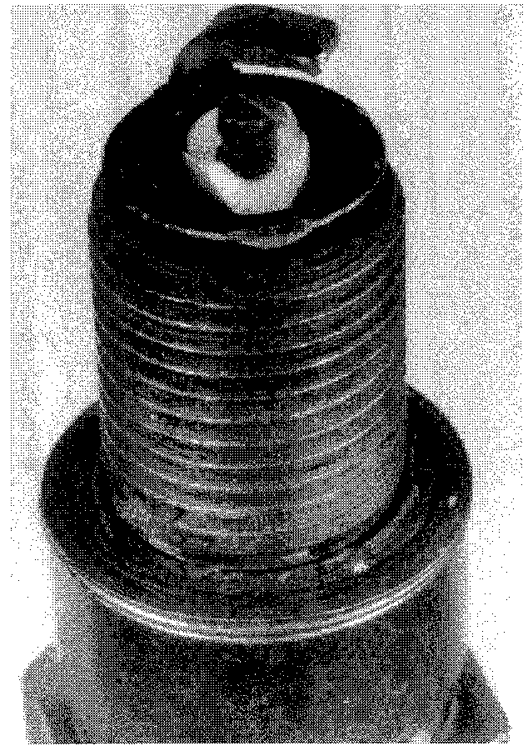

Fig. 40 A physically damaged spark plug may be evidence of severe detonation in that cylinder. Watch that cylinder carefully between services, as a continued detona­tion will not only damage the plug, but could also damage the engine

Fig. 43 A bridged or almost bridged spark plug, identified by the build-up between the electrodes caused by excessive carbon or oil build-upon the plug

INSPECTION & GAPPING

Check spark plug gap before installation. The ground electrode (the L-shaped one connected to the body of the plug) must be parallel to the center electrode and the specified size wire gauge must pass between the electrodes with a slight drag.

Always check the gap on new plugs as they are not always set correctly at the factory. Do not use a flat feeler gauge when measuring the gap on a used plug,

because the reading may be inaccurate. A round-wire type gapping tool is the best way to check the gap. The correct gauge should pass through the electrode gap with a slight drag. If you're in doubt, try a wire that is one size smaller and one larger. The smaller gauge should go through easily, while the larger one shouldn't go through at all.

Wire gapping tools usually have a bending tool attached. Use this tool to
  
adjust the side electrode until the proper distance is obtained. Never attempt to

**3-16** MAINTENANCE

**Fig. 44 Typical spark plug problems showing damage which may indicate engine problems**

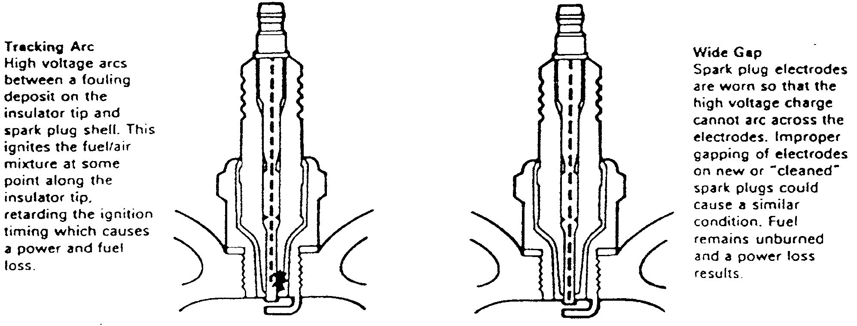

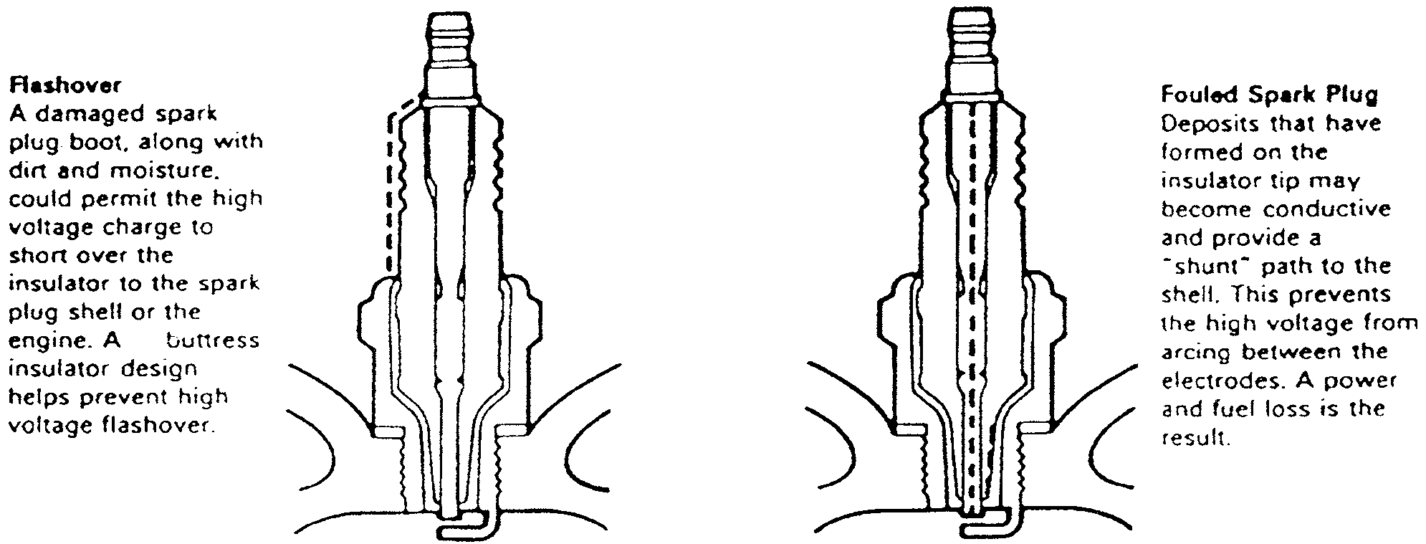

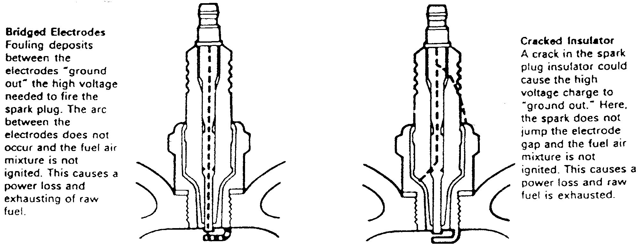

MAINTENANCE **3-17**

bend the center electrode. Also, be careful not to bend the side electrode too far or too often as it may weaken and break off within the engine, requiring removal of the cylinder head to retrieve it.

**Spark Plug Wires**

TESTING

At every tune-up/inspection, visually check the spark plug wires for burns, cuts, or breaks in the insulation. Check the boots on the coil and at the spark plug. Replace any wire that is damaged.

Once a year, usually when you change your spark plugs, check the resistance of the spark plug wires with an ohmmeter. Wires with excessive resistance will cause misfiring and may make the engine difficult to start. In addition worn wires will allow arcing and misfiring in humid conditions.

Remove the spark plug wire from the engine. Test the wires by connecting one lead of the ohmmeter to the coil end of the wire and the other lead to the spark plug end of the wire. Resistance should measure approximately 7000 ohms per foot of wire.

When installing a new set of spark plug wires, replace the wires one at a time so there will be no confusion. Coat the inside of the boots with dielectric grease to prevent sticking. Install the boot firmly over the spark plug until it clicks into place. The click may be felt or heard. Gently pull back on the boot to assure proper contact. Route the wire the same as the original and install it in a similar manner on the engine. Repeat the process for each wire.

REMOVAL & INSTALLATION

When installing a new set of spark plug wires, replace the wires one at a time so there will be no confusion. Coat the inside of the boots with dielectric grease to prevent sticking. Install the boot firmly over the spark plug until it clicks into place. The click may be felt or heard. Gently pull back on the boot to assure proper contact. Route the wire the same as the original and install it in a similar manner on the engine. Repeat the process for each wire.

**Ignition System**

The electronic CDI ignition system has become one of the most reliable components on the modern outboard engine. There is very little maintenance involved in the operation of the ignition and even less to repair if the component fails. Most systems are sealed and there is no option other than to replace the failed component.

It is very important to narrow down the ignition problem and replace the cor­rect component rather than just replace parts hoping to solve the problem. Elec­tronic components can be very expensive and are usually not returnable. Please refer to the "Ignition and Electrical" Section for more information on trouble-

shooting and repairing the CDI ignition system.

**Timing And Synchronization**

TIMING

Timing and synchronization on an outboard engine is extremely important to obtain maximum efficiency. The powerhead cannot perform properly and pro­duce its designed horsepower output if the fuel and ignition systems have not been precisely adjusted.

All units covered in this manual except those equipped with the Integrated Circuit (IC) and Micro Link Ignition System, are equipped with a mechanical advance type Capacitor Discharge Ignition (CDI) system and use a series of link rods between the carburetor and the ignition base plate assembly. At the time the throttle is opened, the ignition base plate assembly is rotated by means of the link rod, thus advancing the timing.

On the IC and Micro Link equipped models, the microcomputer decides when to advance or retard the timing, based on input from various sensors. Therefore, there is no link rod between the magneto control lever and the stator assembly.

Many models have timing marks on the flywheel and CDI base. A timing light is normally used to check the ignition timing dynamically—with the powerhead

operating. An alternate method is to check the static timing—with the powerhead not operating. This second method requires the use of a dial indicator gauge.

Various models have unique methods of checking ignition timing. These dif­ferences are explained in detail later in this section.

SYNCHRONIZATION

In simple terms, synchronization is timing the fuel system to the ignition. As the throttle is advanced to increase powerhead rpm, the carburetor and the igni­tion systems are both advanced equally and at the same rate.

Any time the fuel system or the ignition system on a powerhead is serviced to replace a faulty part or any adjustments are made for any reason, powerhead timing and synchronization must be carefully checked and verified. For this rea­son the timing and synchronizing procedures have been separated from all oth­ers and presented alone in this section.

Before making adjustments with the timing or synchronizing, the ignition system should be thoroughly checked and the fuel system verified to be in good working order.

On the breaker point ignitions, synchronization is automatic once the point gap and the piston travel or timing mark alignments are correct.

Models equipped with electronic ignitions are statically timed by aligning the timing marks on the throttle cam or throttle stopper with timing marks on the flywheel. Initial timing and timing advance are both set this way before using a timing light to check the timing.

Before making adjustments with the timing or synchronizing, the ignition system should be thoroughly checked and the fuel system verified to be in good working order.

PREPARATION

Timing and synchronizing the ignition and fuel systems on an outboard motor are critical adjustments. The following equipment is essential and is called out repeatedly in this section. This equipment must be used as described, unless otherwise instructed by the equipment manufacturer. Naturally, the equipment is removed following completion of the adjustments.

Suzuki also recommends the use of a test wheel instead of a normal pro­peller in order to put a load on the engine and propeller shaft. The use of the test wheel prevents the engine from excessive rpm.

The Synchronizing of the fuel systems on an outboard motor are critical adjustments. The following equipment is essential and is called out repeatedly in this section. This equipment must be used as described, unless otherwise instructed by the equipment manufacturer. Naturally, the equipment is removed following completion of the adjustments.

**Dial Indicator**

Top dead center (TDC) of the No. 1 (top) piston must be precisely known before the timing adjustment can be made. TDC can only be determined through installation of a dial indicator into the No. 1 spark plug opening.

**Timing Light**

During many procedures in this section, the timing mark on the flywheel must be aligned with a stationary timing mark on the engine while the power­head is being cranked or is running. Only through use of a timing light con­nected to the No. 1 spark plug lead, can the timing mark on the flywheel be observed while the engine is operating.

**Tachometer**

A tachometer connected to the powerhead must be used to accurately deter­mine engine speed during idle and high-speed adjustment. Engine speed read­ings range from 0 to 6,000 rpm in increments of 100 rpm. Choose a tachometers with solid state electronic circuits which eliminates the need for relays or batteries and contribute to their accuracy.

A tachometer is installed as standard equipment on most powerheads covered in this manual. Due to local conditions, it may be necessary to adjust the carbure­tor while the outboard unit is running in a test tank or with the boat in a body of water. For maximum performance, the idle rpm should be adjusted under actual operating conditions. Under such conditions it might be necessary to attach a tachometer closer to the powerhead than the one installed on the control panel.

**3-18** MAINTENANCE

**Flywheel Rotation**

The instructions may call for rotating the flywheel until certain marks are aligned with the timing pointer. When the flywheel must be rotated, always move the flywheel in the indicated direction. If the flywheel should be rotated in the opposite direction, the water pump impeller vanes would be twisted.

Should the powerhead be started with the pump tangs bent back in the wrong direction, the tangs may not have time to bend in the correct direction before they are damaged. The least amount of damage to the water pump will affect cooling of the powerhead.

**Test Tank**

Since the engine must be operated at various times and engine speeds dur­ing some procedures, a test tank or moving the boat into a body of water, is necessary. If installing the engine in a test tank, outfit the engine with an appro­priate test propeller.

**\*\* CAUTION**

**Water must circulate through the lower unit to the powerhead any­time the powerhead is operating to prevent damage to the water pump in the lower unit. Just five seconds without water will damage the water pump impeller.**

**.Remember the powerhead will not start without the emergency tether in place behind the kill switch knob.**

**\*\* CAUTION**

**Never operate the powerhead above a fast idle with a flush attach­ment connected to the lower unit. Operating the powerhead at a high rpm with no load on the propeller shaft could cause the power­head to runaway causing extensive damage to the unit.**

**DT2 and DT2.2**

IGNITION TIMING

► **See Figures 45, 46, 47 and 48**

1. Mount the engine in a test tank or move the boat to a body of water.
2. Remove the cowling and connect a tachometer to the powerhead.
3. Remove the flywheel.
4. Remove the spark plug.
5. Disconnect the magneto lead (usually white) from the connector and the stator lead (usually black) from the connector.

.Before checking the ignition timing, make sure that the contact point faces are in good condition. Sand and make parallel the two faces by grinding with an oil stone if necessary and wipe the points clean with solvent. Apply a small dab of grease to the breaker shaft.

1. Check and adjust the breaker point gap to 0.012-0.016 in. (0.3-0.4 mm) by moving the breaker base plate.
2. Install a dial indicator with a special adapter (09931-00112) in the spark plug hole.
3. Rotate the flywheel clockwise until the piston has reached TDC then reset the indicator to zero.
4. Connect an ohmmeter between the magneto wire and a good engine ground. A timing tester (09900-27003) can also be used.
5. Gently turn the rotor clockwise (with the tester turned on) until the ohm­meter indicates continuity or the timing tester starts buzzing. Read the dial indi­cator, this reading is the piston travel and if the timing is set correctly, the indicator should read: 0.032 in. (0.804 mm).

If the reading is not within specification, retime the ignition system as fol­lows:

1. Remove the flywheel magneto, loosen the screws securing the stator, and manually turn the stator clockwise to retard and counterclockwise to advance the timing by the amount necessary to meet specification.

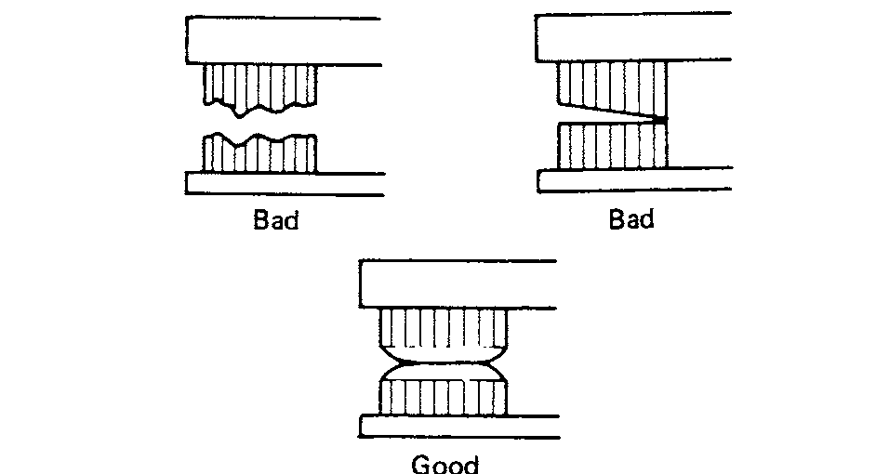

Fig. 45 Check the condition of the points before setting the point gap

**Fig. 48 Remove the spark plug and install the dial indicator to mea- sure the piston travel**

**Fig. 47 Using a screwdriver, adjust the breaker point gap by rotating the points**

**Fig. 46 Measure the breaker point gap using a feeler gauge**

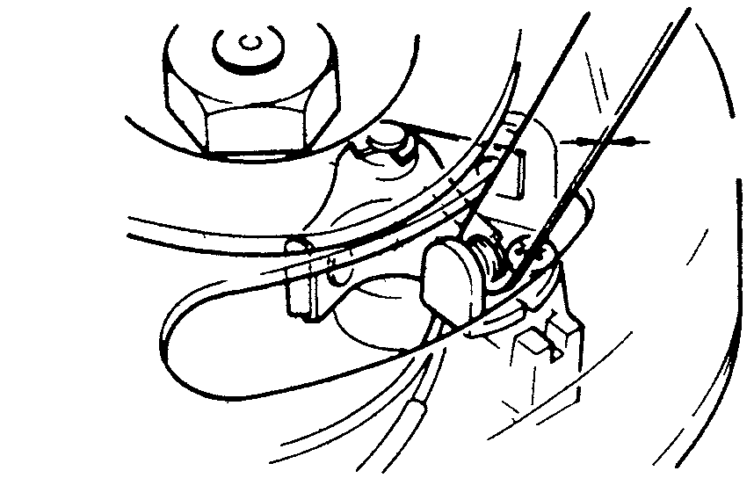

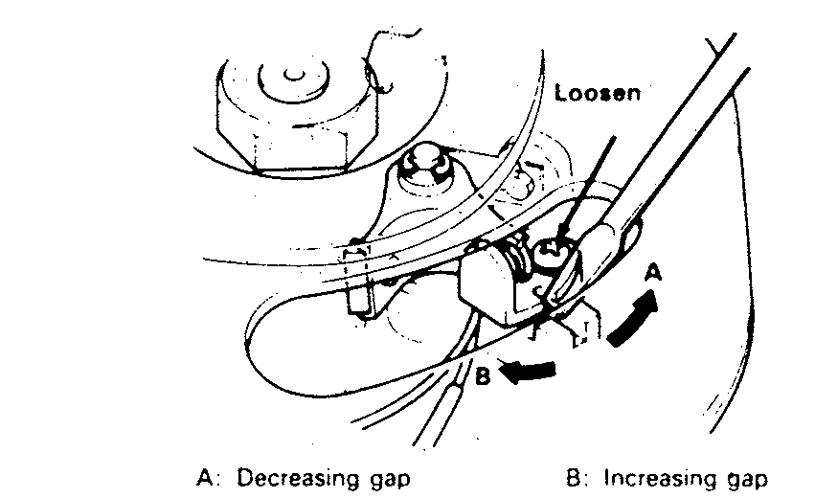

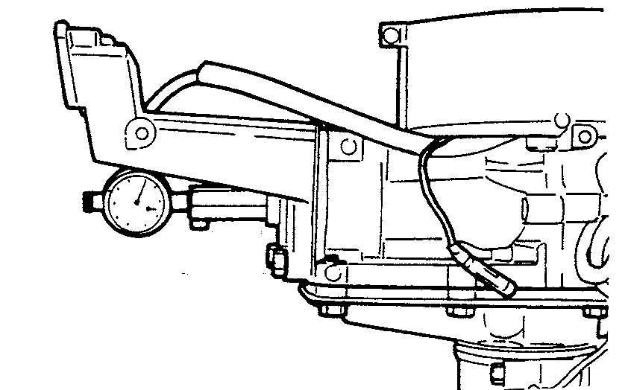

MAINTENANCE **3-19**

If the correct gap cannot be obtained by adjustment, the points should be replaced.

IDLE SPEED

See Figure 49

1. Mount the engine in a test tank or move the boat to a body of water.
2. Remove the cowling and connect a tachometer to the powerhead.
3. Start the engine and allow it to reach operating temperature.
4. Check idle speed and compare it with the specified idle speed in the "Tune-Up Specifications" chart.
5. If adjustment is necessary, rotate the idle adjustment screw on the carburetor until the powerhead idles at the required rpm.

**DT4 and DT5Y**

IGNITION TIMING

* See Figure 50

The DT4 and DT5Y ignition system is a magneto CDI which provides high spark performance regardless of engine rpm. The electronic advance system provides optimum ignition timing for all conditions. Ignition timing is not adjustable. Each coil is not provided with any base plate for installation, but instead is constructed so that the coil itself can be mounted directly to the boss projected from the cylinder or crankcase. If the coils are installed in the correct position, the ignition timing will be within specification.

1. Mount the engine in a test tank or move the boat to a body of water.
2. Remove the cowling and connect a tachometer and a timing light to the powerhead.
3. Start the engine and allow it to warm to operating temperature. Place the engine in gear.
4. Aim the timing light at the timing window and the pointer on the recoil starter should line up with the timing mark on the rotor.
5. Ignition timing is about: 7°BTDC at 1000 rpm and 24-25°BTDC at 5000 rpm. For more details, please refer to the Tune-Up Specifications chart.
6. Timing cannot be adjusted. If timing is incorrect, a fault has occurred in the CDI system and a test of the CDI unit needs to be performed.

IDLE SPEED

See Figure 51

1. Mount the engine in a test tank or move the boat to a body of water.
2. Remove the cowling and connect a tachometer to the powerhead.
3. Start the engine and allow it to warm to operating temperature.
4. Turn the air screw (1) in until it lightly seats and then back it out gradually. The engine will pick up speed correspondingly and then cease to rise. Set the air screw slightly before this point. See the "Idle Air Screw Specifications" chart for the base setting.
5. Shift the clutch into the forward position.
6. Run the throttle stop screw (2) in and out until the correct engine speed is reached. Idle speed specifications are :coated in the "Tune-Up Specifications" chart.

**DT6 and DT8**

IGNITION TIMING

0 See Figures 52, 53, 54, 55 and 56

The DT6 and DT8 models use the Suzuki PEI simultaneous ignition system. The ignition timing is advanced in this system by moving the magneto stator according to the carburetor throttle opening.

The Suzuki PEI system is maintenance free because of the absence of breaker points. It produces a strong spark over a wide range of engine speeds from idle to wide open throttle.

The CDI unit which is integral with the ignition coil is compact and easy to handle.

1. Mount the engine in a test tank or the boat in a body of water.
2. Remove the cowling and connect a tachometer and timing light to the powerhead.

* Magneto Stator Assembly

The stator base moves according to the throttle opening to obtain the correct ignition timing. For this reason, brass is cast in the spigot joint of the oil seal housing and the stator base. Parts of the stator base include a coil which charges a capacitor of the CDI unit, a pulser coil which sends a signal to the CDI unit at ignition timing, and a lighting coil which generates lighting output of 12V and 80W.

* Setting the static ignition timing

Bring the face of the retainer stopper in line with the alignment mark of the magneto stator and fix the retainer stopper with bolts. When the end face of the stopper retainer is aligned with the boss of the cylinder center, ignition timing is -2°–+2° (no advance angle).

a. For the full-advance angle, adjust the length of the stator rod so that the throttle arm contacts the inlet case-side stopper. Now the ignition timing is 23-27°BTDC (full advance angle).

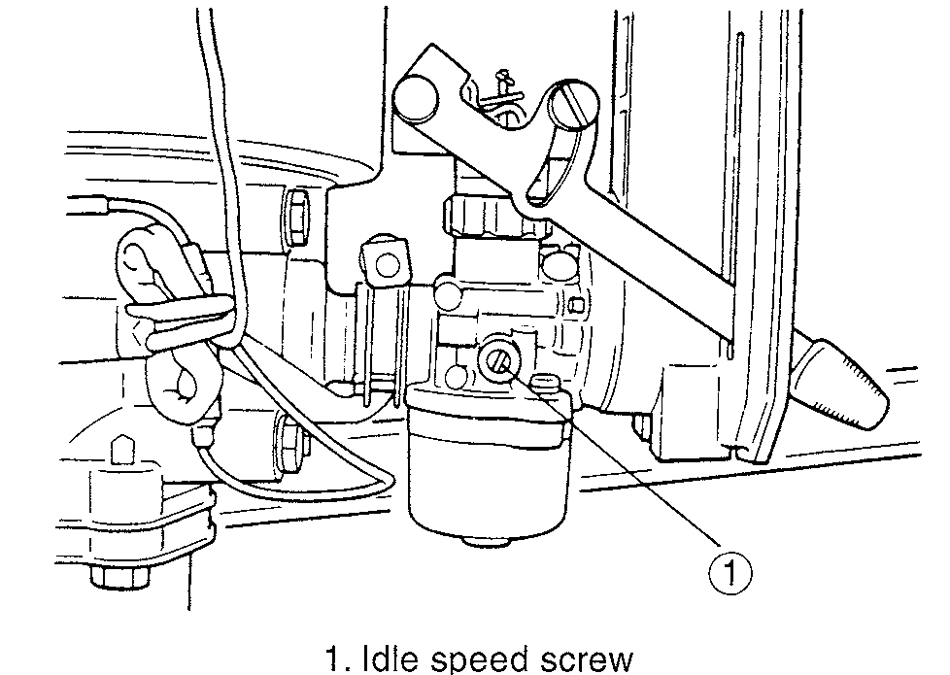

Fig. 49 To raise or lower the idle, turn the throttle stop screw

Fig. 50 Ignition timing marks on the flywheel—DT4 and DT5Y

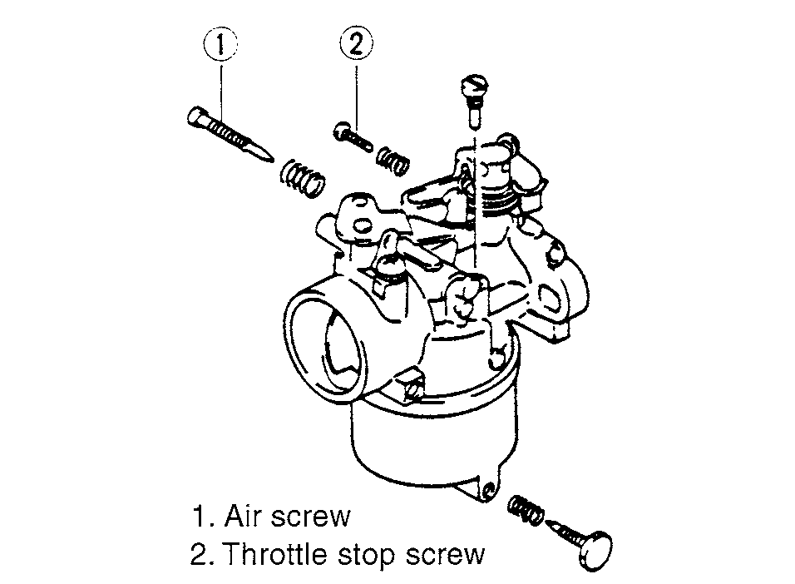

Fig. 51 Air screw and throttle stop screw—DT4 and DT5Y

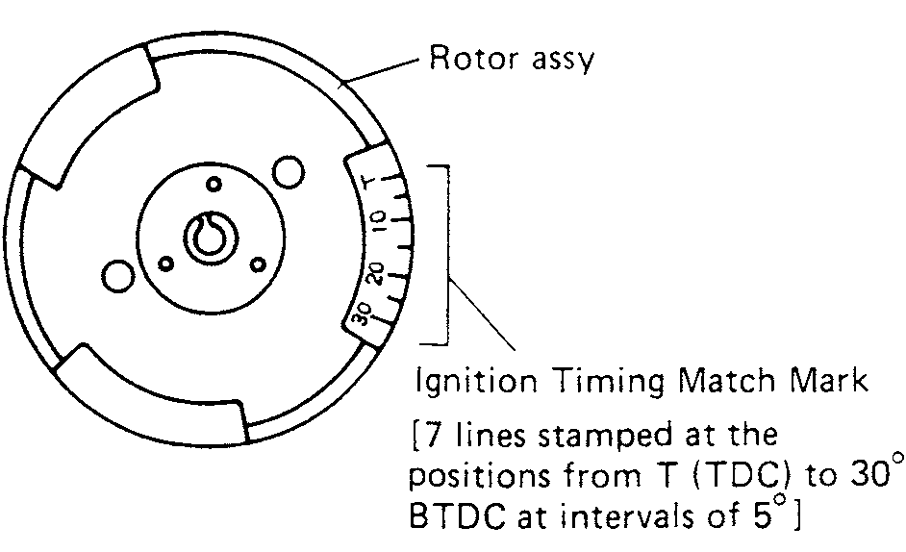

**3-20** MAINTENANCE

Fig. 54 Correct position of the retainer stopper against the boss of the cylinder center

Fig. 52 Align the end of the retainer stopper (1) with the stator alignment mark (2)

Fig. 55 With the throttle fully closed, tim- ing mark should be like this (no advance TDC)—DT6 and DT8

Fig. 53 Adjust the length of the stator rod so that the throttle arm contacts the inlet case side stopper

Fig. 56 Fully open the throttle, timing marks should line up this (full advance 25°BTDC) — DT6 and DT8

5. Checking the ignition timing (dynamic adjustment). To check ignition tim­ing, warm up the engine for about 5 minutes. Then check if the cylinder center line is in line with the mark engraved beside the letter "T" on the flywheel with the throttle fully closed. If the marks in line, the engine piston is at TDC. Next fully open the throttle. If the cylinder center line is within the range bounded by the three mark lines engraved on the flywheel, the piston is within 2°of 25°BTDC.

IDLE SPEED

See Figures 57 and 58

1. Mount the engine in a test tank or move the boat to a body of water.

1. Remove the cowling and connect a tachometer to the powerhead.
2. Start the engine and allow it to warm to operating temperature.
3. Turn the air screw in until it lightly seats and then back it out gradually. The engine will pick up speed correspondingly and then cease to rise. Set the air screw slightly before this point. See the "Idle Air Screw Specifications" chart for the base setting.
4. Shift the clutch into the forward position.
5. Run the throttle stop screw in and out until the correct engine speed is reached. Idle speed specifications are located in the "Tune-Up Specifications" chart.

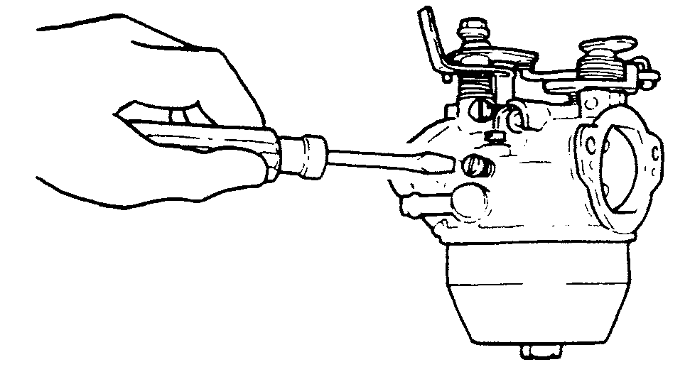

Fig. 57 Adjust the pilot air screw the specified turns open

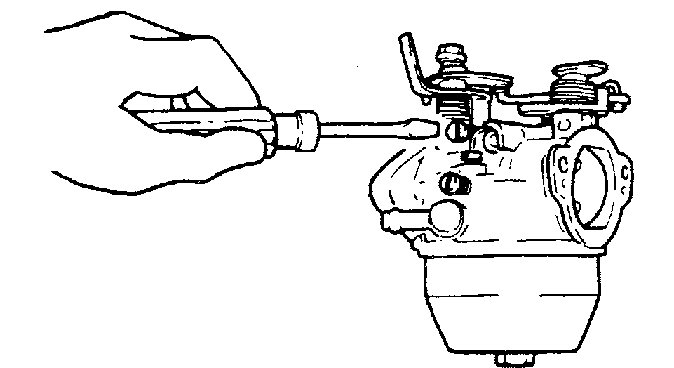

Fig. 58 With the engine in forward gear, adjust the throttle stop screw to the correct position

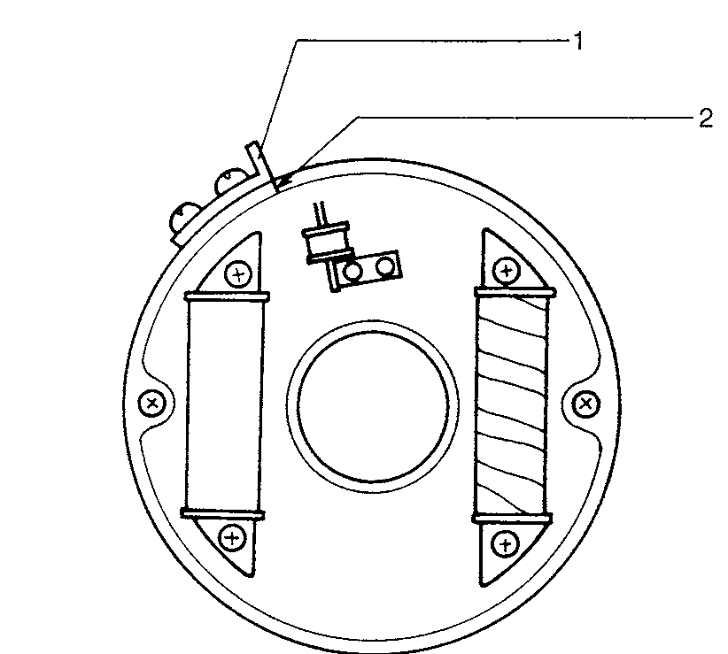

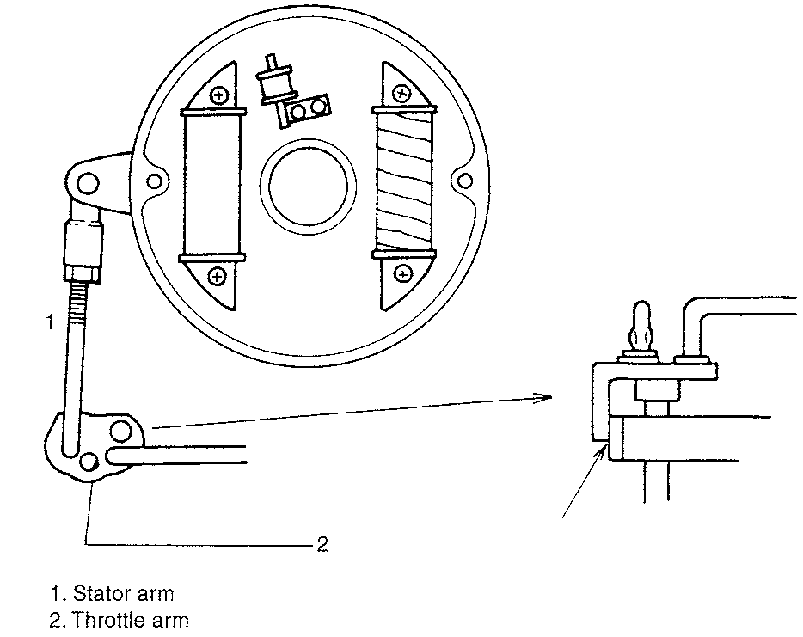

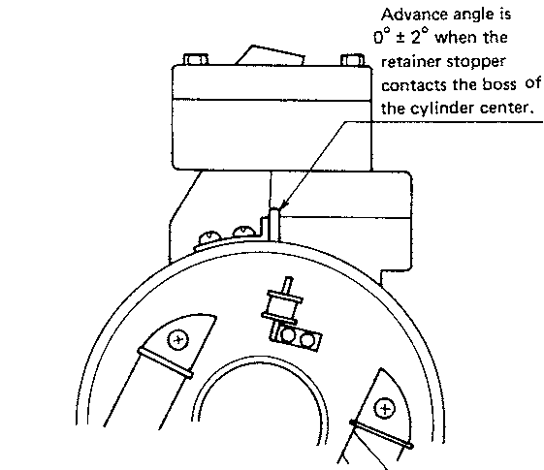

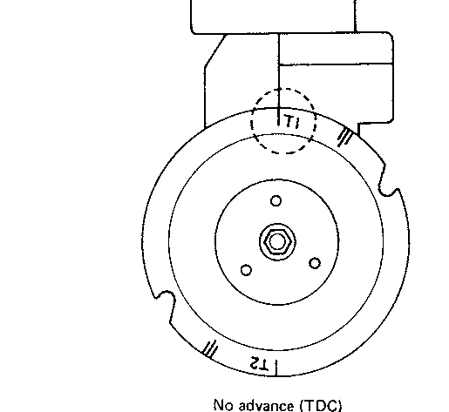

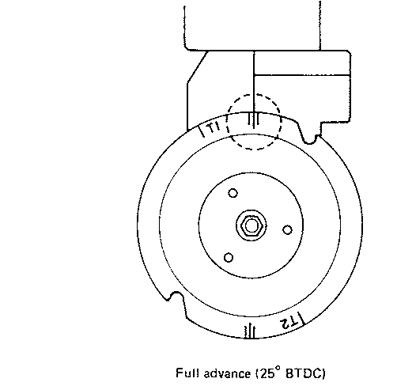

MAINTENANCE **3-33**

**Carburetor Idle Air Screw Specification**

|  |  |  |  |
| --- | --- | --- | --- |
| Turns Out From  Model Year Type Lightly Seated | | | |
| DT 2 | 1988-96 |  | 1.25-1.75 |
| DT2.2 | 1997 |  | 0.375-0.875 |
| DT 4 | 1988-98 |  | 1-1.50 |
| DT5Y | 1998-02 |  | 1.25 |
| DT 6 | 1988-02 | S-type | 0.875-1.375 |
| 1988-02 | L and UL type | 1-1.50 |
| DT 8 | 1988-91 |  | 1.75-2.25 |
| 1992-97 |  | 0.50-1.0 |
| DT 9.9 | 1988-97 |  | 1.125-1.625 |
| DT 15 | 1988-97 |  | 1.50-2 |
| DT 20 | 1988 |  | 1.75-2.25 |
| DT 25 (2-cyl) |  |  | 1.25-1.75 |
| DT 25 (3-cyl) | 1989 | MC | 1.25-1.75 |
| 1988-90 | Except MC | 1.5-2.0 |
| 1991-00 |  | 1.0-1.5 |
| DT 30 | 1989 | MC | 1.25-1.75 |
| 1988-90 | Except MC | 1.5-2.0 |
| 1991-97 |  | 1.0-1.5 |
| DT 35 | 1988-89 |  | 1.5-2.0 |
| DT 40 | 1988-91 |  | 1.5-2.0 |
| 1992-98 |  | 0.875-1.375 |
| DT 55 | 1988-89 |  | 1.25-1.75 |
| 1990-97 |  | 1.0-1.5 |
| DT 65 | 1988-89 |  | 1.25-1.75 |
| 1990-97 |  | 1.0-1.5 |
| DT75 | 1988-90 |  | 1.75-2.25 |
| 1991-94 |  | 1.5-2.0 |
| 1995-97 |  | 1.375-1.875 |
| DT85 | 1988-90 |  | 1.625-2.125 |
| 1991 |  | 0.75-1.25 |
| 1992 |  | 0.50-1.0 |
| 1993-00 |  | 1.375-1.875 |
| DT 90 | 1989-97 |  | 1.125-1.625 |
| DT100 | 1989-91 |  | 1.125-1.625 |
| 1992-00 |  | 1.375-1.875 |
| DT 115 | 1988 |  | 1.25-1.75 |
| 1989 |  | 0.875 |
| 1990-91 |  | 1.0-1.5 |
| 1992-95 |  | 0.625-1.125 |
| 1996-01 |  | 0.75-1.25 |
| DT 140 | 1988 |  | 1.0-1.5 |
| 1989-91 |  | 1.125-1.625 |
| 1992-01 |  | 0.625-1.125 |
| DT 150 | 1988 |  | 1-1.50 |
| 1989-03 |  | 1.25-1.75 |
| DT 175 | 1988 |  | 1.5-2.0 |
| 1989-92 |  | 1.25-1.75 |
| DT 200 | 1988-00 |  | 1.25-1.75 |
| DT225 | 1998-03 |  | EFI |

3-34 MAINTENANCE

|  |  |  |  |  |  |  |
| --- | --- | --- | --- | --- | --- | --- |
| Tuneup Specifications Chart | | | | | | |
| Spark Ignition Idle Speed  Spark Plug Plug Gap Timing RPM  Model NGK Champion Inch (mm) ° BTDC (Neutral) | | | | | | |
| DT2 | 1988-89 | B4H | L81, L88A | .024 - .028 (.6 - .7) | 15 @ 4500 | 800-900 |
| 1990 | B4H | L81, L88A | .024 - .028 (.6 - .7) | 19 @ 4500 | 800-900 |
| 1991 | B5HS | L81, L88A | .024 - .028 (.6 - .7) | 19 @ 4500 | 800-900 |
| 1992-96 | B5HS | L81, L88A | .024 - .028 (.6 - .7) | 17 - 21 @ 4500 | 800-900 |
| DT2 .2 | 1997 | BR5HS | L81, L88A | .024 - .028 (.6 - .7) | 23 - 27 @ 5000 | 1000-1100 |
| DT4 | 1988-89 | BP6HS | RL12Y, RL87Y, L66Y | .024 - .028 (.6 - .7) | 25 @ 5000 | 850-900 |

MAINTENANCE **3-35**

**WINTER STORAGE CHECKLIST**

Taking extra time to store the boat properly at the end of each season will increase the chances of satisfactory service at the next season. Remember, stor­age is the greatest enemy of an outboard motor. The unit should be run on a monthly basis. The boat steering and shifting mechanism should also be worked through complete cycles several times each month. If a small amount of time is spent in such maintenance, the reward will be satisfactory performance, increased longevity and greatly reduced maintenance expenses.

For many years there has been the widespread belief simply shutting off the fuel at the tank and then running the powerhead until it stops is the proper procedure before storing the engine for any length of time. Right? WRONG!

First, it is not possible to remove all fuel in the carburetor by operating the powerhead until it stops. Considerable fuel is trapped in the float chamber and other passages and in the line leading to the carburetor. The only guaranteed method of removing all fuel is to take the time to remove the carburetors, and drain the fuel.

Proper storage involves adequate protection of the unit from physical dam­age, rust, corrosion, and dirt. The following steps provide an adequate mainte­nance program for storing the unit at the end of a season.

1. Squirt a small quantity of engine oil into each spark plug hole and crank the engine over to distribute the oil around the engine internals. Reinstall the old spark plugs (you will install new spark plugs in the spring).

1. Drain all fuel from the carburetor float bowls. On fuel injected models, drain the fuel from the vapor separator.
2. Drain the fuel tank and the fuel lines Store the fuel tank in a cool dry area with the vent OPEN to allow air to circulate through the tank. Do not store the fuel tank on bare concrete. Place the tank to allow air to circulate around it.
3. Change the fuel filter.
4. Drain, and then fill the lower unit with new lower unit gear oil.
5. Lubricate the throttle and shift linkage and the steering pivot shaft.
6. Clean the outboard unit thoroughly. Coat the powerhead with a commer­cial corrosion and rust preventative spray. Install the cowling, and then apply a thin film of fresh engine oil to all painted surfaces.
7. Remove the propeller. Apply Perfect Seal® or a waterproof sealer to the propeller shaft splines, and then install the propeller back in position.
8. Be sure all drain holes in the gear housing are open and free of obstruc­tions. Check to be sure the flush plug has been removed to allow all the water to drain. Trapped water could freeze, expand, and cause expensive castings to crack.
9. Always store the outboard unit off the boat with the lower unit below the powerhead to prevent any water from being trapped inside.
10. Be sure to consult your owners manual for any particular storage proce­dures applicable to your specific model.

**SPRING COMMISSIONING CHECKLIST**

► **See Figures 83 thru 90**

A spring tune-up is essential to getting the most out of your engine. If the engine has been properly winterized, it is usually no problem to get it in top running condition again in the springtime. If the engine has just been put in the garage and forgotten for the winter, then it is doubly important to do a complete tune up before putting the engine back into service. If you have ever been stranded out on the water because your engine has died, and you had to suffer the embarrassment of having to be towed back to the marina, now is the time to prevent that from occurring.

Satisfactory performance and maximum enjoyment can be realized if a little time is spent in preparing the outboard unit for service at the beginning of the season. Assuming the unit has been properly stored, a minimum amount of work is required to prepare the unit for use. The following steps outline an ade­quate and logical sequence of tasks to be performed before using the outboard the first time in a new season.

1. Lubricate the outboard according to the manufacturer's recommenda­tions.
2. Perform a tune-up on the engine. This should include replacing the spark plugs and making a thorough check of the ignition system. The ignition

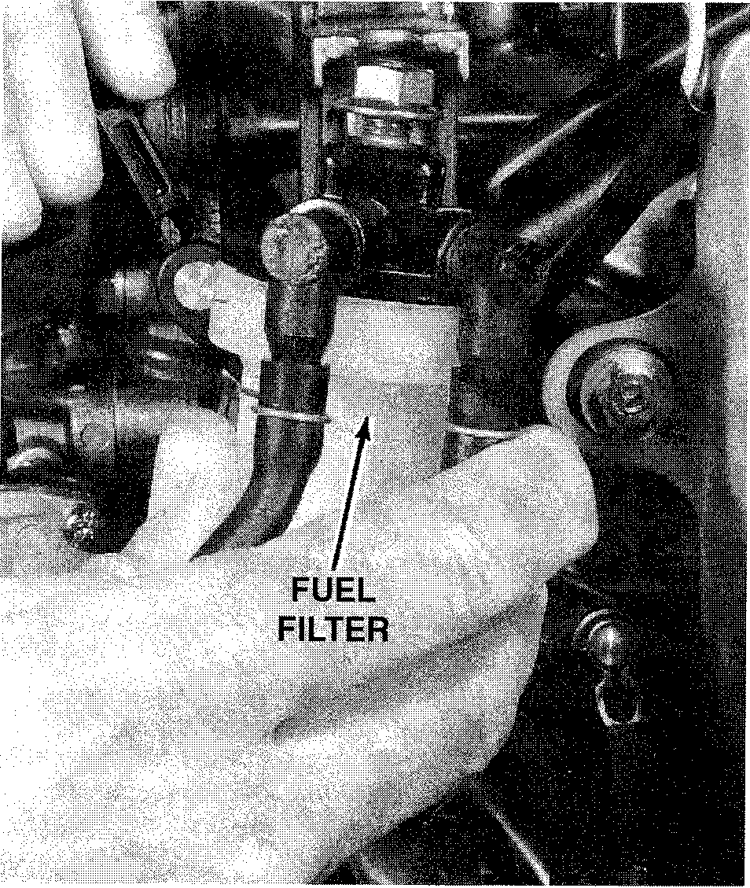

**Fig. 83 Removing the fuel filter for inspection and possible replace- ment**

**Fig. 84 Make a pre-season check of the fuel line coupling at the fuel joint to ensure a proper and clean connection**

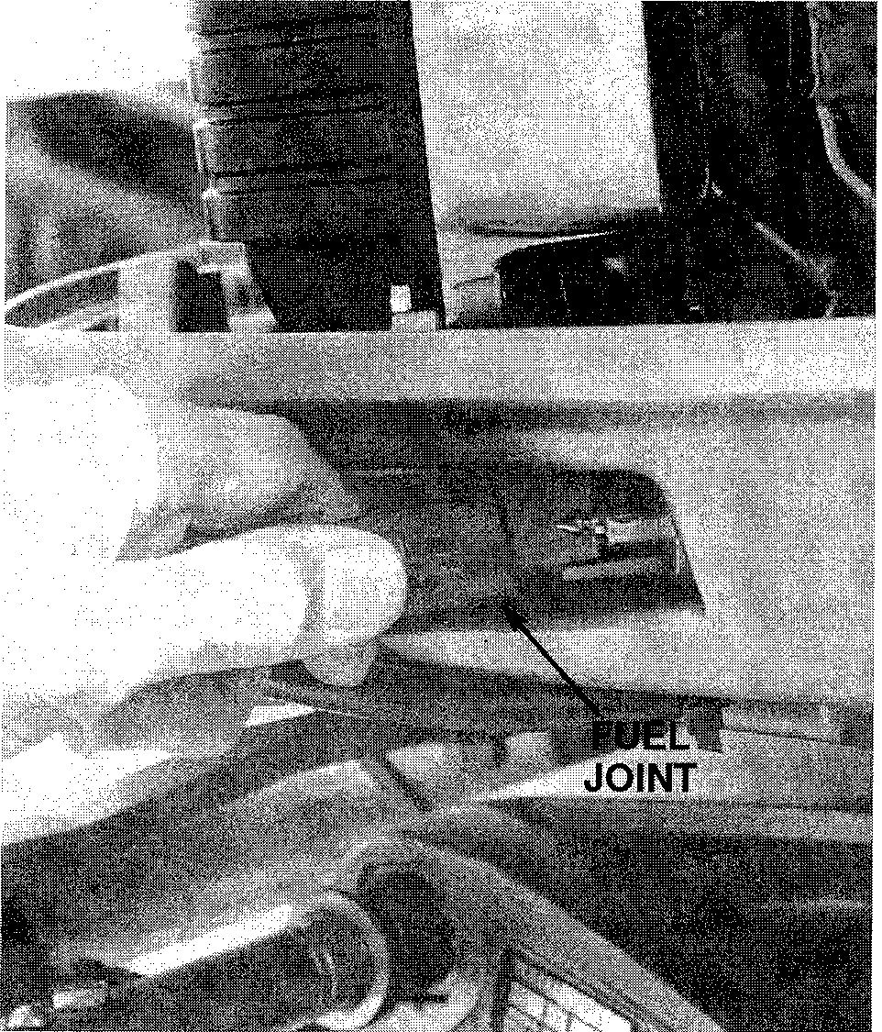

**3-36** MAINTENANCE

system check should include the ignition coils, stator assembly, condition of the wiring and the battery.

1. If a built-in fuel tank is installed, take time to check the tank and all fuel lines, fittings, couplings, valves, including the flexible tank fill and vent. Turn on the fuel supply valve at the tank. If the fuel was not drained at the end of the previous season, make a careful inspection for gum formation. If a six-gallon fuel tank is used, take the same action. When gasoline is allowed to stand for long periods of time, particularly in the presence of copper, gummy deposits form. This gum can clog the filters, lines, and passageways in the carburetor.
2. Replace the oil in the lower unit.
3. Replace the fuel filter.
4. Replace the engine oil and filter. Make sure to use only a quality four stroke engine oil and NEVER use two stroke oil in a four stroke engine.
5. Close all water drains. Check and replace any defective water hoses. Check to be sure the connections do not leak. Replace any spring-type hose clamps with band-type clamps, if they have lost their tension or if they have distorted the water hose.
6. The engine can be run with the lower unit in water to flush it. If this is not practical, a flush attachment may be used. This unit is attached to the water pick-up in the lower unit. Attach a garden hose, turn on the water, allow the water to flow into the engine for awhile, and then run the engine.

**CAUTION**

**Water must circulate through the lower unit to the powerhead any­time the powerhead is operating to prevent the engine from over­heating and damage to the water pump in the lower unit. Just five seconds without water will damage the water pump impeller.**

1. Check the exhaust outlet for water discharge. Check for leaks. Check operation of the thermostat.

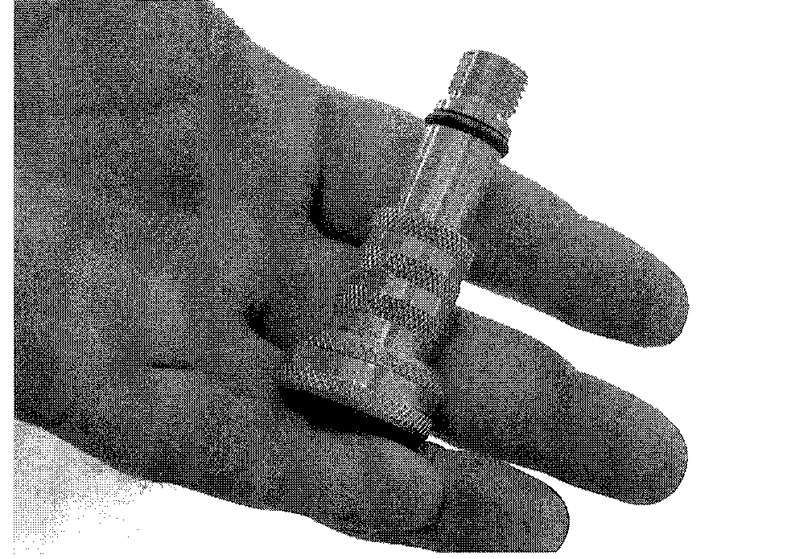

Fig. 86 Honda outboards come with a self contained flushing port on the lower unit that uses a special flush kit adapter available from your dealer

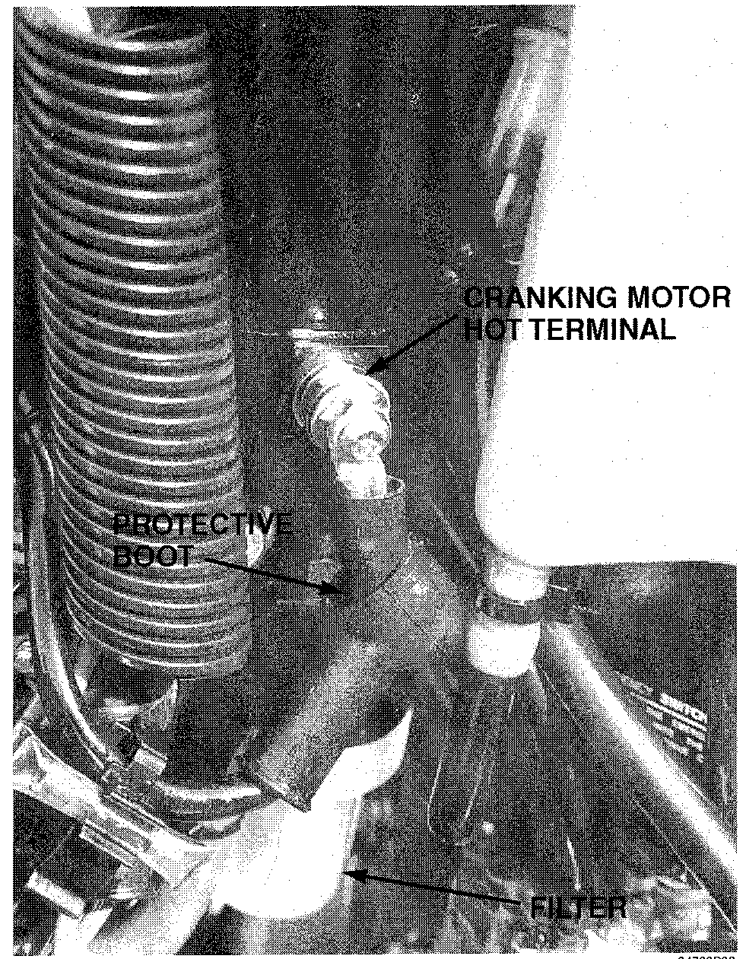

Fig. 87 Electrical and fuel system components should be checked on a regular basis

1. Check the electrolyte level in the battery and the voltage for a full charge. Clean and inspect the battery terminals and cable connections. Take time to check the polarity, if a new battery is being installed. Cover the cable connections with grease or special protective compound as a preven­tion to corrosion formation. Check all electrical wiring and grounding cir­cuits.

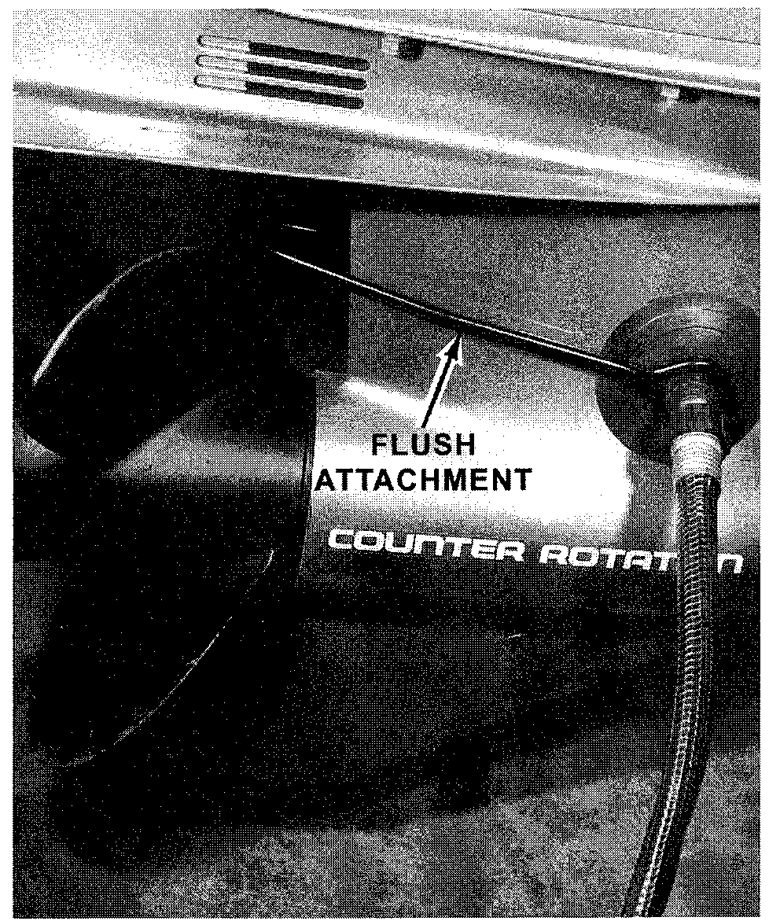

Fig. 85 This popular and inexpensive flushing device should be included in every boat owner's maintenance kit

Fig. 90 The thermostat is usually located in an accessible place for easy maintenance or replacement

1. Check all electrical parts on the engine and lower portions of the hull. Rubber boots help keep electrical connections clean and reduce the possibility of arcing.

**Electric cranking motors and high tension wiring harnesses should be of a marine type that cannot cause an explosive mixture to ignite.**

1. If a water separating filter is installed between the fuel tank and the pow­erhead fuel filter, replace the element at least once each season. This filter removes water and fuel system contaminants such as dirt, rust, and other solids, thus reducing potential problems.
2. As a last step in spring commissioning, perform a full engine tune-up.

**\*\* CAUTION**

Before putting the boat in the water, take time to verify the drain plugs are installed. Countless number of boating excursions have had a very sad beginning because the boat was eased into the water only to have the boat begin to fill with the water.

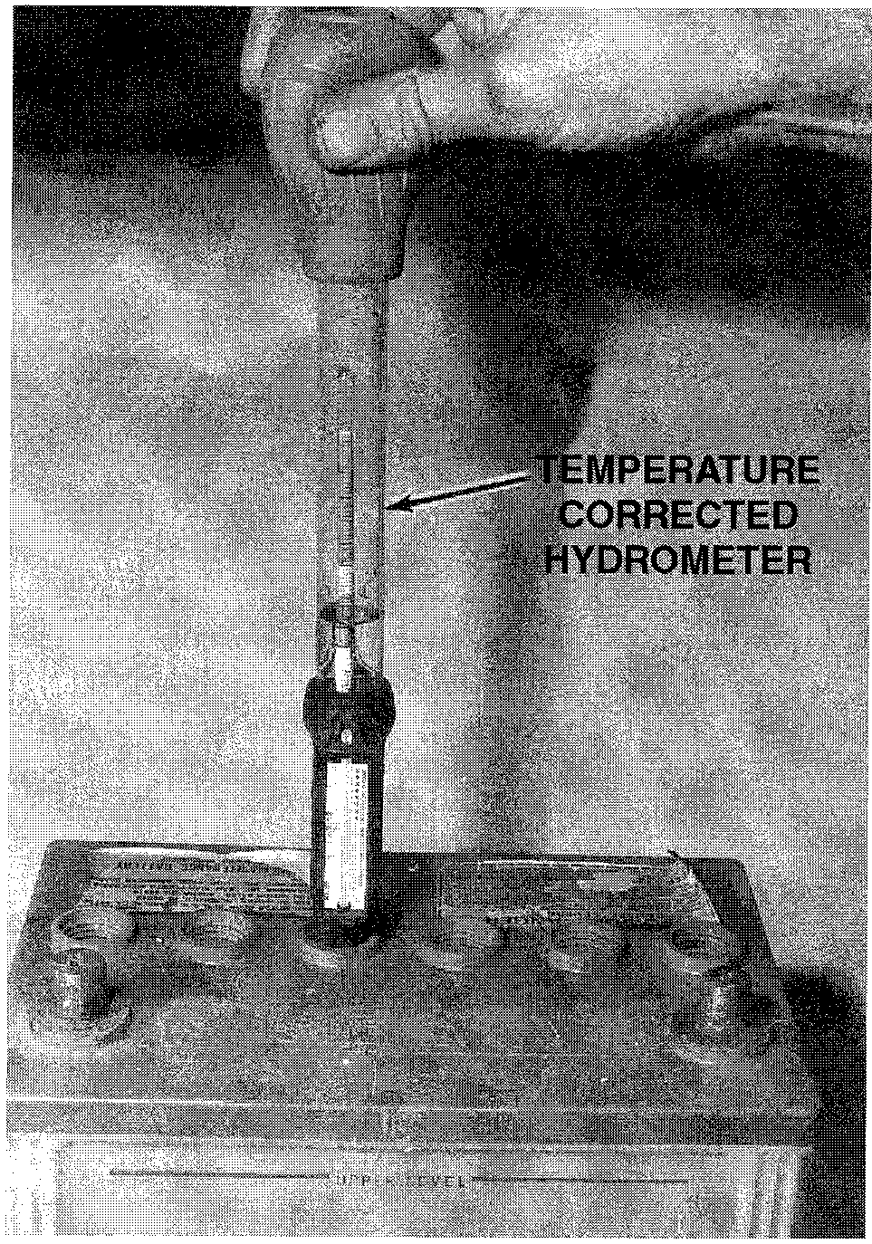

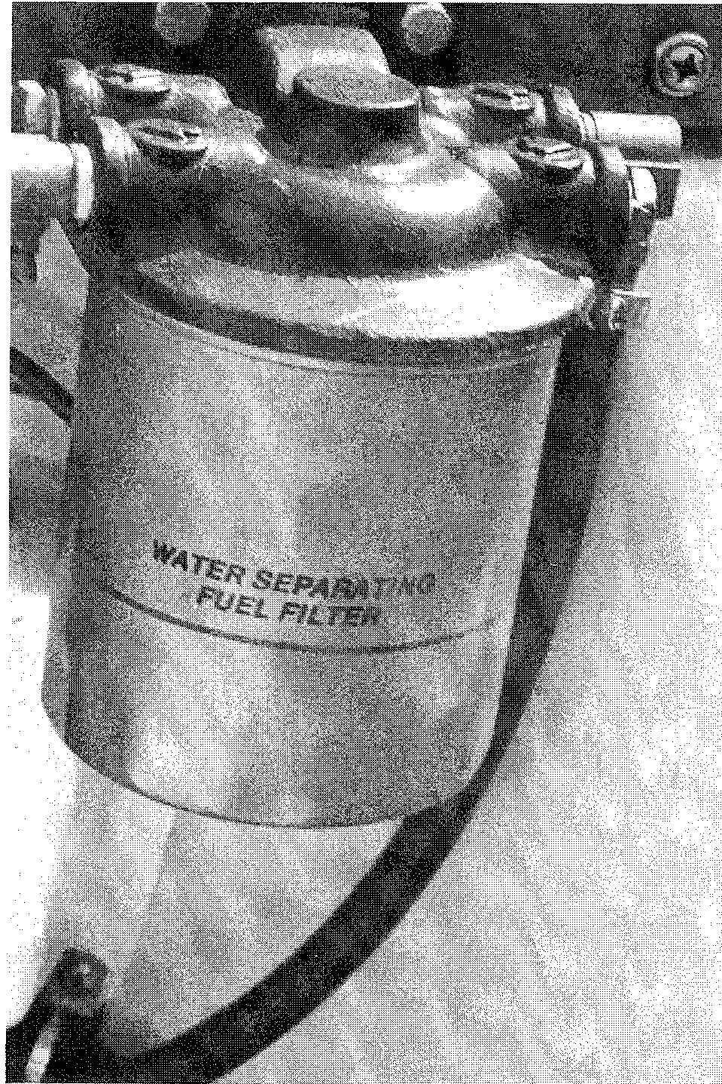

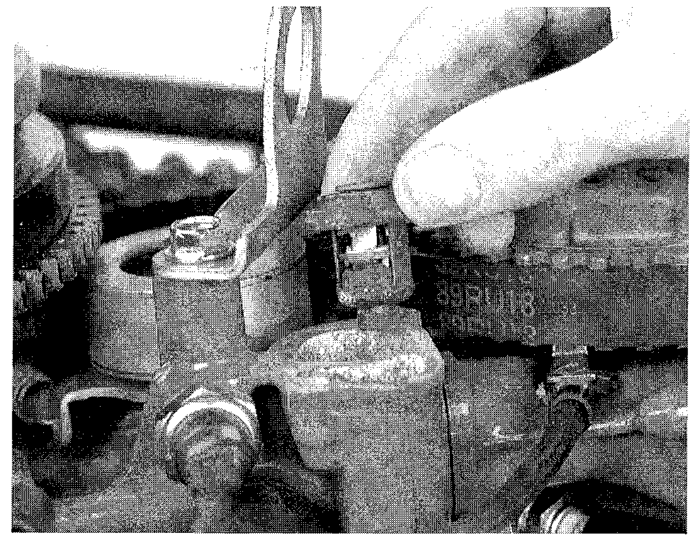

MAINTENANCE **3-37**

Fig. 88 Checking the condition of the battery electrolyte using a hydrometer

Fig. 89 A water separating fuel filter installed inside the boat on the transom



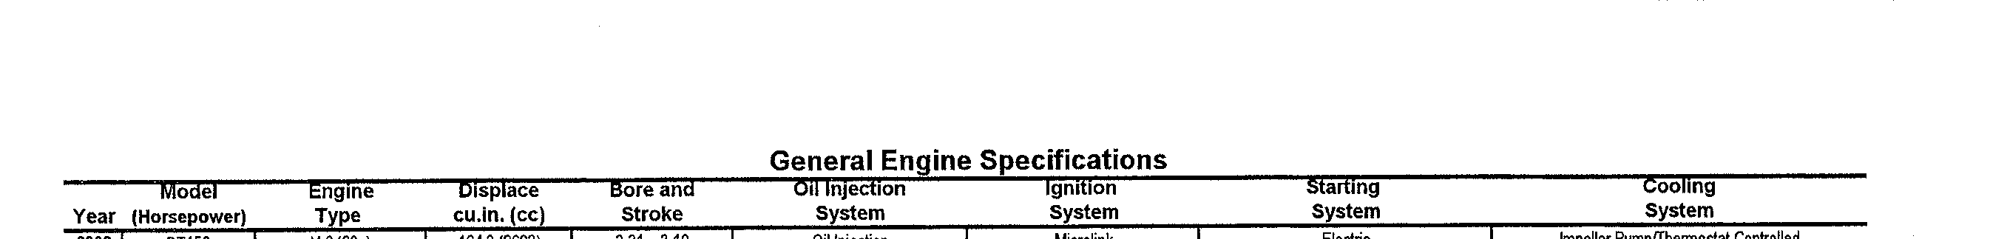



|  |  |  |  |  |  |
| --- | --- | --- | --- | --- | --- |
| Serial Number Identification | | | | | |
| Parts Serial No. Sales Model Designation  Model Year Designation Example Designation Example | | | | | |
| DT2 | 1988 | VJ | 8XXXXX | J | DT 2 SJ |
| 1989 | VK | 9XXXXX | K | DT 2 SK |
| 1990 | VL | 011XXX | L | DT 2 LL |
| 1991 | VM | 131XXX | M | DT 2SM |
| 1992 | VN | 231XXX | N | DT 2 SN |
| 1993 | VP | 351XXX | P | DT 2 SP |
| 1994 | VR | 461XXX | R | DT 2 SR |
| 1995 | VS | 581XXX | S | DT 2 SS |
| 1996 | VT | 651XXX | T | DT 2ST |
| 1997 | W | 751XXX | V | DT 2.2 SV |
| DT2 2 | 1997 | SV | xxxxxx | * | DT 2.2 SV |



MAINTENANCE **3-45**

|  |  |  |  |  |
| --- | --- | --- | --- | --- |
| Maintenance Interval Chart —  2, 2.2, 4, 5Y, 20, 25, 28 and Early Model 5, 6, 8, 9.9, 15 | | | | |
| Component | First  1mth/l0hrs | Every  3mths/50hrs | Every  6mths/100hrs | Off  Season |
| Bolts and nuts | T | T |  | T |
| Spark plugs |  | C&A |  | C&A |
| Wire harness | I | I |  |  |
| Starter Motor Brush Length |  |  | I |  |
| Ignition timing |  |  | C&A | C&A |
| Carburetor | C&A | C&A |  | C&A |
| Gear oil | R | R |  | R |
| Pistons, cylinder and head |  | De-Carbon |  |  |
| Propeller | I | I |  |  |
| Choke | I | I |  |  |
| Fuel tank |  |  |  | I |
| Fuel strainer |  | I |  | I |
| Fuel hoses | I | I |  | I |
| Water pump |  | I |  | I |
| Handle | L | L & A |  | L |
| Clutch lever |  | L |  | L |
| Starter rope |  | I |  |  |
| Tilt |  | A |  |  |
| Neutral start interlock switch |  | I |  |  |
| Zinc Anodes |  | I |  | I |
| A-Adjust C-Clean I-Inspect and Clean, Adjust, Lubricate or Replace  L-Lubricate R-Replace T-Tighten | | | | |

**FUEL AND COMBUSTION 4-2**

FUEL 4-2

RECOMMENDATIONS 4-2

OCTANE RATING 4-2

VAPOR PRESSURE AND ADDITIVES 4-2 THE BOTTOM LINE WITH FUELS 4-2 HIGH ALTITUDE OPERATION 4-2 ALCOHOL-BLENDED FUELS 4-2 COMBUSTION 4-3

ABNORMAL COMBUSTION 4-3

FACTORS AFFECTING COMBUSTION 4-3 **FUEL SYSTEM 4.3**

CARBURETION 4-3

GENERAL INFORMATION 4-3 CARBURETOR CIRCUITS 4-4

BASIC FUNCTIONS 4-5 DUAL-THROAT CARBURETORS 4-6

REMOVING FUEL FROM THE SYSTEM 4-6 FUEL PUMP 4-6

**TROUBLESHOOTING 4-7** FUEL SYSTEM 4-7

LOGICAL TROUBLESHOOTING 4-7 COMMON PROBLEMS 4-8

FUEL PUMP 4-8

FUEL LINE 4-9

COMMON PROBLEMS 4-10

COMBUSTION RELATED PISTON FAILURES 4-10

**CARBURETOR SERVICE 4-11**

DT2 AND DT2.2 4-11

REMOVAL & INSTALLATION 4-11 DISASSEMBLY 4-11

CLEANING & INSPECTION 4-12 ASSEMBLY 4-12

DT4 AND DT5Y 4-13

REMOVAL & INSTALLATION 4-13 DISASSEMBLY 4-13

CLEANING & INSPECTION 4-13 ASSEMBLY 4-14

DT6 AND 1988 DT8 4-14 REMOVAL & INSTALLATION 4-14 DISASSEMBLY 4-14

CLEANING & INSPECTION 4-15 ASSEMBLY 4-15

DT9.9, DT15 AND 1989-97 DT8 4-15 REMOVAL & INSTALLATION 4-15 DISASSEMBLY 4-16

CLEANING & INSPECTION 4-16 ASSEMBLY 4-17

DT20 TO DT85, DT115 AND DT140 4-17 REMOVAL & INSTALLATION 4-19 DISASSEMBLY 4-20

CLEANING & INSPECTION 4-21 ASSEMBLY 4-21

V4 & V6 POWERHEADS 4-22

REMOVAL & INSTALLATION 4-23 DISASSEMBLY 4-24

FUEL LEVEL TEST 4-24 CLEANING & INSPECTION 4-25 ASSEMBLY 4-25

**REED VALVE SERVICE 4-25**

DT2, DT2.2 4-25

REMOVAL & INSTALLATION 4-25

ALL OTHER MODELS 4-25

REMOVAL & INSTALLATION 4-26 INSPECTION & CLEANING 4-26

REED & REED STOP REPLACEMENT 4-26 **FUEL PUMP SERVICE 4-27**

DIAPHRAGM TYPE FUEL PUMPS 4-27 DESCRIPTION & OPERATION 4-27 REMOVAL & INSTALLATION 4-27 OVERHAUL 4-27

**ELECTRONIC FUEL INJECTION 4-32** DESCRIPTION AND OPERATION 4-32

FUEL INJECTION BASICS 4-32

SUZUKI ELECTRONIC FUEL INJECTION 4­32

CYLINDER WALL TEMPERATURE SENSOR 4­36

DESCRIPTION & OPERATION 4-36

TESTING 4-38

REMOVAL & INSTALLATION 4-39

AIR TEMPERATURE SENSOR 4-39 DESCRIPTION & OPERATION 4-39 TESTING 4-39

REMOVAL & INSTALLATION 4-39 ATMOSPHERIC PRESSURE SENSOR 4-39 DESCRIPTION & OPERATION 4-39

TESTING 4-39

REMOVAL & INSTALLATION 4-39

THROTTLE VALVE SENSOR 4-40 DESCRIPTION AND OPERATION 4-40 TESTING 4-40

ADJUSTMENT 4-42

REMOVAL AND INSTALLATION 4-45

GEAR COUNTER COIL (ENGINE SPEED SENSOR) 4-45

DESCRIPTION AND OPERATION 4-45 TESTING 4-45

PULSER COIL 4-45

DESCRIPTION AND OPERATION 4-45 TESTING 4-45

FUEL INJECTORS 4-45

DESCRIPTION AND OPERATION 4-45 TESTING 4-45

FUEL PRESSURE REGULATOR 4-46

TESTING 4-46

REMOVAL AND INSTALLATION 4-47

HIGH PRESSURE FUEL PUMP 4-47

TESTING 4-48 ADDITIONAL INPUTS 4-48

SELF DIAGNOSTIC SYSTEM 4-48 DESCRIPTION AND OPERATION 4-48 DIAGNOSIS PROCEDURE 4-49

FAIL SAFE EMERGENCY BACKUP 4-49 **SPECIFICATIONS 12-5**

CARBURETOR SPECIFICATIONS

(DT4 THRU DT85) 12-5

CARBURETOR SPECIFICATIONS

(DT90 THRU DT200) 12-6

211

**FUEL SYSTEM**

|  |  |
| --- | --- |
| FUELTROD COOBUSTSPECI | 4-2 |
| FUEL SYSTEM | 4-3 |
| TROUBLESHOOTING | 4-7 |
| CARBURETOR SERVICE | 4-11 |
| REED VALVE SERVICE | 4-25 |
| FUEL PUMP SERVICE | 4-27 |

ELE TR•1 1 • 4-

t-PEFICATIONS 12-'

**4-2** FUEL SYSTEM

**FUEL AND COMBUSTION**

**Fuel**

RECOMMENDATIONS

Reformulated gasoline fuels are now found in many market areas. Current test­ing indicates no particular problems with using this fuel. Shelf life is shorter and, because of the oxygenates, a slight leaning out at idle may be experienced. This slightly lean condition can be compensated for by adjusting idle mixture screws.

Fuel recommendations have become more complex as the chemistry of modern gasoline changes. The major driving force behind the changes in gasoline chem­istry is the search for additives to replace lead as an octane booster and lubricant. These new additives are governed by the types of emissions they produce in the combustion process. Also, the replacement additives do not always provide the same level of combustion stability, making a fuel's octane rating less meaningful.

In the search for new fuel additives, automobiles are used as the test medium. Not one high performance two cycle engine was tested in the process of determining the chemistry of today's gasoline.

In the 1960's and 1970's, leaded fuel was common. The lead served two functions. The lead served as an octane booster (combustion stabilizer) and, in four cycle engines, served as a valve seat lubricant. For two cycle engines, the primary benefit of lead was to serve as a combustion stabilizer. Lead served very well for this purpose, even in high heat applications.

Today, all lead has been removed from the gasoline process. This means that the benefit of lead as an octane booster has been eliminated. Several substitute octane boosters have been introduced in the place of lead. While many are ade­quate in an automobile, most do not perform nearly as well as lead did, even though the octane rating of the fuel is the same.

OCTANE RATING

A fuel's octane rating is a measurement of how stable the fuel is when heat is introduced. Octane rating is a major consideration when deciding whether a fuel is suitable for a particular application. For example, in an engine, we want the fuel to ignite when the spark plug fires and not before, even under high pressure and temperatures. Once the fuel is ignited, it must burn slowly and smoothly, even though heat and pressure are building up while the burn occurs. The unburned fuel should be ignited by the traveling flame front, not by some other source of ignition, such as carbon deposits or the heat from the expanding gasses. A fuel's octane rating is known as a measurement of the fuel's anti­knock properties (ability to burn without exploding).

Usually a fuel with a higher octane rating can be subjected to a more severe combustion environment before spontaneous or abnormal combustion occurs. To understand how two gasoline samples can be different, even though they have the same octane rating, we need to know how octane rating is determined.

The American Society of Testing and Materials (ASTM) has developed a uni­versal method of determining the octane rating of a fuel sample. The octane rat­ing you see on the pump at a gasoline station is known as the pump octane number. Look at the small print on the pump. The rating has a formula. The rat­ing is determined by the R+M/2 method.

Therefore, the number you see on the pump is the average of two other octane ratings.

The Research Octane Reading is a measure of a fuel's anti-knock properties under a light load, or part throttle conditions. During this test, combustion heat is easily dissipated.

The Motor Octane Rating is a measure of a fuel's anti-knock properties under a heavy load, or full throttle conditions, when heat buildup is at maximum.

Because a two cycle engine has a power stroke every revolution, with heat buildup every revolution, it tends to respond more to the motor octane rating of the fuel than the research octane rating. Therefore, in an outboard motor, the motor octane rating of the fuel is the best indication of how it will perform, not the research octane. Unfortunately, the user has no way of knowing for sure the exact motor octane rating of the fuel.

VAPOR PRESSURE AND ADDITIVES

Two other factors besides octane rating affect how suitable the fuel is for a particular application.

Fuel vapor pressure is a measure of how easily a fuel sample evaporates. Many additives used in gasoline contain aromatics. Aromatics are light hydro­carbons distilled off the top of a crude oil sample. They are effective at increas­ing the research octane of a fuel sample, but can cause vapor lock on a very hot day. If you have an inconsistent running engine and you suspect vapor lock, use a piece of clear fuel line to look for bubbles, indicating that the fuel is vaporiz­ing.

One negative side effect of aromatics is that they create additional combus­tion products such as carbon and varnish. If your engine requires high octane fuel to prevent detonation, de-carbon the engine more frequently with an internal engine cleaner to prevent ring sticking due to excessive varnish buildup.

Besides aromatics, two types of alcohol are used in fuel today as octane boosters, ethanol and methanol. Again, alcohol tends to raise the research octane of the fuel. This usually means they will have limited benefit in an out­board motor. Also, alcohol contains oxygen, which means that since it is replac­ing gasoline without oxygen content, alcohol fuel blends cause the fuel-air mixture to be leaner.

THE BOTTOM LINE WITH FUELS

If we could buy fuel of the correct octane rating, free of alcohol and aromat­ics, this would be our first choice.

Suzuki continues to recommend unleaded fuel. This is almost a redundant recommendation due to the near universal unavailability of any other type fuel.

According to the fuel recommendations that come with your outboard, there is no engine in the product line that requires more than 89 octane. Most Suzuki engines need only 86 octane or less. An 89 octane rating generally means mid­dle grade unleaded. Premium unleaded is more stable under severe conditions, but also produces more combustion products. Therefore, when using premium unleaded, more frequent de-carboning is necessary.

Regardless of the fuel octane rating you choose, try to stay with a name brand fuel. You never know for sure what kinds of additives or how much is in off brand fuel.

HIGH ALTITUDE OPERATION

At elevated altitudes there is less oxygen in the atmosphere than at sea level. Less oxygen means lower combustion efficiency and less power output. Power output is reduced three percent for every thousand feet above sea level. At ten thousand feet, power is reduced 30 percent from that available at sea level.

Re-jetting for high altitude does not restore this lost power. Re-jetting simply corrects the air-fuel ratio for the reduced air density, and makes the most of the remaining available power. If you re-jet an engine, you are locked into the higher elevation. You cannot operate at sea level until you re-jet for sea level. Understand that going below the elevation jetted for your motor will damage the engine. As a general rule, jet for the lowest elevation anticipated. Spark plug insulator tip color is the best guide for high altitude jetting.

If you are in an area of known poor fuel quality, you may want to use fuel additives. Today's additives are mostly alcohol and aromatics, and their effec­tiveness may be limited. It is difficult to find additives without ethanol, methanol, or aromatics. If you use octane boosters frequent de-carboning may be necessary. If possible, the best policy is to use name brand pump fuel with no additional additives except Suzuki fuel conditioner and Ring-Free•.

ALCOHOL-BLENDED FUELS

The Environmental Protection Agency mandated a phase-out of the leaded fuels. Lead was used to boost the octane of fuel. By January of 1986, the maxi­mum allowable amount of lead was 0.1 gm/gal, down from 1.1 gm/gal.

Gasoline suppliers, in general, feel that the 0.1 gm/gal limit is too low to make lead of any real use to improve octane. Therefore, alternate octane improvers are being used. There are multiple methods currently employed to improve octane but the most inexpensive additive seems to be alcohol.

There are, however, some special considerations due to the effects of alcohol in fuel. You should know about them and what steps to take when using alco­hol-blended fuels commonly called gasohol.

FUEL SYSTEM **4-3**

Alcohol in fuel is either methanol (wood alcohol) or ethanol (grain alcohol). Either type can have serious effects when applied to outboard motor applica­tions.

The leaching affect of alcohol will, in time, cause fuel lines and plastic com­ponents to become brittle to the point of cracking. Unless replaced, these cracked lines could leak fuel, increasing the potential for hazardous situations.

Suzuki fuel lines and plastic fuel system components have been spe­cially formulated to resist alcohol leaching effects.

When gasohol becomes contaminated with water, the water combines with the alcohol then settles to the bottom. This leaves the gasoline and the oil for models using premix, on a top layer. With alcohol-blended fuels, the amount of water necessary for this phase separation to occur is 0.5% by volume.

All fuels have chemical compounds added to reduce the tendency towards phase separation. If phase separation occurs, however, there is a possibility of a lean oil/fuel mixture with the potential for engine damage. With oil-injected out­boards (Precision Blend models), phase separation will be less of a problem because the oil is injected separately rather than being premixed.

**Combustion**

A two cycle engine has a power stroke every revolution of the crankshaft. A four cycle engine has a power stroke every other revolution of the crankshaft. Therefore, the two cycle engine has twice as many power strokes for any given RPM. If the displacement of the two types of engines is identical, then the two cycle engine has to dissipate twice as much heat as the four cycle engine. In such a high heat environment, the fuel must be very stable to avoid detonation. If any parameters affecting combustion change suddenly (the engine runs lean for example), uncontrolled heat buildup occurs very rapidly in a two cycle engine.

ABNORMAL COMBUSTION

There are two types of abnormal combustion:

* Pre-ignition—Occurs when the air-fuel mixture is ignited by some other incandescent source other than the correctly timed spark from the spark plug.
* Detonation—Occurs when excessive heat and or pressure ignites the air/fuel mixture rather than the spark plug. The burn becomes explosive.

FACTORS AFFECTING COMBUSTION

The combustion process is affected by several interrelated factors. This means that when one factor is changed, the other factors also must be changed to maintain the same controlled burn and level of combustion stability.

Compression

Determines the level of heat buildup in the cylinder when the air-fuel mixture
  
is compressed. As compression increases, so does the potential for heat buildup.

Ignition Timing

Determines when the gasses will start to expand in relation to the motion of the piston. If the gasses begin to expand too soon, such as they would during pre-ignition or in an overly advanced ignition timing, the motion of the piston opposes the expansion of the gasses, resulting in extremely high combustion chamber pressures and heat.

As ignition timing is retarded, the burn occurs later in relation to piston posi­tion. This means that the piston has less distance to travel under power to the bottom of the cylinder, resulting in less usable power.

Fuel Mixture

Determines how efficient the burn will be. A rich mixture burns slower than a lean one. If the mixture is too lean, it can't become explosive. The slower the burn, the cooler the combustion chamber, because pressure buildup is gradual.

Fuel Quality (Octane Rating)

Determines how much heat is necessary to ignite the mixture. Once the burn is in progress, heat is on the rise. The unburned poor quality fuel is ignited all at once by the rising heat instead of burning gradually as a flame front of the burn passing by. This action results in detonation (pinging).

Other Factors

In general, anything that can cause abnormal heat buildup can be enough to push an engine over the edge to abnormal combustion, if any of the four basic fac­tors previously discussed are already near the danger point, for example, excessive carbon buildup raises the compression and retains heat as glowing embers.

**FUEL SYSTEM**

**Carburetion**

GENERAL INFORMATION

The carburetor is merely a metering device for mixing fuel and air in the proper proportions for efficient engine operation. At idle speed, an outboard engine requires a mixture of about 8 parts air to 1 part fuel. At high speed or under heavy duty service, the mixture may change to as much as 12 parts air to 1 part fuel.

Float Systems
  
0 See Figure 1

A small chamber in the carburetor serves as a fuel reservoir. A float valve admits fuel into the reservoir to replace the fuel consumed by the engine. If the carburetor has more than one reservoir, the fuel level in each reservoir (cham­ber) is controlled by identical float systems.

Fuel level in each chamber is extremely critical and must be maintained accurately. Accuracy is obtained through proper adjustment of the floats. This adjustment will provide a balanced metering of fuel to each cylinder at all speeds.

Following the fuel through its course, from the fuel tank to the combustion chamber of the cylinder, will provide an appreciation of exactly what is taking place. In order to start the engine, the fuel must be moved from the tank to the carburetor by a squeeze bulb installed in the fuel line. This action is necessary because the fuel pump does not have sufficient pressure to draw fuel from the lank during cranking before the engine starts.

The fuel for some small horsepower units is gravity fed from a tank mounted at the rear of the powerhead. Even with the gravity feed method, a small fuel pump may be an integral part of the carburetor. After the engine starts, the fuel passes through the pump to the carburetor. All systems have some type of filter installed somewhere in the line between the tank and the carburetor. Many units have a filter as an integral part of the carburetor.

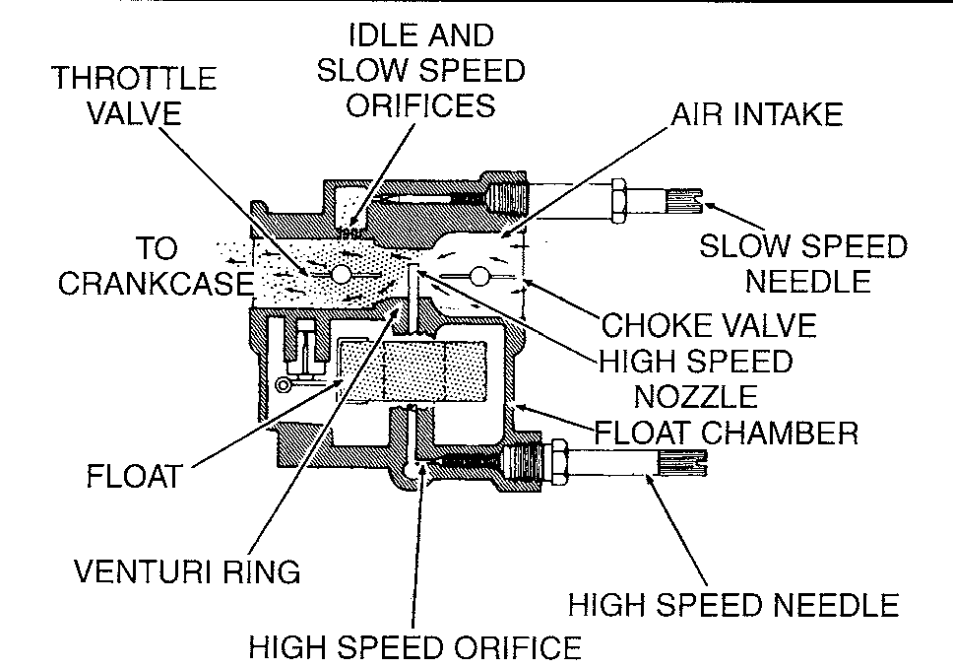

Fig. 1 Fuel flow through a venturi, showing principle and related parts controlling intake and outflow

**4-4** FUEL SYSTEM

At the carburetor, the fuel passes through the inlet passage to the needle and seat, and then into the float chamber (reservoir). A float in the chamber rides up and down on the surface of the fuel. After fuel enters the chamber and the level rises to a predetermined point, a tang on the float closes the inlet needle and the flow enter­ing the chamber is cut off. When fuel leaves the chamber as the engine operates, the fuel level drops and the float tang allows the inlet needle to move off its seat and fuel once again enters the chamber. In this manner, a constant reservoir of fuel is maintained in the chamber to satisfy the demands of the engine at all speeds.

A fuel chamber vent hole is located near the top of the carburetor body to permit atmospheric pressure to act against the fuel in each chamber. This pres­sure assures an adequate fuel supply to the various operating systems of the powerhead.

**Air/Fuel Mixture
  
See Figure 2**

A suction effect is created each time the piston moves upward in the cylinder. This suction draws air through the throat of the carburetor. A restriction in the throat, called a venturi, controls air velocity and has the effect of reducing air pressure at this point.

The difference in air pressures at the throat and in the fuel chamber, causes the fuel to be pushed out of metering jets extending down into the fuel chamber. When the fuel leaves the jets, it mixes with the air passing through the venturi. This fuel/air mixture should then be in the proper proportion for burning in the cylinders for maximum engine performance.

In order to obtain the proper air/fuel mixture for all engine speeds, some mod­els have high and low speed jets. These jets have adjustable needle valves which are used to compensate for changing atmospheric conditions. In almost all

cases, the high-speed circuit has fixed high-speed jets and are not adjustable.

A throttle valve controls the flow of air/fuel mixture drawn into the combus­tion chambers. A cold powerhead requires a richer fuel mixture to start and dur­ing the brief period it is warming to normal operating temperature. A choke valve is placed ahead of the metering jets and venturi. As this valve begins to close, the volume of air intake is reduced, thus enriching the mixture entering the cylinders. When this choke valve is fully closed, a very rich fuel mixture is drawn into the cylinders.

The throat of the carburetor is usually referred to as the barrel. Carburetors with single, double, or four barrels have individual metering jets, needle valves, throttle and choke plates for each barrel. Single and two barrel carburetors are fed by a single float and chamber.

CARBURETOR CIRCUITS

The following section illustrates the circuit functions and locations of a typi­cal marine carburetor.

**Starting Circuit** I **See Figure 3**

The choke plate is closed, creating a partial vacuum in the venturi. As the piston rises, negative pressure in the crankcase draws the rich air-fuel mixture from the float bowl into the venturi and on into the engine.

**Low Speed Circuit I See Figure 4**

Zero—one-eighth throttle, when the pressure in the crankcase is lowered, the air-fuel mixture is discharged into the venturi through the pilot outlet because the throttle plate is closed. No other outlets are exposed to low venturi pressure. The fuel is metered by the pilot jet. The air is metered by the pilot air jet. The combined air-fuel mixture is regulated by the pilot air screw.

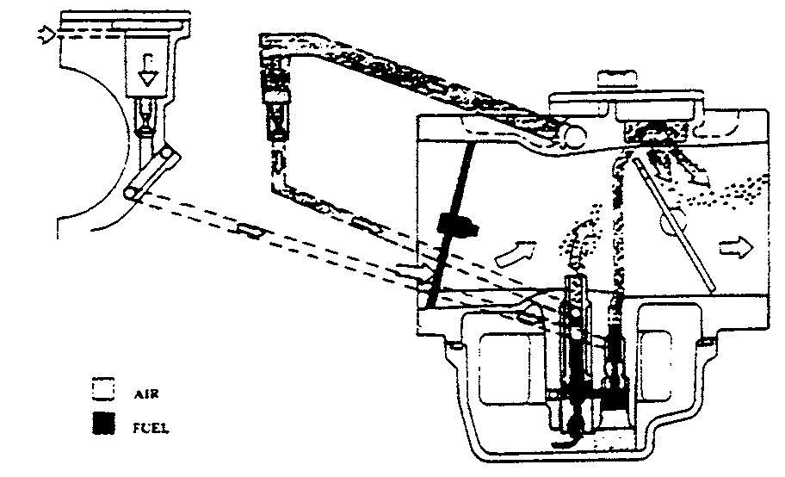

**Fig. 4 The low speed circuit**

**Mid-Range Circuit I See Figure 5**

One-eighth—three-eighths throttle, as the throttle plate continues to open, the air-fuel mixture is discharged into the venturi through the bypass holes. As the throttle plate uncovers more bypass holes, increased fuel flow results because

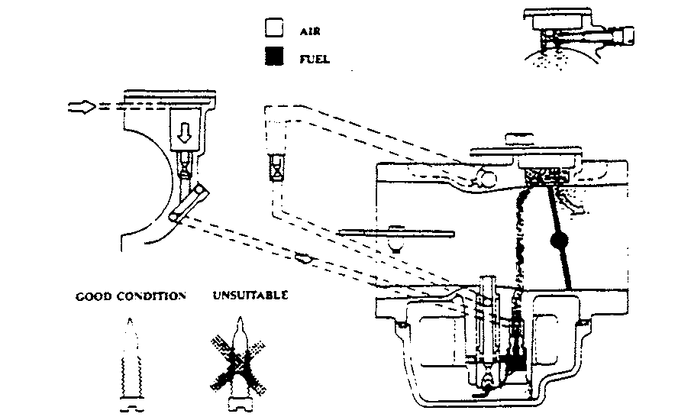

**Fig. 5 The mid-range circuit**

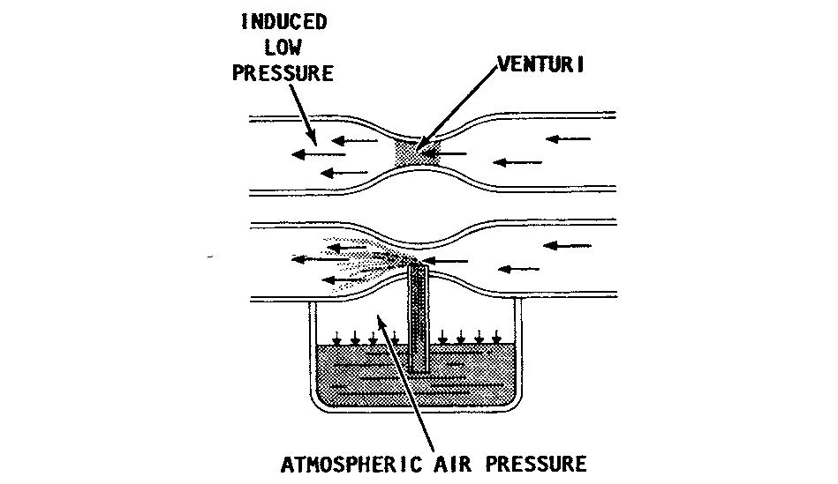

**Fig. 2 Air flow principle of a modern carburetor**

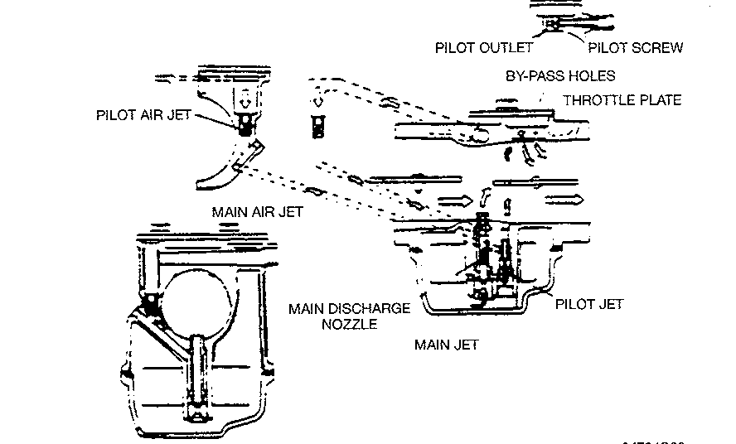

**Fig. 3 The starting circuit**

FUEL SYSTEM **4-5**

of the low pressure in the venturi. Depending on the model, there could be two, three or four bypass holes.

**High Speed Circuit 0 See Figure 6**

Three-eighths—wide-open throttle, as the throttle plate moves toward wide open, we have maximum air flow and very low pressure. The fuel is metered through the main jet, and is drawn into the main discharge nozzle. Air is metered by the main air jet and enters the discharge nozzle, where it combines with fuel. The mixture atomizes, enters the venturi, and is drawn into the engine.

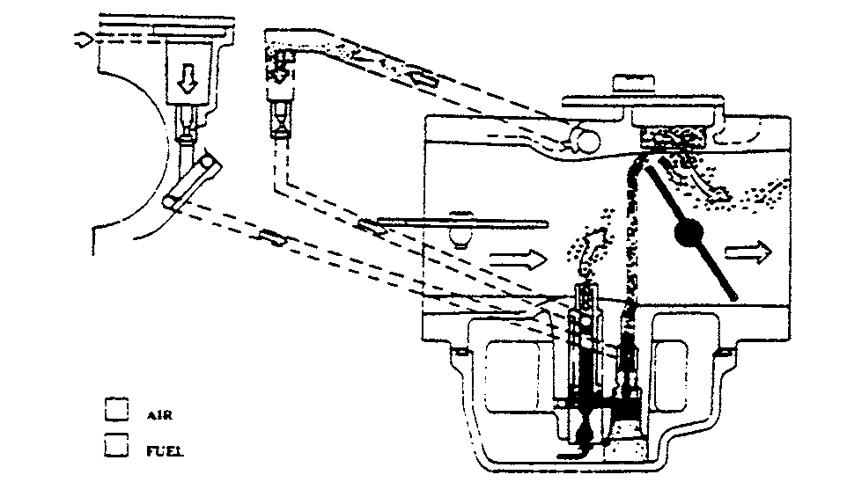

**Fig. 6 The high speed circuit**

BASIC FUNCTIONS

**See Figures 7, 8 and 9**

The carburetor systems on in line engines require careful cleaning and adjustment if problems occur. These carburetors are complicated but not too complex to understand. All carburetors operate on the same principles.

Traditional carburetor theory often involves a number of laws and principles. To troubleshoot carburetors learn the basic principles, watch how the carburetor comes apart, trace the circuits, see what they do and make sure they are clean. These are the basic steps for troubleshooting and successful repair.

The diagram illustrates several carburetor basics. If you blow through the straw an atomized mixture (air and fuel droplets) comes out. When you blow through the straw a pressure drop is created in the straw column inserted in the liquid. In a carburetor this is mostly air and a little fuel. The actual ratio of air to fuel differs with engine conditions but is usually from 15 parts air to one part fuel at optimum cruise to as little as 7 parts air to one part fuel at full choke.

If the top of the container is covered and sealed around the straw what will
  
happen? No flow. This is typical of a clogged carburetor bowl vent. If the base of
  
the straw is clogged or restricted what will happen? No flow or low flow. This

represents a clogged main jet. If the liquid in the glass is lowered and you blow through the straw with the same force what will happen? Not as much fuel will flow. A lean condition occurs. If the fuel level is raised and you blow again at the same velocity what happens? The result is a richer mixture.

Suzuki carburetors control air flow semi-independently of RPM. This is done with a throttle plate. The throttle plate works in conjunction with other systems or circuits to deliver correct mixtures within certain RPM bands. The idle circuit pilot outlet controls from 0-1/2 throttle. The series of small holes in the carbure­tor throat called transition holes control the 1/8—% throttle range. At wide open throttle the main jet handles most of the fuel metering chores, but the low and mid-range circuits continue to supply part of the fuel.

Enrichment is necessary to start a cold engine. Fuel and air mix does not want to vaporize in a cold engine. In order to get a little fuel to vaporize, a lot of fuel is dumped into the engine. On many older inline engines a choke plate is used for cold starts. This plate restricts air entering the engine and increases the fuel to air ratio.

The V4 and V6 engines use a solenoid release valve and large volume chamber for fuel delivery into the intake system behind No. 2 and No.3 carbu­retors (V6 models), and No.1 and No.2 (V4 models) to ensure easy starting under all conditions. Fuel for this system is delivered from the fuel pump (top pump on the V6) directly to the fuel starter valve assembly where it is con­trolled by a float and inlet needle valve. When the ignition key, in the ON posi­tion, is pushed in, the solenoid will open the solenoid release valve and fuel will flow to the two starter jet ports at the end of the carburetor bore. Turning the manual valve counterclockwise, to open, will allow fuel to flow in the event of an electrical problem. The manual valve must remain closed during normal engine operation.

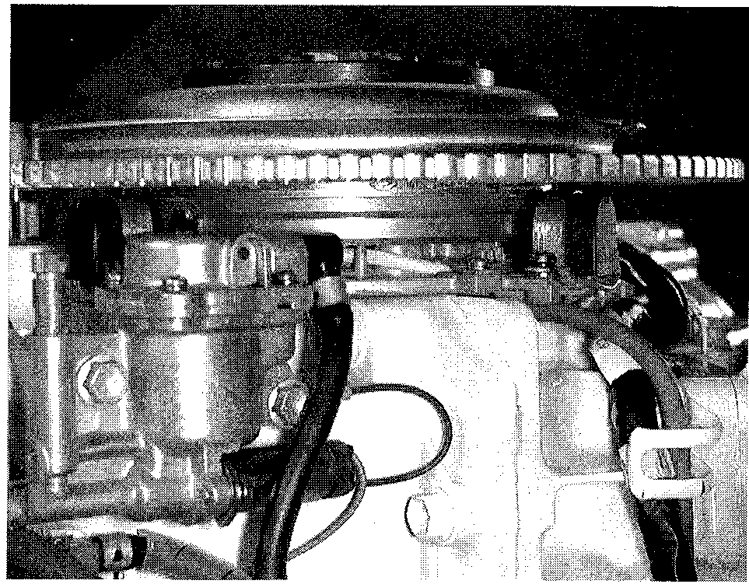

**Fig. 8 The V4 and V6 engines use a solenoid release valve and large volume chamber for fuel delivery into the intake system**

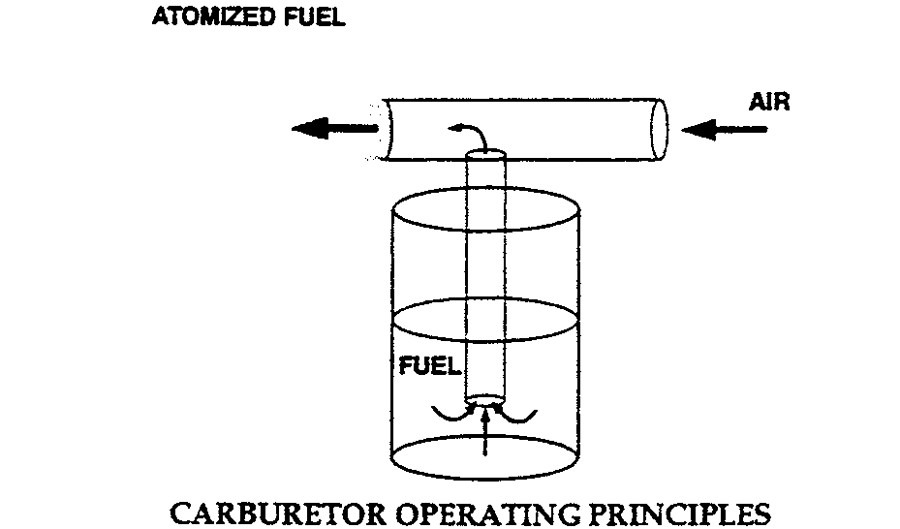

**Fig. 7 If you blow through the straw, an atomized mixture (air and fuel droplets) comes out**

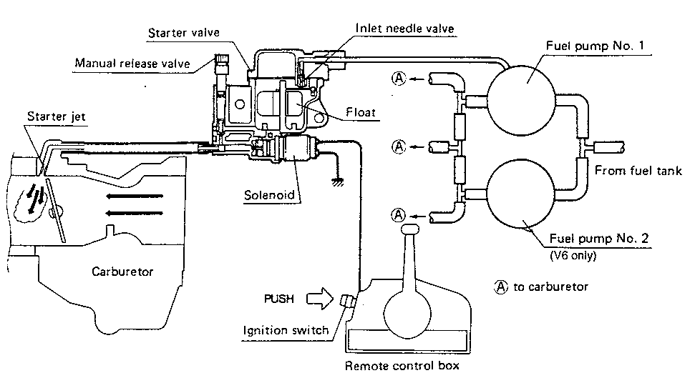

**Fig. 9 Illustration of the V4 and V6 solenoid release valve starting system. The V4 engines have only one fuel pump**

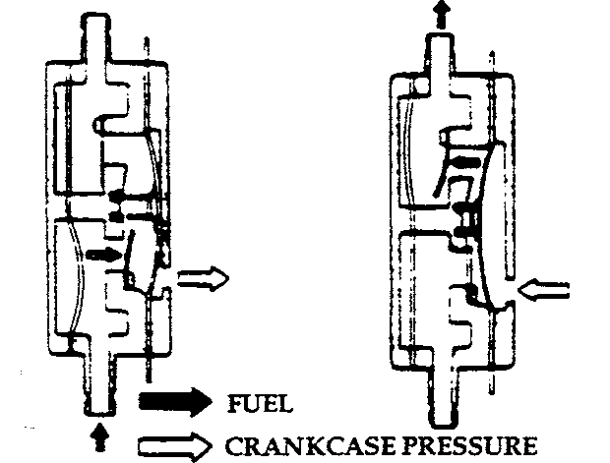

**4-6** FUEL SYSTEM

DUAL-THROAT CARBURETORS

The carburetor systems on V4 and V6 engines require careful cleaning and adjustment if problems occur. These carburetors are not difficult to understand. All carburetors operate on the same principles. For best results, trace and ana­lyze one circuit at a time.

Beginning in 1996, all Saltwater series 90 degree V engines have an addi­tional jet in the carburetor. This pull over or enrichment jet improves mid-range response while maintaining fuel economy. Additional enrichment is necessary to start a cold engine. Fuel/air mixes to not want to vaporize in a cold engine. In order to get a little fuel to vaporize, a lot of fuel is dumped into the engine. On most V4 and V6 engines, a choke plate is used for cold starts. This plate restricts air entering the engine and increases the fuel/air ratio.

The enrichment system on the 90-degree 225 hp engines is controlled by a microprocessor. Temperature and throttle position are monitored and enrich­ment is automatic. A pair of injectors with different diameters are used to pro­vide enrichment.

REMOVING FUEL FROM THE SYSTEM

**0 See Figures 10 and 11**

For many years there has been the widespread belief that simply shutting off the fuel at the tank and then running the engine until it stops is the proper pro­cedure before storing the engine for any length of time. Right? Wrong!

It is not possible to remove all of the fuel in the carburetor by operating the engine until it stops. Some fuel is trapped in the float chamber and other pas­sages and in the line leading to the carburetor. The only guaranteed method of removing ALL of the fuel is to take the time to remove the carburetor, and drain the fuel.

If the engine is operated with the fuel supply shut off until it stops, the fuel and oil mixture inside the engine is removed, leaving bearings, pistons, rings, and other parts with little protective lubricant, during long periods of storage.

Proper procedure involves:

1. Shutting off the fuel supply at the tank.
2. Disconnecting the fuel line at the tank.
3. Operating the engine until it begins to run rough, then stopping the engine, which will leave some fuel/oil mixture inside.
4. Removing and draining the carburetor.

By disconnecting the fuel supply, all small passages are cleared of fuel even though some fuel is left in the carburetor. A light oil should be put in the com­bustion chamber as instructed in the owner's manual. On some model carbure­tors the high-speed jet plug can be removed to drain the fuel from the

carburetor.

For short periods of storage, simply running the carburetor dry may help prevent severe gum and varnish from forming in the carburetor. This is espe­cially true during hot weather.

**Fuel Pump**

**0 See Figures 12 thru 18**

A fuel pump is a basic mechanical device that utilizes crankcase positive and negative pressures to pump fuel from the fuel tank to the carburetors.

This device contains a flexible diaphragm and two check valves (flappers or fingers) that control flow. As the piston goes up, crankcase pressure drops (negative pressure) and the inlet valve opens, pulling fuel from the tank. As the piston nears TDC, pressure in the pump area is neutral (atmospheric pressure). At this point both valves are closed. As the piston comes down, pressure goes up (positive pressure) and the fuel is pushed toward the carburetor bowl by the diaphragm through the now open outlet valve.

This is a reliable method to move fuel but can have several problems. Some­times an engine backfire can rupture the diaphragm. The diaphragm and valves are moving parts subject to wear. The flexibility of the diaphragm material can go away, reducing or stopping flow. Rust or dirt can hang a valve open and reduce or stop fuel flow.

**Fig. 12 A fuel pump is a basic mechanical device that utilizes crankcase positive and negative pressures to pump fuel**

**Fig. 10 Typical fuel line quick disconnect fitting**

**Fig. 11 Fuel shutoff knob on a 4 hp out­board**

**Fig. 13 The diaphragm is most subject to wear in a fuel pump**

**Fig. 14 Typical fuel pump mounting on the engine crankcase**

**Fig. 15 Make sure to inspect the fuel pump gasket .. .**

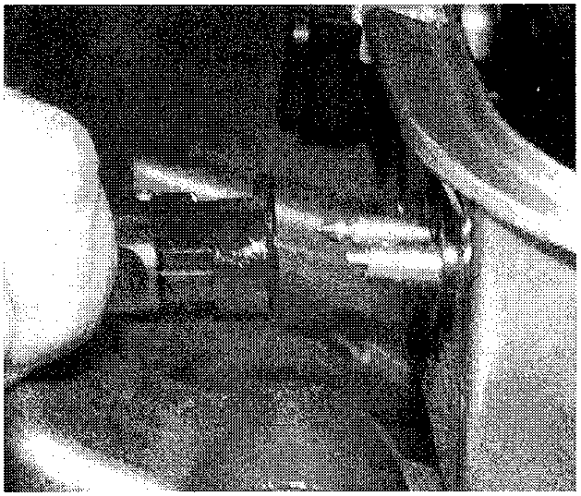

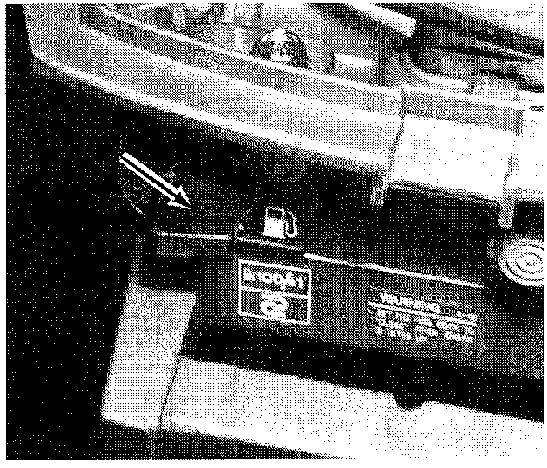

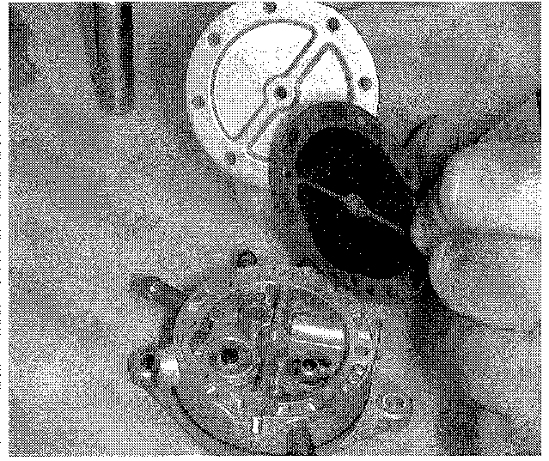

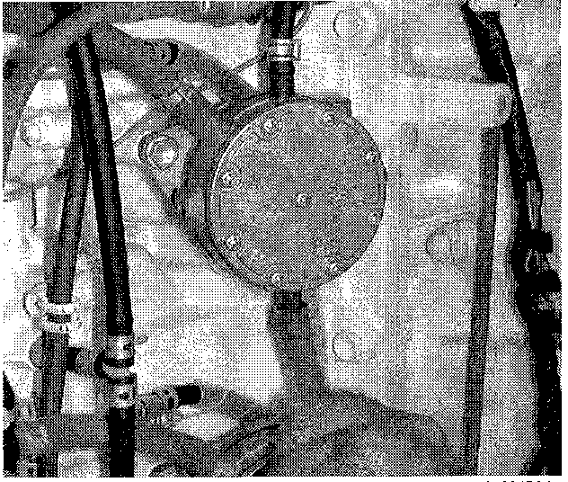

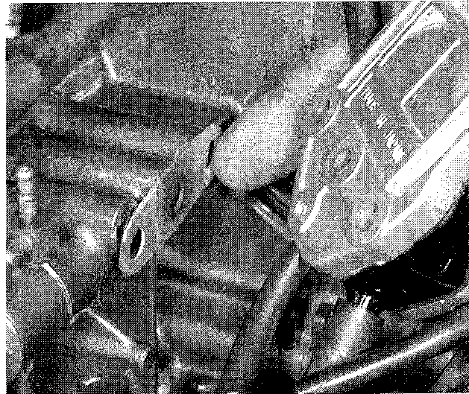

FUEL SYSTEM **4-7**

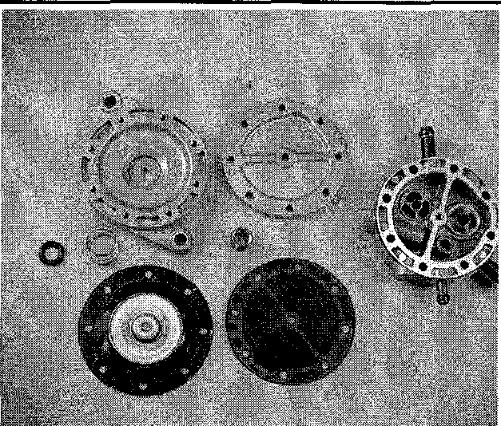

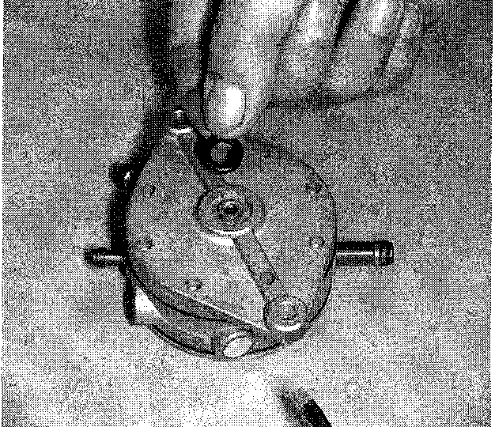

Fig. 16 . . . or 0-ring for tears or damage

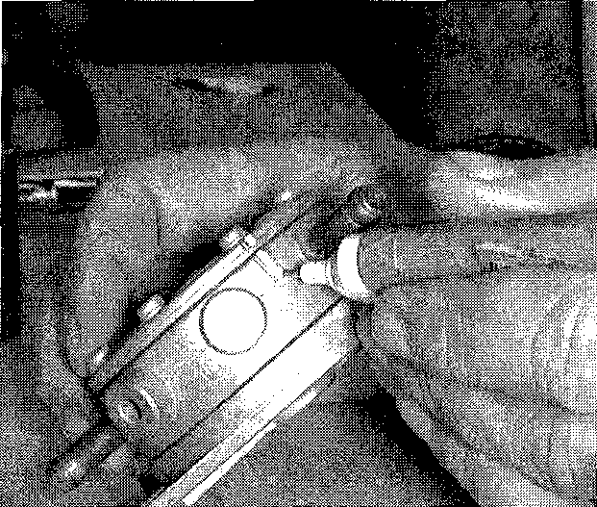

Fig. 17 When taking the pump apart, mark the pump sections for correct reassembly

Fig. 18 Exploded view of a diaphragm fuel pump—DT175

**TROUBLESHOOTING**

**Fuel System**

Troubleshooting fuel systems requires the same techniques used in other areas. A thorough, systematic approach to troubleshooting will pay big rewards. Build your troubleshooting checklist, with the most likely offenders at the top. Use your experience to adjust your list for local conditions. Everyone has been tempted to jump into the carburetor on a vague hunch. Pause a moment and review the facts when this urge occurs.

In order to accurately troubleshoot a carburetor or fuel system problem, you must first verify that the problem is fuel related. Many symptoms can have sev­eral different possible causes. Be sure to eliminate mechanical and electrical systems as the potential fault. Carburetion is the number one cause of most engine problems, but there are other possibilities.

One of the toughest tasks with a fuel system is the actual troubleshooting. Several tools are at your disposal for making this process very simple. A timing light works well for observing carburetor spray patterns. Look for the proper amount of fuel and for proper atomization in the two fuel outlet areas (main noz­zle and bypass holes). The strobe effect of the lights helps you see in detail the fuel being drawn through the throat of the carburetor. On multiple carburetor engines, always attach the timing light to the cylinder you are observing so the strobe doesn't change the appearance of the patterns. If you need to compare two cylinders, change the timing light hookup each time you observe a different cylinder.

Pressure testing fuel pump output can determine whether the fuel spray is adequate and if the fuel pump diaphragms are functioning correctly. A pressure gauge placed between the fuel pumps and the carburetors will test the entire fuel delivery system. Normally a fuel system problem will show up at high speed where the fuel demand is the greatest. A common symptom of a fuel pump out­put problem is surging at wide open throttle, but normal operation at slower speeds. To check the fuel pump output, install the pressure gauge and acceler­ate the engine to wide open throttle. Observe the pressure gauge needle. It should always swing up to some value between 5-6 psi and remain steady. This reading would indicate a system that is functioning properly.

If the needle gradually swings down toward zero, fuel demand is greater than the fuel system can supply. This reading isolates the problem to the fuel deliv­ery system (fuel tank or line). To confirm this, an auxiliary tank should be

installed and the engine re-tested. Be aware that a bad anti-siphon valve on a built-in tank can create enough restriction to cause a lean condition and serious engine damage.

If the needle movement becomes erratic, suspect a ruptured diaphragm in the fuel pump.

A quick way to check for a ruptured fuel pump diaphragm is while the engine is at idle speed, to squeeze the primer bulb and hold steady firm pressure on it. If the diaphragm is ruptured, this will cause a rough running condition because of the extra fuel passing through the diaphragm into the crankcase. After per-

forming this test you should check the spark plugs for cylinders that the fuel pump supplies. If the spark plugs are OK, but the fuel pumps are still sus­pected, you should remove the fuel pumps and completely disassemble them. Rebuild or replace the pumps as needed.

To check the boat's fuel system for a restriction, install a vacuum gauge in the line before the fuel pump. Run the engine under load at wide open throttle to get a reading. Vacuum should read no more than 4.5 in. Hg (15.2 kPa) for engines up to and including 200 hp, and should not exceed 6.0 in. Hg (20.2 kPa) for engines greater than 200 hp.

To check for air entering the fuel system, install a clear fuel hose between the fuel screen and fuel pump. If air is in the line, check all fittings back to the boat's fuel tank.

Spark plug tip appearance is a good indication of combustion efficiency. The tip should be a light tan. A white insulator or small beads on the insulator indi­cate too much heat. A dark or oil fouled insulator indicates incomplete combus­tion. To properly read spark plug tip appearance, run the engine at the RPM you are testing for about 15 second and then immediately turn the engine OFF with­out changing the throttle position.

Reading spark plug tip appearance is also the proper way to test jet verifica­tions in high altitude.

The following chart explains the relationship between throttle position and carburetion circuits.

LOGICAL TROUBLESHOOTING

The following paragraphs provide an orderly sequence of tests to pinpoint problems in the fuel system.

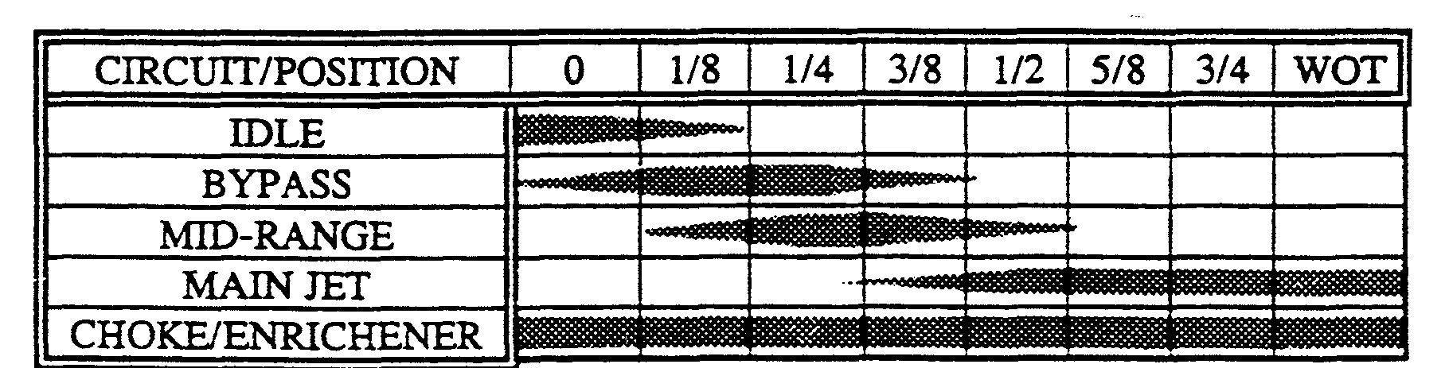

**4-8** FUEL SYSTEM

1. Gather as much information as you can.
2. Duplicate the condition. Take the boat out and verify the complaint.
3. If the problem cannot be duplicated, you cannot fix it. This could be a product operation problem.
4. Once the problem has been duplicated, you can begin troubleshooting. Give the entire unit a careful visual inspection. You can tell a lot about the engine from the care and condition of the entire rig. What's the condition of the propeller and the lower unit? Remove the hood and look for any visible signs of failure. Are there any signs of head gasket leakage. Is the engine paint discol­ored from high temperature or are there any holes or cracks in the engine block? Perform a compression and leak down test. While cranking the engine during the compression test, listen for any abnormal sounds. If the engine passes these simple tests we can assume that the mechanical condition of the engine is good. All other engine mechanical inspection would be too time con­suming at this point.
5. Your next step is to isolate the fuel system into two sub-systems. Sepa­rate the fuel delivery components from the carburetors. To do this, substitute the boat's fuel supply with a known good supply. Use a 6 gallon portable tank and fuel line. Connect the portable fuel supply directly to the engine fuel pump, bypassing the boat fuel delivery system. Now test the engine. If the problem is no longer present, you know where to look. If the problem is still present, fur­ther troubleshooting is required.
6. When testing the engine, observe the throttle position when the problem occurs. This will help you pinpoint the circuit that is malfunctioning. Carburetor troubleshooting and repair is very demanding. You must pay close attention to the location, position and sometimes the numbering on each part removed. The ability to identify a circuit by the operating RPM it affects is important. Often your best troubleshooting tool is a can of cleaner. This can be used to trace those mystery circuits and find that last speck of dirt. Be careful and wear safety glasses when using this method.

COMMON PROBLEMS

**Fuel Delivery See Figure 19**

Many times fuel system troubles are caused by a plugged fuel filter, a defec­tive fuel pump, or by a leak in the line from the fuel tank to the fuel pump. A defective choke may also cause problems. would you believe, a majority of starting troubles which are traced to the fuel system are the result of an empty fuel tank or aged sour fuel.

**Sour Fuel**

**See Figure 20**

Under average conditions (temperate climates), fuel will begin to break down in about four months. A gummy substance forms in the bottom of the fuel tank and in other areas. The filter screen between the tank and the carburetor and small passages in the carburetor will become clogged. The gasoline will begin to give off an odor similar to rotten eggs. Such a condition can cause the owner much frustration, time in cleaning components, and the expense of replacement or overhaul parts for the carburetor.

Even with the high price of fuel, removing gasoline that has been standing unused over a long period of time is still the easiest and least expensive pre­ventative maintenance possible. In most cases, this old gas can be used without harmful effects in an automobile using regular gasoline.

The gasoline preservative additive Suzuki Fuel Conditioner and Stabilizer for 2 cycle engines, will keep the fuel fresh for up to twelve months. If this particu­lar product is not available in your area, other similar additives are produced under various trade names.

**Choke Problems**

When the engine is hot, the fuel system can cause starting problems. After a hot engine is shut down, the temperature inside the fuel bowl may rise to 200 degrees F and cause the fuel to actually boil. All carburetors are vented to allow this pressure to escape to the atmosphere. However, some of the fuel may per­colate over the high-speed nozzle.

If the choke should stick in the open position, the engine will be hard to start. If the choke should stick in the closed position, the engine will flood, making it very difficult to start.

In order for this raw fuel to vaporize enough to burn, considerable air must be added to lean out the mixture. Therefore, the only remedy is to remove the spark plugs, ground the leads, crank the powerhead through about ten revolu­tions, clean the plugs, reinstall the plugs, and start the engine.

If the needle valve and seat assembly is leaking, an excessive amount of fuel may enter the reed housing in the following manner. After the powerhead is shut down, the pressure left in the fuel line will force fuel past the leaking needle valve. This extra fuel will raise the level in the fuel bowl and cause fuel to over­flow into the reed housing.

A continuous overflow of fuel into the reed housing may be due to a sticking inlet needle or to a defective float, which would cause an extra high level of fuel in the bowl and overflow into the reed housing.

**Fuel Pump**

**I See Figure 21**

Fuel pump testing is an excellent way to pinpoint air leaks, restricted fuel lines and fittings or other fuel supply related performance problems.

When a fuel starvation problem is suspected such as engine hesitation or engine stopping, perform the following fuel system test:

1. Connect the piece of clear fuel hose to a side barb of the "T" fitting 0.

**Fig. 19 An excellent way of protecting fuel hoses against contami- nation is an end cap filter**

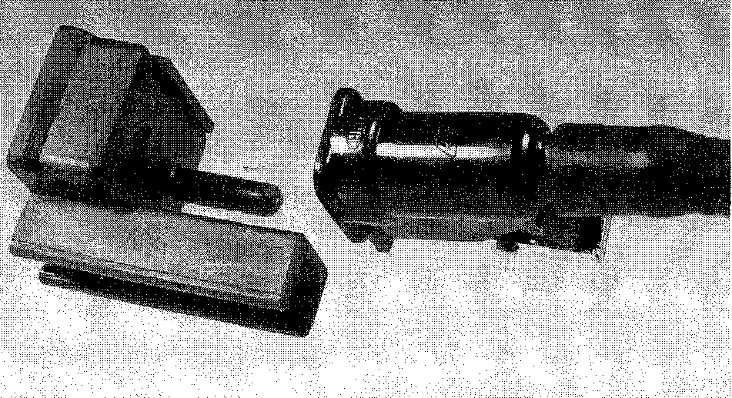

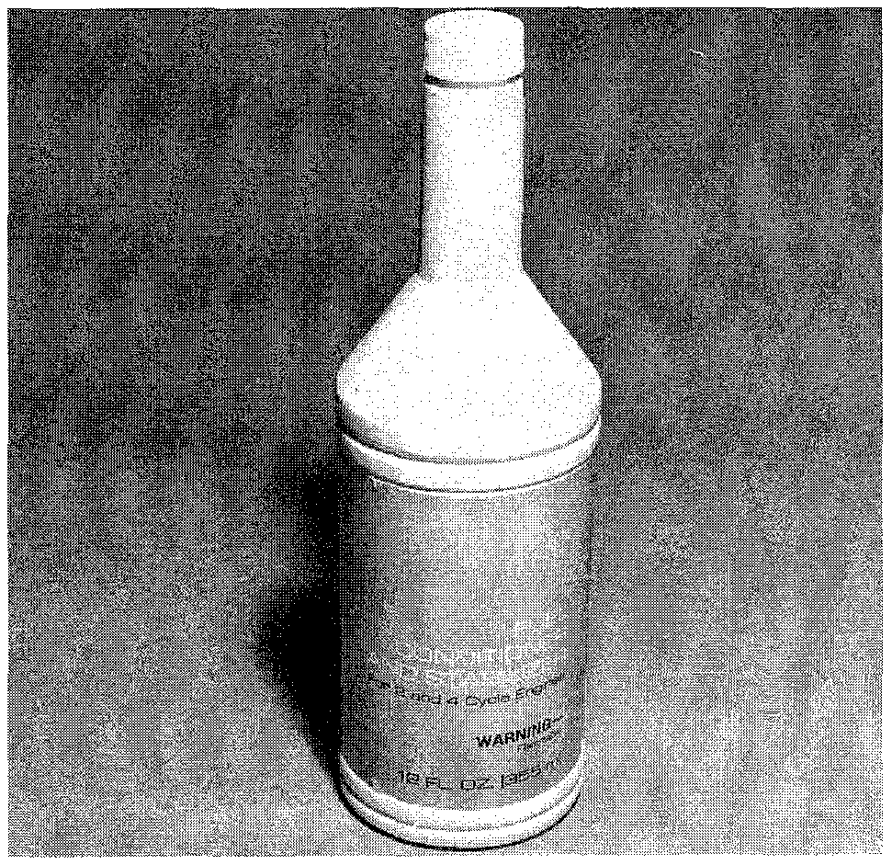

**Fig. 20 The use of an approved fuel additive, such as this Suzuki Fuel Conditioner and Stabilizer, will prevent fuel from souring for up to twelve months**

FUEL SYSTEM **4-9**

1. Connect one end of the long piece of fuel hose to the vacuum gauge and the other end to the center barb of the "T" fitting.

Use a long enough piece of fuel hose so the vacuum gauge may be read at the helm.

1. Remove the existing fuel hose from the fuel tank side of the fuel pump, and connect the remaining barb of the "T" fitting to the fuel hose.
2. Connect the short piece of clear fuel hose to the fuel check valve leading from the fuel filter. If a check valve does not exist, connect the clear fuel hose directly to the fuel filter.
3. Check the vacuum gauge reading after running the engine long enough to stabilize at full power.

The vacuum is to not exceed 4.5 in. Hg (15.2 kPa) for up to 200 hp engines. The vacuum is to not exceed 6.0 in. Hg (20.3 kPa) for engines greater than 200 hp.

1. An anti-siphon valve (required if the fuel system drops below the top of the fuel tank) will cause a 1.5 to 2.5 in. Hg (8.4 kPa) increase in vacuum.
2. If high vacuum is noted, move the T-fitting to the fuel filter outlet 0 and retest.
3. Continue to the fuel filter inlet and along the remaining fuel system until a large drop in vacuum locates the problem.
4. A good clean water separator fuel filter will increase vacuum about 0.5 in. Hg (1.7 kPa).
5. Small internal passages inside a fuel selector valve, fuel tank pickup, or fuel line fittings may cause excessive fuel restriction and high vacuum.
6. Unstable and slowly rising vacuum readings, especially with a full tank of fuel, usually indicates a restricted vent line.

Bubbles in the clear fuel line section indicate an air leak, making for an inaccurate vacuum test. Check all fittings for tightened clamps and a tight fuel filter.

m►Vacuum gauges are not calibrated and some may read as much as 2 in. Hg (6.8 kPa) lVacuumn the actual vacuum. It is recommended to perform a fuel system test while no problems exist to determine vacuum gauge accuracy.

**Fuel Line**

0 See Figures 22, 23 and 24

On most installations, the fuel line is provided with quick-disconnect fittings at the tank and at the engine. If there is reason to believe the problem is at the quick-disconnects, the hose ends should be replaced as an assembly. For a small additional expense, the entire fuel line can be replaced and thus eliminate this entire area as a problem source for many future seasons.

The primer squeeze bulb can be replaced in a short time. First, cut the hose line as close to the old bulb as possible. Slide a small clamp over the end of the fuel line from the tank. Next, install the small end of the check valve assembly into this side of the fuel line. The check valve always goes towards the fuel tank. Place a large clamp over the end of the check valve assembly. Use Primer Bulb Adhesive when the connections are made. Tighten the clamps. Repeat the pro­cedure with the other side of the bulb assembly and the line leading to the engine.

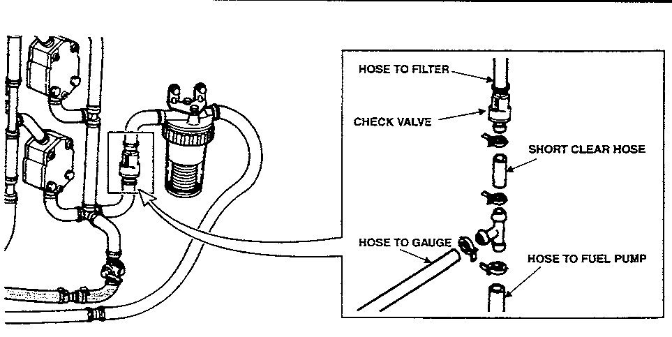

Fig. 21 Connecting a fuel pressure gauge inline in preparation for a fuel pump test

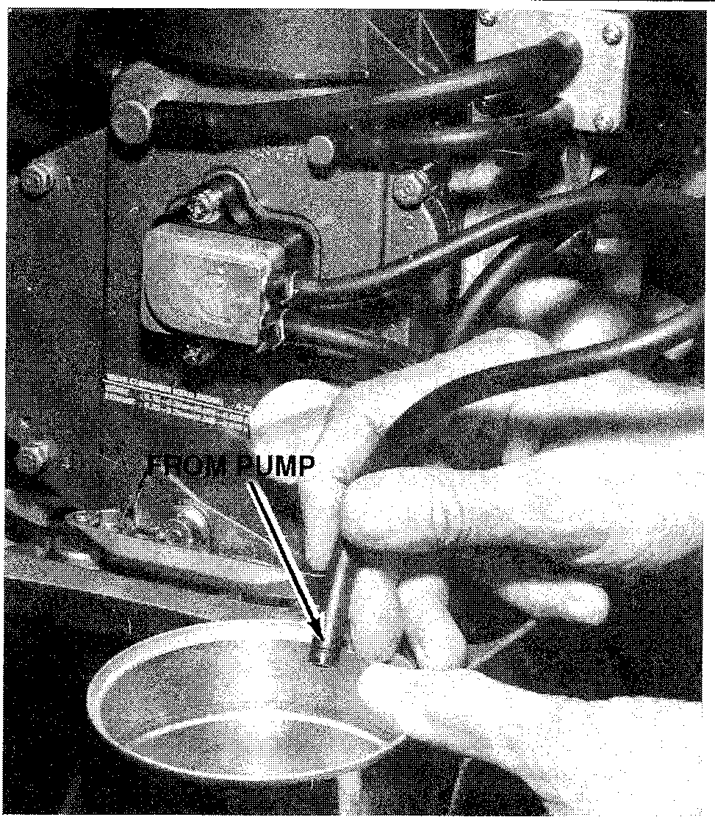

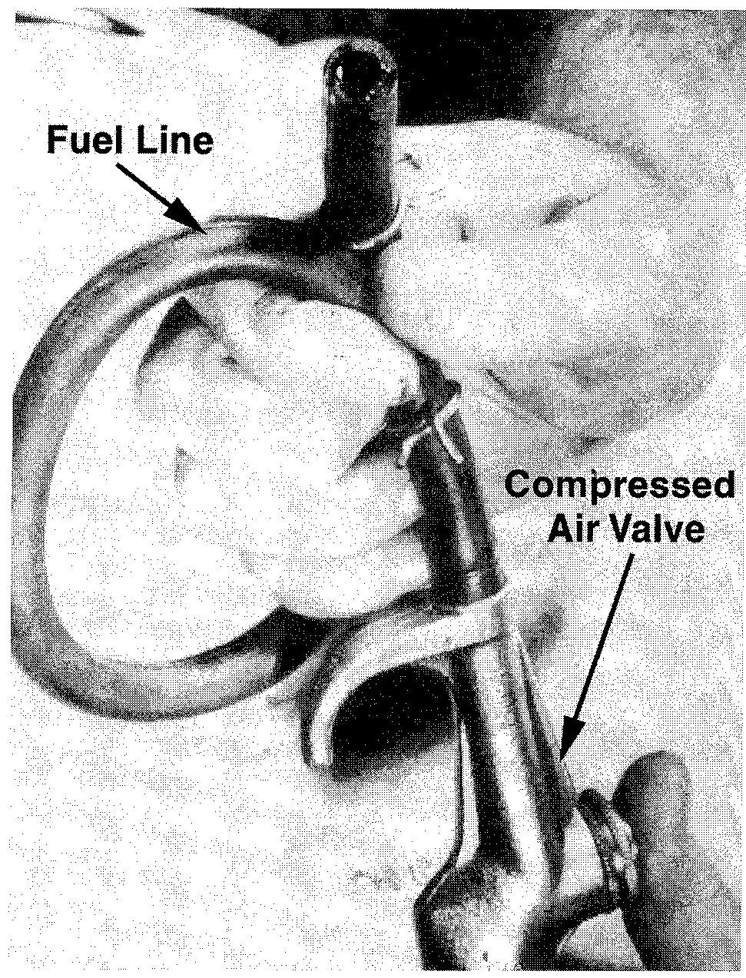

Fig. 22 To test the fuel pickup in the fuel tank, operate the squeeze bulb and observe fuel flowing from the disconnected line at the fuel pump. Discharge fuel into an approved container.

Fig. 23 Many times restrictions such as foreign material may be cleared from the fuel lines using compressed air. Ensure the open end of the hose is pointing in a clear direction to avoid personal injury

**4-10** FUEL SYSTEM

COMMON PROBLEMS

**Rough Engine Idle**

If an engine does not idle smoothly, the most reasonable approach to the problem is to perform a tune-up to eliminate such areas as:

* Defective points
* Faulty spark plugs
* Timing out of adjustment

Other problems that can prevent an engine from running smoothly include:

* An air leak in the intake manifold
* Uneven compression between the cylinders
* Sticky or broken reeds

Of course any problem in the carburetor affecting the air/fuel mixture will also prevent the engine from operating smoothly at idle speed. These problems usually include:

* Too high a fuel level in the bowl
* A heavy float
* Leaking needle valve and seat
* Defective automatic choke
* Improper adjustments for idle mixture or idle speed

**Excessive Fuel Consumption**

Excessive fuel consumption can be the result of any one of four conditions, or a combination of all.

* Inefficient engine operation.
* Faulty condition of the hull, including excessive marine growth.
* Poor boating habits of-the operator.
* Leaking or out of tune carburetor.

If the fuel consumption suddenly increases over what could be considered normal, then the cause can probably be attributed to the engine or boat and noof theoperator.

Marine growth on the hull can have a very marked effect on boat perfor­mance. This is why sail boats always try to have a haul-out as close to race time as possible.

While you are checking the bottom, take note of the propeller condition. A bent blade or other damage will definitely cause poor boat performance.

If the hull and propeller are in good shape, then check the fuel system for
  
possible leaks. Check the line between the fuel pump and the carburetor while

the engine is running and the line between the fuel tank and the pump when the engine is not running. A leak between the tank and the pump many times will not appear when the engine is operating, because the suction created by the pump drawing fuel will not allow the fuel to leak. Once the engine is turned off and the suction no longer exists, fuel may begin to leak.

If a minor tune-up has been performed and the spark plugs, points, and tim­ing are properly adjusted, then the problem most likely is in the carburetor and an overhaul is in order.

Check the needle valve and seat for leaking. Use extra care when making any adjustments affecting the fuel consumption, such as the float level or automatic choke.

**Engine Surge**

If the engine operates as if the load on the boat is being constantly increased and decreased, even though an attempt is being made to hold a constant engine speed, the problem can most likely be attributed to the fuel pump, or a restric­tion in the fuel line between the tank and the carburetor.

**Combustion Related Piston Failures**

**I/ See Figure 25**

When an engine has a piston failure due to abnormal combustion, fixing the mechanical portion of the engine is the easiest part. The hard part is determining what caused the problem, in order to prevent a repeat failure. Think back to the four basic areas that affect combustion to find the cause of the failure.

Since you probably removed the cylinder head. Inspect the failed piston, look for excessive deposit buildup that could raise compression, or retain heat in the combustion chamber. Statically check the wide open throttle timing. Be sure that the timing is not over advanced. It is a good idea to seal these adjustments with paint to detect tampering.

Look for a fuel restriction that could cause the engine to run lean. Don't for­get to check the fuel pump, fuel tank and lines, especially if a built in tank is used. Be sure to check the anti-siphon valve on built in tanks.

If everything else looks good, the final possibility is poor quality fuel.

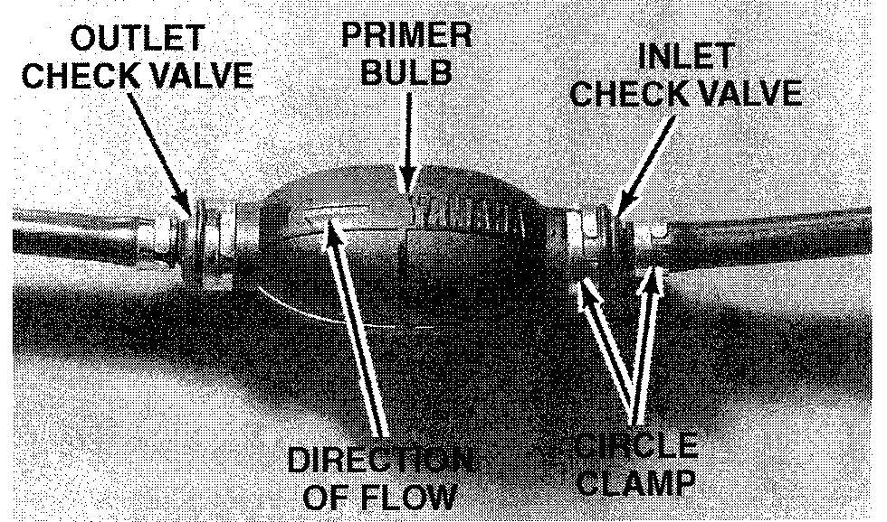

Fig. 24 Major parts of a typical fuel line squeeze bulb. The bulb is used to prime the fuel system until the powerhead is operating and the pump can deliver the required amount of fuel to run the engine

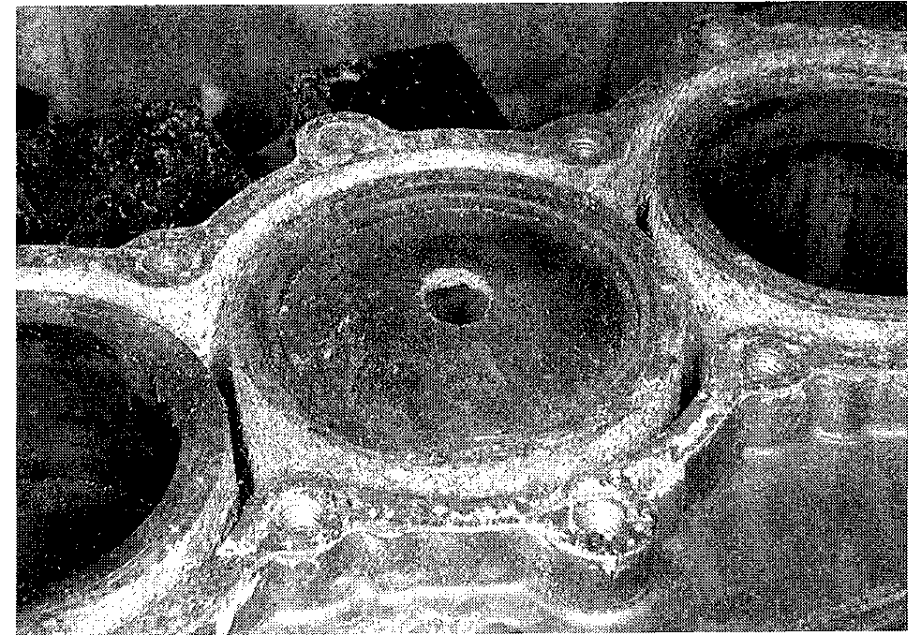

Fig. 25 This burned piston is typical of a combustion relate failure. The combustion chamber temperature got so hot that it melted the top of the piston (hole in the top of the piston)

FUEL SYSTEM **4-11**

**CARBURETOR SERVICE**

**DT2 and DT2.2**

This carburetor is a single-barrel, float feed type with a manual choke. Fuel to the carburetor is gravity fed from a fuel tank mounted at the rear of the powerhead.

REMOVAL & INSTALLATION

**See accompanying illustrations**

Good shop practice dictates a carburetor repair kit be purchased and new parts be installed any time the carburetor is disassembled.

Make an attempt to keep the work area organized and to cover parts after they have been cleaned. This practice will prevent foreign matter from entering pas­sageways or adhering to critical parts.

1. Remove the port and starboard engine covers.

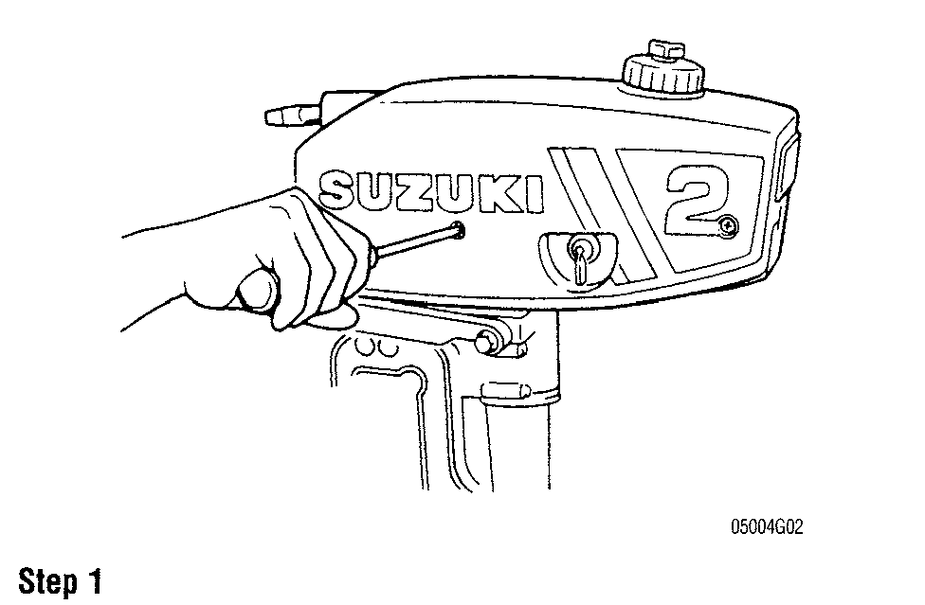

1. With the fuel petcock lever in the OFF position (marked "S"), remove the fuel hose from the carburetor fitting and plug the hose to prevent fuel from leaking.
2. Loosen the choke knob set screw and remove the knob from the control panel.

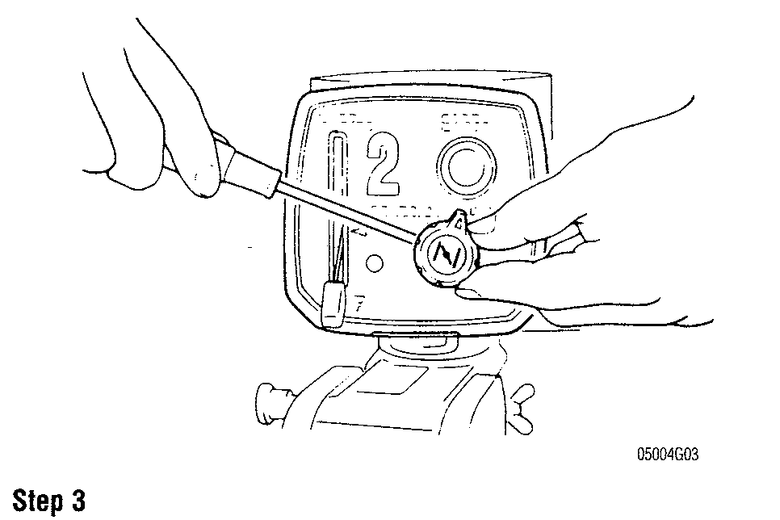

1. Remove the screws holding the control panel to the carburetor and lift off the control panel and throttle link knob.
2. Loosen the carburetor clamp and remove the carburetor from the engine crankcase. Discard the 0-ring.

**To install:**

1. Install the throttle lever post in the throttle valve with the anchor in the pocket at the bottom of the valve body.
2. Secure the carburetor in place by tightening the bolt and nut securely.
3. Install the control panel and the chock knob. Don't forget to tighten the set screw.

Slowly tighten the idle speed screw until it barely seats, then back it out the

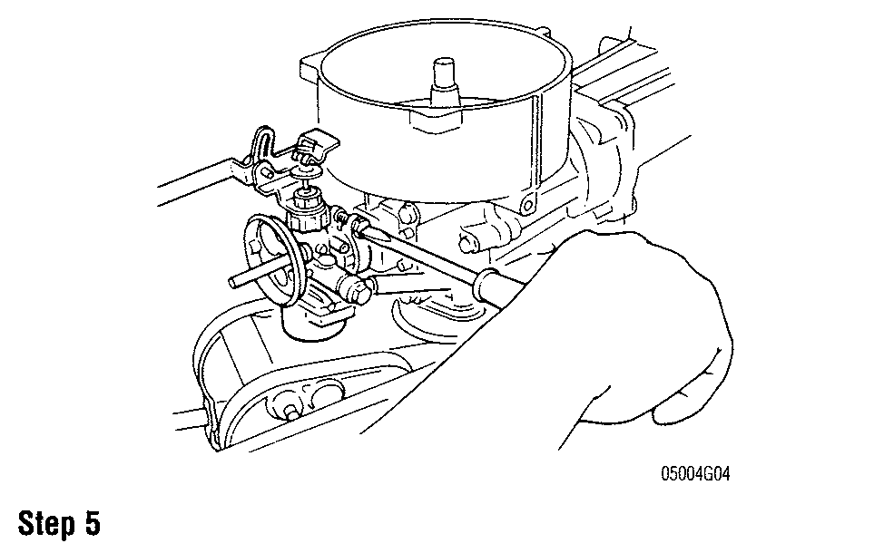

same number of turns recorded during disassembly. If the number of turns was not recorded, back the screw out 1-3/4 turns as a rough adjustment. Idle speed should be as specified in the "Tune-Up Specifications" chart.

1. Install the two halves of the cowling around the powerhead.
2. Secure the engine cover.

Mount the outboard unit in a test tank, or the boat in a body of water, or con­nect a flush attachment and hose to the lower unit. Start the engine and check the completed work. Allow the powerhead to warm to normal operating tempera­ture. Adjust the idle speed to specification.

DISASSEMBLY

**0 See Figure 26**

1. With the carburetor on clean working surface, remove the screws secur­ing the fuel float bowl to the carburetor body. Discard the float bowl gasket.

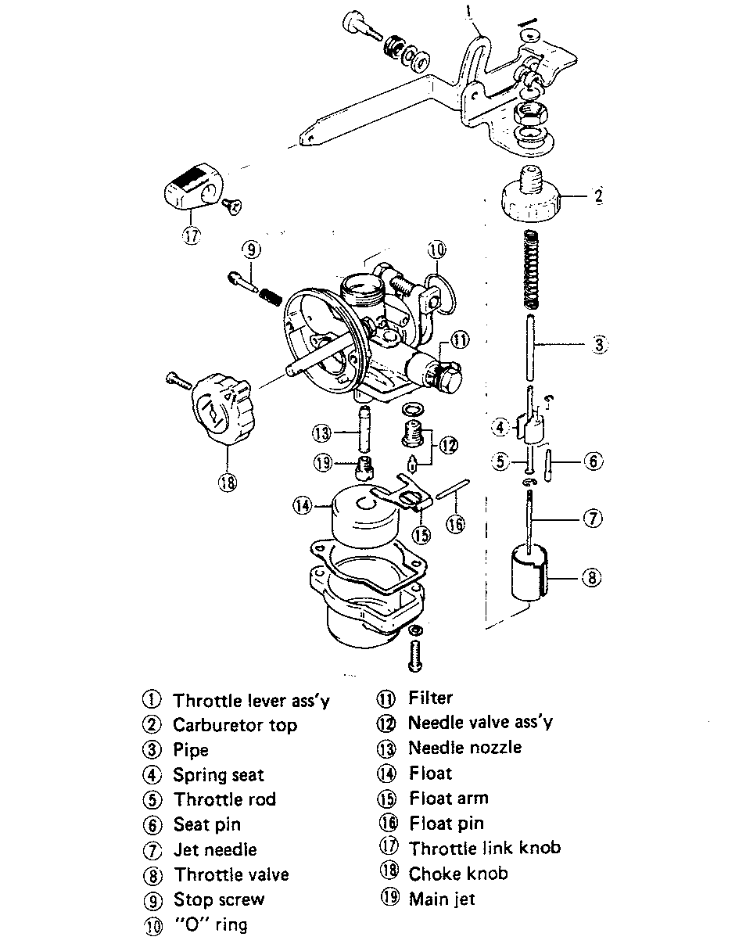

Fig. 26 Exploded view of carburetor with major parts identified—DT2 and DT2.2 models

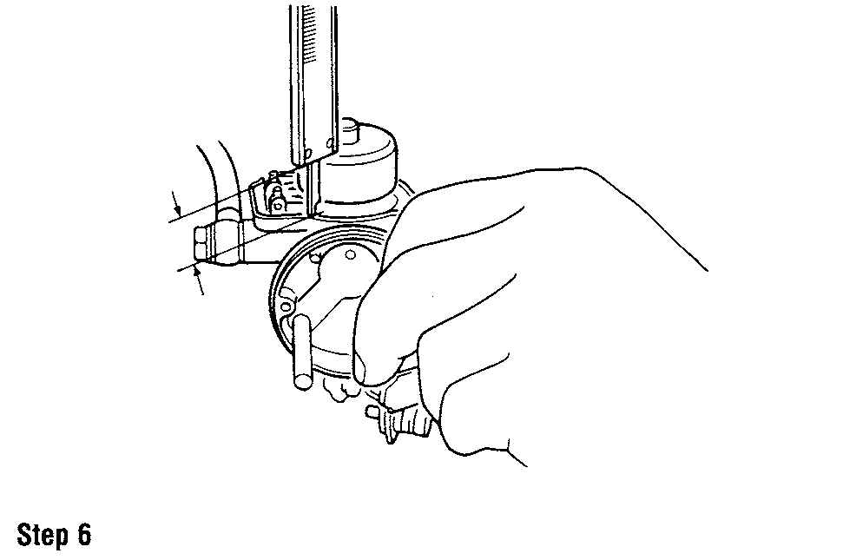

4-12 FUEL SYSTEM

1. Push the float pin free using a fine pointed awl and remove the float pin from the float arm and lift off the float and needle valve from the bowl.
2. Remove the main nozzle and the main jet assembly.
3. Remove the needle seat and gasket using a wide bladed screwdriver. Dis­card the gasket.
4. Loosen the throttle stop screw and unscrew the carburetor top with the throttle lever assembly as one unit.
5. Disconnect the throttle plunger from the needle valve and remove the valve, spring and retainer.

It is not necessary to remove the E-clip from the jet needle, unless replacement is required or if the powerhead is to be operated at a sig­nificantly different elevation.

1. Turn in the throttle stop screw (counting the turns for reassembly) until it lightly seats. Turn out the screw and remove it and the attached spring.
2. Remove the fuel inlet fitting and fuel filter.

CLEANING & INSPECTION I See Figures 27 and 28

** CAUTION

Never dip rubber parts, plastic parts, diaphragms, or pump plungers in carburetor cleaner. These parts should be cleaned only in solvent, and then blown dry with compressed air.

Place all metal parts in a screen-type tray and dip them in carburetor cleaner until they appear completely clean, then blow them dry with com­pressed air.

Blow out all passages in the castings with compressed air. Check all parts and passages to be sure they are not clogged or contain any deposits. Never use a piece of wire or any type of pointed instrument to clean drilled passages or calibrated holes in a carburetor.

Move the throttle shaft back and forth to check for wear. If the shaft appears to be too loose, replace the complete throttle body because individual replace­ment parts are not available.

Inspect the main body, airhorn, and venturi cluster gasket surfaces for cracks and burrs which might cause a leak. Check the float for deterioration. Check to be sure the float spring has not been stretched. If any part of the float is dam­aged, the unit must be replaced. Check the float arm needle contacting surface and replace the float if this surface has a groove worn in it.

Fig. 27 Metal parts from our disassembled 2 hp carburetor in a bas- ket ready to be immersed in carburetor cleaner

7. Carefully, bend the hinge, if necessary, to achieve the required measurement.

**'Make sure the gasket is removed when making the float height mea­surement.**

Fig. 28 A carburetor repair kit, like this one for our disassembled carburetor, are available at your local service dealer. They contain the necessary components to perform a carburetor overhaul

Inspect the tapered section of the idle adjusting needles and replace any that have developed a groove. As previously mentioned, most of the parts which should be replaced during a carburetor overhaul are included in overhaul kits available from your local marine dealer. One of these kits will contain a matched fuel inlet needle and seat. This combination should be replaced each time the carburetor is disassembled as a precaution against leakage.

ASSEMBLY

0 See accompanying illustrations

1. Install a new carburetor 0-ring into the carburetor body.
2. Apply an all-purpose lubricant to a new idle speed screw. Install the idle speed screw and spring.
3. Install the main jet into the main nozzle and tighten it just snug with a screwdriver.
4. Slide a new needle valve into the groove of the float arm.
5. Lower the float arm into position with the needle valve sliding into the needle valve seat. Now, push the float pin through the holes in the carburetor body and hinge using a small awl or similar tool.
6. Hold the carburetor body in a perfect upright position. Check the float hinge adjustment. The vertical distance between the float chamber mating face and the float should be 0.75-0.83 in. (19-21 mm).

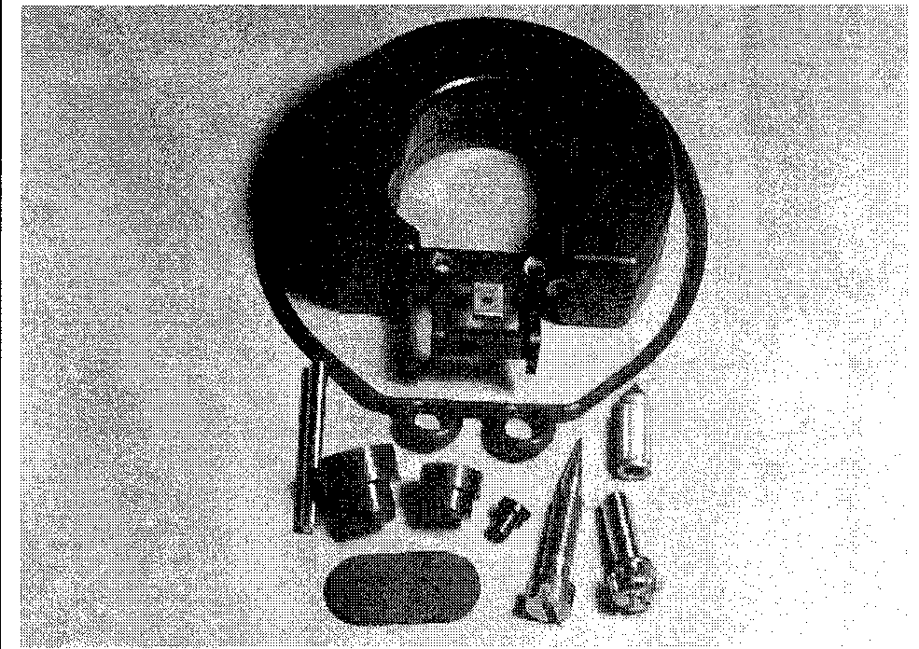

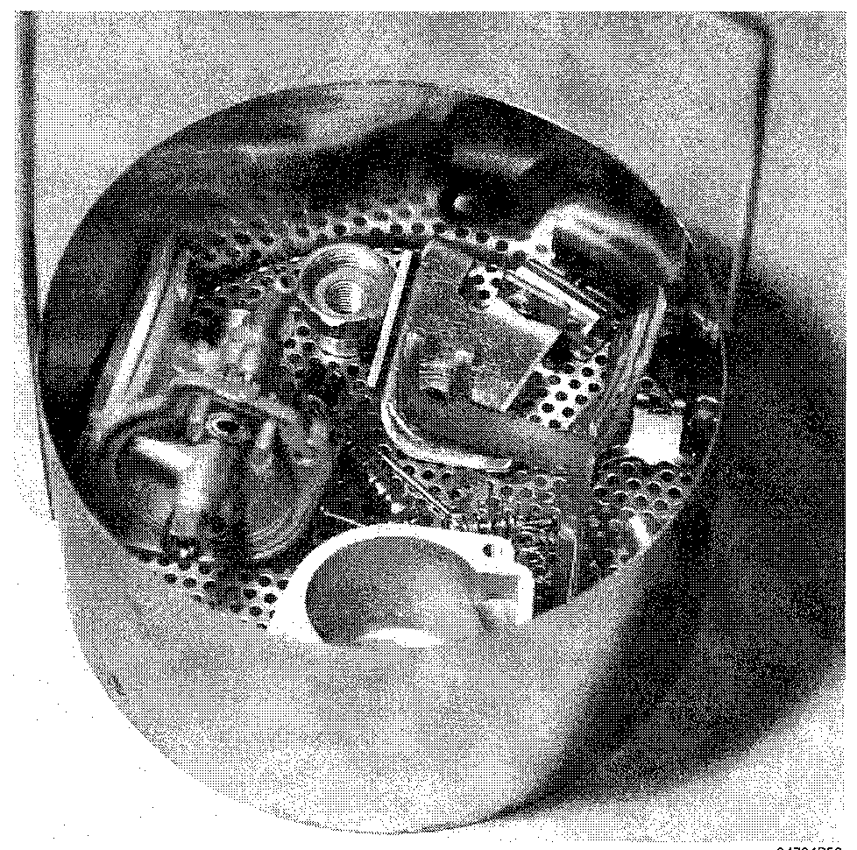

FUEL SYSTEM **4-25**

CLEANING & INSPECTION

**0 See Figure 44**

**CAUTION**

**Never dip rubber or plastic parts in carburetor cleaner. These parts should be cleaned only in solvent, and then blown dry with com­pressed air.**

Place all metal parts in a screen type tray and dip them in carburetor cleaner until they appear completely clean, then blow them dry with compressed air.

Blow out all passages in the castings with compressed air. Check all parts and passages to be sure they are not clogged or contain any deposits. Never use a piece of wire or any type of pointed instrument to clean drilled passages or calibrated holes in a carburetor.

Move the throttle and choke shafts back and forth to check for wear. If the shaft appears to be too loose, replace the complete mixing chamber because individual replacement parts are not available.

Inspect the mixing chamber, and fuel bowl gasket surfaces for cracks and burrs which might cause a leak. Check the floats for deterioration. Check to be sure the needle valve loop has not been stretched. If any part of the float is dam­aged, the float must be replaced. Check the needle valve tip contacting surface and replace the needle valve if this surface has a groove worn in it.

Inspect the tapered section of the pilot screw and replace the screw if it has developed a groove.

As previously mentioned, most of the parts which should be replaced during

a carburetor overhaul are included in an overhaul kit available from your local marine dealer. One of these kits will contain a matched fuel inlet needle and seat. This combination should be replaced each time the carburetor is disas­sembled as a precaution against leakage.

ASSEMBLY

**See accompanying illustration**

1. Install the main jet in the main jet holder with a new 0-ring.
2. Install the main jet holders into the float bowl.
3. Install the high speed nozzles.
4. Install the pilot screw and spring. Turn in the screw until it lightly seats, then back it out the correct number of turns.
5. Install the pilot (idle) jet.
6. Install the fuel inlet needle valve and valve seat into the carburetor body.
7. Install the float.
8. Invert the carburetor and lower the float until the adjusting tab on the float just touches the needle. Hold the float in the is position and measure the height between the carburetor body (with gasket removed) and the bottom of the float.
9. If the float level is not within specification, adjust the level by bending the adjusting tab as needed.

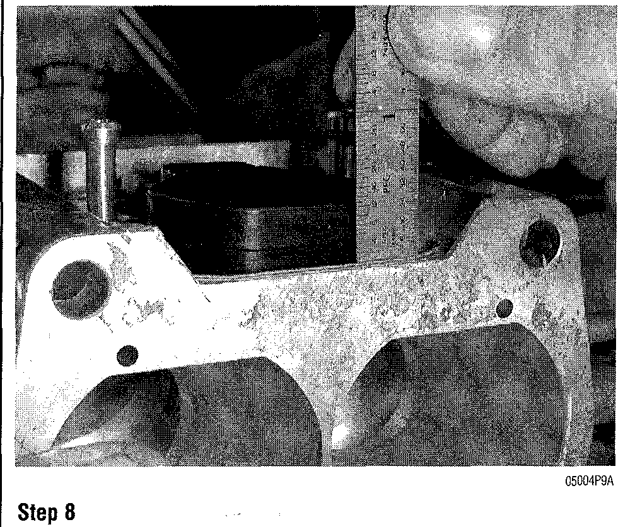

**Fig. 44 Use compressed air to blow out all the carburetor passage- ways**

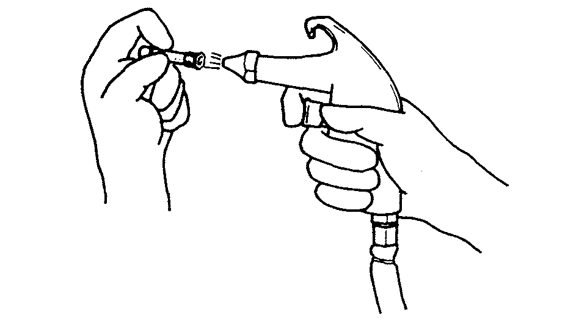

**REED VALVE SERVICE**

The reed valves operate in response to changes in crankcase pressure. Located between the intake manifold and the crankcase, the reed valves admit the air-fuel mixture into the crankcase and during the scavenging stroke, act as a one-way valve to prevent the mixture from flowing back into the intake manifold. The travel of the reed itself is limited by the reed stop. By this action, the scavenging action is improved and the engine will produce greater power.

On all Suzuki models, except the DT2 and DT2.2, the reed valves are located between the intake manifold and the crankcase. On the DT2 models the reed valves are an integral part of the front crankcase half of the engine.

**DT2, DT2.2**

REMOVAL & INSTALLATION

On these models, the reed valves are located in the front half of the engine crankcase. In order to access the reed valves on this model, the engine must be removed and the crankcase separated. See "Powerhead Overhaul".

**All Other Models**

**See Figures 45 and 46**

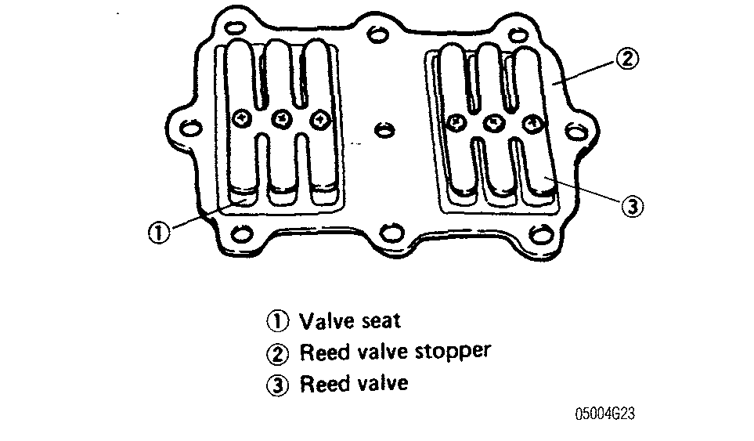

**Fig. 45 Typical in-line reed valve assembly**

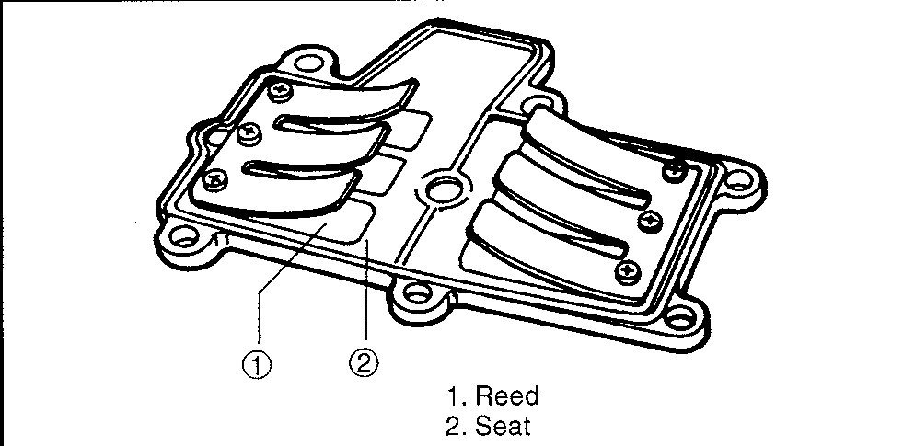

**4-26** FUEL SYSTEM

REMOVAL & INSTALLATION

I See accompanying illustrations

1. Remove the carburetor assembly.
2. Disconnect any hose attached to the intake manifold.

On some models, the reed valve assembly is secured by separate fas­teners. On models with this design, the intake manifold must first be removed in order to remove the reed valve and gasket assembly.

1. Remove the intake manifold fasteners holding the intake manifold to the crankcase cover.
2. Remove the intake manifolds.
3. Remove the gaskets and reed valve assemblies from the crankcase. Make sure to discard all used gaskets.
4. Clean all the mounting surfaces of any sealant or gasket residue. To install:
5. Make sure during installation that the reeds are installed in the correct direction.
6. Install new gaskets and tighten the reed valve assembly to the crankcase.
7. Reconnect any hoses to the intake manifold.
8. Install the carburetor assembly.

INSPECTION & CLEANING

See Figures 47 and 48

1. Check the reeds for sign of cracking, wear or any other damage. Replace the reeds if any damage is found.
2. Check the reeds to see if they lie flat on the valve seat with no preload on them.
3. To check the flatness of the reed, gently push each reed out from the seat. Constant resistance should be felt while pushing the reed.
4. Check the clearance between the reed and the seat with a feeler gauge. If the clearance is greater than 0.008 in. (0.20 mm), you will need to replace the reed set.
5. Measure the distance between the reed stop and the valve seat. If the measurement is not within specifications, check the valve seat for warpage and replace it as required. If the seat is okay, replace the reed stop assembly.

REED & REED STOP REPLACEMENT

I See Figure 49

1. Remove the screws holding the reed stop and reeds to the valve seat.
2. Remove the reed stop and reeds.
3. Place the new reed on the valve seat and check the assembly for flat­ness.
4. Center the reed over the valve seat openings.
5. Before installing the reed stop screws, apply a thread locker.
6. Check the reed tension and range of motion.

Fig. 47 Typical reed valve measurement dimensions

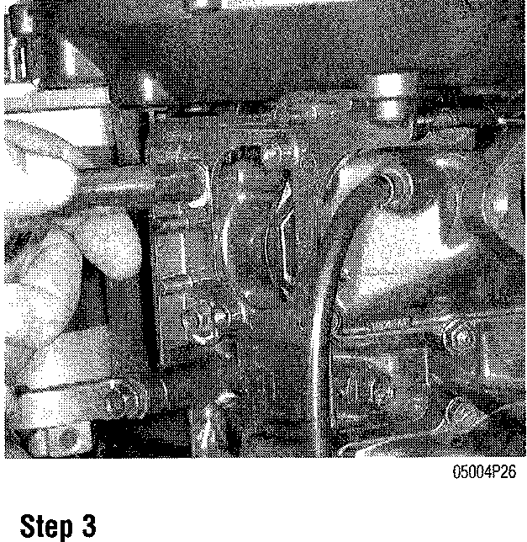

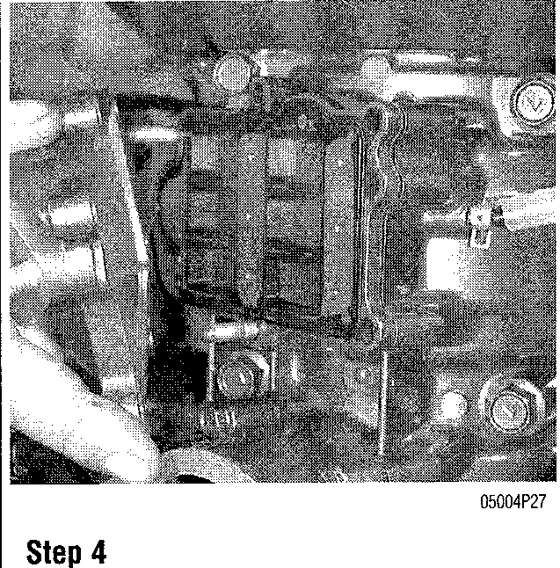

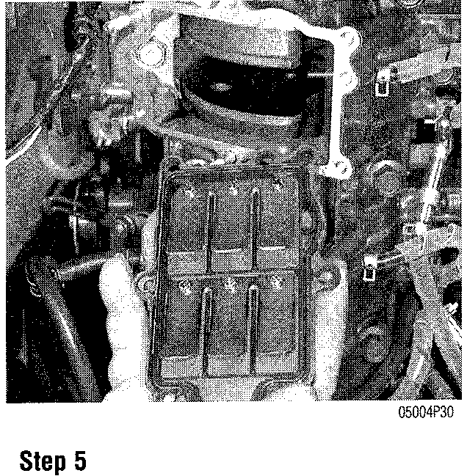

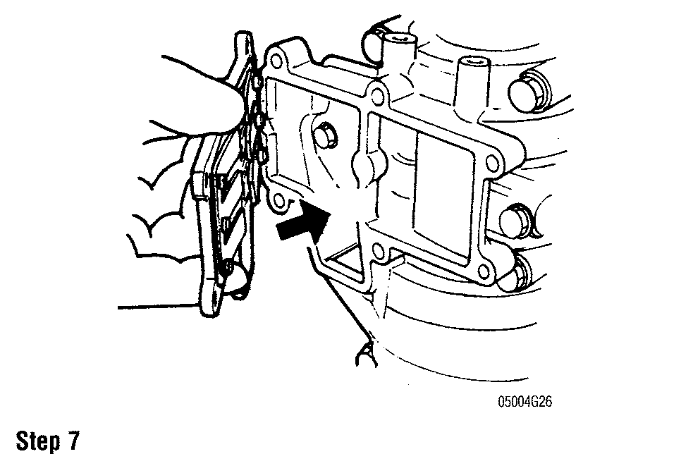

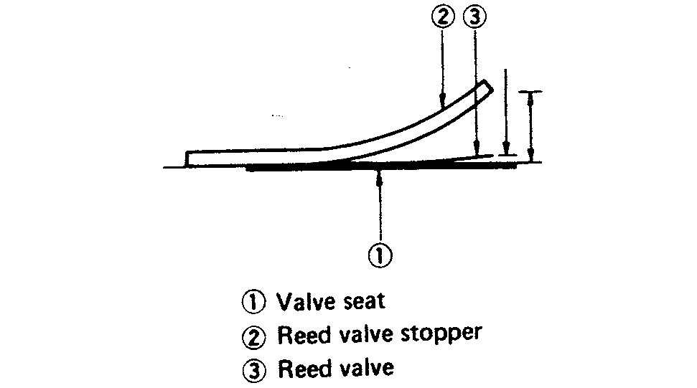

Fig. 46 Typical V-block reed valve assembly

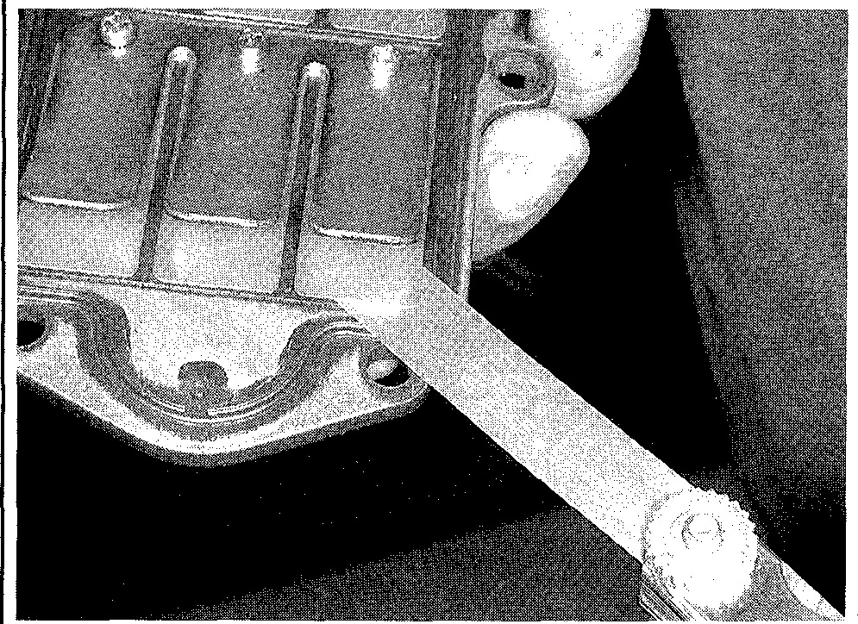

Fig. 49 Removing the reed valve stop

Fig. 48 Check the clearance between the reed and the seat with a feeler gauge

FUEL SYSTEM **4-27**

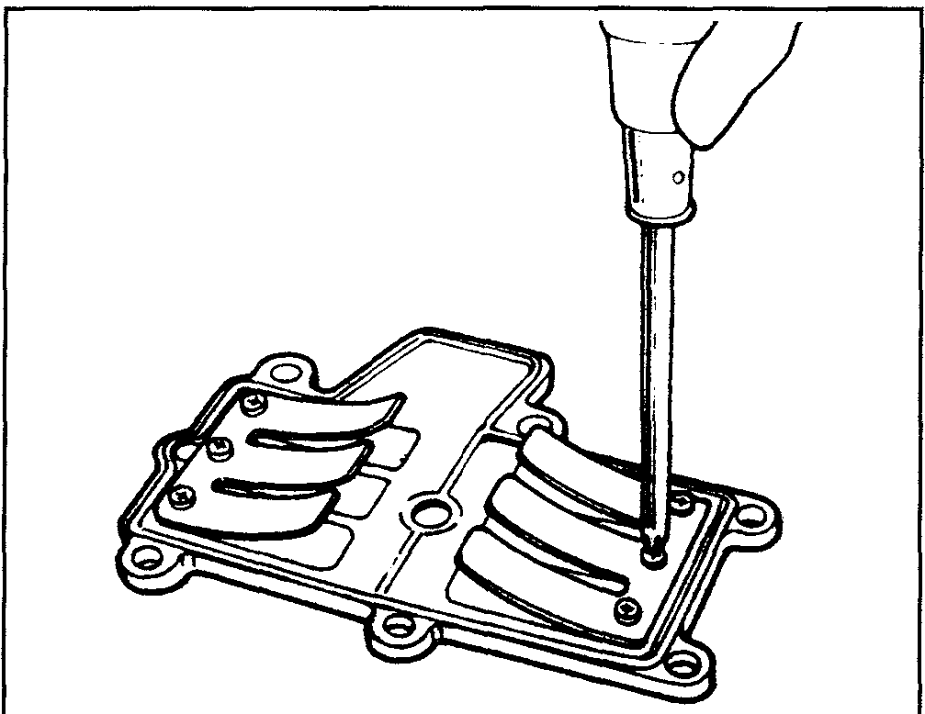

**FUEL PUMP SERVICE**

**Diaphragm Type Fuel Pumps**

DESCRIPTION & OPERATION

The smaller capacity powerheads do not have a fuel pump of any type. Fuel is provided to the carburetor by gravity flow from the fuel tank atop the powerhead.

The rest of the carbureted models use a diaphragm-type fuel pump. These pumps are operated by crankcase pressures. These pressure pulses are created by the movement of the piston in the crankcase and are directed to the pump by a passageway in the crankcase wall.

The piston moving upwards creates a low-pressure on the diaphragm in the pump body. This low pressure opens a check valve in the pump body, allowing fuel to be drawn from the fuel line to the pump. At the same time, the low pressure in the crankcase draws the air-fuel mixture into the crankcase from the intake manifold and carburetors.

Downward motion of the piston creates a high-pressure on the diaphragm. This high-pressure closes the inlet check valve in the pump body and open the outlet check valve, forcing the fuel in the fuel lines into the carburetor float bowl and moving the fuel-air mixture in the crankcase into the combustion chamber where ignition occurs.

This type of fuel pump is not powerful enough to draw fuel from the fuel tank during cranking. In that case, it is necessary to introduce fuel into the carburetor with the priming bulb mounted on the fuel line.

Suzuki uses both powerhead mounted, remote pumps and integral carburetor/fuel pumps. Both designs are very simple and reliable. The most common failure is to the diaphragm, and dirty fuel can block the check valve, causing it to fail. Most fuel systems are equipped with a separate fuel filter and some are equipped with a fuel/water separating filter assembly.

REMOVAL & INSTALLATION

Remote Mounted

1. Loosen the hose clamps and slide the fuel lines off the pump body. Plug the hoses to prevent fuel leaks.
2. Remove the screws holding the pump to the powerhead and pull the fuel pump off the power head.
3. If so equipped, remove the fuel pump insulator from the powerhead.
4. Thoroughly clean the pump mounting surface of any gasket or sealer residue. Do not scratch or gouge the sealing surface of the powerhead. To install:
5. If needed, install the fuel pump insulator and new 0-ring.
6. Install the pump onto the powerhead with a new gasket and 0-ring in the pump body.

Carburetor Mounted

1. Remove the fuel hose at the pump inlet cover and plug the line.

1. Remove the retaining screws that hold the pump to the carburetor.
2. Remove the pump as an assembly.

To install:

1. Reassemble the pump components in the reverse order of disassembly, using new gaskets.
2. Mount the pump assembly back on the side of the carburetor. Do not over-tighten the mounting screws.
3. Unplug and reinstall the fuel hoses.

OVERHAUL

Remote Mounted

I/ See Figures 50 thru 61

There are several variations in the pumps used on the different models. All operate in the same manner, but there are differences in the internal

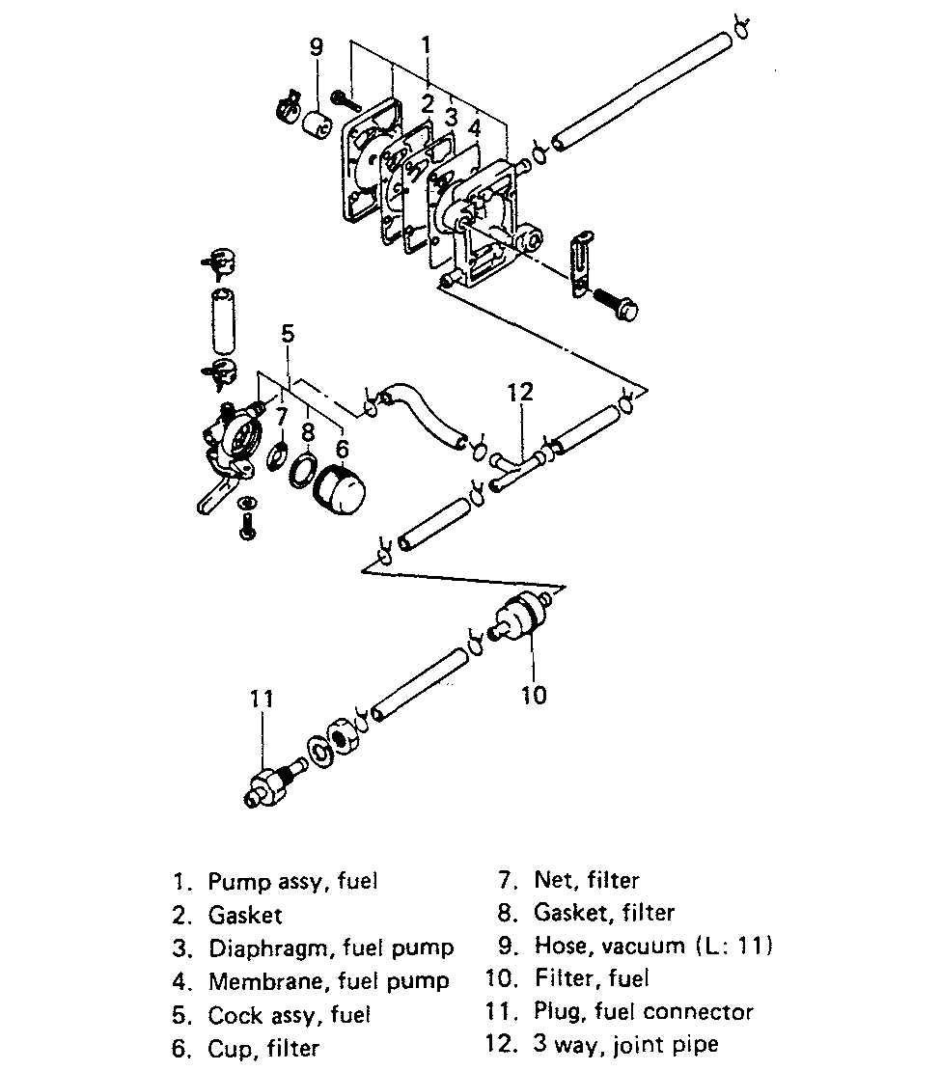

Fig. 50 Fuel pump assembly—DT4 and DT5Y



IGNITION\

AND

ELECTRICAL

SYSTEMS

UNDERSTANDING AND

TROUBLESHOOTING ELECTRICAL

SYSTEMS 5-2

BREAKER POINTS IGNITION (MAGNETO IGNITION) 5-7

CAPACITOR DISCHARGE IGNITION

(CDI) SYSTEM 5-11

CHARGING CIRCUIT 5-39 ELECTRONIC IGNITION 5-38

STARTING CIRCUIT 5-45

IGNITION AND ELECTRICAL WIRING DIAGRAMS 5-52

**UNDERSTANDING AND TROUBLESHOOTING ELECTRICAL SYSTEMS 5-2**

BASIC ELECTRICAL THEORY 5-2 HOW ELECTRICITY WORKS: THE WATER ANALOGY 5-2

OHM'S LAW 5-2

ELECTRICAL COMPONENTS 5-2 POWER SOURCE 5-2

GROUND 5-3

PROTECTIVE DEVICES 5-3 SWITCHES & RELAYS 5-3

LOAD 5-3

WIRING & HARNESSES 5-4 CONNECTORS 5-4

TEST EQUIPMENT 5-4

JUMPER WIRES 5-4

TEST LIGHTS 5-5

MULTIMETERS 5-5 TROUBLESHOOTING THE ELECTRICAL SYSTEM 5-6

TESTING 5-6

VOLTAGE 5-6

VOLTAGE DROP 5-6

RESISTANCE 5-6

OPEN CIRCUITS 5-7

SHORT CIRCUITS 5-7

WIRE AND CONNECTOR REPAIR 5-7 ELECTRICAL SYSTEM

PRECAUTIONS 5-7

**BREAKER POINTS IGNITION (MAGNETO IGNITION) 5-7** SYSTEM TESTING 5-8

BREAKER POINTS 5-8

POINT GAP ADJUSTMENT 5-8 TESTING 5-9

REMOVAL & INSTALLATION 5-9 CONDENSER 5-10

DESCRIPTION & OPERATION 5-10 TESTING 5-10

REMOVAL & INSTALLATION 5-10 IGNITION COIL 5-10

DESCRIPTION & OPERATION 5-10 TESTING 5-11

REMOVAL & INSTALLATION 5-11 **CAPACITOR DISCHARGE IGNITION (CDI) SYSTEM 5-11**

DESCRIPTION AND OPERATION 5-11 SINGLE-CYLINDER IGNITION 5-11 SUZUKI PEI IGNITION 5-12

SYSTEM TESTING 5-14

PROCEDURE 5-14 PULSAR/CHARGING/GEAR COUNTER COILS 5-14

DESCRIPTION & OPERATION 5-14 TESTING 5-15

REMOVAL & INSTALLATION 5-20 IGNITION COILS 5-25

DESCRIPTION & OPERATION 5-25 TESTING 5-25

REMOVAL & INSTALLATION 5-26 CDI UNIT 5-28

DESCRIPTION & OPERATION 5-28 TESTING 5-28

REMOVAL & INSTALLATION 5-34 RECTIFIER 5-37

DESCRIPTION & OPERATION 5-37 TESTING 5-37

REMOVAL & INSTALLATION 5-38 REGULATOR 5-38

DESCRIPTION & OPERATION 5-38 TESTING 5-38

REMOVAL & INSTALLATION 5-38 **ELECTRONIC IGNITION 5-38** DESCRIPTION AND OPERATION 5-38 WARNING SYSTEMS 5-38

OVER REVOLUTION 5-38

OIL LEVEL 5-38

OIL FLOW 5-38

OVERHEAT 5-38

BATTERY VOLTAGE 5-39 **CHARGING CIRCUIT 5-39** DESCRIPTION AND OPERATION 5-39

SINGLE PHASE CHARGING

SYSTEM 5-39

THREE-PHASE CHARGING

SYSTEM 5-39

PRECAUTIONS 5-39 TROUBLESHOOTING THE CHARGING SYSTEM 5-40

OVERCHARGING 5-40 UNDERCHARGING 5-40 ALTERNATOR (STATOR) 5-40

TESTING 5-40

BATTERY 5-41

MARINE BATTERIES 5-41

BATTERY CONSTRUCTION 5-41 BATTERY RATINGS 5-42

BATTERY LOCATION 5-42

BATTERY SERVICE 5-42

BATTERY TERMINALS 5-44

SAFETY PRECAUTIONS 5-44 BATTERY CHARGERS 5-44

BATTERY CABLES 5-45

BATTERY STORAGE 5-45

**STARTING CIRCUIT 5-45** DESCRIPTION AND OPERATION 5-45 TROUBLESHOOTING THE STARTING SYSTEM 5-46

STARTER MOTOR 5-46

DESCRIPTION & OPERATION 5-46 TESTING 5-48

REMOVAL & INSTALLATION 5-48 OVERHAUL 5-49

STARTER MOTOR RELAY SWITCH 5-50 DESCRIPTION & OPERATION 5-50 TESTING 5-51

REMOVAL & INSTALLATION 5-51 **IGNITION AND ELECTRICAL WIRING DIAGRAMS 5-52**

IGNITION AND ELECTRICAL SYSTEMS **5-7**

4. Connect the meter leads to both sides of the circuit (wire or component) and read the actual measured ohms on the meter scale. Make sure the selector switch is set to the proper ohm scale for the circuit being tested, to avoid mis­reading the ohmmeter test value.

OPEN CIRCUITS
  
II See Figure 10

This test already assumes the existence of an open in the circuit and it is used to help locate the open portion.

1. Isolate the circuit from power and ground.
2. Connect the self-powered test light or ohmmeter ground clip to the ground side of the circuit and probe sections of the circuit sequentially.
3. If the light is out or there is infinite resistance, the open is between the probe and the circuit ground.
4. If the light is on or the meter shows continuity, the open is between the probe and the end of the circuit toward the power source.

Fig. 10 The infinite reading on this multimeter (1 . ) indicates that the circuit is open

SHORT CIRCUITS

Never use a self-powered test light to perform checks for opens or shorts when power is applied to the circuit under test. The test light can be damaged by outside power.

1. Isolate the circuit from power and ground.
2. Connect the self-powered test light or ohmmeter ground clip to a good ground and probe any easy-to-reach point in the circuit.

BREAKER POINTS IGNITION (MAGNETO IGNITION)

See Figures 11, 12 and 13 widening gap. The condenser is wired in parallel with the points. The condenser

absorbs some of the current flow as the points open. This reduces arc over and **All Suzuki outboard engines use a pointless electronic ignition system** extends the life of the points.

**with the exception of the pre**-1990 DT2 engines which use a breaker The breaker point ignition consists of the rotor assembly, contact point

**point type magneto.** assembly, ignition coil, condenser spark plug, spark plug cap and the engine

This ignition system uses a mechanically switched, collapsing field to induce stop switch.

spark at the plug. A magnet moving by a coil produces current in the primary As the pole pieces of the magnet pass over the heels of the coil, a magnetic field

coil winding. The current in the primary winding creates a magnetic field. When is built up about the coil, causing a current to flow through the primary winding.

the points are closed the current goes to ground. As the breaker points open the At the proper time, the breaker points are separated by action of a cam

primary magnetic field collapses across the secondary field. This induces designed into the collar of the crankshaft and the primary circuit is broken.

(transforms) a high voltage potential in the secondary coil winding. This high When the circuit is broken, the flow of primary current stops and causes the

voltage current travels to the spark plug and jumps the gap. magnetic field about the coil to break down instantly. At this precise moment, an

The breaker point ignition system contains a condenser that works like a electrical current of extremely high voltage is induced in the fine secondary

sponge in the circuit. Current that is flowing through the primary circuit tries to windings of the coil. This high voltage is conducted to the spark plug where it

keep going. When the breaker point switch opens the current will arc over the jumps the gap between the points of the plug to ignite the compressed charge

of air-fuel mixture in the cylinder.

1. If the light comes on or there is continuity, there is a short somewhere in the circuit.
2. To isolate the short, probe a test point at either end of the isolated circuit (the light should be on or the meter should indicate continuity).
3. Leave the test light probe engaged and sequentially open connectors or switches, remove parts, etc. until the light goes out or continuity is bro­ken.
4. When the light goes out, the short is between the last two circuit compo­nents which were opened.

**Wire and Connector Repair**

Almost anyone can replace damaged wires, as long as the proper tools and parts are available. Wire and terminals are available to fit almost any need. Even the specialized weatherproof, molded and hard shell connectors are now avail­able from aftermarket suppliers.

Be sure the ends of all the wires are fitted with the proper terminal hardware and connectors. Wrapping a wire around a stud is never a permanent solution and will only cause trouble later. Replace wires one at a time to avoid confusion. Always route wires in the same manner of the manufacturer.

When replacing connections, make absolutely certain that the connectors are certified for marine use. Automotive wire connectors may not meet United States Coast Guard (USCG) specifications.

If connector repair is necessary, only attempt it if you have the proper tools. Weatherproof and hard shell connectors require special tools to release the pins inside the connector. Attempting to repair these con­nectors with conventional hand tools will damage them.

Electrical System Precautions

* Wear safety glasses when working on or near the battery.
* Don't wear a watch with a metal band when servicing the battery or starter. Serious burns can result if the band completes the circuit between the positive battery terminal and ground.
* Be absolutely sure of the polarity of a booster battery before making connections. Connect the cables positive-to-positive, and negative-to-nega­tive. Connect positive cables first, and then make the last connection to ground on the body of the booster vessel so that arcing cannot ignite hydro­gen gas that may have accumulated near the battery. Even momentary connec­tion of a booster battery with the polarity reversed will damage alternator diodes.
* Disconnect both vessel battery cables before attempting to charge a bat­tery.
* Never ground the alternator or generator output or battery terminal. Be cautious when using metal tools around a battery to avoid creating a short cir­cuit between the terminals.
* When installing a battery, make sure that the positive and negative cables are not reversed.
* Always disconnect the battery (negative cable first) when charging.
* Never smoke or expose an open flame around the battery . Hydrogen gas accumulates near the battery and is highly explosive.

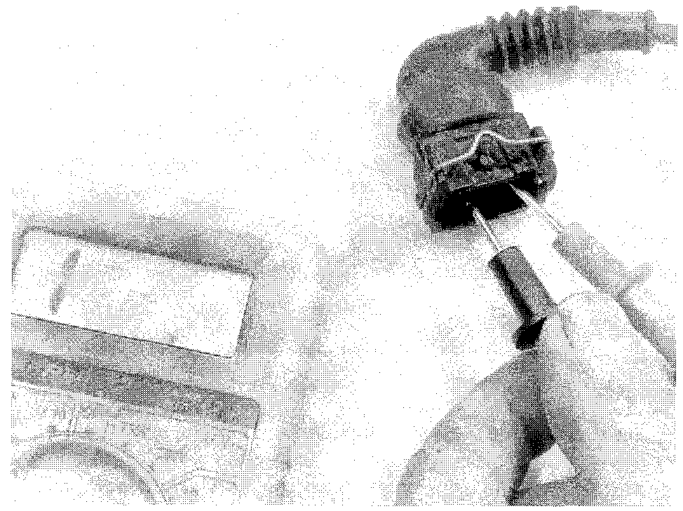

5-8 IGNITION AND ELECTRICAL SYSTEMS

Fig. 11 Breaker points installation—DT2

Fig. 12 Breaker points ignition wiring—DT2

Fig. 13 Adjusting the breaker points igni­tion on the DT2 model

**Fig. 14 Examples of good and bad point faces**

**Fig. 15 Measure the point gap with a feeler gauge**

The breaker points must be aligned accurately to provide the best contact surface. This is the only way to assure maximum contact area between the point surfaces; accurate setting of the point gap; proper synchronization; and satisfac­tory point life. If the points are not aligned properly, the result will be premature wear or pitting. This type of damage may change the cam angle, although the actual distance will remain the same.

Magnetos installed on outboard engines will usually operate over extremely long periods of time without requiring adjustment or repair. However, if ignition system problems are encountered, and the usual corrective actions such as replacement of spark plugs does not correct the problem, the magneto output should be checked to determine if the unit is functioning properly.

**System Testing**

Perform a spark test if you suspect the ignition system of not working properly. **WARNING**

When checking the spark, make sure there is no fuel on either the engine or the spark plug. Also keep your hands away from high volt­age electrical components.

1. Remove the spark plug and ground the plug electrode to the engine.
2. Pull the recoil starter and check for spark at the plug.

If there is a good spark at the plug, the ignition system should be performing properly. If there is no spark, precede to the next step in Troubleshooting the ignition system problem.

**Breaker Points**

POINT GAP ADJUSTMENT
  
See Figures 14 and 15

.Before checking the ignition timing, be sure that the contact point faces are in good condition. Smoothen and make parallel the two faces by grinding with an oil stone as much as necessary and then clean the points by wiping them with cloth dampened with a suitable solvent. Then apply a small amount of grease to the breaker shaft.

1. Remove the engine cover to access the engine.
2. Remove the hand rewind starter assembly.

**There are slots in the flywheel rotor in which to insert the feeler gauge and measure the points gap without removing the flywheel itself.**

1. Rotate the stator base until it is at the wide open throttle position.
2. Turn the crankshaft using a wrench on the flywheel nut clockwiseuntil the breaker point rubbing block touches the high point on the cam. At this point the points will be wide open.
3. Measure the point gap with a feeler gauge. There should be a slight drag on the feeler gauge if the gap is correct. The point gap should measure: 0.012-0.016 in. (0.3-0.4 mm). If the gap is out of specification, adjustment will be necessary.

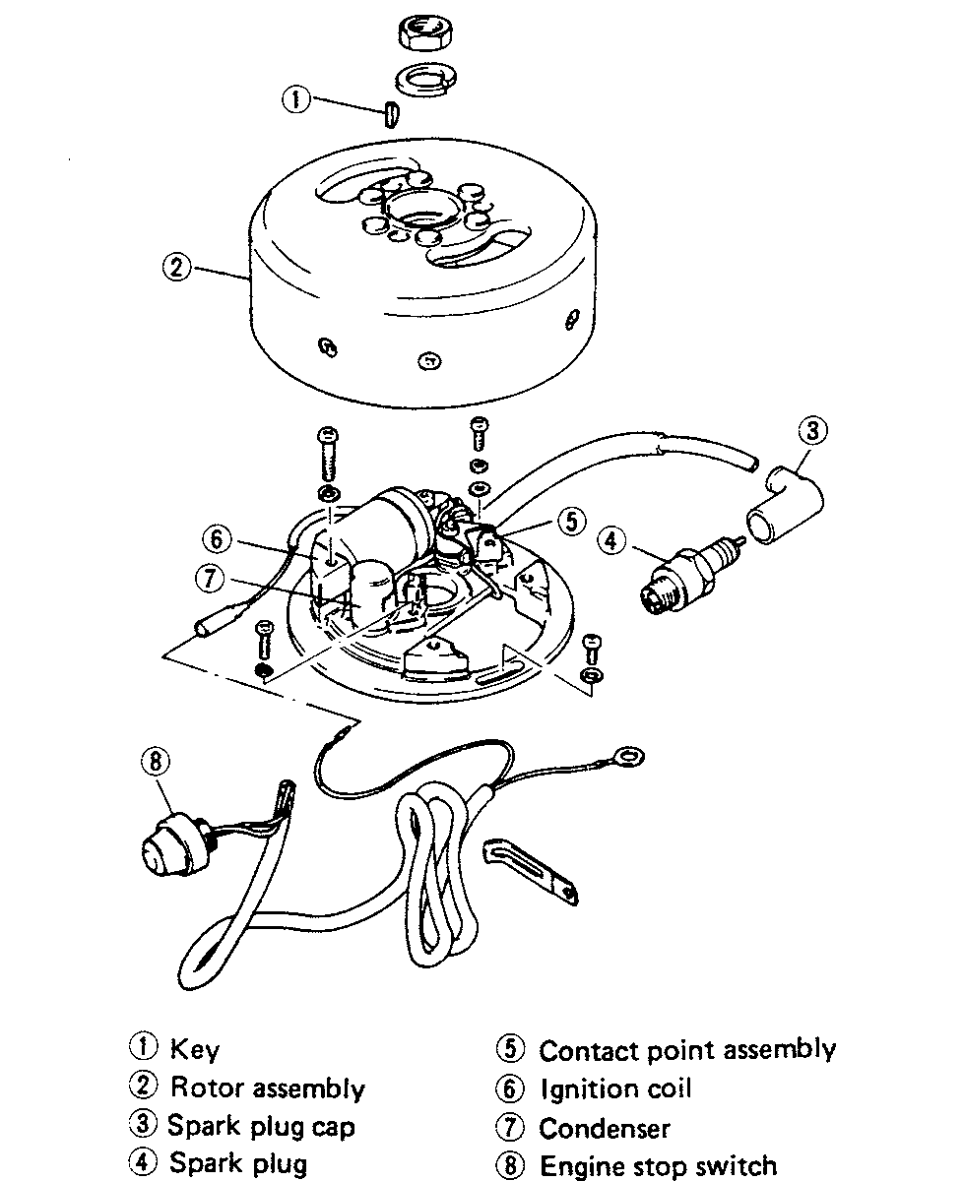

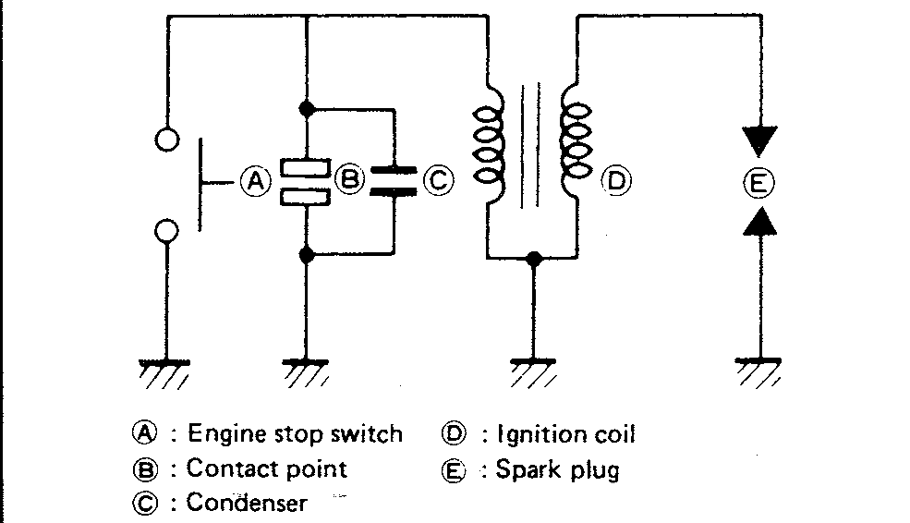

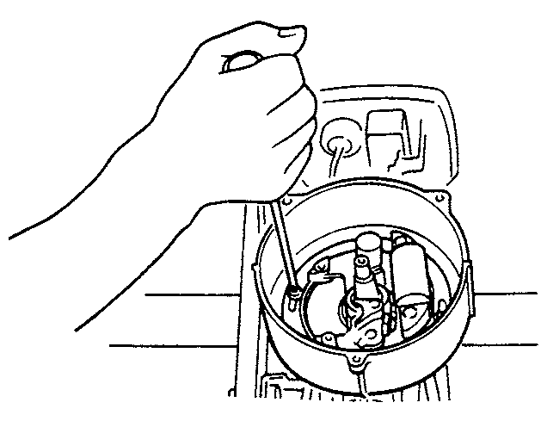

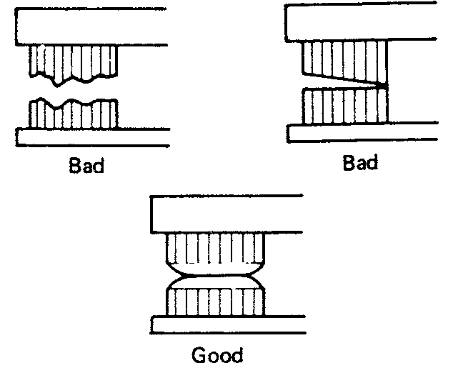

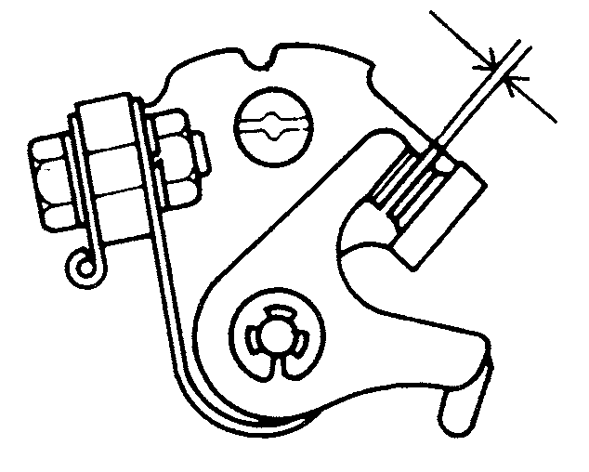

IGNITION AND ELECTRICAL SYSTEMS **5-9**

TESTING

**See accompanying illustrations**

1. Remove the flywheel.
2. Remove the spark plug.
3. With the contact points set right, now check the ignition timing by using the timing gauge (09931-00112). Remove the spark plug and install this gauge in the spark plug hole as illustrated. Bring the piston up to TDC and set the indicating hand of the gauge to read zero millimeters.
4. Obtain a timing digital multimeter, also know as a buzz box: (09900-27003).
5. Disconnect the breaker point leads from the stator base.
6. Connect the positive (red) digital multimeter lead to the black lead of the contact breaker and the negative digital multimeter lead to an engine ground.
7. Gently turn the flywheel clockwise (with the digital multimeter switch turned ON) until the digital multimeter starts buzzing.

REMOVAL & INSTALLATION

**See accompanying illustrations**

1. Remove the engine cover.
2. Remove the fuel tank assembly.
3. Remove the recoil starter assembly.
4. Remove the starter cup and magneto insulator.
5. With a flywheel holder or a commonly available strap wrench, hold the flywheel and loosen the retaining nut.
6. With the flywheel rotor remover (09930-30713) remove the fly­wheel. Make sure to keep track of the flywheel key when removing the fly­wheel.
7. Disconnect the plug cap and the two lead wires (that are coming from the stator) and remove the stator.
8. A typical points set with major components identified.
9. Point faces must be in good condition and aligned correctly.

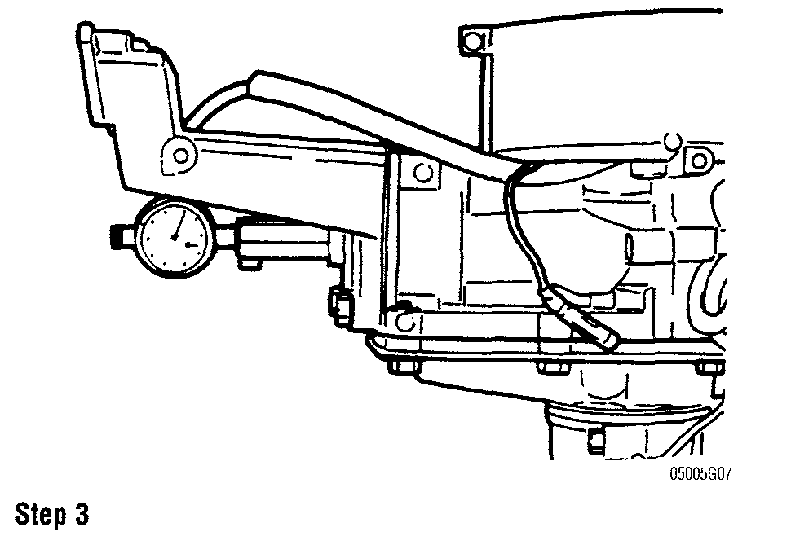

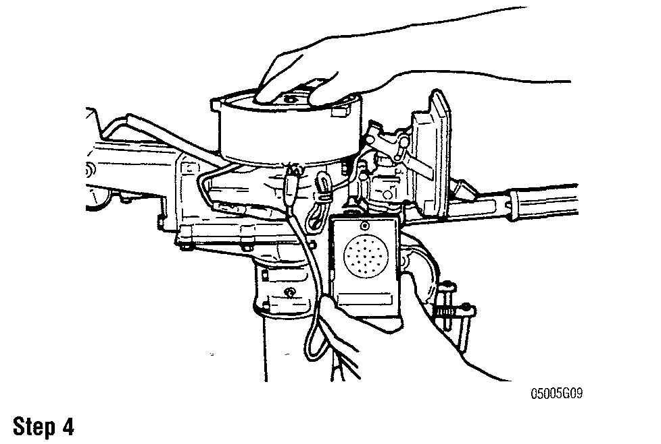

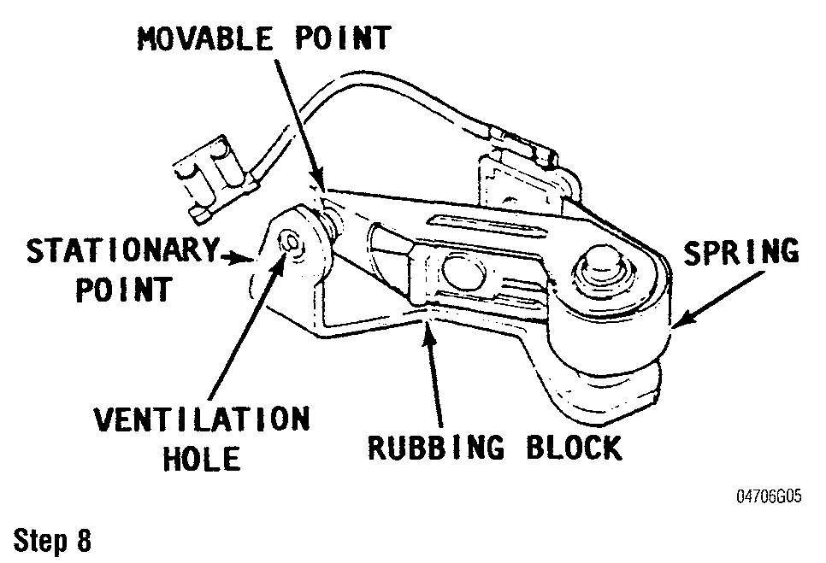

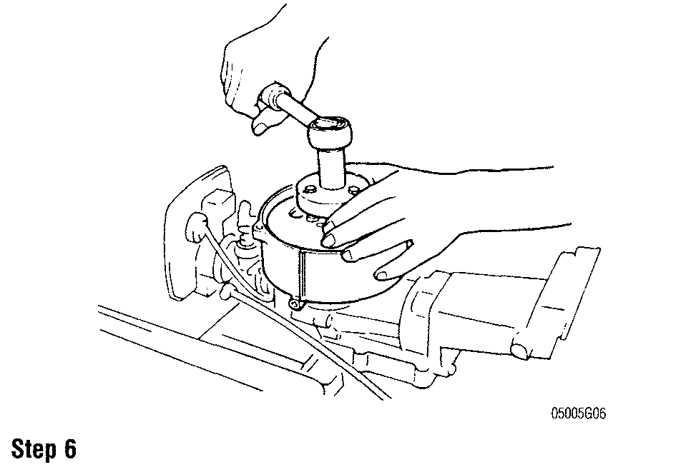

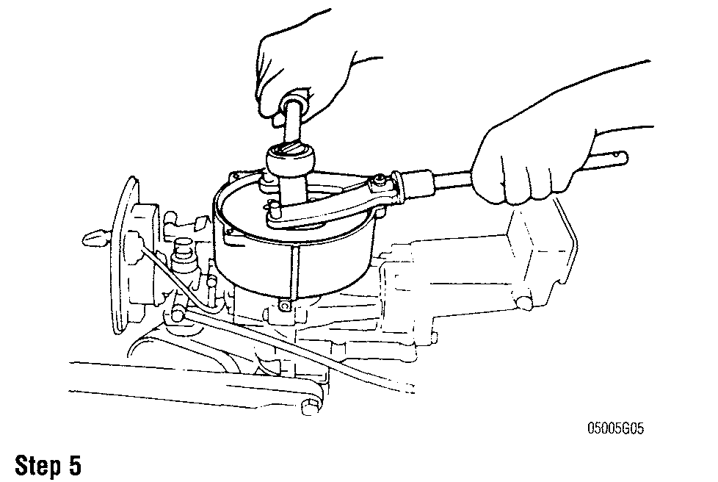

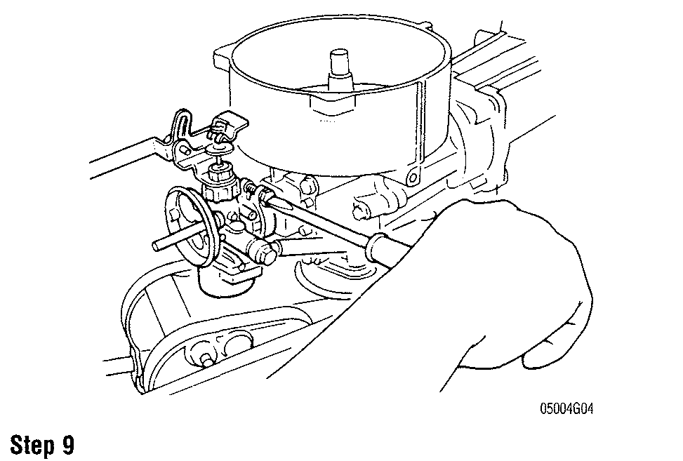

**5-10** IGNITION AND ELECTRICAL SYSTEMS

1. Remove the stator base screw which holds the breaker point assembly to the base.
2. Disconnect the coil and condenser leads at the breaker point. Now remove the breaker point assembly.
3. Remove the condenser from the stator base by removing the screw. **To install:**
4. Install the replacement breaker point set on the stator base. Make sure the pivot point on the bottom of the point set engages the hole in the stator base. Now, install, but don't tighten the retaining screw.
5. Install the condenser on the stator base and now tighten the retaining screw securely.
6. Reconnect the stator leads. Inspect the connectors and clean off any cor­rosion before connecting.
7. Check the lubrication felt for dryness. If it dry, add a couple of drops of 30w engine oil.
8. Reconnect the spark plug lead.

**Before installing the flywheel, thoroughly inspect the crankshaft and flywheel tapers. These surfaces must be absolutely clean and free of oil, grease and dirt. Use solvent and a lint free cloth to clean the sur­faces and then blow dry with compressed air.**

1. Install the flywheel key, starter cup and flywheel and flywheel bolt. Tighten the bolt to 30-36 ft. lbs. (40-50 Nm.)
2. Install the fuel and engine cover.

**Condenser**

DESCRIPTION & OPERATION

**See Figure** 16

In simple terms, a condenser is composed of two sheets of tin or aluminum foil laid one on top of the other, but separated by a sheet of insulating material such as waxed paper, etc. The sheets are rolled into a cylinder to conserve space and then inserted into a metal case for protection and to permit easy assembling.

The purpose of the condenser is to prevent excessive arcing across the points and to extend their useful life. When the flow of primary current is brought to a sudden stop by the opening of the points, the magnetic field in the primary windings collapses instantly, and is not allowed to fade away, which would happen if the points were allowed to arc.

The condenser stores the electricity that would have arced across the points and discharges that electricity when the points close again. This discharge is in the opposite direction to the original flow, and tends to smooth out the current. The more quickly the primary field collapses, the higher the voltage produced in the secondary windings and delivered to the spark plugs. In this way, the con­denser (in the primary circuit), affects the voltage (in the secondary circuit) at the spark plugs.

Modern condensers seldom cause problems, therefore, it is not necessary to install a new one each time the points are replaced. However, if the points show evidence of arcing, the condenser may be at fault and should be replaced. A

faulty condenser may not be detected without the use of special test equipment. Testing will reveal any defects in the condenser, but will not predict the useful life left in the unit.

The modest cost of a new condenser justifies its purchase and installation to eliminate this item as a source of trouble.

TESTING

1. Remove the flywheel.
2. Disconnect the condenser lead from the breaker points assembly.
3. Connect on test lead to the condenser lead. Connect the other test lead to the stator base.
4. Set the digital multimeter controls according to the manufacturers instructions. Check the condenser for resistance, leakage and capacity.
5. Compare the results in the previous step with the ignition digital multi­meter. Replace the condenser if it does not pass any one of the three tests.

REMOVAL & INSTALLATION

1. Remove the engine cover.
2. Remove the fuel tank assembly.
3. Remove the recoil starter assembly.
4. Remove the starter cup and magneto insulator.
5. With a flywheel holder or a commonly available strap wrench, hold the flywheel and loosen the retaining nut.
6. With the flywheel rotor remover (09930-30713) remove the flywheel. Make sure to keep track of the flywheel key when removing the flywheel.
7. Disconnect the plug cap and the two lead wires (that are coming from the stator) and remove the stator.
8. Remove the stator base screw which holds the breaker point assembly to the base.
9. Disconnect the coil and condenser leads at the breaker point. Now remove the breaker point assembly.
10. Remove the condenser from the stator base by removing the screw. **To install:**
11. Install the replacement breaker point set on the stator base. Make sure the pivot point on the bottom of the point set engages the hole in the stator base. Now, install, but don't tighten the retaining screw.
12. Install the condenser on the stator base and now tighten the retaining screw securely.
13. Reconnect the stator leads. Inspect the connectors and clean off any cor­rosion before connecting.
14. Check the lubrication felt for dryness. If it dry, add a couple of drops of 30w engine oil.
15. Reconnect the spark plug lead.

**Before installing the flywheel, thoroughly inspect the crankshaft and flywheel tapers. These surfaces must be absolutely clean and free of oil, grease and dirt. Use solvent and a lint free cloth to clean the sur­faces and then blow dry with compressed air.**

1. Install the flywheel key, starter cup and flywheel and flywheel bolt. Tighten the bolt to 30-36 ft. lbs. (40-50 Nm.)
2. Install the fuel and engine cover.

**Ignition Coil**

DESCRIPTION & OPERATION

The coil is the heart of the ignition system. Essentially, it is nothing more than a transformer which takes the relatively low voltage (12 volts) available from the primary coil and increases it to a point where it will fire the spark plug as much as 20,000 volts.

Once the voltage is discharged from the ignition coil the secondary circuit begins and only stretches from the ignition coil to the spark plugs via extremely large high tension leads. At the spark plug end, the voltage arcs in the form of a spark, across from the center electrode to the outer electrode, and then to ground via the spark plug threads. This completes the ignition circuit.

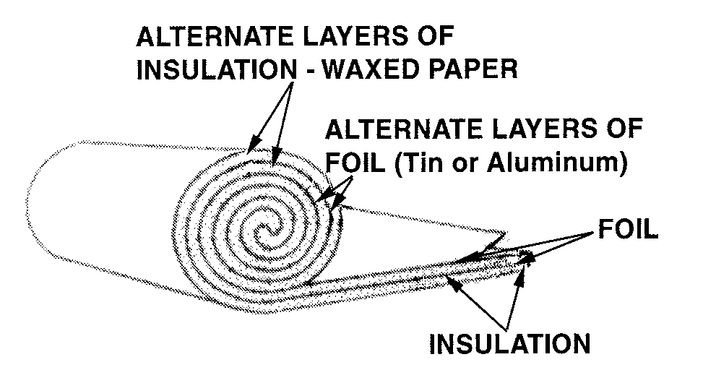

**Fig. 16 This sketch illustrates how waxed paper, aluminum foil and insulation are rolled in the manufacture of a typical condenser**

IGNITION AND ELECTRICAL SYSTEMS **5-11**

Fig. 17 DT2 / DT2.2 CDI igniter unit

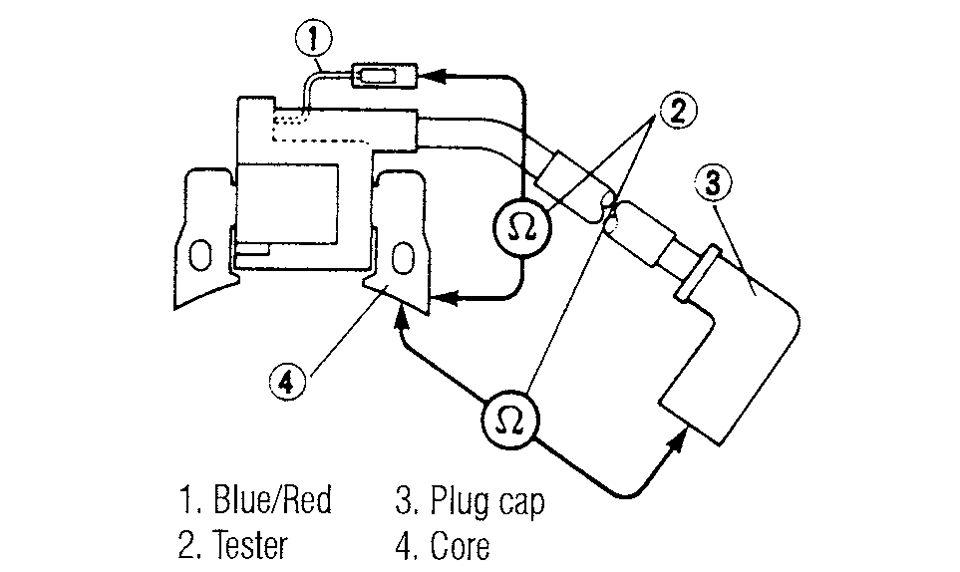

TESTING

1. Remove the flywheel.

2. For coil primary resistance:

1. Disconnect the black primary ignition coil lead at the connector.
2. Disconnect the secondary coil lead (spark plug wire) at the spark plug.
3. Make sure the ohmmeter is on the low-ohm scale. Connect the meter between the primary coil lead and an engine ground.
4. Check the resistance reading in the "Ignition Coil Resistance" chart.

3. For coil secondary resistance:

1. Make sure the ohmmeter is on the high-ohms scale.
2. Connect the meter between the secondary coil lead and an engine ground.
3. Check the resistance reading in the "Ignition Coil Resistance" chart.

4. Replace the ignition coil if the either the primary or secondary resistance does not meet specifications.

REMOVAL & INSTALLATION

1. Remove the engine cover.
2. Remove the fuel tank assembly.
3. Remove the recoil starter assembly.
4. Remove the starter cup and magneto insulator.
5. With a flywheel holder or a commonly available strap wrench, hold the flywheel and loosen the retaining nut.
6. With the flywheel rotor remover (09930-30713) remove the flywheel. Make sure to keep track of the flywheel key when removing the fly­wheel.
7. Disconnect the plug cap and the two lead wires (that are coming from the stator) and remove the stator.
8. Remove the stator base screw which holds the breaker point assembly to the base.
9. Disconnect the coil and condenser leads at the breaker point. Now remove the breaker point assembly.
10. Remove the condenser from the stator base by removing the screw. **To install:**
11. Install the replacement breaker point set on the stator base. Make sure the pivot point on the bottom of the point set engages the hole in the stator base. Now, install, but don't tighten the retaining screw.
12. Install the condenser on the stator base and now tighten the retaining screw securely.
13. Reconnect the stator leads. Inspect the connectors and clean off any cor­rosion before connecting.
14. Check the lubrication felt for dryness. If it dry, add a couple of drops of 30w engine oil.
15. Reconnect the spark plug lead.

**.Before installing the flywheel, thoroughly inspect the crankshaft and flywheel tapers. These surfaces must be absolutely clean and free of oil, grease and dirt. Use solvent and a lint free cloth to clean the sur­faces and then blow dry with compressed air.**

1. Install the flywheel key, starter cup and flywheel and flywheel bolt. Tighten the bolt to 30-36 ft. lbs. (40-50 Nm.)
2. Install the fuel and engine cover.
3. Remove the spark plug caps
4. With an ohmmeter, measure the resistance between the spark plug wires. Resistance should measure 6.4K-9.6K ohms.
5. Measure the resistance between the primary terminal and the coil mounting lug (for ground).
6. Resistance should measure 0.46-0.66 ohms.

CAPACITOR DISCHARGE IGNITION (CDI) SYSTEM

theory of induction. Induction theory states that if we move a magnet (magnetic

**Description and Operation** field) past a coil of wire(or the coil by the magnet), AC current will be generated

in the coil.

SINGLE-CYLINDER IGNITION The amount of current produced depends on several factors:

* How fast the magnet moves past the coil

See Figure 17 • The size of the magnet(strength)

* How close the magnet is to the coil

In its simplest form, a CDI ignition is composed of the following elements: • Number of turns of wire and the size of the windings

* Magneto When the flywheel rotates, the electrical power generated at the exciter coil is
* Pulser coil rectified by the diode and charged into the ignition condenser. The thyristor is
* Charge, or source coil off at this time.
* Igniter (CDI) box When the magnet on the crankshaft passes the pulser coil, the electric pulser
* Ignition coil coil signal is emitted by the magnetic force. This signal passes the gate circuit,
* Spark plug turns on the thyristor, and discharges the electric charge from the condenser.

Other components such as main switches, stop switches, or computer sys- When the discharged current flows through the ignition coil primary circuit,

tems may be included, though, these items are not necessary for basic CDI high voltage is generated in the secondary circuit and the spark plug sparks.

operation. The spark advance is handled by electronic advance spark system, which

To understand basic CDI operation, it is important to understand the basic advances the ignition timing when the gate circuit turns on the thyristor accord-

ing to the engine speed to obtain high speed power.

The current produced in the charge coil goes to the CDI box. On the way in, it is converted to DC current by a diode. This DC current is stored in the capacitor located inside the box. As the charge coil produces current, the capacitor stores it.

At a specific time in the magneto's revolution, the magnets go past the pulser coil. The pulser coil is smaller than the charge coil so it has less current output. The current from the pulser also goes into the CDI box. This current signals the CDI box when to fire the capacitor (the pulser may be called a trigger coil for obvious reasons). The current from the capacitor flows out to the ignition coil and spark plug. The pulser acts much like the points in older ignitions systems.

When the pulser signal reaches the CDI box, all the electricity stored in the capacitor is released at once. This current flows through the ignition coil's pri­ mary windings.

The ignition coil is a step-up transformer. It turns the relatively low voltage entering the primary windings into high voltage at the secondary windings. This occurs due to a phenomena known as induction.

The high voltage generated in the secondary windings leaves the ignition coil and goes to the spark plug. The spark in turn ignites the air-fuel charge in the combustion chamber.

**5-28** IGNITION AND ELECTRICAL SYSTEMS

1. Unbolt the ignition coils and remove them from the electric parts holder.

To install:

1. Install the ignition coils in the electric parts holder. Make sure all ground connections are in place and the retaining bolts are tight.
2. Connect the ignition coil leads to the CDI unit. Make sure all the connections are tight and free of corrosion.
3. Install the cover on the electric parts holder.
4. Install the spark plug wires.
5. Install the engine cover.

DT150, DT175, DT200 and DT 225

1. Remove the engine cover.
2. Disconnect the spark plug wires.
3. Open the electric parts holder on the front of the engine and disconnect the ignition coil leads from the wiring harness leading to the CDI unit.
4. Unbolt the ignition coils and remove them from the electric parts holder.

To install:

1. Install the ignition coils in the electric parts holder. Make sure all ground connections are in place and the retaining bolts are tight.
2. Connect the ignition coil leads to the CDI unit. Make sure all the connections are tight and free of corrosion.
3. Install the cover on the electric parts holder.
4. Install the spark plug wires.
5. Install the engine cover.

**CDI Unit**

DESCRIPTION & OPERATION

In its simplest form, a CDI ignition is composed of the following elements:

* Magneto
* Pulser coil
* Charge, or source coil
* Igniter (CDI) box
* Ignition coil
* Spark plug

Other components such as main switches, stop switches, or computer systems may be included, though, these items are not necessary for basic CDI operation.

To understand basic CDI operation, it is important to understand the basic theory of induction. Induction theory states that if we move a magnet (magnetic field) past a coil of wire (or the coil by the magnet), AC current will be generated in the coil.

The amount of current produced depends on several factors:

* How fast the magnet moves past the coil
* The size of the magnet (strength)
* How close the magnet is to the coil
* Number of turns of wire and the size of the windings

The current produced in the charge coil goes to the CDI box. On the way in, it is converted to DC current by a diode. This DC current is stored in the capacitor located inside the box. As the charge coil produces current, the capacitor stores it.

At a specific time in the magneto's revolution, the magnets go past the pulser coil. The pulser coil is smaller than the charge coil so it has less current output. The current from the pulser also goes into the CDI box. This current signals the CDI box when to fire the capacitor (the pulser may be called a trigger coil for obvious reasons). The current from the capacitor flows out to the ignition coil and spark plug. The pulser acts much like the points in older ignitions systems.

When the pulser signal reaches the CDI box, all the electricity stored in the capacitor is released at once. This current flows through the ignition coil's primary windings.

The ignition coil is a step-up transformer. It turns the relatively low voltage entering the primary windings into high voltage at the secondary windings. This occurs due to a phenomena known as induction.

The high voltage generated in the secondary windings leaves the ignition coil and goes to the spark plug. The spark in turn ignites the air-fuel charge in the combustion chamber.

Once the complete cycle has occurred, the spinning magneto immediately starts the process over again.

Main switches, engine stop switches, and the like are usually connected on the wire in between the CDI box and the ignition coil. When the main switch or stop switch is turned to the <b>OFF</b> position, the switch is closed. This closed switch short-circuits the charge coil current to ground rather than sending it through the CDI box. With no charge coil current through the CDI box, there is no spark and the engine stops or, if the engine is not running, no spark is produced.

TESTING

The unit may remain installed on the powerhead, or it may be removed for testing. In either case, the testing procedures are identical.

Measure the continuity between the CDI unit terminals. If the any of the readings are not within specifications, the CDI unit must be replaced.

DT2 and DT2.2

See accompanying illustrations

The DT2 model uses a combined CDI unit/ignition coil.

1. Using a multi-meter, measure the resistance in the primary (core—blue/red wire: 0.8-1.2 ohms) and the secondary (core—plug cap: 7-10 kilo-ohms)

DT4 and DT5Y

I See accompanying illustrations

1. Obtain a Suzuki CDI tester (09930-99810) and test cord (09930-40113).
2. Before using the tester, be sure to select the proper voltage range on the

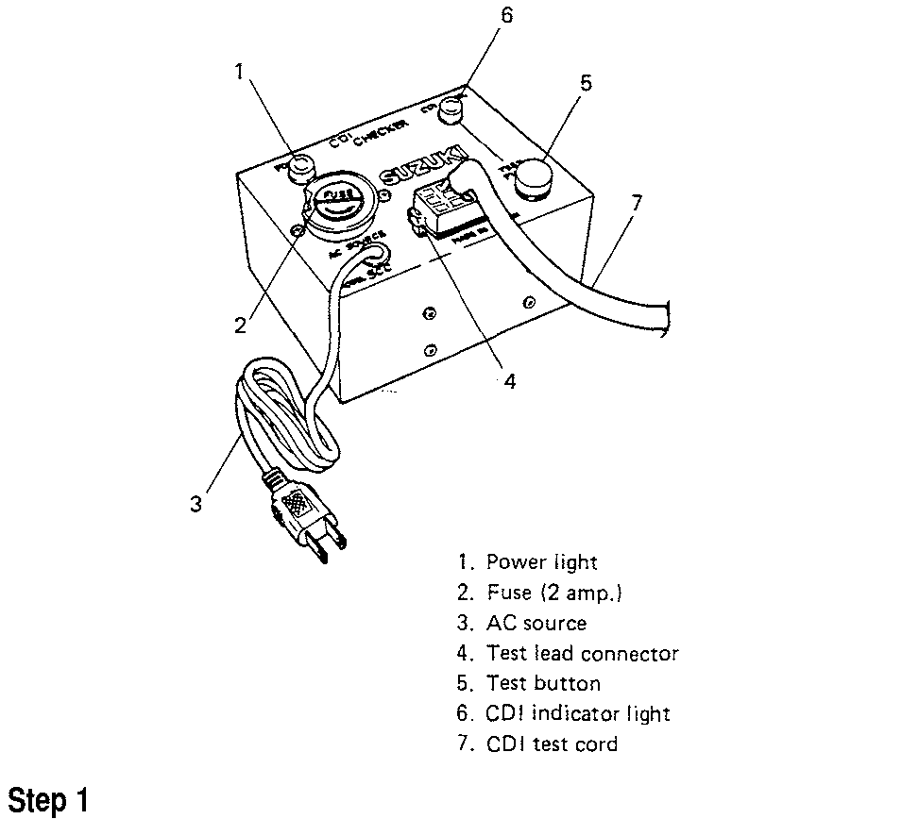

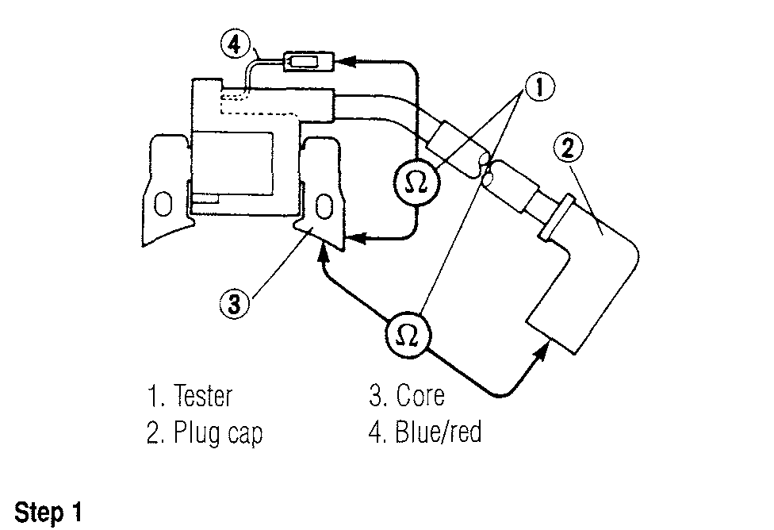

IGNITION AND ELECTRICAL SYSTEMS **5-29**

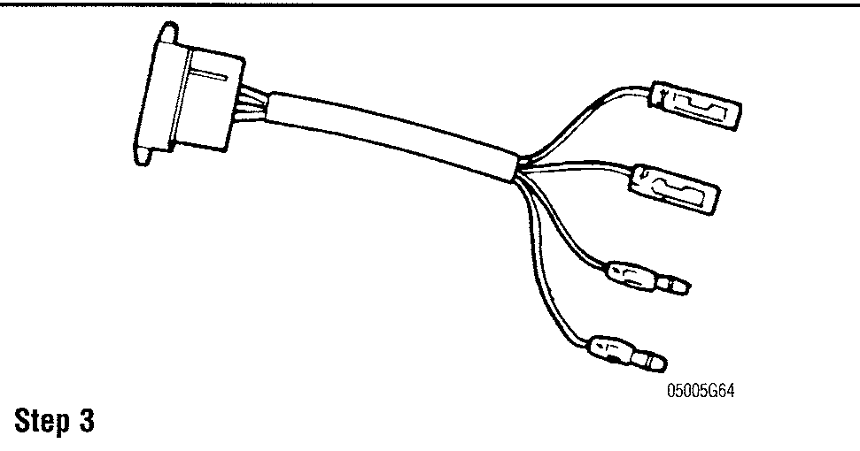

voltage selector (100v, 117v, 220v and 240v). If the selector socket is not set at the proper voltage range, remove the fuse and pull out the voltage selector and reinsert into the unit so that the proper voltage scale is visible in the cutaway.

1. Disconnect the CDI unit leads and install the test leads in their place.
2. Connect the CDI unit to test lead to the tester.
3. Plug the tester into a power outlet.
4. Push the "Test" button.

* Both the power light and the CDI indicator light should come on. This indicates that the CDI unit is functioning correctly.
* If the power light is ON and the CDI indicator light is Oft the CDI unit is not functioning correctly and needs to be replaced.
* If both lights are Oft check the fuse (replace if blown) and the A/C power source.

**DT6 and DT8**

**0 See accompanying illustrations**

1. Obtain a Suzuki CDI tester (09930-99830) and test cord (09930-89812).
2. Make sure the correct voltage range is chosen on the tester "1".

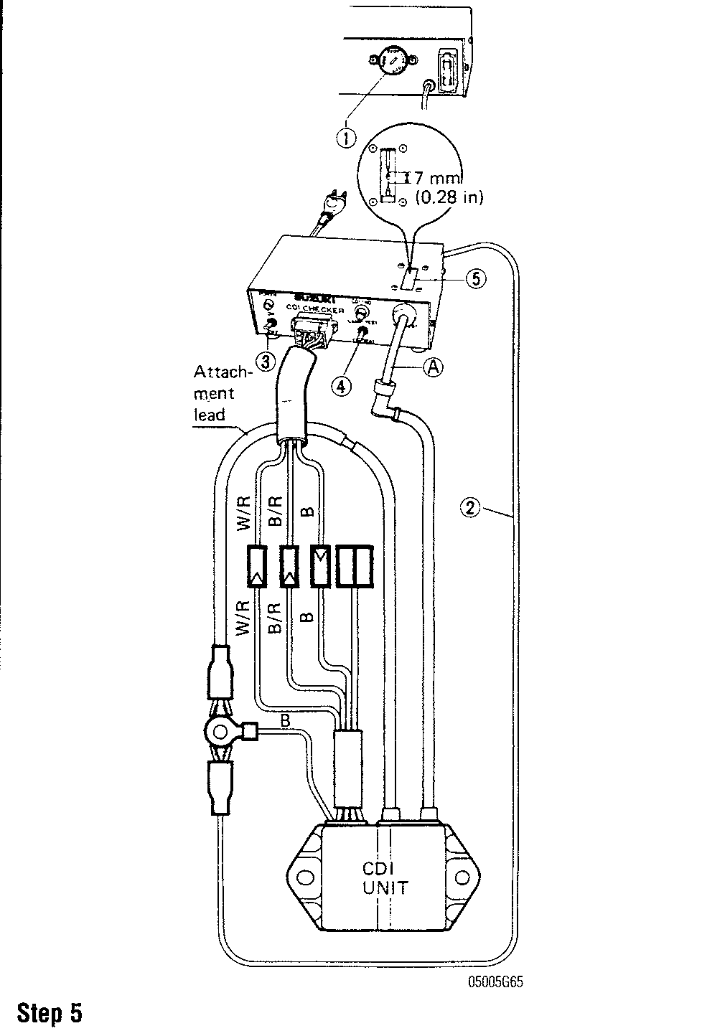

1. Connect the CDI test cord to the tester.
2. Connect the A/C cord to a power outlet.
3. Connect the CDI tester, CDI test cord and CDI unit as illustrated.

**When checking the ignition coil assembly with a plug cap left detached, insert the spark plug wire directly into the tester without using the attachment "A".**

**WARNING**

**Failure to connect this ground lead "2" wire may cause an electric shock upon touching the tester.**

Turn the main switch "3" of the tester to the ON position. Turning the switch "4" to the "CDI TEST" side, check if a spark occurs across the needles in the indicator window "5". If the spark occurs, it means that the CDI unit is function­ing normally. If there is no spark indicated, the CDI unit is not operating nor­mally and will need to be replaced.

**DT9.9, DT15, DT25 and DT30 See Figure 24**

1. Obtain a CDI tester (09930-99830) and CDI test cord

(DT9.9/15:09930-88910; DT25/30: 09930-89630).

* ON: Meter reading should be 100k ohms or less
* OFF: Meter reading should be more than 100k ohms
* CON: The meter pointer swings slightly and immediately return to the original position. Watch the meter carefully. If you have failed to see the pointer moving, wait for about 10 minutes and repeat the test.

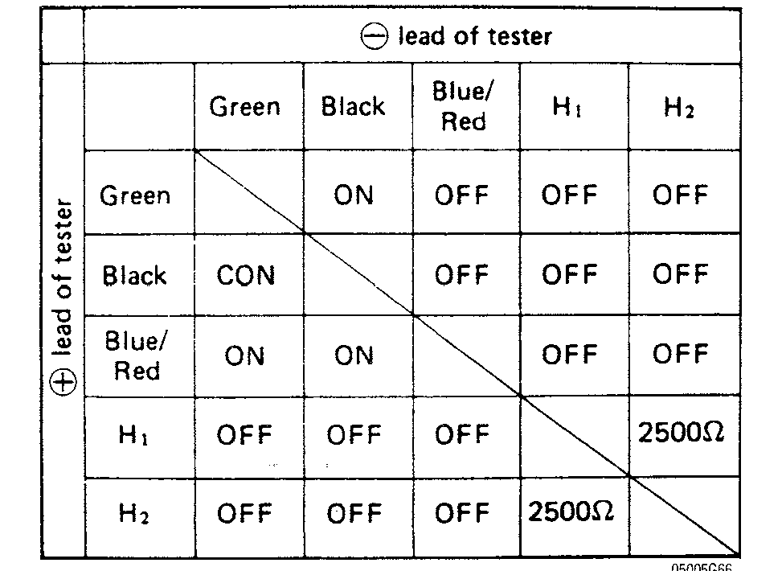

**Fig. 24 Use the CDI unit test chart to determine the condition of the CDI unit**

***CHECK BY INDICATOR LAMP* See Figure 25**

1. Before using the tester first be sure to select the proper voltage range on the voltage selector "1". (100V, 117V, 220V and 240V)
2. Connect the CDI test cord to the tester.
3. Connect the A/C power cord to a power outlet.
4. Connect the CDI test cord to the CDI unit lead wire as follows: (check each cylinder individually)

* DT9.9/15: No.1 cylinder: orange, Connectors, black; No.2 cylinder: gray, Connectors, black
* DT25/30: Not cylinder: orange, connectors; No.2 cylinder: blue, con­nectors; No.3 cylinder: gray, connectors

1. Turn the main switch "2" of the tester to the ON position.
2. Turn the test switch "3" to the "LAMP TEST" side. Make sure the CDI indicator lamp "4" comes ON.
3. Turning the switch "3" to the "CDI TEST" side, check if the lamp "4" comes on. If the lamp is ON, the CDI unit is good. If the lamp is OFF, the CDI unit is bad and needs to be replaced.

**5-34** IGNITION AND ELECTRICAL SYSTEMS

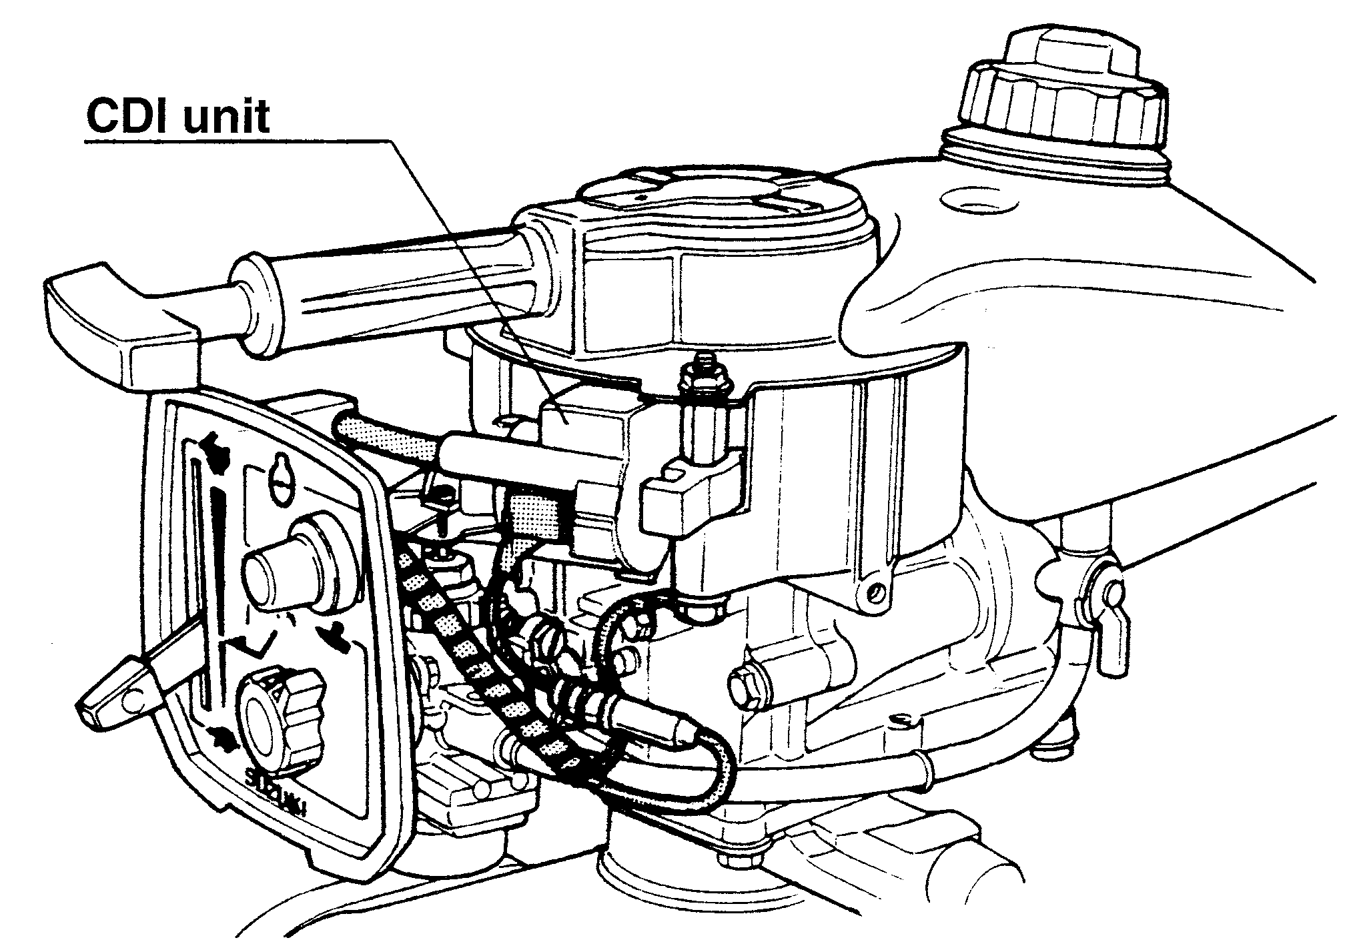

Fig. 34 Unbolt the CDI unit and remove

1. Connect each of the ECU leads to the positive tester probe and ground the negative test probe.
2. Crank the engine using the electric starter. DO NOT crank the engine for more than 20 seconds at a time.
3. Peak voltage measured at the CD-77 should be 104 volts or over. Make each measurement at least three times and if the voltage is too low, the ECU will need to be replaced.

**DT150, DT175, DT200 and DT225**

Check the ECU/CDI using a Stevens Model CD-77 peak voltage tester.

1. Remove all the spark plugs to eliminate variables at cranking speed.
2. Connect each of the ECU leads to the positive tester probe and ground the negative test probe.
3. Crank the engine using the electric starter. DO NOT crank the engine for more than 20 seconds at a time.
4. Peak voltage measured at the CD-77 should be 120 volts or over. Make each measurement at least three times and if the voltage is too low, the ECU will need to be replaced.

REMOVAL & INSTALLATION DT2 and DT2.2

See Figure 34

1. Remove the engine cover.
2. With the fuel petcock in the closed position (marked "S"), remove the fuel hose from the petcock.
3. Unbolt the fuel tank and remove it from the engine.
4. Disconnect the spark plug wire.
5. Disconnect the CDI unit lead.
6. Unbolt the CDI unit and remove.

To install:

7. When installing the CDI/ignition coil unit, measure the clearance between the flywheel magneto and the ignition unit.

• Clearance should measure 0.016 in. (0.4 mm).

**DT4 and DT5Y**

1. Remove the engine cover.
2. Disconnect the spark plug lead.
3. Disconnect the CDI leads and remove the retaining bolt.
4. Remove the CDI unit.

**To install:**

1. Install the CDI unit. Make sure that the ground wire is connected and the retaining bolt is tightened.
2. Connect the CDI unit leads making sure they are tight and corrosion free.
3. Connect the spark plug wire.
4. Install the engine cover.

**DT6 and DT8**

The CDI unit and ignition coil are integrated into one unit. Removal and installation are covered in the ignition coil section.

**DT9.9 and DT15**

The CDI unit and ignition coil are integrated into one unit. Removal and installation are covered in the ignition coil section.

**DT25 and DT30**

The removal and installation of the CDI unit is covered in the ignition coil section.

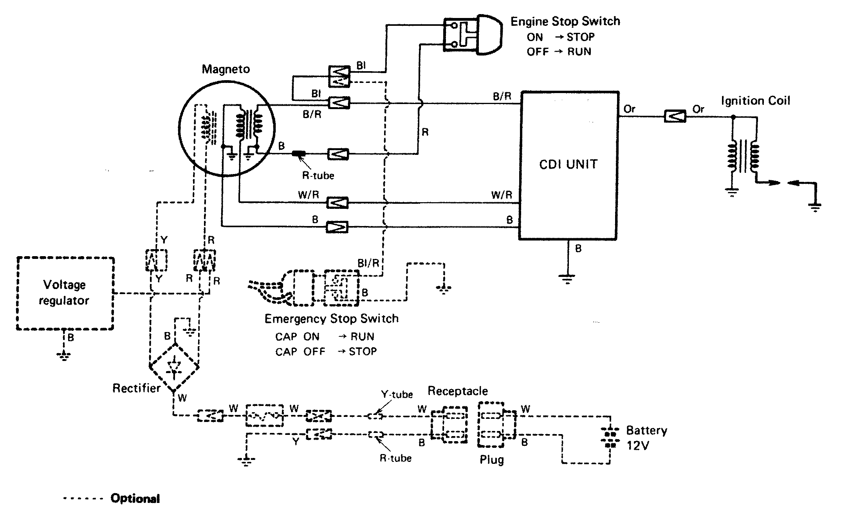

**1988-96 DT2 and 1997 DT2.2 Wiring Diagram**

**1988-98 DT4 and 1999 and later DT5Y Wiring Diagram**

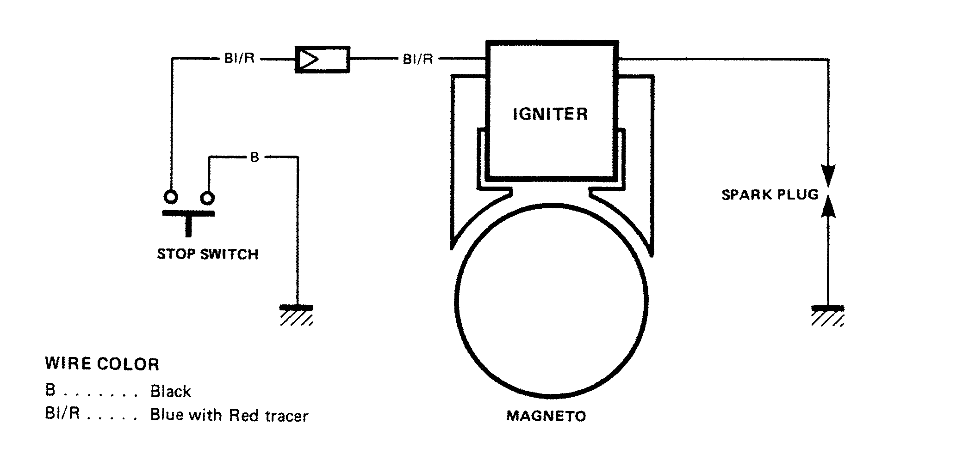

5-52 IGNITION AND ELECTRICAL SYSTEMS

**IGNITION AND ELECTRICAL WIRING DIAGRAMS**

The following diagrams represent the most popular models with the most popular optional equipment

**OIL INJECTION SYSTEM 6-2** DESCRIPTION AND OPERATION 6-2 OIL PUMP 6-2

AIR/OIL MIXING VALVE 6-2 TROUBLESHOOTING THE OIL INJECTION SYSTEM 6-2

BLEEDING THE OIL INJECTION SYSTEM 6-3

PROCEDURE 6-3

OIL TANK 6-3

REMOVAL & INSTALLATION 6-3 CLEANING & INSPECTION 6-4 OIL PUMP 6-5

REMOVAL & INSTALLATION 6-5 OIL LINES 6-6

OIL LINE CAUTIONS 6-6

REMOVAL & INSTALLATION 6-6 AIR/OIL MIXING VALVE 6-7

REMOVAL & INSTALLATION 6-7 OIL PUMP DISCHARGE RATE 6-7 TESTING 6-7

ADJUSTMENT 6-8

OIL PUMP CONTROL ROD 6-8 ADJUSTMENT 6-8

**COOLING SYSTEM 6-11** DESCRIPTION AND OPERATION 6-11 WATER PUMP 6-11

THERMOSTAT 6-12 TROUBLESHOOTING THE COOLING SYSTEM 6-12

WATER PUMP 6-12

REMOVAL & INSTALLATION 6-12 CLEANING & INSPECTION 6-13 THERMOSTAT 6-13

REMOVAL & INSTALLATION 6-13 CLEANING & INSPECTION 6-14 **OIL INJECTION WARNING**

**SYSTEMS 6-14**

DESCRIPTION AND OPERATION 6-14 LOW OIL LEVEL 6-14

OIL FLOW 6-14

TROUBLESHOOTING THE OIL INJECTION WARNING SYSTEM 6-15

OIL LEVEL SENSOR 6-16

TESTING 6-16

REMOVAL & INSTALLATION 6-16 OIL FLOW SENSOR 6-17

TESTING 6-17

REMOVAL & INSTALLATION 6-17 CLEANING & INSPECTION 6-17 **OVERHEAT WARNING**

**SYSTEM 6-17**

DESCRIPTION AND OPERATION 6-17 TROUBLESHOOTING THE OVERHEAT WARNING SYSTEM 6-17

OVERHEAT SENSOR 6-19

REMOVAL & INSTALLATION 6-19 TESTING 6-19

**SPECIFICATIONS CHARTS**

OIL PUMP DISCHARGE RATE 6-8 **TROUBLESHOOTING CHARTS** OIL INJECTION WARNING

SYSTEM 6-15

OVERHEAT WARNING SYSTEM 6-18



OIL INJECTION

OIL INJECTION SYSTEM 6-2

COOLING SYSTEM 6-11

OIL INJECTION WARNING

SYSTEMS 6-14

OVERHEAT WARNING SYSTEM 6-17

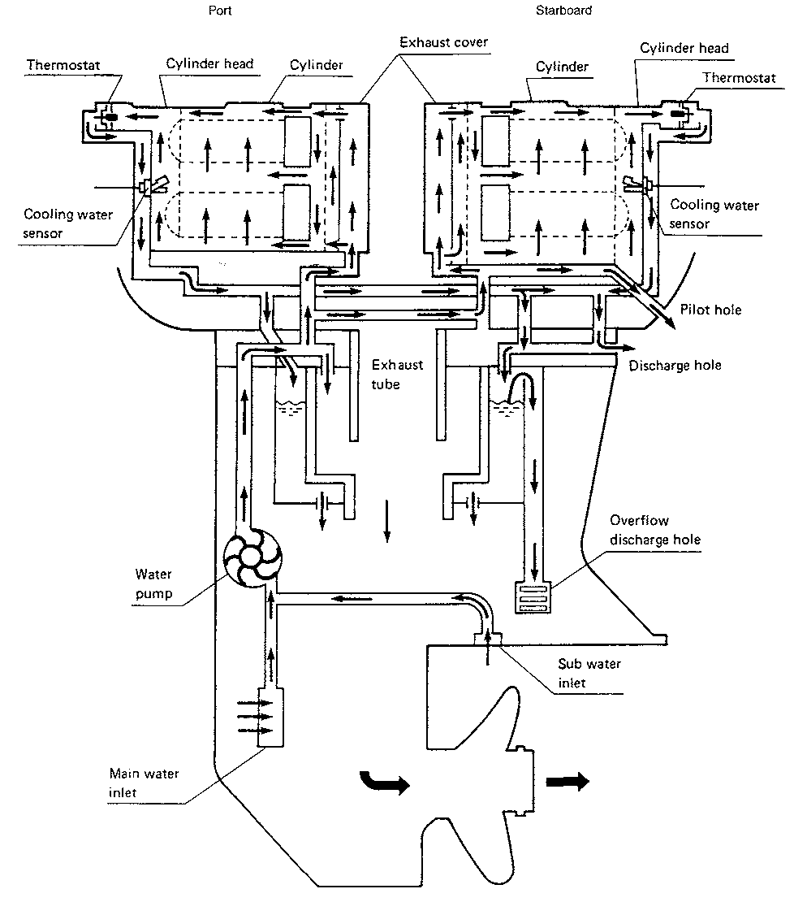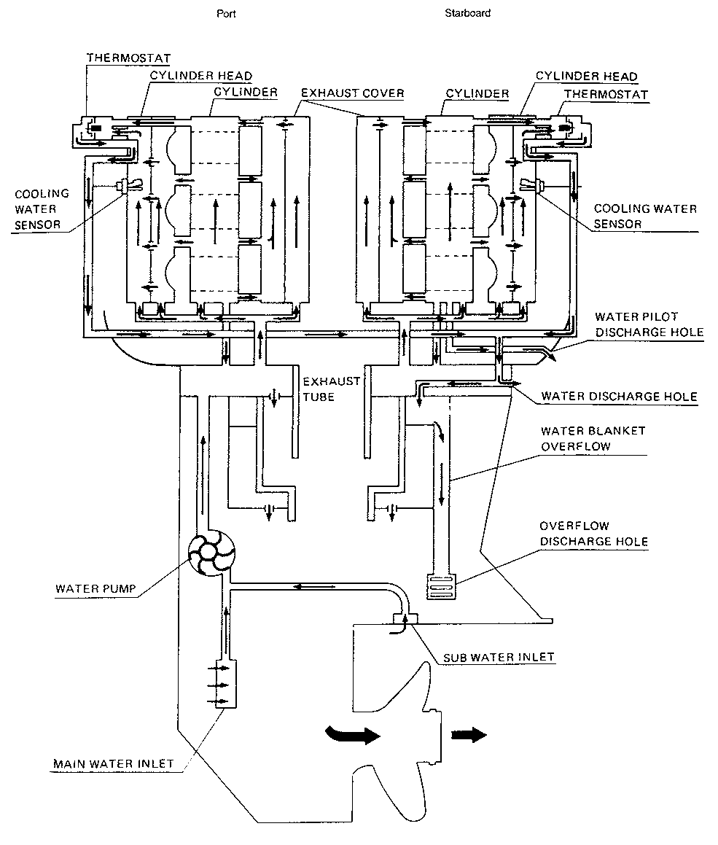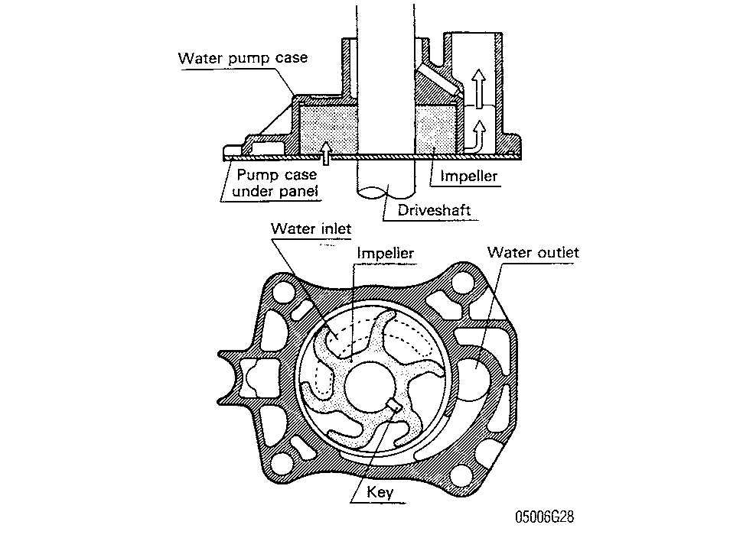

**Description and Operation**

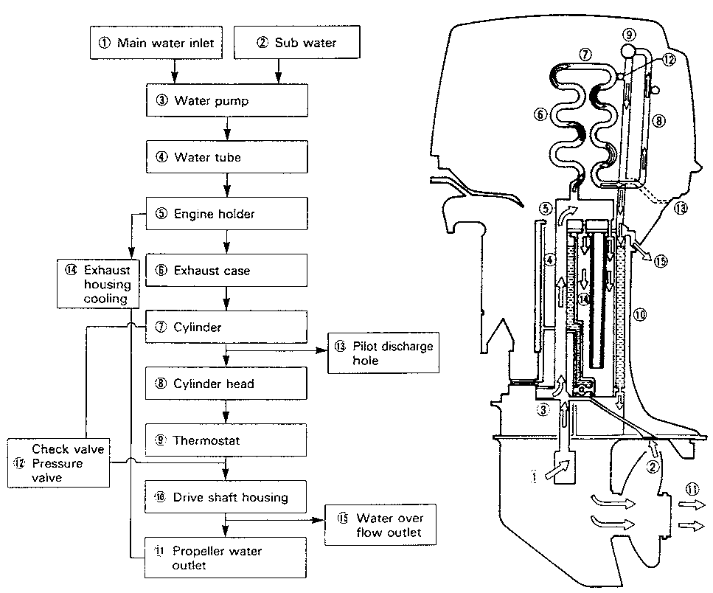

**COOLING SYSTEM**

OIL INJECTION **6-11**

**Fig. 19 Cooling circuit diagram—inline powerhead**

Fig. 20 Cooling circuit diagram—V4 powerhead

speed limiters, in case the engine's operating temperature exceeds predeter­mined limits.

Poor operating habits can play havoc with the cooling system. For instance, running the engine with the water pickup out of water can destroy the water pump impeller in a matter of seconds. Running in shallow water, kicking up debris that is drawn through the pump, can not only damage the pump itself, but send the debris throughout the entire system, causing water restrictions that create overheating.

WATER PUMP

I See Figure 16

The water pumps used on all Suzuki outboards are a displacement type water pump. Water pressure is increased by the change in volume between the impeller and the pump case.

Fig. 21 Cooling circuit diagram—V6 powerhead



Fig. 22 Cutaway view of a water pump with all major components labeled

0 See Figures 19, 20 and 21

Water cooling is the most popular method in use to cool outboard power-heads. A "raw-water" type pump delivers seawater to the powerhead, circulating it through the cylinder head(s), the thermostat, the exhaust housing, and back down through the outboard. The water runs down the exhaust cavity and away, either through an exhaust tube or through the propeller hub.

Routine maintenance of the cooling system is quite important, as expensive damage can occur if it overheats. The cooling system is so important, that many outboards covered in this manual incorporate overheat alarm systems and

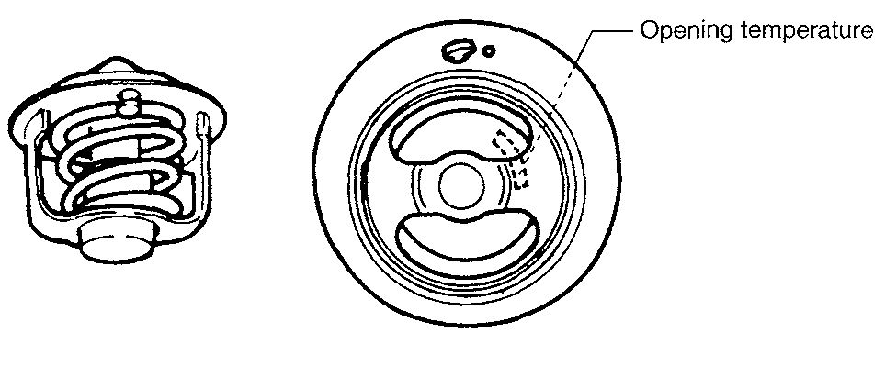



6-12 OIL INJECTION

On most outboards, the water pump is mounted on top of the lower unit. A driveshaft key engages a flat on the driveshaft and a notch in the impeller hub. As the driveshaft rotates, the impeller rotates with it.

On the DT2 and DT2.2 the water pump is mounted in a pump case installed on the propeller shaft between the lower unit and propeller. The pump impellers are secured to the propeller shaft by a pin that fits into the propeller shaft and a similar notch in the impeller hub. The propeller on other small displacement models is secured to the drive shaft in the same manner.

THERMOSTAT

0 See Figure 23

A pellet-type thermostat is used to control the flow of engine water, to pro­vide fast engine warm-up and to regulate water temperatures. A wax pellet ele­ment in the thermostat expands when heated and contracts when cooled. The pellet element is connected through a piston to a valve. When the pellet element is heated, pressure is exerted against a rubber diaphragm, which forces the valve to open. As the pellet element is cooled, the contraction allows a spring to close the valve. Thus, the valve remains closed while the water is cold, limiting circulation of water.

As the engine warms, the pellet element expands and the thermostat valve opens, permitting water to flow through the powerhead. This opening and clos­ing of the thermostat permits enough water to enter the powerhead to keep the engine within operating limits.

Fig. 23 A pellet-type thermostat is used to control the flow of engine water

Troubleshooting the Cooling System

Water cooling is the most popular method in use on outboard engines today. A "raw-water" pump delivers seawater to the powerhead, circulating it through the cylinder head(s), the thermostat, the exhaust housing, and back down through the outboard. The water runs down the exhaust cavity and away, either through an exhaust tube mounted behind the propeller or, on the larger engines, through the propeller hub.

Routine maintenance of the cooling system is quite important, as expensive damage can occur if it overheats. The cooling system is so important, that many outboards covered in this manual incorporate overheat alarm systems and speed limiters, in case the engine's operating temperature exceeds predeter­mined limits.

Poor operating habits can play havoc with the cooling system. For instance, running the engine with the water pickup out of water can destroy the water pump impeller in a matter of seconds. Running in shallow water, kicking up debris that is drawn through the pump, can not only damage the pump itself, but send the debris throughout the entire system, causing water restrictions that create overheating.

Symptoms of overheating are numerous and include:

* A "pinging" noise coming from the engine, commonly known as detona­tion
* Loss of power
* A burning smell coming from the engine
* Paint discoloration on the powerhead in the area of the spark plugs and cylinder heads

If these symptoms occur, immediately seek and correct the cause. If the engine has overheated to the point where paint has discolored, it may be too late to save the powerhead. Powerheads in this state usually require at least par­tial overhaul.

So what are major causes of overheating? Well the most prevalent cause is lack of maintenance. Other causes which are directly attributable to lack of maintenance or poor operating habits are:

* Fuel system problems causing lean mixture
* Incorrect oil mixture in fuel or a problem with the oil injection system
* Spark plugs of incorrect heat range
* Faulty thermostat
* Restricted water flow through the powerhead due to sand or silt buildup
* Faulty water pump impeller
* Sticking thermostat

**Water Pump** REMOVAL & INSTALLATION

Since proper water pump operation is critical to outboard operation, all seals and gaskets should be replaced whenever the water pump is removed. Also, installation of a new impeller each time the water pump is disassembled is good insurance against overheating.

Never turn a used impeller over and reuse it. The impeller rotates with the driveshaft and the vanes take a set in a clockwise direction. Turning the impeller over will cause the vanes to move in the opposite and result in premature impeller failure.

DT2 and DT2.2

The water pumps on the DT2 and DT.2.2 are mounted in a pump case installed on the propeller shaft between the lower unit and propeller. The water pumps can be serviced without removing the lower unit from the drive shaft housing.

1. Remove the propeller.
2. Place a suitable container under the lower unit.
3. Remove the drain screw and drain the lubricant from the unit.
4. Remove the bolts holding the water pump case cover to the lower unit housing and remove the cover.
5. Carefully pry the impeller from the water pump case
6. Remove the impeller drive pin from the propeller shaft .

To install:

1. Insert impeller drive pin in propeller shaft.
2. Install a new impeller in the pump body with a counterclockwise rotating motion.
3. Install the pump case cover
4. Tighten the fasteners securely.
5. Install the propeller.
6. Fill the lower unit with lubricant.
7. Place the outboard in a test tank or move the boat to a body of water.
8. Test the cooling system for proper operation.

Except DT2 and DT2.2

1. Remove the lower unit.
2. Place the lower unit in a suitable holding fixture, keeping the unit upright.
3. As required, remove the water tube from the pump cover .
4. Remove the water pump cover.
5. Slide the impeller off the drive shaft .
6. Remove the impeller drive pin or key from the drive shaft.
7. Carefully pry the pump base plate and gasket assembly free of the lower unit housing.
8. Discard the gasket.

To install:

1. Clean the gasket mating surfaces thoroughly.
2. Install the pump base plate using a new gasket.
3. Install the impeller drive key into the drive shaft .
4. Install a new impeller onto the drive shaft, aligning the impeller slot with the drive shaft key.

P►Make sure the locating pins are in place prior to installing the pump Cover.

**ENGINE MECHANICAL 7-2** THE TWO-STROKE CYCLE 7-2 FLYWHEEL 7-2

REMOVAL & INSTALLATION 7-2 INSPECTION 7-5

POWERHEAD 7-5

REMOVAL & INSTALLATION 7-5 DISASSEMBLY & ASSEMBLY 7-15 **POWERHEAD**

**RECONDITIONING 7-32** DETERMINING POWERHEAD CONDITION 7-32

PRIMARY COMPRESSION TEST 7-32

SECONDARY COMPRESSION TEST 7-32

BUY OR REBUILD? 7-33

POWERHEAD OVERHAUL TIPS 7-33 TOOLS 7-34

CAUTIONS 7-34

CLEANING 7-34

REPAIRING DAMAGED

THREADS 7-34

POWERHEAD PREPARATION 7-35

CYLINDER BLOCK AND HEAD 7-35 GENERAL INFORMATION 7-35 INSPECTION 7-36

CYLINDER BORES 7-36

GENERAL INFORMATION 7-36 INSPECTION 7-37

REFINISHING 7-37

PISTONS 7-37

GENERAL INFORMATION 7-37 INSPECTION 7-38

PISTON PINS 7-39

GENERAL INFORMATION 7-39 INSPECTION 7-39

PISTON RINGS 7-40

GENERAL INFORMATION 7-40 INSPECTION 7-41

CONNECTING RODS 7-41

GENERAL INFORMATION 7-41 INSPECTION 7-42 -

THE CRANKSHAFT 7-43

GENERAL INFORMATION 7-43 INSPECTION 7-44

BEARINGS 7-44

GENERAL INFORMATION 7-44 INSPECTION 7-45

**SPECIFICATIONS CHARTS** TORQUE SPECIFICATIONS 7-46 ENGINE REBUILDING

SPECIFICATIONS 7-49



POWERHEAD

ENGINE MECHANICAL 7-2 POWERHEAD RECONDITIONING 7-32

**7-2** POWERHEAD

**ENGINE MECHANICAL**

**The Two-Stroke Cycle**

The two-stroke engine can produce substantial power for its size and weight. But why is a two-stroke so much smaller and lighter than a four-stroke? Well, there is no valvetrain. Camshafts, valves and pushrods can really add weight to an engine. A two-stroke engine doesn't use valves to control the air and fuel mixture entering and exiting the engine. There are holes, called ports, cut into the cylinder which allow for entry and exit of the fuel mixture. The two-stroke engine also fires on every second stroke of the piston, which is the primary rea­son why so much more power is produced than a four-stroke.

Since two-stroke engines discharge approximately one fourth of their fuel unburned, they have come under close scrutiny by environmentalists. Many states have tightened their grip on two-strokes and most manufacturers are hard at work developing new efficient models that can meet the tough emissions standards. Check out your state's regulations before you buy any two-stroke outboard.

The two-stroke engine is able to function because of two very simple physi­cal laws. The first, gases will flow from an area of high pressure to an area of lower pressure. A tire blowout is an example of this principle. The high-pres­sure air escapes rapidly if the tube is punctured. Second, if a gas is compressed into a smaller area, the pressure increases, and if a gas expands into a larger area, the pressure is decreased. If these two laws are kept in mind, the operation of the two-stroke engine will be easier understood.

Two-stroke engines utilize an arrangement of port openings to admit fuel to the combustion chamber and to purge the exhaust gases after burning has been com­pleted. The ports are located in a precise pattern in order for them to be opened and closed at an exact moment by the piston as it moves up and down in the cylinder. The exhaust port is located slightly higher than the fuel intake port. This arrangement opens the exhaust port first as the piston starts downward and there­fore, the exhaust phase begins a fraction of a second before the intake phase.

Actually, the intake and exhaust ports are spaced so closely together that both open almost simultaneously. For this reason, the pistons of most two-stroke engines have a deflector-type top. This design of the piston top serves two purposes very effectively. First, it creates turbulence when the incoming charge of fuel enters the combustion chamber. This turbulence results in more complete burning of the fuel than if the piston top were flat. Second, it forces the exhaust gases from the cylinder more rapidly.

Beginning with the piston approaching top dead center on the compression stroke, the intake and exhaust ports are closed by the piston, the reed valve is open, the spark plug fires, the compressed air/fuel mixture is ignited, and the power stroke begins. The reed valve was open because as the piston moved upward, the crankcase volume increased, which reduced the crankcase pressure to less than the outside atmosphere.

As the piston moves downward on the power stroke, the combustion chamber is filled with burning gases. As the exhaust port is uncovered, the gases, which are under great pressure, escape rapidly through the exhaust ports. The piston continues its downward movement. Pressure within the crankcase increases, closing the reed valves against-their seats. The crankcase then becomes a sealed chamber. The air/fuel mixture is compressed ready for delivery to the combustion chamber. As the piston continues to move downward, the intake port is uncov­ered. A fresh air/fuel mixture rushes through the intake port into the combustion chamber striking the top of the piston where it is deflected along the cylinder wall. The reed valve remains closed until the piston moves upward again.

When the piston begins to move upward on the compression stroke, the reed valve opens because the crankcase volume has been increased, reducing crankcase pressure to less than the outside atmosphere. The intake and exhaust ports are closed and the fresh fuel charge is compressed inside the combustion chamber.

Pressure in the crankcase decreases as the piston moves upward and a fresh charge of air flows through the carburetor picking up fuel. As the piston approaches top dead center, the spark plug ignites the air/fuel mixture, the power stroke begins and one full cycle has been completed.

The exact time of spark plug firing depends on engine speed. At low speed the spark is retarded, fires later than when the piston is at or beyond top dead center. Engine timing is built into the unit at the factory.

At high speed, the spark is advanced, fires earlier than when the piston is at top dead center. On all but the smallest horsepower outboards the timing can be changed adjusted to meet advance and retard specifications.

Because of the design of the two-stroke engine, lubrication of the piston and cylinder walls must be delivered by the fuel passing through the engine. Since gasoline doesn't make a good lubricant, oil must be added to the fuel and air

mixture. The trick here is to add just enough oil to the fuel to provide lubrica­tion. If too much oil is added to the fuel, the spark plug can become "fouled" because of the excessive oil within the combustion chamber. If there is not enough oil present with the air/fuel mixture, the piston can "seize" within the cylinder. What usually happens in this case is the piston and cylinder become scored and scratched, from lack of lubrication. In extreme cases, the piston will turn to liquid and eventually disintegrate within the cylinder.

Most two-stroke engines require that the fuel and oil be mixed before being poured into the fuel tank. This is known as "pre-mixing" the fuel. This can become a real hassle. You must be certain that the ratio is correct. Too little oil in the fuel could cause the piston to seize to the cylinder, causing major engine damage and completely ruining your weekend. Most modern two-stroke engines have an oil injection system that automatically mixes the proper amount of oil with the fuel as it enters the engine.

**Flywheel**

REMOVAL & INSTALLATION

**DT2 and DT2.2**

**II See accompanying illustrations**

1. Remove the engine cover.
2. Remove the fuel tank assembly.
3. Remove the recoil starter assembly.
4. Remove the starter cup and magneto insulator.
5. Using a flywheel holder (09930-40113 for 1988/89 models; 09930-48720 1990 to present), hold the flywheel and loosen the retaining nut.
6. Using a flywheel rotor remover remove the flywheel. Make sure to keep track of the flywheel key when removing the flywheel.

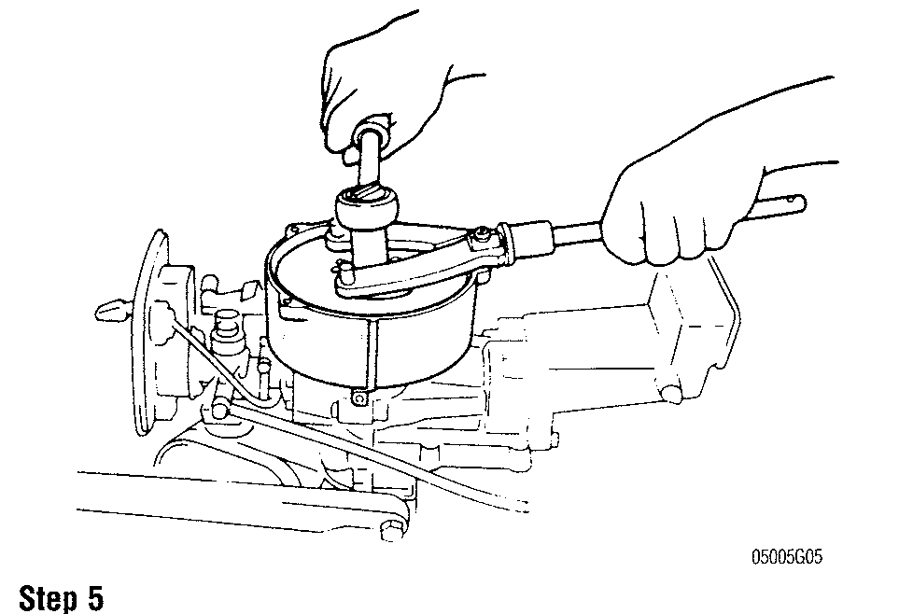

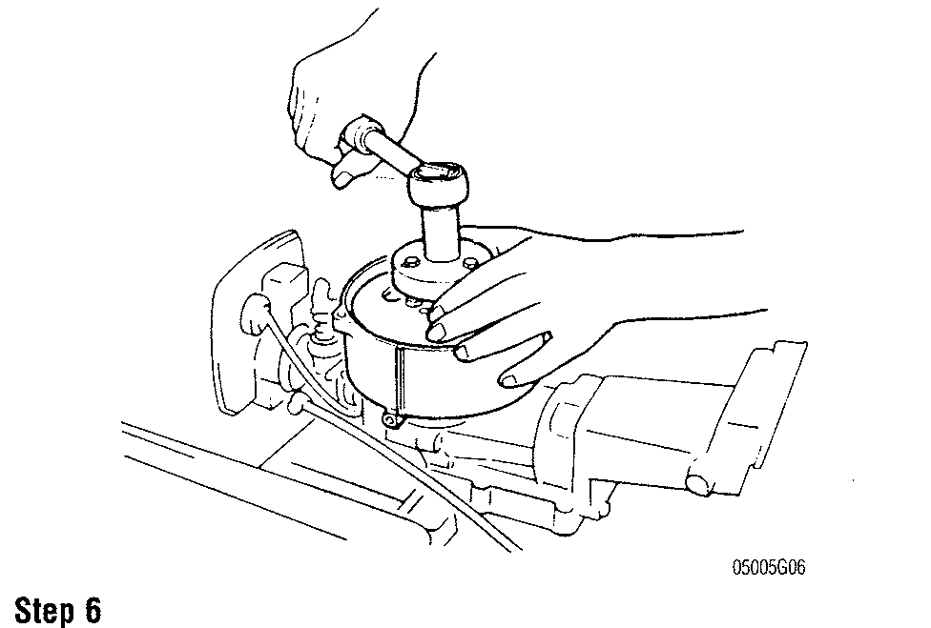

POWERHEAD **7-3**

To install:

1. Before installing the flywheel, thoroughly inspect the crankshaft and flywheel tapers. These surfaces must be absolutely clean and free of oil, grease and dirt. Use solvent and a lint free cloth to clean the surfaces and then blow dry with compressed air.
2. Install the flywheel key, starter cup and flywheel and flywheel bolt. Tighten the bolt to 30-36 ft. lbs. (40-50 Nm.)
3. Install the fuel and engine cover.

DT4, DT5Y, DT6 and DT8

I See accompanying illustrations

1. Remove the engine cover from the engine.
2. Remove the built-in fuel tank (if equipped).
3. After removing the bolts, remove the recoil starter assembly.
4. Remove the starter cup. If the screws are hard to loosen, use an impact drive to remove them.
5. Use a flywheel holder (09930-40113) to remove the flywheel nut.
6. Use a flywheel holder and flywheel rotor remover (09930-30713) to remove the flywheel.
7. Make sure to remove the flywheel key from the crankshaft.

To install:

1. Install the flywheel key into the keyway on the crankshaft. Make sure the key is seated correctly into the keyway.
2. Install the flywheel onto the crankshaft.
3. Using a flywheel holder, install the flywheel nut and tighten to 32.5 ft. lbs. (45 Nm).
4. Install the starter cup onto the flywheel and tighten the screws.
5. Install the recoil starter.
6. Install the fuel tank.
7. Install the engine cover.

DT9.9 and DT15

See accompanying illustrations

1. Remove the engine cover from the engine.
2. Remove the two nuts and disconnect the battery/starting motor cables and the neutral switch wire (if equipped).
3. Remove the recoil starter assembly (if equipped).
4. Disconnect the wire lead extending from the stator assembly to the rectifier assembly.
5. Remove the two bolts and remove the starter motor from the engine.
6. Using a flywheel holder (09930-49310), remove the flywheel nut.
7. Using a flywheel holder and the flywheel remover plate (09930­30713), remove the flywheel.

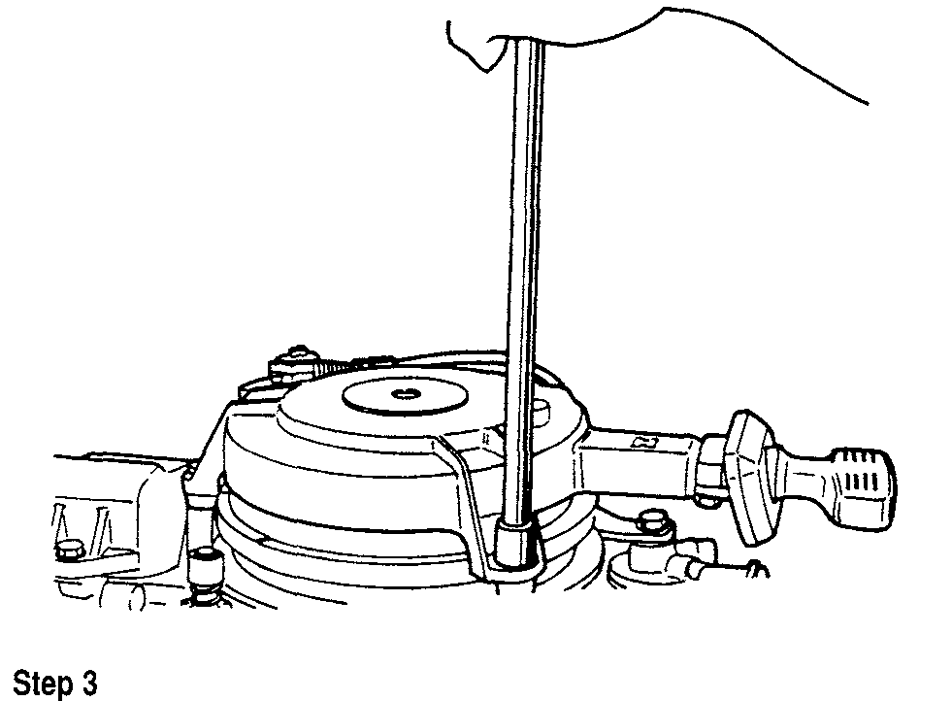

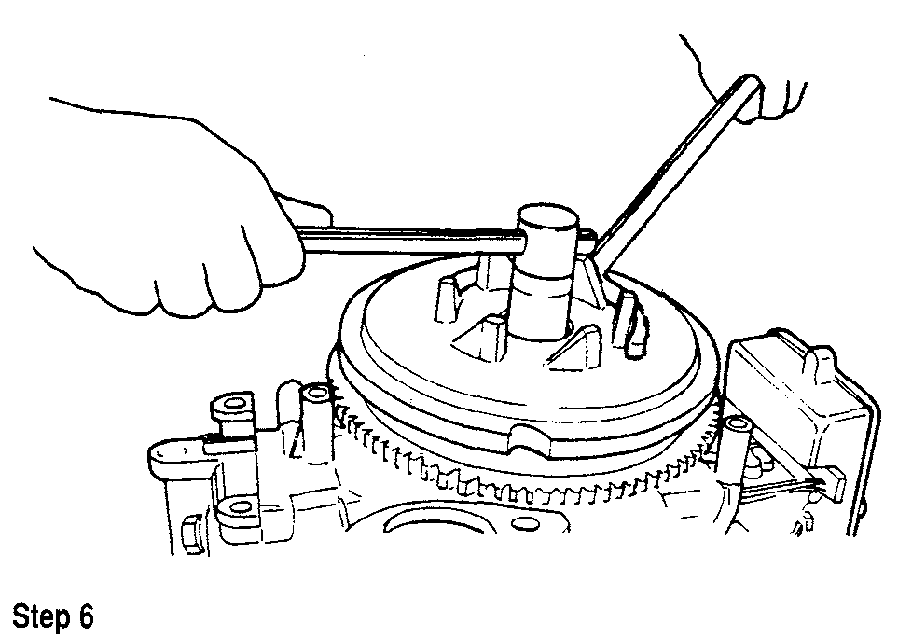

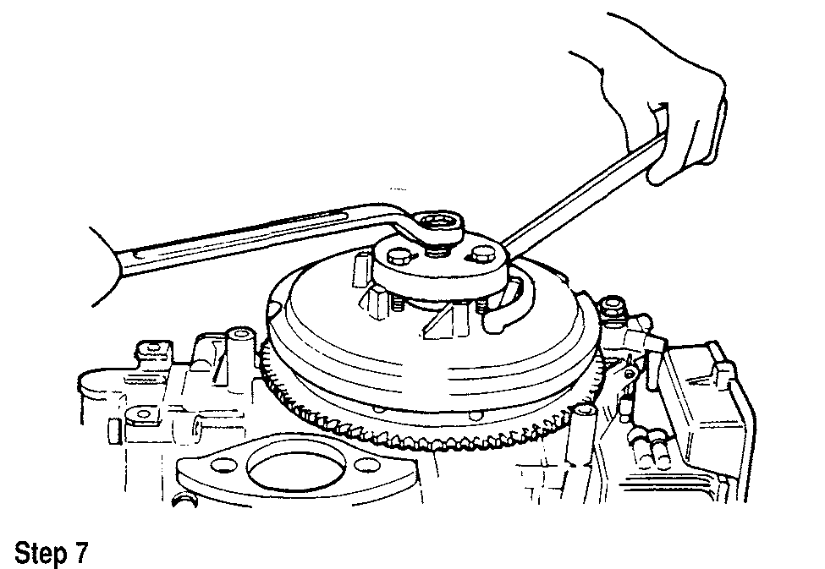

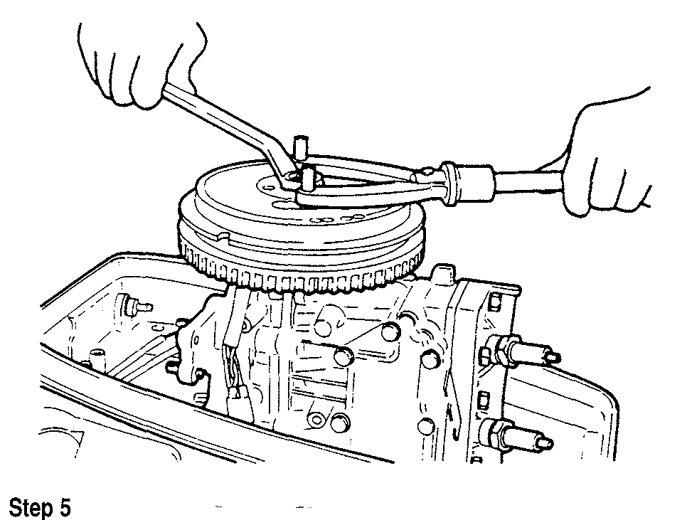

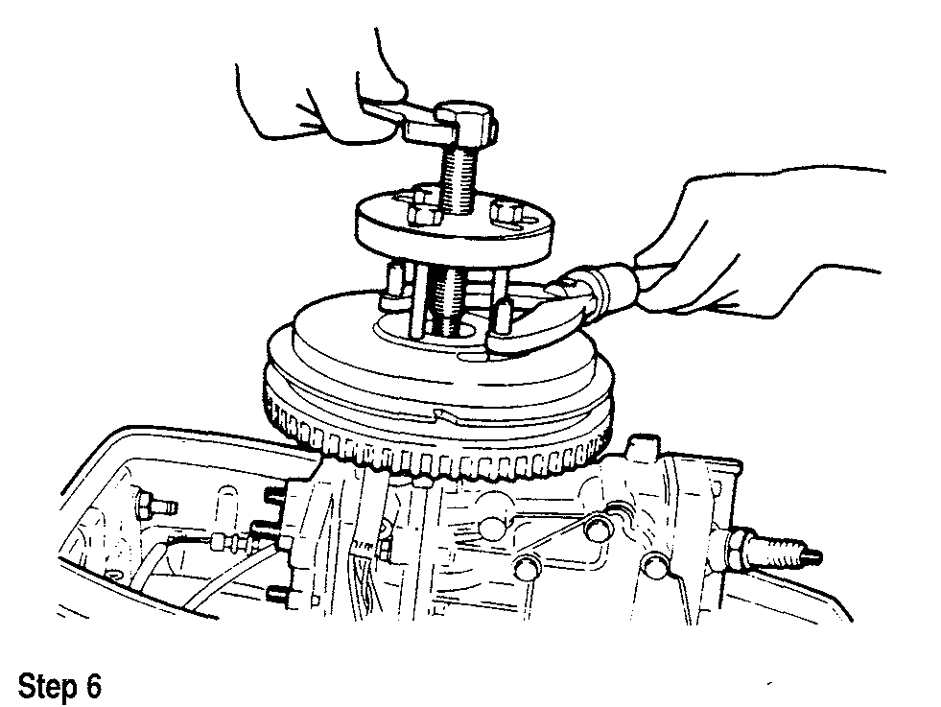

POWERHEAD **7-5**

1. Connect the battery negative battery cable.
2. Install the engine cover.

**DT115, DT140 and V4**

1. Remove the engine cover.
2. Remove the electrical junction box cover and disconnect the stator leads.
3. Remove the flywheel cover.
4. Using a flywheel holder (09930-48720), remove the flywheel nut.
5. Using a flywheel holder, flywheel remover (09930-39411) and flywheel bolts (09930-39420), remove the flywheel.
6. Remove the flywheel from the crankshaft.

**To install:**

1. Thoroughly clean the mating surface of the flywheel and crankshaft taper with cleaning solvent. Install the key onto the crankshaft securely.
2. Install the flywheel onto the crankshaft.
3. Using a flywheel holder, tighten the flywheel nut to 181-188 ft. lbs. (250-260 Nm).
4. Connect the stator wire leads to their proper connections.
5. Connect the battery negative battery cable.
6. Install the engine cover.

**V6**

1. Remove the engine cover.
2. Remove the electrical junction box cover and disconnect the stator leads.
3. Remove the flywheel cover.
4. Using a flywheel holder (09930-48720), remove the flywheel nut.
5. Using a flywheel holder, flywheel remover (09930-39411) and flywheel bolts (09930-39420), remove the flywheel.

**To install:**

1. Thoroughly clean the mating surface of the flywheel and crankshaft taper with cleaning solvent. Install the key onto the crankshaft securely.
2. Install the flywheel onto the crankshaft.
3. Using a flywheel holder, tighten the flywheel nut to 181-188 ft. lbs. (250-260 Nm).
4. Connect the stator wire leads to their proper connections.
5. Connect the battery negative battery cable.
6. Install the engine cover.

INSPECTION

Check the flywheel carefully for cracks or fractures.

**\*\* CAUTION**

**A cracked or chipped flywheel must be replaced. A damaged fly­wheel may fly apart at high rpm, throwing metal fragments over a large area. Do not attempt to repair a damaged flywheel.**

Check tapered bore of flywheel and crankshaft taper for signs of fretting or working.

On electric start models, check the flywheel teeth for excessive wear or damage. Check crankshaft and flywheel nut threads for wear or damage.

Replace flywheel, crankshaft and/or flywheel nut as required.

**Powerhead**

REMOVAL & INSTALLATION

When removing any powerhead, it is a good idea to make a sketch or take an instant picture of the location, routing and positioning of electrical harnesses, brackets and component locations for installation reference.

**Sometimes when attempting to remove the powerhead it won't come loose from the adapter. The gasket may hold the powerhead. Rock the powerhead back and forth or give it a gentile nudge with a pry bar. If the gasket breaks loose and the powerhead still will not come loose, then the driveshaft is seized to the crankshaft at the splines.**

The following procedures assume that the outboard has been removed from the boat and placed on a suitable work stand. If the powerhead is being

removed with the outboard still mounted on the boat and the powerhead is equipped with an electric starter, disconnect first the negative, then the positive battery cables to prevent accidental starting.

On some powerheads it will be necessary to remove attached components if the powerhead is to be overhauled. Refer to the specific sections covering these components for removal and installation information.

**DT2 and DT2.2**

**0 See accompanying illustrations**

1. Remove the engine covers.
2. Turn the fuel shutoff to the **OFF** position. Disconnect and plug the fuel line.
3. Remove the fuel tank.
4. Remove the rewind starter assembly.
5. Remove the starter cup and flywheel insulator.
6. Using a flywheel holder loosen and remove the flywheel nut.
7. Remove the flywheel using a flywheel puller.

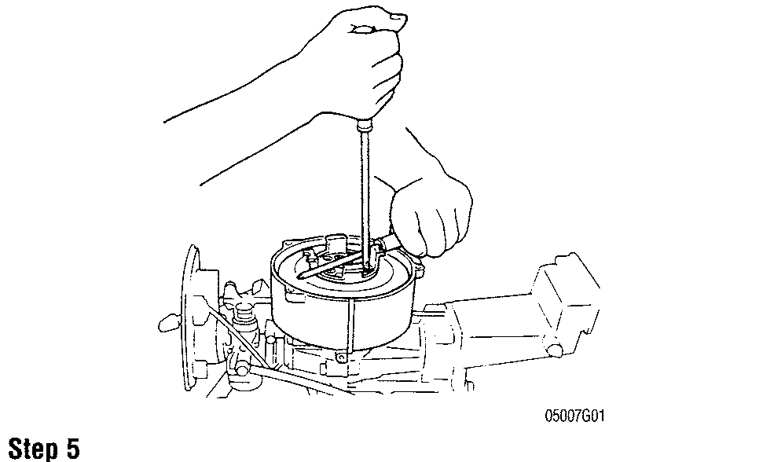

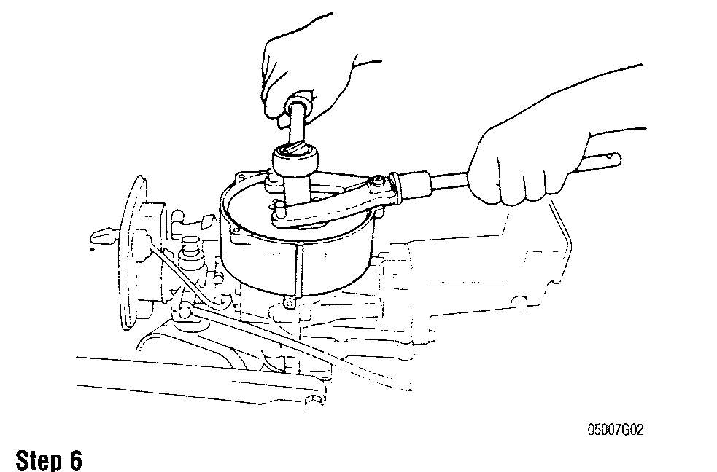

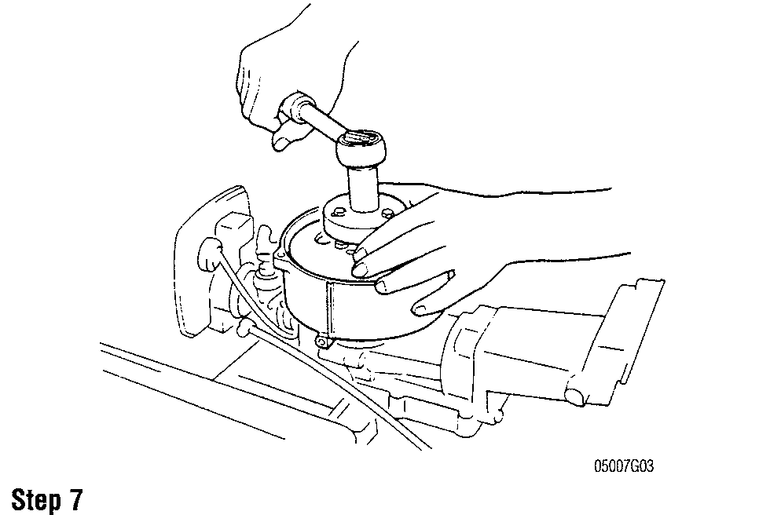

**7-6** OIL INJECTION

1. Disconnect the spark plug lead.
2. Label and disconnect the stator lead wires.
3. Remove the choke knob
4. Remove the throttle link knob and the control panel.
5. Remove the carburetor and fuel shut-off valve.
6. Remove the bolts holding the powerhead to the driveshaft housing.
7. Remove the powerhead.

If the powerhead will not come off, rotate the propeller to free the powerhead from the driveshaft.

1. Remove and discard the powerhead mounting gasket. To install:
2. Clean the powerhead mounting and driveshaft housing gasket surfaces thoroughly.
3. Lightly coat driveshaft splines with marine grease.
4. Install a new powerhead new mounting gasket.
5. Install the powerhead, rotating the propeller as required to align driveshaft and crankshaft splines.
6. Coat powerhead mounting bolt threads with thread locking

compound.

1. Install the powerhead mounting bolts and tighten to specification.
2. Install the carburetor and fuel shut-off valve.
3. Install the control panel, the choke knob and the throttle link knob.
4. Connect the stator lead wires.
5. Connect the spark plug lead.
6. Install the flywheel.
7. Using a flywheel holder tighten the flywheel nut.
8. Install the starter cup and flywheel insulator.
9. Install the rewind starter assembly.
10. Install the fuel tank.
11. Connect the fuel line and turn the fuel shutoff to the ON position.
12. Start the engine and make adjustments as necessary.
13. Check engine for proper operation.
14. Install the engine covers.

DT4 and DT5Y

1. Remove the engine cover.
2. Remove the fuel tank.
3. Remove the hand rewind starter.
4. Using a flywheel holder loosen and remove the flywheel nut.
5. Remove the flywheel using the flywheel puller.
6. Label and disconnect the stator and CDI unit electrical leads.
7. Remove the ignition coil and CDI unit.
8. Disconnect the throttle cable from the carburetor.
9. Loosen the hose clamp, disconnect and plug the fuel hose.
10. Remove the silencer.
11. Remove the carburetor.
12. Remove the fuel pump.
13. Remove the powerhead mounting bolts.
14. Remove the powerhead.

If the powerhead will not come off, rotate the propeller to free the powerhead from the driveshaft.

1. Remove and discard the powerhead mounting gasket.

To install:

1. Clean the powerhead mounting and driveshaft housing gasket surfaces thoroughly.
2. Lightly coat the driveshaft splines with marine grease.
3. Install a new powerhead new mounting gasket.
4. Install the powerhead, rotating the propeller as required to align driveshaft and crankshaft splines.
5. Coat powerhead mounting bolt threads with silicone sealer.
6. Install the powerhead mounting bolts and tighten to specification.
7. Install the fuel pump.
8. Install the carburetor.
9. Install the silencer.
10. Connect the throttle cable top the carburetor and adjust it to specification.
11. Install the ignition coil and CDI unit.
12. Connect the stator and CDI unit electrical leads.
13. Install the flywheel. Tighten the flywheel nut to specification.
14. Install the hand rewind starter.
15. Install the fuel tank.
16. Unplug and connect the fuel hose. Using a new hose clamp, fasten the hose properly.
17. Start the engine and make adjustments as necessary.
18. Check engine for proper operation.
19. Install the engine cover.

DT6 and DT8

0 See accompanying illustrations

1. Remove the engine cover.
2. Remove the silencer cover.
3. Loosen the hose clamp, disconnect and plug the fuel hose.
4. Disconnect the choke knob.

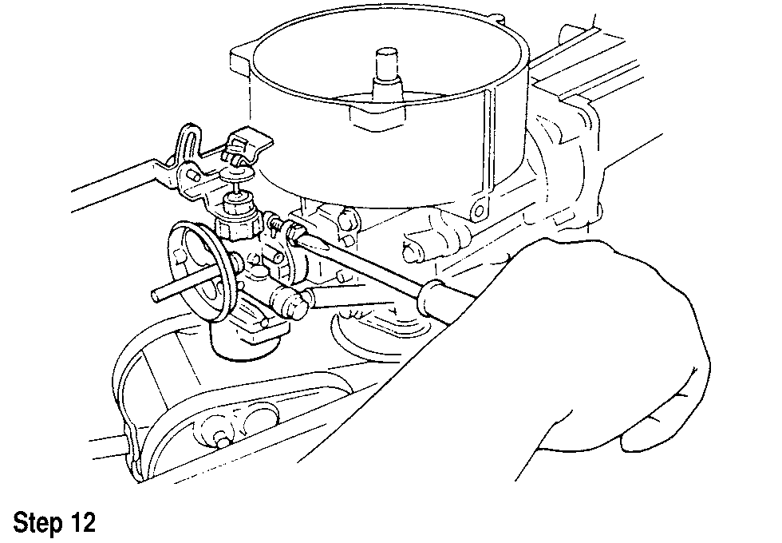

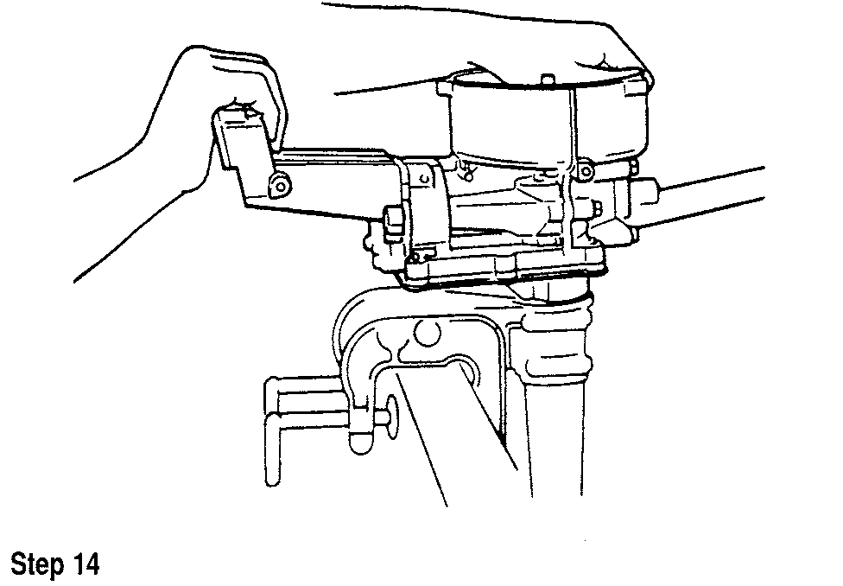

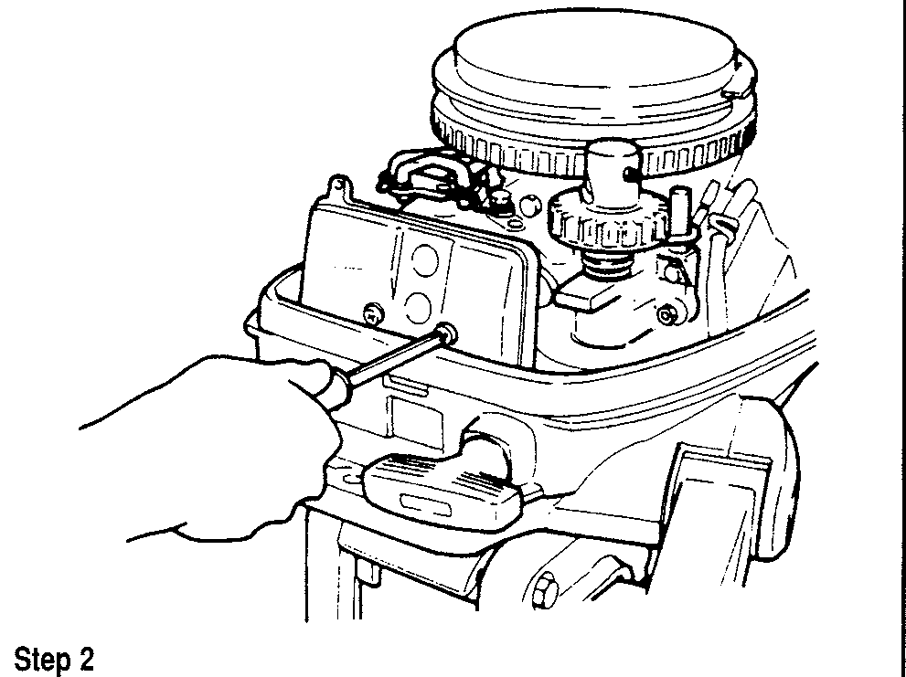

POWERHEAD **7-15**

1. Connect the starter relay to the relay holder.
2. Install the starter cable to the starter.
3. Install the relay cover under the starter.
4. Start the engine and make adjustments as necessary.
5. Check engine for proper operation.
6. Install the engine cover.

V6

1. Remove the engine cover.
2. Disconnect the negative, then the positive battery cables.
3. Remove the cover from the electrical parts holder.
4. Disconnect the battery cable and the power trim and tilt motor electrical leads from the powerhead.
5. Disconnect and plug the fuel hose.
6. Remove the cover from the electrical parts holder
7. Disconnect all electrical leads inside the electrical parts holder, then remove the electrical parts holder.
8. Remove the bolts holding the powerhead to the driveshaft housing.
9. Remove the lower front under cover.
10. Remove the lower rear under cover.
11. Disconnect the water outlet hose.
12. Remove the bolts holding the powerhead to the driveshaft housing.
13. Remove the upper to lower clutch rod clevis pin.
14. Attach a hoist to the engine hooks and lift the powerhead slightly.

If the powerhead will not come off, rotate the propeller to free the powerhead from the driveshaft.

1. Disconnect the clutch lever rod connector from the clutch shaft.
2. Disconnect the upper clutch rod from the clutch shaft.
3. Remove the powerhead using a hoist.
4. Remove and discard the powerhead mounting gasket.
5. Remove the aligning dowel pins from the bottom of the powerhead. To install:
6. Clean the powerhead mounting and driveshaft housing gasket surfaces thoroughly.
7. Lightly coat the driveshaft splines with marine grease.
8. Install a new powerhead new mounting gasket.
9. Install the powerhead, rotating the propeller as required to align drive­shaft and crankshaft splines.
10. Install the upper to lower clutch rod clevis pin.
11. Coat powerhead mounting bolt threads with silicone sealer.
12. Install the powerhead mounting bolts and tighten to specification.
13. Connect the water outlet hose.
14. Install the lower rear under cover.
15. Install the lower front under cover.
16. Install the electrical parts holder, then connect all electrical leads inside the electrical parts holder.
17. Install the cover on the electrical parts holder
18. Connect the fuel-hose.
19. Connect the battery cable and the power trim and tilt motor electrical leads to the powerhead.
20. Connect the positive, then the negative battery cables.
21. Start the engine and make adjustments as necessary.
22. Check engine for proper operation.
23. Install the engine cover.

DISASSEMBLY & ASSEMBLY DT2 and DT2.2

See accompanying illustrations

1. Loosen the cylinder head nuts in several stages using a criss-cross pattern.
2. Remove the nuts and lift the cylinder head from the cylinder block.
3. Remove and discard the cylinder head gasket.
4. Loosen the crankcase bolts in several stages using a criss-cross pattern.
5. Carefully pry apart and separate the crankcase halves.

If the halves resist coming apart, tap them lightly with a plastic ham­mer. Do not pry heavily on the crankcase halves, as severe damage may occur.

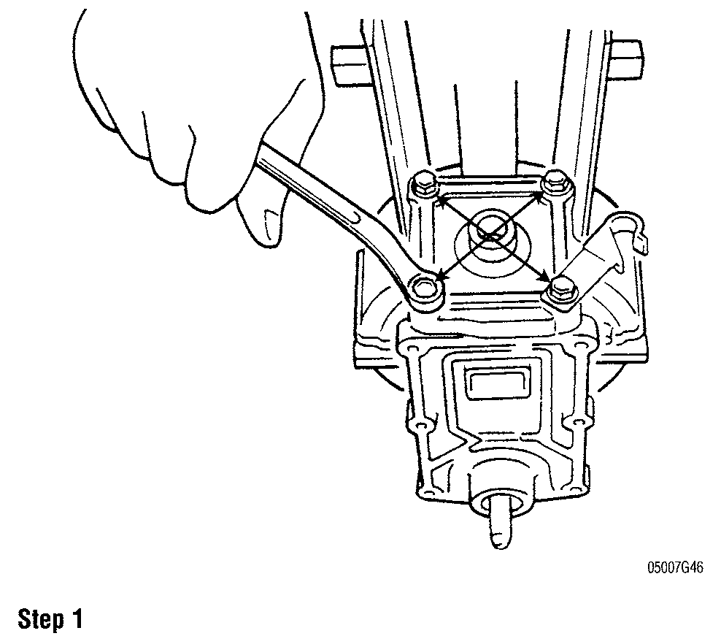

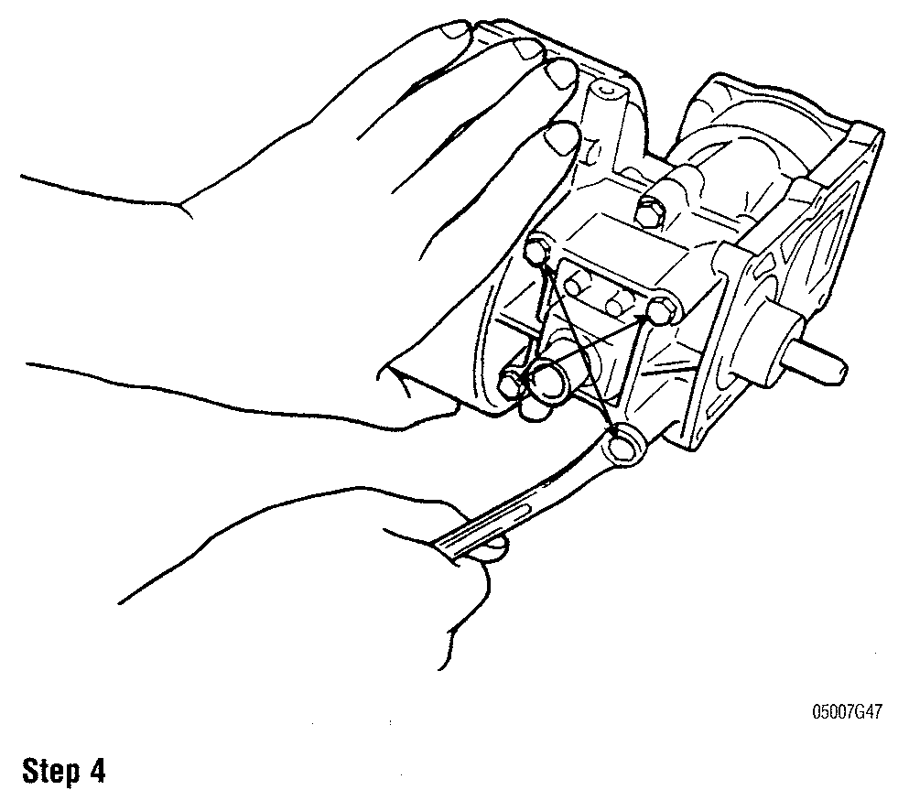

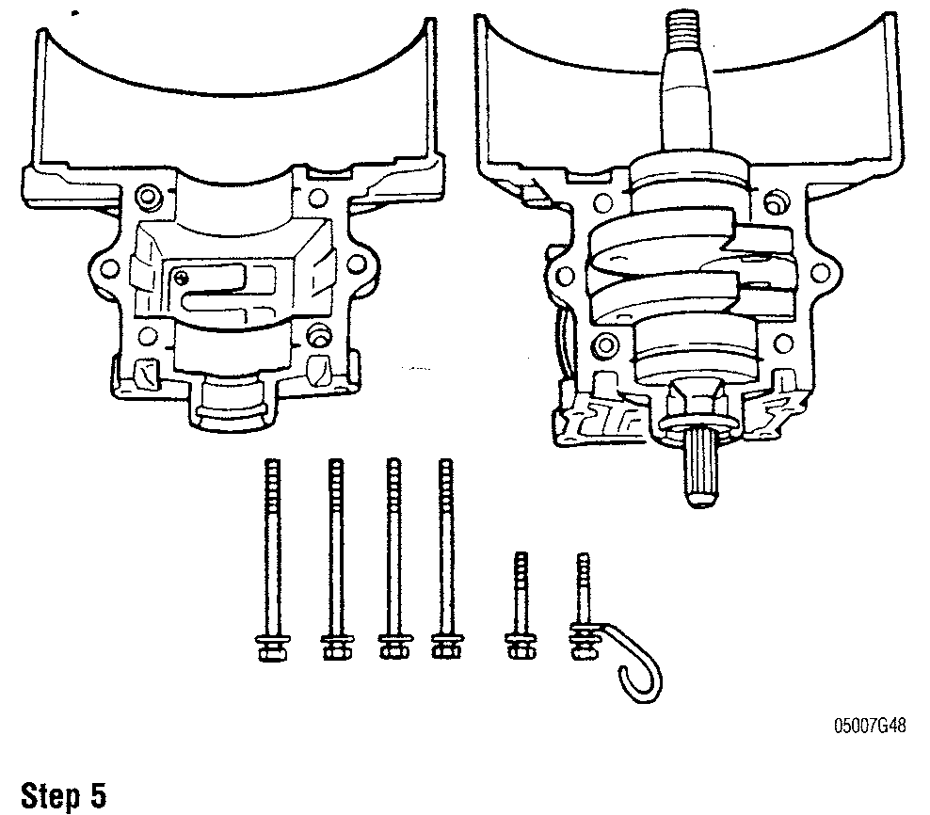

**7-16** POWERHEAD

1. Remove the 0-ring from the crankshaft lower end.
2. To remove the rotating assembly, hold the crankshaft while sliding the cylinder block away from the piston.
3. Remove the crankshaft thrust rings.
4. Carefully pry the piston pin retainer from its groove on the piston. Then repeat the procedure for the other side.

The circlip will tend to fly when removed. Be ready to catching it as it comes free.

9. Piston pin retainers are only good for one usage, discard the retainers after removing them.

1. Push the piston pin from it bore in the piston using a brass drift if necessary.

The piston pin should slide smoothly from its bore. If opposition is felt, either the bore is out of round or the pin is bent. Inspect the com­ponents and replace as necessary.

1. Remove the piston and needle bearing from the connecting rod.
2. Slide the top and bottom crankshaft oil seals from the crank­shaft.

To assemble:

1. Install the piston and needle bearing on the connecting rod. Make sure the arrow on the piston points to the splined portion of the crankshaft (down­ward).
2. Push the piston pin into the piston bore using a brass drift if neces­sary.
3. Install new piston pin retainers
4. Lubricate the seals with marine grease prior to installation.
5. Install the top and bottom crankshaft oil seals with the numbers facing the ends of the crankshaft.
6. Install the crankshaft thrust rings.
7. Lubricate the rotating assembly with 2-stroke oil prior to installa­tion.

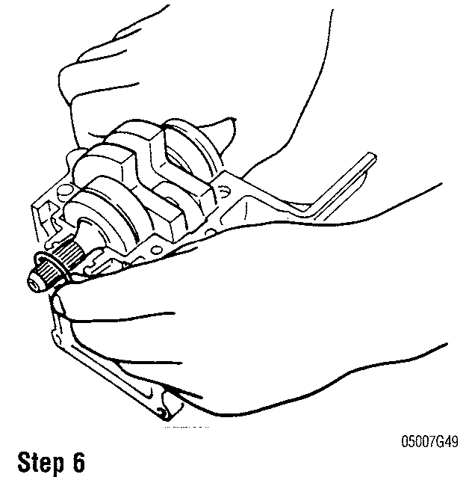

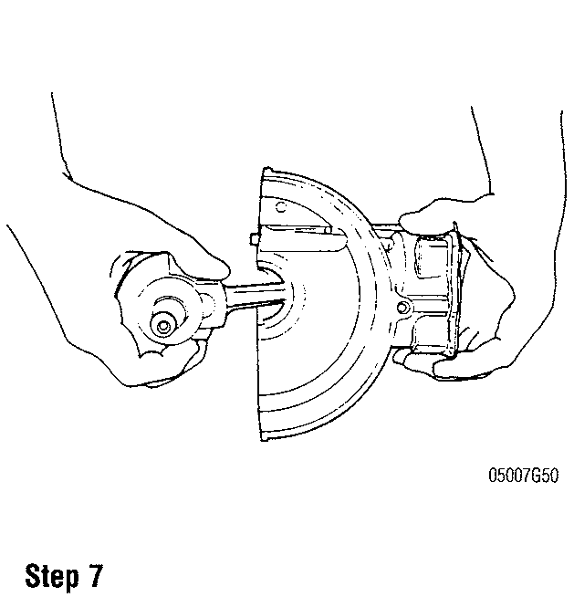



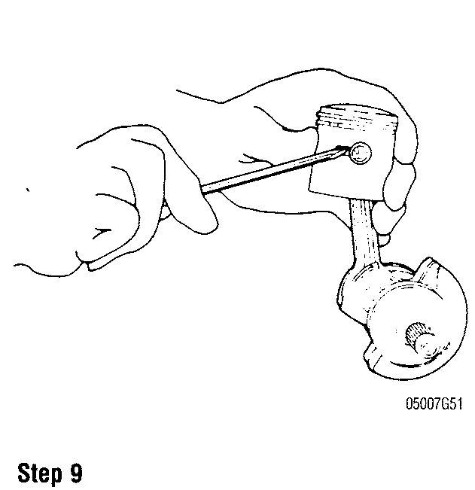

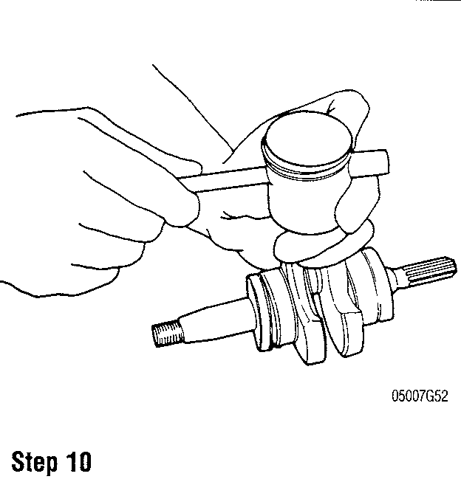

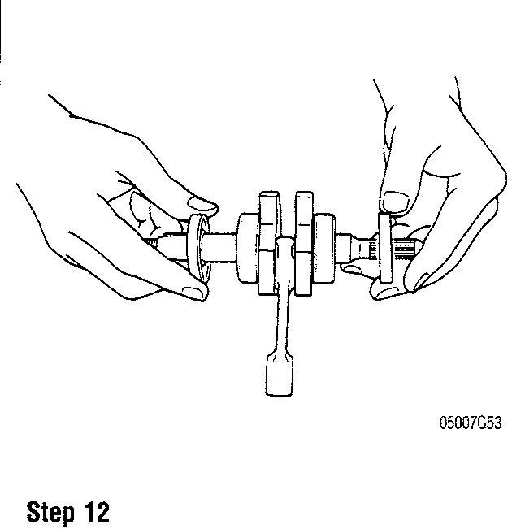

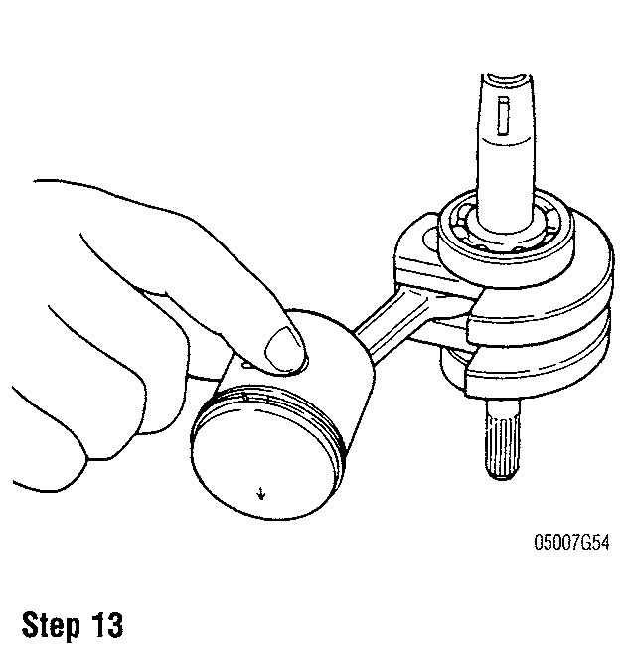

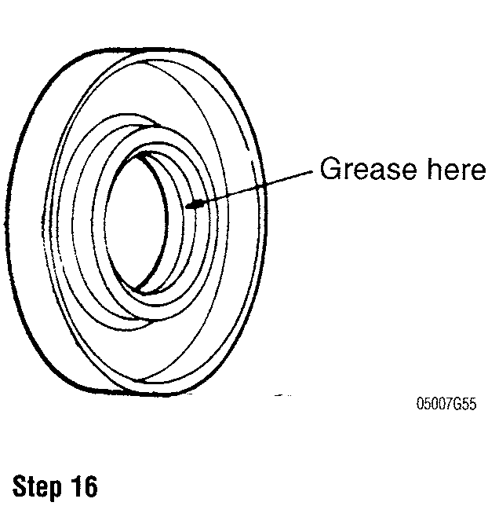

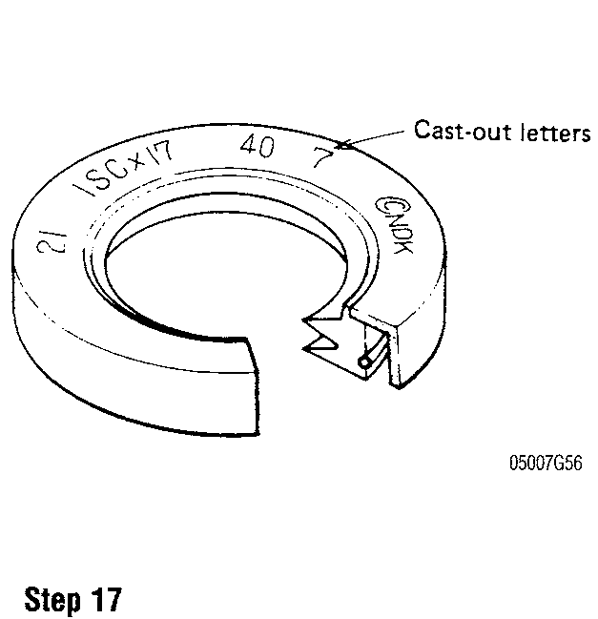

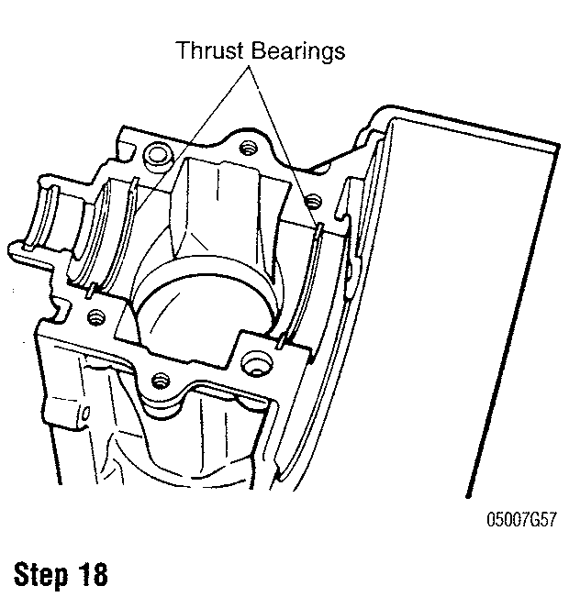

POWERHEAD **7-17**

1. Install the rotating assembly into the cylinder block, making sure the crankshaft faces the correct way. The splined end of the crankshaft should face driveshaft housing side.
2. Apply marine grease to the 0-ring and the splined portion of the crankshaft. Install the 0-ring.
3. Apply a bead of Suzuki Bond No. 4 (99000-31030), or equivalent sealer to the crankcase halves (shaded areas in the illustration).
4. Tighten the crankcase bolts to specification in several stages using a criss-cross pattern.
5. Install a new cylinder head gasket noting the position of the cooling water hole.
6. Install the cylinder head matching the waterway on the head to the water hole on the cylinder block.
7. Tighten the cylinder head nuts to specification in several stages using a criss-cross pattern.
8. Rotate the crankshaft several turns to check for binding. If crankshaft does not turn freely, determine the cause and correct prior to assembling the powerhead.

DT4 and DT5Y

See Figures 1 and 2

1. Loosen the clips and disconnect the lubrication hose from each fitting.
2. Remove the mounting bolts and remove the rewind starter mounting base.
3. Remove the screws and remove the water jacket cover and gasket.
4. Loosen the cylinder head bolts in several stages using a criss-cross pattern.
5. Remove the cylinder head.
6. Loosen the crankcase bolts in several stages using a criss-cross pattern.
7. Carefully pry apart and separate the crankcase halves.
8. To remove the rotating assembly, hold the crankshaft while sliding the cylinder block away from the piston.

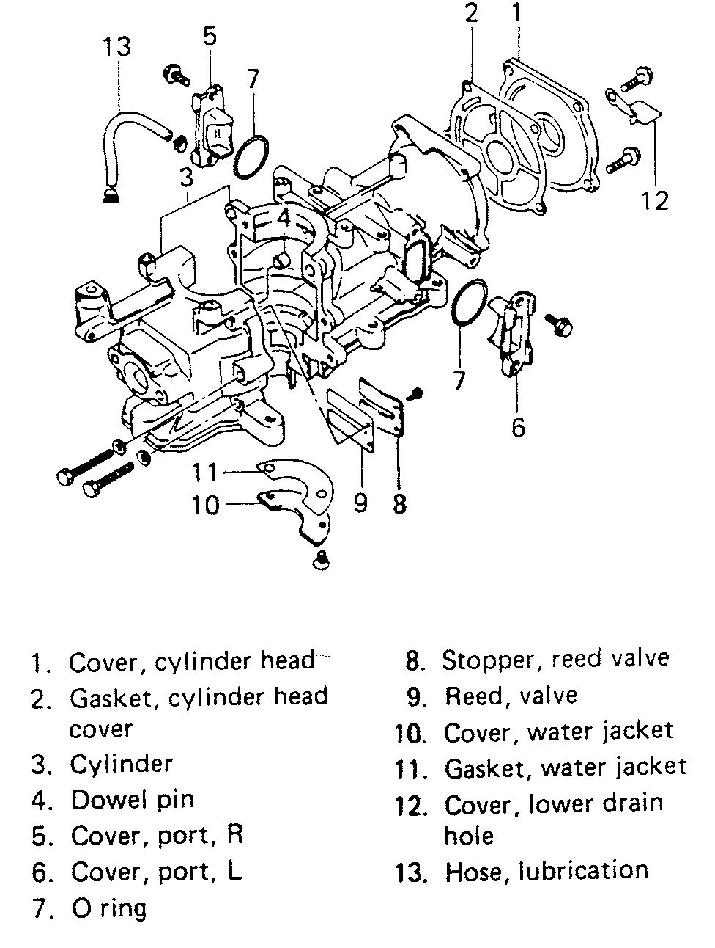

Fig. 1 Exploded view of the powerhead—DT4

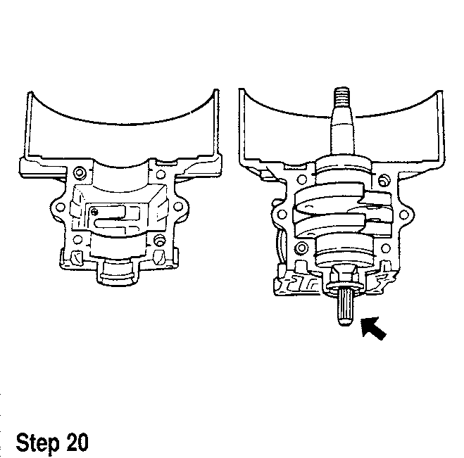

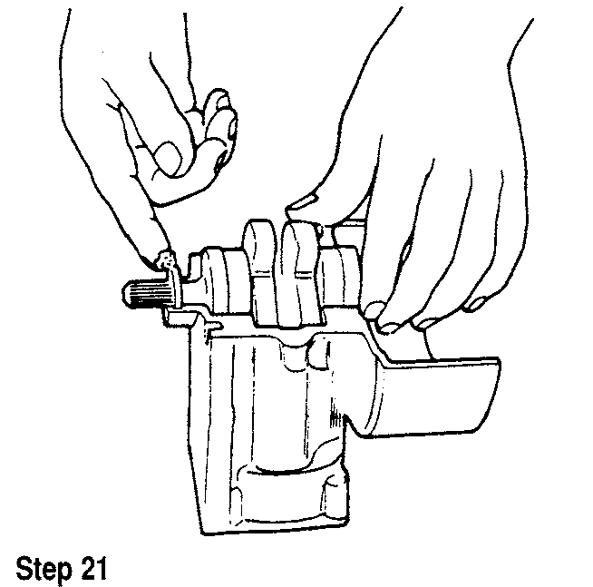

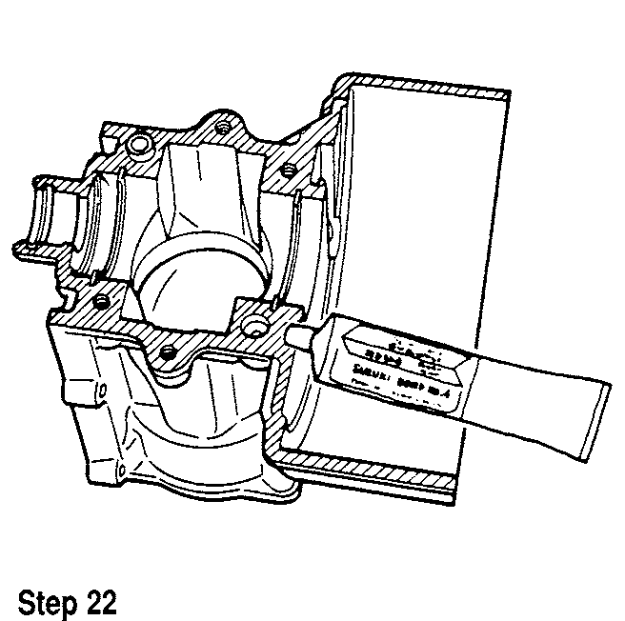

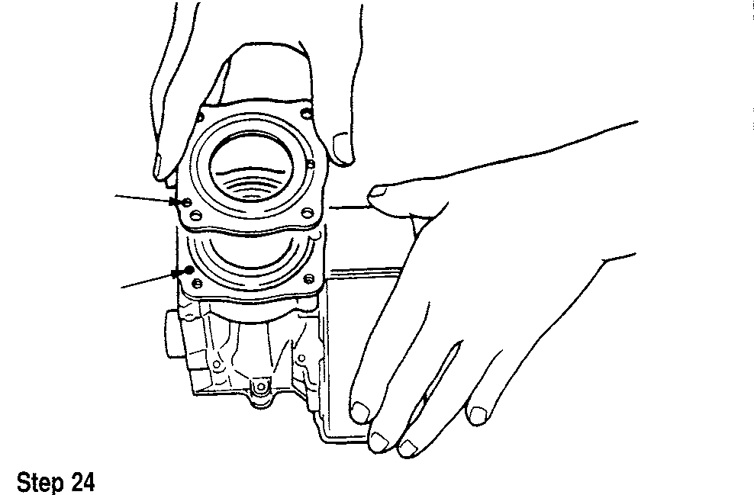

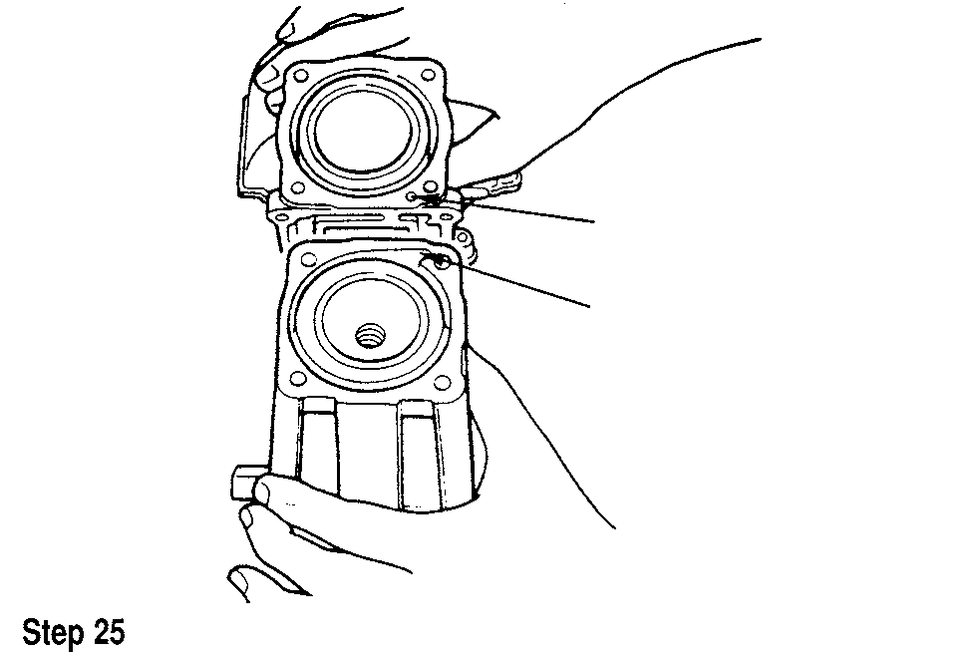

**7-46 POWERHEAD**

|  |  |  |
| --- | --- | --- |
| Engine Torque Specifications  Component Diameter Standard (ft. lbs.) | | Metric (Nm) |
| Conventional bolt/nut |  |  |
| 5mm | 1.5-3 | 2-4 |
| 6mm | 3-5 | 4-7 |
| 8mm | 7-11.5 | 10-16 |
| 10mm | 16-25.5 | 22-35 |
| Stainless steel bolt/nut |  |  |
| 5mm | 1.5-3 | 2-4 |
| 6mm | 4.5-7 | 6-10 |
| 8mm | 11-14.5 | 15-20 |
| 10mm | 24.5-29.5 | 34-41 |
| Clamp bra10mmt |  |  |
| DT4, DT5Y | 17.5-19 | 24-26 |
| DT9.9, DT15, DT35, DT40 | 2-2.5 | 20-25 |
| DT15C | 16.5-18 | 23-25 |
| DT25C, DT30C, DT55, DT65, DT75, DT85 | 29.5-32.5 | 41-45 |
| DT90, DT100, DT150, DT175, DT200, DT225 |  |  |
| Clamp bracket shaft |  |  |
| DT115, DT140, DT150, DT175, DT200 | 31 | 43 |
| Crankcase |  |  |
| DT2, DT4, DT5Y, DT9.9, DT15, DT25C, DT30C, | 6-8.5 | 8-12 |
| DT35, DT40, DT55, DT65 |  |  |
| DT15C | 14.5-19 | 20-26 |
| DT35, DT40, DT55, DT65, DT75, 85 | 33.5-39 | 46-54 |
| DT115, DT140 8mm | 16.5 | 23 |
| DT115, DT140 10mm | 36 | 50 |
| Crankcase |  |  |
| DT150, DT175, DT200 6mm | 10 | 14 |
| 8mm | 14.5-19 | 20-26 |
| 12mm | 54 | 75 |
| DT225 8mm | 14.5-19 | 20-26 |
| 10mm | 33.5-39 | 46-54 |
| Cylinder head |  |  |
| DT6, DT8, DT9.9, DT15, DT35, DT40 | 14.5-19 | 20-26 |
| DT15C, DT55, DT65 | 15-18 | 21-25 |
| DT25C, DT30C | 6-8.5 | 8-12 |
| DT75, DT85, DT90, DT100 | 33.5-39.5 | 46-54 |
| DT90, DT100 | 20-23 | 28-32 |
| DT115, DT140 8mm | 14.5-19 | 20-26 |
| 10mm | 33.5-39.5 | 46-54 |
| DT150, DT175, DT200 8mm | 21.5 | 30 |
| 10mm | 54 | 75 |
| DT225 8mm | 20-23 | 28-32 |
| 12mm | 33.5-39.5 | 46-54 |
| Cylinder head cover | 6-8.5 | 8.12 |
|  |  |  |

**POWERHEAD 7-47**

|  |  |  |
| --- | --- | --- |
| Engine Torque Specifications  Component Diameter Standard (ft. lbs.) | | Metric (Nm) |
| Drive shaft housing |  |  |
| DT55, DT65  DT75, 85  DT90, DT100, DT150, DT175, DT200, DT225 DT115, DT140 | 1.5-2  6-8.5  24.5-29.5  13 | 15-20 8-12 34-41  18 |
| Engine holder |  |  |
| DT4, DT5Y, DT9.9, DT15, DT25C, DT30C, | 11-14.5 | 15-20 |
| DT35, DT40, DT90, DT100 |  |  |
| DT55, DT65, DT75, DT85 | 13-20 | 18-28 |
| DT200 8mm | 11-14.5 | 15-20 |
| 10mm | 24.5-29.5 | 34-41 |
| DT225 8mm | 11-14.5 | 15-20 |
| 10mm | 24.5-29.5 | 34-41 |
| Exhaust cover |  |  |
| DT6, DT8 | 3-5 | 4-7 |
| Except DT6, DT8 | 6-8.5 | 8-12 |
| Exhaust tube |  |  |
| DT35, DT40, DT55, DT65, DT75, | 6-8.5 | 8-12 |
| DT85, DT90, DT100, DT225 |  |  |
| DT115, DT140 6mm | 6 | 8 |
| DT115, DT140 8mm | 13 | 18 |
| DT150, DT175, DT200 | 14.5 | 20 |
| Exhaust tube housing |  |  |
| DT150, DT175, DT200 | 14.5 | 20 |
| Except DT150, DT175, DT200 | 6-8.5 | 8-12 |
| Flywheel |  |  |
| DT2 | 29-36 | 40-50 |
| DT4, DT5Y | 32.5 | 45 |
| DT6, DT8 | 43.5-50.5 | 60-70 |
| DT9.9, DT15 | 58-65 | 80-90 |
| DT20 | 72.5-79.5 | 100-110 |
| DT25C, DT30C | 94-108.5 | 130-150 |
| DT35, DT40, DT55, DT65 | 20-21 | 200-210 |
| DT75, 85 | 144.5-152 | 200-210 |
| DT90, DT100 DT115, DT140, DT150, | 180-188 | 250-260 |
| DT175, DT200, DT225 |  |  |
| Gear case |  |  |
| DT4, DT5Y, DT6, DT8, DT9.9, DT15, DT35, DT4C | 11-14.5 | 15-20 |
| DT55, DT65 8mm | 11-14.5 | 15-20 |
| DT55, DT65 10mm | 24.5-29.5 | 34-41 |
| DT75, 85 8mm | 11-14.5 | 15-20 |
| DT75, 85 10mm | 24.5-29.5 | 34-41 |
| DT90, DT100, DT150, DT175, DT200, DT225 | 36-43.5 | 50-60 |
| DT115, DT140 | 40 | 55 |

**7-48 POWERHEAD**

|  |  |  |
| --- | --- | --- |
| Engine Torque Specifications | |  |
| Component Diameter Standard (ft. lbs.) | | Metric (Nm) |
| Gearcase mounting | 11-14.5 | 15-20 |
| Lower mounting |  |  |
| DT9.9, DT15, DT15C | 11-14.5 | 15-20 |
| DT25C, DT30C | 18-19.5 | 25-27 |
| DT35, DT40 | 33.5-39 | 46-54 |
| DT55, DT65 | 5.6-6.4 | 56-64 |
| DT75, 85 | 40.5-46.5 | 5.6-6.4 |
| DT90, DT100, DT115, DT140 DT150, | 65-72.5 | 90-100 |
| DT175, DT200, DT225 |  |  |
| DT150, DT175, DT200 | 68.5 | 95 |
| Pinion |  |  |
| DT25C, DT30C | 19.5-21.5 | 27-30 |
| D135, DT40, DT55, DT65 | 21.5-29 | 30-40 |
| DT75, 85 | 50-58 | 70-80 |
| DT90, DT100 | 58-72.5 | 80-100 |
| DT115, DT140 | 68.5 | 95 |
| DT150, DT175, DT200, DT225 | 101.5-108.5 | 140-150 |
| Power unit mounting |  |  |
| DT115, DT140 | 32 | 44 |
| DT150, DT175, DT200 8mm | 16.5 | 23 |
| DT150, DT175, DT200 10mm | 32 | 44 |
| Propeller |  |  |
| DT9.9, DT15, DT35, DT40, DT75, DT85, | 36-43.5 | 50-60 |
| DT115, DT140, DT150, DT175, DT200 |  |  |
| DT15C | 12.5-14.5 | 17-20 |
| DT25C, DT30C | 21-22.5 | 29-31 |
| Propeller shaft bearing |  |  |
| DT4, DT5Y, DT15C, DT25C, DT30C | 4.5-7 | 6-10 |
| DT35, DT40, DT55, DT65, DT75, DT85 | 11-12.5 | 15-20 |
| DT115, DT140 | 13 | 18 |
| DT150, DT175, DT200 | 137.5 | 190 |
| Propeller shaft housing stopper |  |  |
| DT90, DT100 | 108.5-123 | 150-170 |
| DT150, DT175, DT200, DT225 | 130-144.5 | 180-200 |
| Propeller shaft | 36-45 | 50-62 |
| PT unit | 11-14.5 | 15-20 |
| PTT unit |  |  |
| DT75, 85 | 3.5-5 | 5-7 |
| DT115, DT140 |  |  |
| Tilt Cylinder | 94 | 130 |
| Trim Cylinder | 58 | 80 |

**POWERHEAD 7-49**

**Engine Torque Specifications**

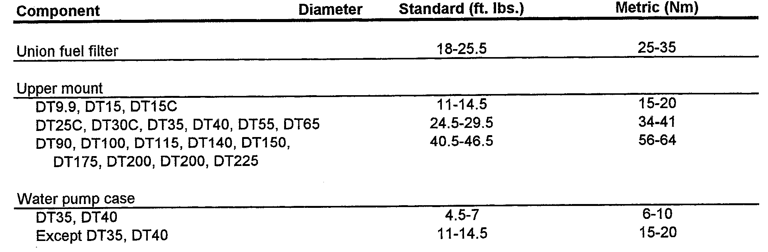

|  |  |  |  |  |
| --- | --- | --- | --- | --- |
| Component | Engine Rebuilding Specifications—DT2  Standard  Standard (in.) Metric (mm) | | Service Limit  Standard (in.) | Metric (mm) |
| Crankshaft deflection | 0.0012 | 0.03 |  |  |
| Conrod deflection | 0.12 | 3 |  |  |
| Cylinder head distortion | 0.0012 | 0.03 |  |  |
| Cylinder distortion | 0.0012 | 0.03 |  |  |
| Piston diameter | 1.6118-1.6124 | 40.940-40.955 |  |  |
| Cylinder bore | 1.6142-1.6148 | 41.000-41.015 |  |  |
| Piston to cylinder clearance | 0-0020-0.0026 | 0.052-0.067 | 0.0058 | 0.147 |
| Piston diameter measuring position | 0.6 | 15 |  |  |
| Cylinder measuring position (2) ® | 0.9 | 22 |  |  |
| Wear on cylinder bore | 0.00 | 0.1 |  |  |
| Piston pin diameter | 0.4723-0.4724 | 11.996-12.000 | 0.4717 | 11.98 |
| Piston pin hole diameter | 0.4724-0.4727 | 11.998-12.006 | 0.4736 | 12.03 |
| Piston ring end gap 1st | 0.004-0.010 | 0.10-0.25 | 0.024 | 0.6 |
| 2nd | 0.004-0.012 | 0.10-0.30 | 0.024 | 0.6 |
| Maximum reed stop opening | 0.15-0.17 | 3.8-4.2 |  |  |
| Reed seat clearance | 0.008 | 0.2 |  |  |
| 0 From piston skirt end |  |  |  |  |
| 0 From cylinder top surface |  |  |  |  |

7-50 POWERHEAD

|  |  |  |  |  |
| --- | --- | --- | --- | --- |
| Component | Engine Rebuilding Specifications—DT2.2  Standard Service Limit  Standard (in.) Metric (mm) Standard (in.) | | | Metric (mm) |
| Crankshaft runout | 0.000-0.002 | 0.00-0.05 | 0.0039 | 0.10 |
| Conrod deflection | 0.12 | 3.0 |  |  |
| Cylinder head distortion | 0.002 | 0.05 |  |  |
| Cylinder distortion | 0.002 | 0.05 |  |  |
| Piston diameter | 1.6905-1.6911 | 42.940-42.955 |  |  |
| Cylinder bore | 1.6929-1.6935 | 43.000-43.015 |  |  |
| Piston to cylinder clearance | 0.0020-0.0026 | 0.052-0.067 | 0.0058 | 0.147 |
| Piston diameter measuring position (1) | 0.6 | 15 |  |  |
| Cylinder measuring position (2) | 0.9 | 22 |  |  |
| Wear on cylinder bore | 0.004 | 0.10 |  |  |
| Piston pin diameter | 0.4723-0.4724 | 11.996-12.000 | 0.4717 | 11.980 |
| Piston pin hole diameter | 0.4725-0.4728 | 12.002-12.010 | 0.4736 | 12.030 |
| Piston ring end gap | 0.004-0.012 | 0.10-0.30 |  |  |
| Maximum reed stop opening | 0.15-0.17 | 3.8-4.2 |  |  |
| Reed to seat clearance | 0.008 | 0.20 |  |  |
| (1) From piston skirt end |  |  |  |  |
| (2) From cylinder top surface |  |  |  |  |

DT115 AND DT140 8-44
  
DISASSEMBLY 8-44

CLEANING & INSPECTION 8-44 ASSEMBLY 8-45

SHIMMING PROCEDURE 8-45

V4 AND V6 8-46

DISASSEMBLY 8-46

CLEANING AND INSPECTING 8-47 ASSEMBLY 8-47

SHIMMING PROCEDURE 8-50

**JET DRIVE 8-51**

DESCRIPTION AND OPERATION 8-51 MODEL IDENTIFICATION AND SERIAL NUMBERS 8-51

JET DRIVE ASSEMBLY 8-51

REMOVAL & INSTALLATION 8-51 ADJUSTMENT 8-54 DISASSEMBLY 8-56

CLEANING AND INSPECTING 8-56 ASSEMBLING 8-57

**LOWER UNIT 8-2**

GENERAL INFORMATION 8-2

SHIFTING PRINCIPLES 8-2

STANDARD ROTATING UNIT 8-2 COUNTERROTATING UNIT 8-2 TROUBLESHOOTING THE LOWER UNIT 8-2 PROPELLER 8-2

REMOVAL & INSTALLATION 8-2

LOWER UNIT - NO REVERSE GEAR 8-3 REMOVAL & INSTALLATION 8-3

LOWER UNIT - WITH REVERSE GEAR 8-3 REMOVAL & INSTALLATION 8-3

**LOWER UNIT OVERHAUL 8-6**

DT2 (FORWARD ONLY) 8-6

DISASSEMBLY 8-6

CLEANING AND INSPECTION 8-7 ASSEMBLY 8-8

SHIMMING PROCEDURE 8-9

DT4 AND DT5Y 8-9 DISASSEMBLY 8-9

CLEANING AND INSPECTION 8-9 ASSEMBLY 8-10

SHIMMING PROCEDURE 8-11

DT6 AND DT8 8-11 DISASSEMBLY 8-11

INSPECTION AND CLEANING 8-13 ASSEMBLY 8-14

SHIMMING PROCEDURE 8-14

DT9.9 AND DT15 8-14 DISSASSEMBLY 8-14

CLEANING AND INSPECTION 8-15 ASSEMBLY 8-16

SHIMMING PROCEDURE 8-17

DT20, DT25 AND DT30 8-19

DISASSEMBLY 8-19

CLEANING & INSPECTION 8-20 ASSEMBLY 8-20

SHIMMING PROCEDURE 8-22

DT35 AND DT40 8-24 DISASSEMBLY 8-24

CLEANING & INSPECTION 8-24 ASSEMBLY 8-24

SHIMMING PROCEDURE 8-26

DT55 AND DT65 8-28 DISASSEMBLY 8-28

CLEANING & INSPECTION 8-30 ASSEMBLY 8-31

SHIMMING PROCEDURE 8-32

DT75 AND DT85 8-35 DISASSEMBLY 8-35

CLEANING & INSPECTION 8-36 ASSEMBLY 8-38

SHIMMING PROCEDURE 8-39



**LOWER UNIT**

LOWER UNIT 8-2

LOWER UNIT OVERHAUL 8-6

JET DRIVE 8-51

**8-2** LOWER UNIT

**LOWER UNIT**

**General Information**

The lower unit consists of the driveshaft, water pump, pinion gear, bearings, forward and reverse gears, propeller shaft. The shifting mechanism and the lower unit housing. The housing is bolted to the exhaust housing, which places the driveshaft and water tube(s) through the center of the exhaust housing. The water tube carries water from the water pump to the powerhead.

The driveshaft splines insert into the crankshaft which then transmits power from the powerhead to the gearcase. A pinion gear on the driveshaft takes the power from the driveshaft and transfers the power to the propeller shaft. The powerhead driveshaft rotates in a clockwise direction continuously while the engine is running, propeller shaft direction is controlled by the gearcase shifting assembly.

The lower unit can be removed from the engine without removing the engine from it's mounting on the boat. The lower units in this chapter differ somewhat in their design and construction and require different servicing procedures.

The lower unit is normally trouble free until water enters the gearcase, the operator shifts incorrectly, or the oil is not changed regularly and corrosion enters the unit. Constant maintenance is required to prevent these problems. Because the unit is normally underwater, extra care must be taken to prevent problems.

Shifting the unit in and out of gear needs to be quick and positive to prevent rounding over the shift clutch dogs. Slow engagement will damage the parts. This problem is evident when the unit jumps out of gear.

Following the recommended oil change schedule allows the oil to be drained and checked for contamination, especially water intrusion. A milky looking oil is a sign of water has entered the gearcase and it must then be pressure tested to check the seals and the leaks repaired to prevent damage to the bearings and gears.

**Shifting Principles**

STANDARD ROTATING UNIT

Non-Reverse Type

Some of the smaller engines equipped with a neutral, but no reverse-gear, utilize a spring-loaded clutch to shaft between neutral and forward gear.

Reverse Type

On Suzuki outboard engines equipped with a reverse gear, a sliding-type clutch engages the chosen gear in the gearcase housing. This clutch when engaged, creates a direct connection that then moves the power flow from the pinion to the propeller shaft.

Power flow in the lower unit goes through the driveshaft into the pinion gear, which constantly turns the forward and reverse gears in opposite directions. The clutch dog is part of the shaft mechanism and is splined to the propeller shaft. The clutch dog is held in the central position (neutral) between the forward and reverse gears. When the shift shaft (rod) is moved, the shift cam (shifter) moves the follower (shifter shaft), which in turn, moves the clutch dog into mesh with the selected gear. Power is then transmitted from the gear through the clutch dog into the propeller shaft, and finally to the propeller.

V4 and V6 Smooth-Shift

1. This design provides easy shifting, positive engagement and extended durability of the gears and shifting mechanism. Its compact design is also partly responsible for the slim design of the lower unit housing with its smooth water flow and low forward water intake.

COUNTERROTATING UNIT

As mentioned earlier in this section a single design shifting mechanism is employed on both the standard and counter-rotating units, with the counter-rotating shift mechanism having the shift rod being turned 180°from the standard shift mechanism.

The main physical differences lie in the shifting mechanism (mirror image) and the propeller shaft. The counterrotating unit has a shoulder machined into it for the forward bevel gear tapered roller bearing. Another difference regards nomenclature: what would be the forward gear on a standard unit becomes the reverse gear on a counterrotating unit and what would normally be the reverse gear on a standard unit, becomes the forward gear on a counterrotating unit. The pinion gear remains the same and driveshaft rotation remains the same as on a standard lower unit.

Mirror image shifting mechanisms produce counter rotation of the propeller shaft. This type lower unit consists of the same major identical components as the standard unit.

On a standard lower unit, the cam on the shift shaft is located on the starboard side of the shifter. Therefore, when the rod is rotated counterclockwise, the clutch shifter is pulled forward and the forward gear is engaged.

On a counterrotating lower unit, the cam on the shift rod is located on the port side of the shifter. Therefore, when the rod is rotated counterclockwise, the clutch shifter is pushed back and the gear in the aft end of the housing (which normally is the reverse gear) is engaged. In this manner, the rotation of the propeller shaft is reversed. The same logic applies to the selection of reverse gear.

Counter-rotational shifting is accomplished without modification to the shift cable at the shift box. The normal setup is essential for correct shifting. The only special equipment the counterrotating unit requires is the installation of a left-hand propeller.

**Troubleshooting the Lower Unit**

Once a season the lower unit needs to be dropped and lubrication on the driveshaft splines renewed. An extreme pressure moly lube is applied directly to the splines. Seals or an 0-ring are used around the driveshaft to retain the lubrication and keep the water and exhaust from the splined joint area. This is a mandatory service to keep the splines from rusting together. Exhaust pressure and water are both present at the joint seal. If a seal failure occurs, water washes the lubricant from the splines and rusting will occur. The rust can be so severe that the two shafts will be rusted together. This will first be known there is an attempt to drop the lower unit. it will not separate from the powerhead.

If rust has seized the joint, the drive shaft will have to be cut with a saw or cutting torch. Some driveshafts use stainless steel and others a good grade of steel. The best preventive service is not to let it happen. Service the spline joint each season along with a water pump impeller replacement. When water has been found in the lower unit oil, the unit should be pressure tested with air to 16-18 psi and the submerged under water or sprayed with a mixture of soapy water. Bubbles will come out of the areas that are leaking. Also, the unit should be subjected to 3-5 inches of vacuum. This will test the seals in the other direction. The pressure vacuum should hold for a few minutes.

After the shafts and housings are cleaned and inspected, special attention should be paid to the area's that are leaking. It is common for grit in the water to wear thew shafts at the seal contact points or for corrosion to eat away at the housing.

If the gearshift jumps out of gear, check the detent balls, spring, clutch dog, gears and shifter.

If the gearshift won't shift, check the pivot pin, lever or cable adjustment, shift rod connection, gearcase components and driveshaft. Replace any damaged or worn parts.

If the gearcase is seized, check the gearcase for lubricant. If lubricant is present, drain and disassemble the gearcase. Inspect all components for damage or corrosion. Replace broken or corroded components. Check for a distorted gearcase housing.

**Propeller**

REMOVAL & INSTALLATION

DT2, DT2.2, DT4, DT5Y, DT6 and DT8
  
See accompanying illustrations

1. Disconnect the spark plug lead(s) to prevent accidental starting of the engine.

LOWER UNIT **8-3**

1. On DT2 models, remove and discard the cotter pin. Remove the propeller from the shaft.
2. On DT4, DT5Y and DT6 models, perform the following:
3. Remove and discard the cotter pin.
4. Unscrew the propeller nut and remove the propeller from the shaft.
5. Remove drive pin from propeller with an appropriate punch .
6. Clean propeller shaft thoroughly.
7. Inspect the pin engagement slot in the propeller hub and shaft for wear or damage. Replace as necessary. To install:
8. Clean propeller shaft thoroughly.
9. Lubricate the propeller shaft with waterproof marine grease.
10. Inspect the pin engagement slot in the propeller hub and shaft for wear or damage.
11. Install the propeller on the shaft
12. Install new drive and cotter pins. Bend the ends of the cotter pin over completely.
13. Install the propeller nut.
14. Connect the spark plug lead(s).

Except DT2, DT2.2, DT4, DT5Y, DT6 and DT8

1. Disconnect the spark plug leads to prevent accidental starting of the engine.
2. On models equipped with a cotter pin, remove it. Discard the cotter pin as it must not be reused.
3. On models equipped with a lockwasher, straighten the tab lockwasher.
4. Remove the propeller nut from the shaft .
5. Remove the tab lockwasher (if used) and propeller nut spacer from the shaft.
6. Remove the propeller and bushing stopper from the shaft.

To install:

1. Thoroughly clean and inspect the propeller shaft for damage.
2. Lubricate propeller shaft with waterproof marine grease.
3. Install the propeller on the shaft.
4. If a tab lockwasher is used, check washer tab condition and replace as required.
5. If a cotter pin is used, install a new one and bend the ends over completely.
6. Tighten the propeller nut to the correct torque:

* DT9.9-DT200: 36-43.5 ft. lbs. (50-60 Nm)
* DT15C:12.5-14.5 ft. lbs. (17-20 Nm)
* DT25C, DT30C: 21-22.5 ft. lbs. (29-31 Nm)

**Lower Unit - No Reverse Gear**

REMOVAL & INSTALLATION

DT2

1. Remove the engine cover and disconnect the spark plug lead to prevent any accidental engine starting during the lower unit removal.
2. Place the shift lever in FORWARD.
3. Remove the propeller.
4. Place a suitable container under the gearcase. Remove the drain screw and drain the lubricant from the unit.

If the lubricant is creamy in color or metallic particles are found, the gearcase must be completely disassembled to determine and correct the cause of the problem.

1. Wipe a small amount of lubricant on a finger and rub the finger and thumb together. Check for the presence of metallic particles in the lubricant. Note the color of the lubricant. A white or creamy color indicates water in the lubricant. Check the drain container for signs of water separation from the lubricant.
2. Remove the bolt cover .
3. Remove the 2 nuts holding the gearcase to the driveshaft housing
4. Carefully separate then remove the gearcase from the driveshaft housing.
5. Install the gearcase in an appropriate holding fixture.

**\*\*CAUTION**

Do not grease the top of the driveshaft. This may excessively preload the driveshaft and crankshaft when the mounting fasteners are tightened and cause a premature failure of the power head or gearcase.

1. Lightly lubricate the driveshaft splines with waterproof marine grease.
2. Apply a thin but uniform coat of a silicone sealer to the gearcase and driveshaft housing mating surfaces.
3. Wipe the driveshaft housing bolt threads with thread locking compound or equivalent.

To install:

1. Position the gearcase under the driveshaft housing. Align the driveshaft splines with the crankshaft.

**\*\*CAUTION**

Do not rotate the flywheel counterclockwise. This can damage the water pump impeller and cause the engine to overheat.

1. Seat the gearcase against the driveshaft housing, rotating the flywheel clockwise as required until the driveshaft and crankshaft engage.
2. Install the gearcase nuts and lockwashers and tighten securely.
3. Install the mounting nut cover.
4. Install the propeller.
5. Reconnect the spark plug lead and refill the gearcase with the proper type and quantity of lubricant.

**Lower Unit - With Reverse Gear**

REMOVAL & INSTALLATION

See accompanying illustrations DT4, DT5Y, DT6 and DT8

1. Remove the engine cover and disconnect the spark plug lead(s) as a safety precaution to prevent any accidental starting of the engine during lower unit removal.
2. Place the shift lever in FORWARD.
3. Remove the propeller.

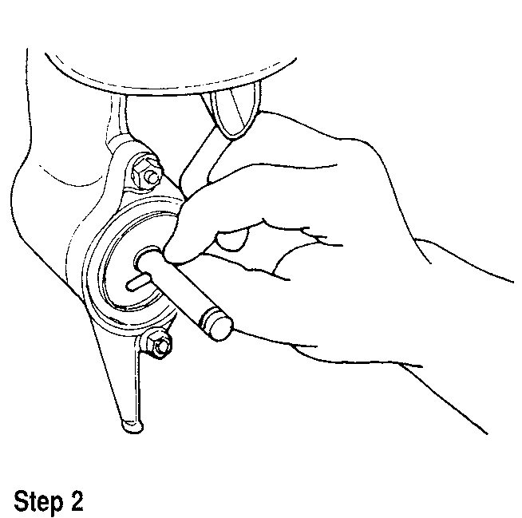

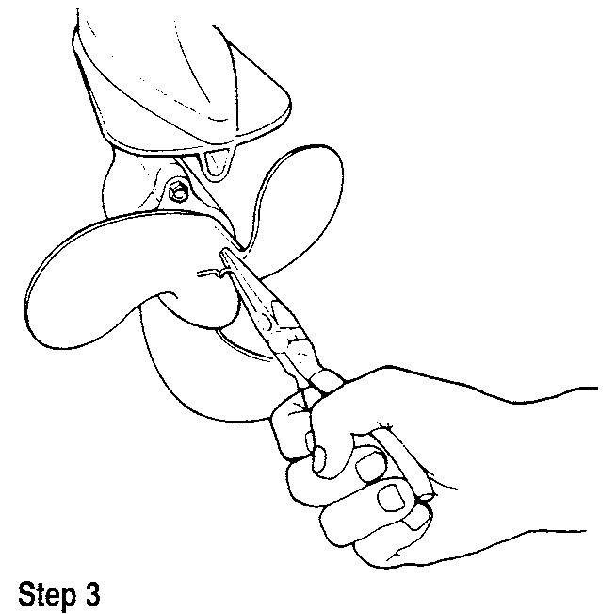

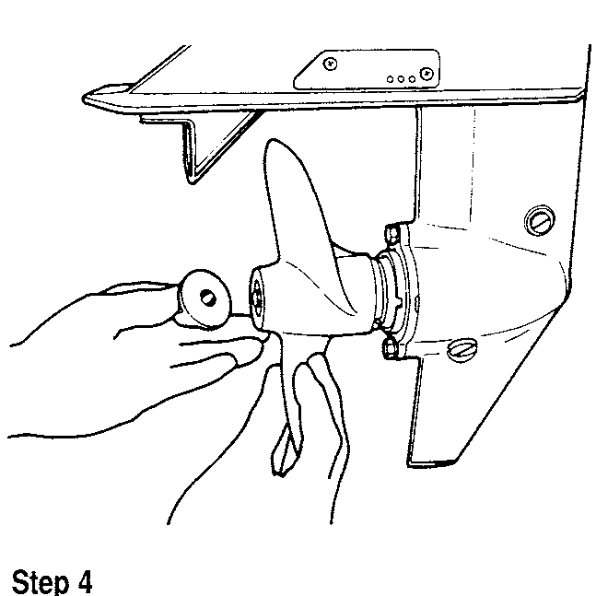

**8-6** LOWER UNIT

**\*\* CAUTION**

**Do not rotate the flywheel counterclockwise. This can damage the water pump impeller and cause the engine to overheat.**

1. Seat the gearcase in place, rotating the flywheel clockwise as required until the driveshaft and crankshaft engage.
2. Apply a silicone sealer to the mounting bolt threads and tighten to spec­ifications.
3. Connect the clutch shaft onto the clutch rod and install the nut. Tighten the nut securely.
4. Install the propeller.
5. Reconnect the spark plug leads and refill the gearcase with proper type and quantity of lubricant. Install the engine cover.

**DT75, DT85, DT115, DT140, V4 and V6 models**

1. Remove the engine cover.
2. Disconnect the spark plug leads to prevent accidental starting of the engine during lower unit removal.
3. Place a container under the gearcase. Remove the vent and drain plugs.
4. Drain the lubricant from the unit.

If **the lubricant is creamy in color or metallic particles are found, the gearcase must be completely disassembled to determine and correct the cause of the problem.**

1. Wipe a small amount of lubricant on a finger and rub the finger and thumb together. Check for the presence of metallic particles in the lubricant. Note the color of the lubricant. A white or creamy color indicates water in the lubricant. Check the drain container for signs of water separation from the lubricant.
2. Remove the propeller.
3. Place the outboard in **NEUTRAL** and remove the cover at the front of the clutch rod.
4. Use needlenose pliers and remove the clutch rod connector cotter pin . Discard the cotter pin.
5. Remove the connector pin .
6. On V6 models, remove the trim tab bolt access cap on the top surface of the driveshaft housing. Remove the bolt and lockwasher securing the trim tab and remove the trim tab.
7. On all other models, remove the bolt and lockwasher securing the trim tab and remove the trim tab.
8. Remove the bolts and lockwashers securing the gearcase to the drive­shaft housing.
9. Remove the gearcase from the driveshaft housing and mount it in a suit­able holding fixture.

**CAUTION**

**Do not grease the top of the driveshaft. This may excessively pre­load the driveshaft and crankshaft when the mounting bolts are tightened and cause a premature failure of the power head or gearcase.**

**To install:**

1. Lightly lubricate the driveshaft splines with waterproof marine grease or equivalent.
2. Apply a thin but uniform coat of a silicone sealer to the gearcase and driveshaft housing mating surfaces.
3. Make sure the locating dowels are in place.
4. Position the gearcase under the driveshaft housing.
5. Align the driveshaft splines with the crankshaft, insert the water tube into the water pump case and the water pump seal tube.
6. Guide the clutch rod into the clutch rod connector.

**CAUTION**

**Do not rotate the flywheel counterclockwise. This can damage the water pump impeller.**

1. Seat the gearcase in place, rotating the flywheel clockwise as required until the driveshaft and crankshaft engage.
2. On DT115 and DT140 models, apply thread locking compound to the mounting bolt threads and tighten securely.
3. On all other models, apply a silicone sealer to the mounting bolt threads and tighten to specifications.
4. Install the trim tab and the bolt and lockwasher. Tighten the bolt securely. On V6 models, install the trim cap over the bolt hole in the driveshaft housing.
5. Connect the clutch rod into the clutch rod connector and insert the con­nector pin through both parts.
6. Install a new cotter pin. Bend the ends over completely.
7. Install the clutch rod cover.
8. Install the propeller.
9. Reconnect the spark plug leads and refill the gearcase case with proper type and quantity of lubricant.
10. Install the engine cover.

**LOWER UNIT OVERHAUL**

**DT2 and DT2.2 (Forward Only)**

DISASSEMBLY

**II See accompanying illustrations** 1. Remove the gearcase.

1. Secure the gearcase in a suitable holding fixture or a vise with protec­tive jaws. If protective jaws are not available, position the gearcase upright with the skeg between wooden blocks in the vise.
2. Remove the water pump case cover.
3. Remove the water pump impeller.
4. Remove the pin.
5. Carefully pry the water pump case free from the gearcase housing .

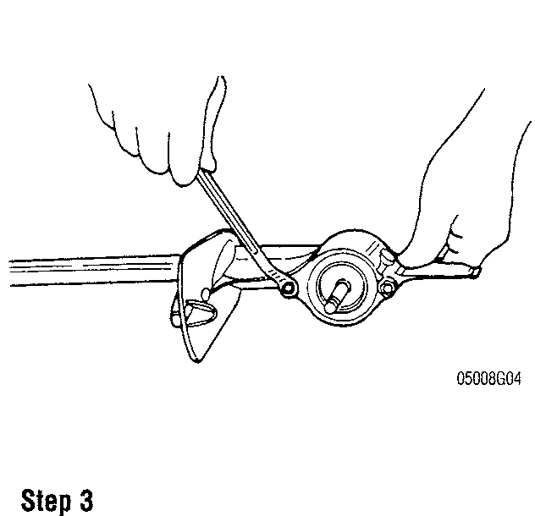

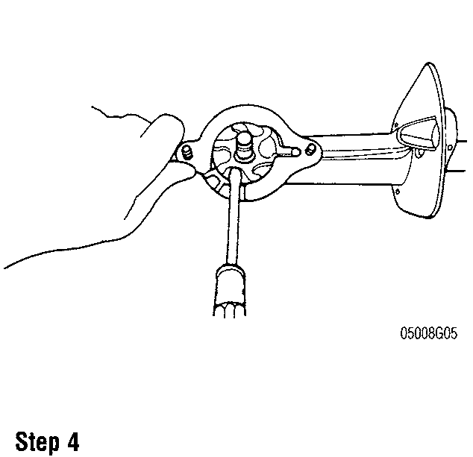

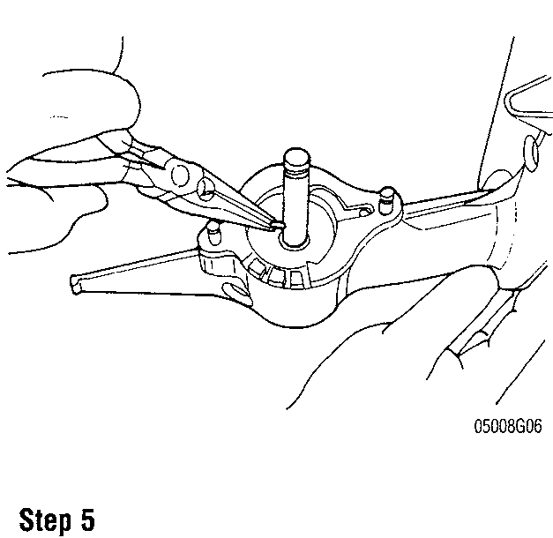

LOWER UNIT **8-7**

1. Draw out the water tube and driveshaft seal pipe.
2. Use a pair of screwdrivers to pry the E-clip from the pinion gear.
3. Take out the driveshaft.
4. Remove the pinion gear and shim(s) from the gearcase housing.
5. Pull out the propeller shaft and gear assembly.
6. Remove the shim(s) from the gearcase housing.
7. Remove the driveshaft seal pipe bushing and oil seal.

CLEANING & INSPECTION

II See Figures 1 and 2

1. Clean and inspect all parts
2. Inspect the driveshaft pinion and propeller shaft gear for broken teeth and wear.
3. Inspect the water pump impeller for wear and damage.
4. Inspect the driveshaft housing oil seal and water pump case oil seal lips for tears, nicks or other damage and wear.
5. Inspect the propeller for damage or distortion.
6. Check the driveshaft and propeller shaft bearings for wear and damage. Make sure there is no damage to these bearings and that they spin smoothly with no rattles or noise.
7. Inspect the cooling water passage to make sure it is clear of debris.
8. If inspection of the driveshaft bearings indicates replacement is required, proceed as follows:

* Remove the driveshaft snap ring with snap-ring pliers .
* Remove the shim(s) from the top driveshaft bearing.
* Insert a bearing remover handle into the seal pipe bore.
* Insert the bearing remover into the gearcase bore and attach to the remover
* Pull the 2 driveshaft bearings and spacer from the gearcase.

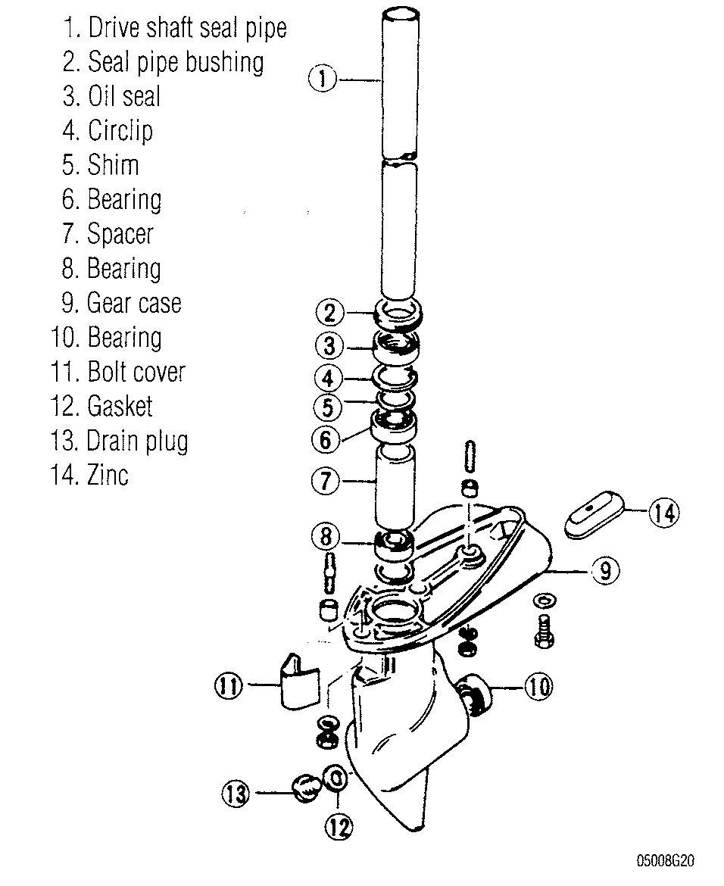

Fig. 1 DT2 and DT2.2 gearcase assembly

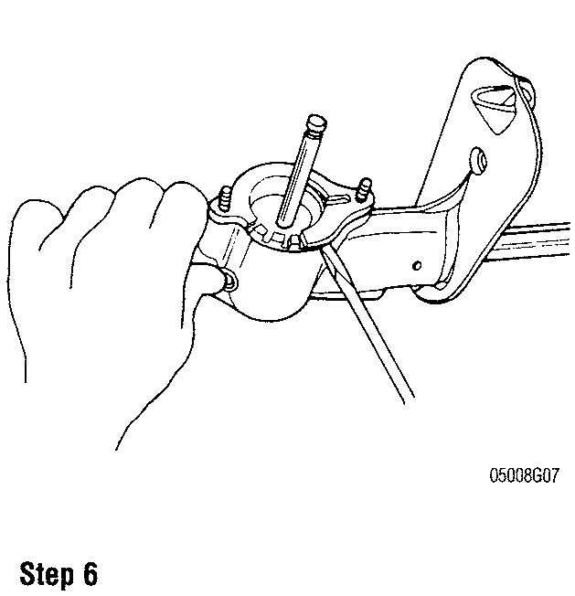

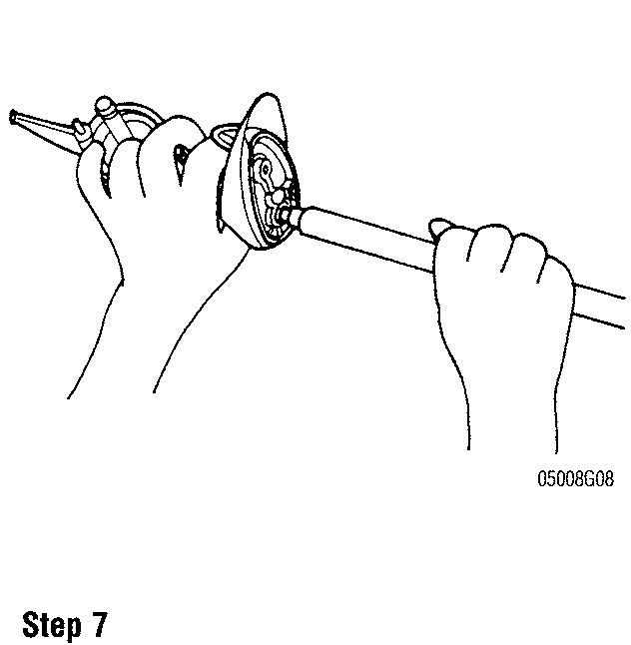

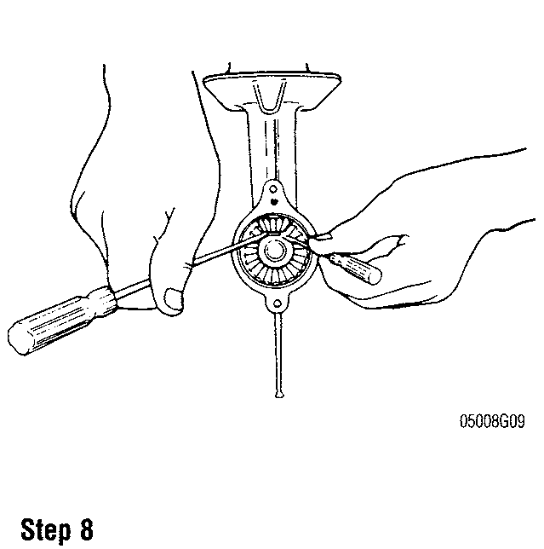

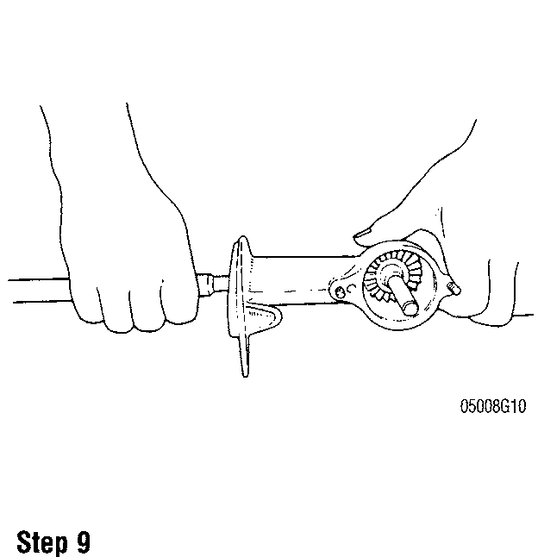

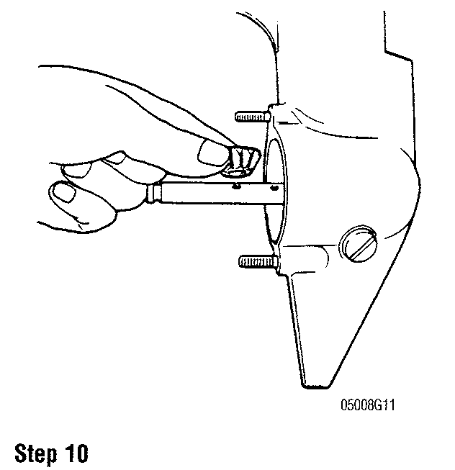

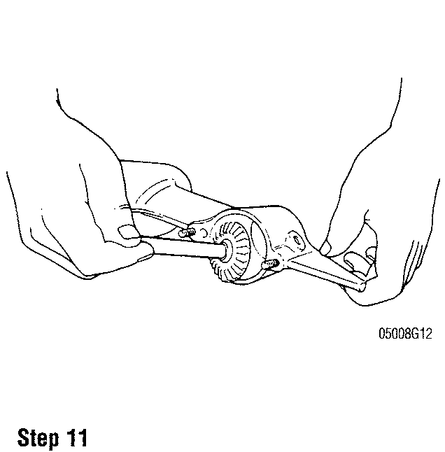

**8-8** LOWER UNIT

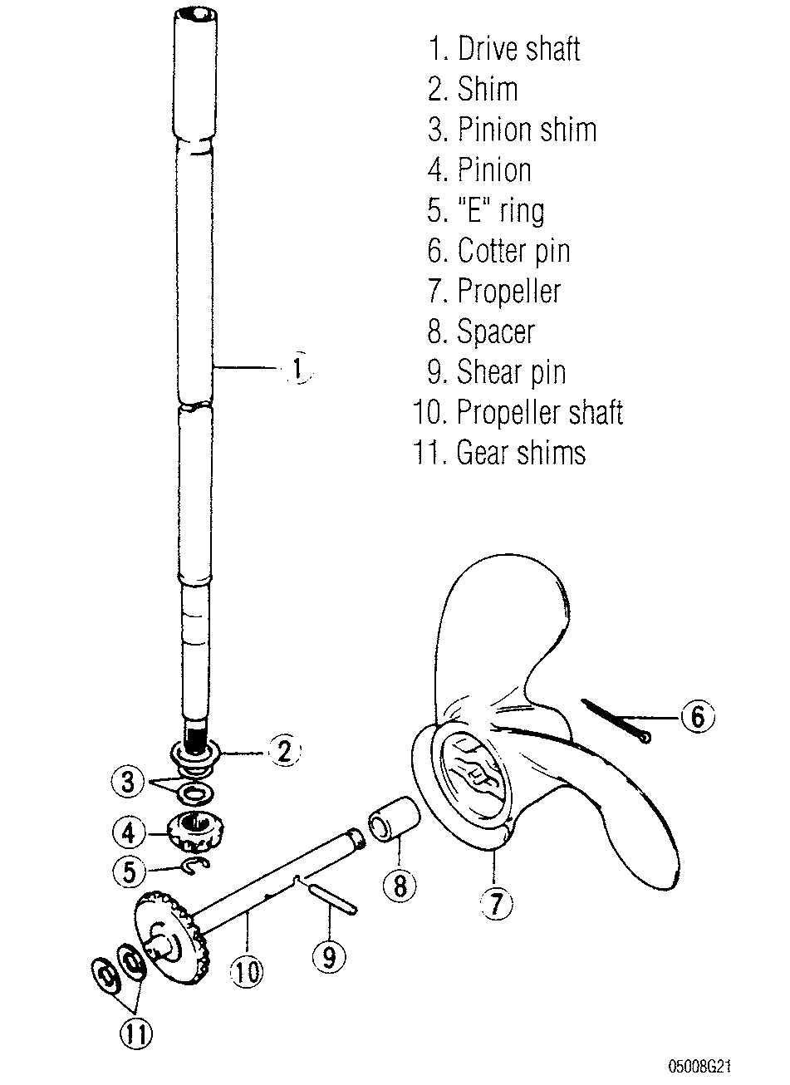

Fig. 2 DT2 and DT2.2 transmission assembly

1. Install the propeller shaft shims and propeller shaft in the gearcase housing.
2. Position the pinion gear and shim(s) in the housing under the driveshaft bore, insert the driveshaft and engage the pinion gear. Install the E-clip on the end of the driveshaft to retain the pinion gear.
3. Install the driveshaft seal pipe and water tube.
4. Remove the water pump case bearing and oil seal.
5. Install a new bearing with an installer (09914-79510).
6. Install a new oil seal and coat its lips with waterproof marine grease.
7. Before installing the water pump case to the gearcase, apply waterproof marine grease to the oil seal.
8. Also apply waterproof marine grease to the 0-ring.
9. Install the water pump. Be sure to position the water pump impeller in the direction shown in the illustration. Note that the impeller vanes curve back relative to the direction of rotation. Don't forget to install the impeller pin.

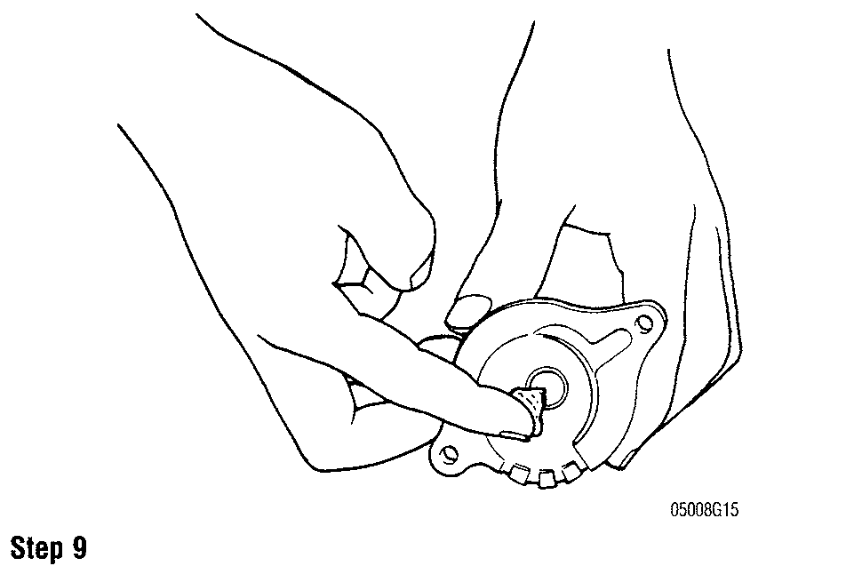

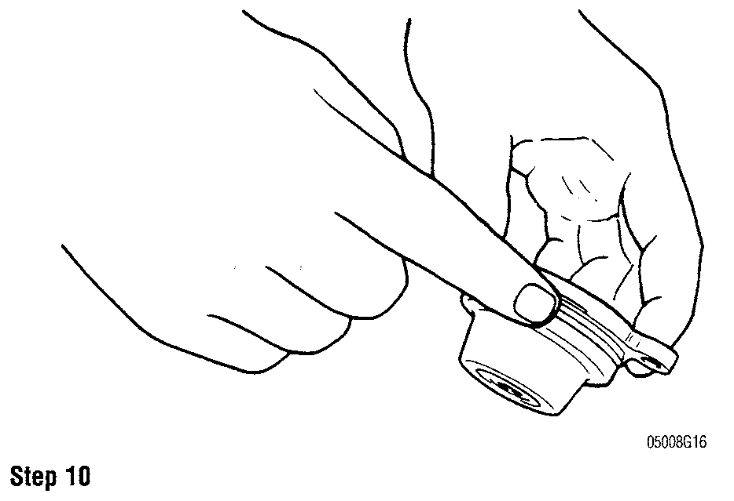

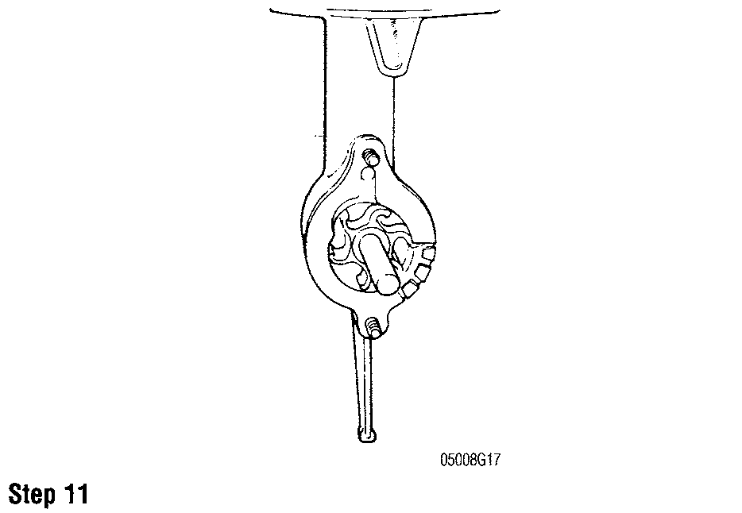

ASSEMBLY

0 See accompanying illustrations

1. If the driveshaft bearings are replaced:

* Install new bearings with the spacer between them using an appropri­ate bearing installer.
* Install the shim(s) on the top driveshaft bearing.
* Install the driveshaft snap ring with pliers.

2. When installing new oil seals, make sure each seal is in its specific location.

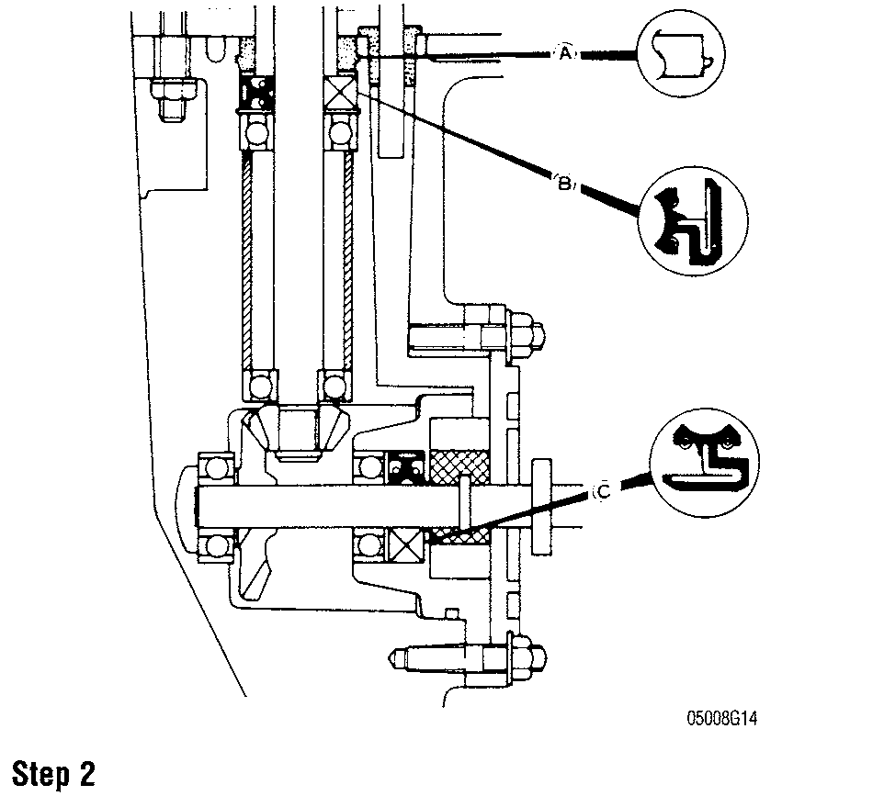

LOWER UNIT **8-9**

1. Apply waterproof marine grease to the propeller shaft and then fit the propeller onto the greased shaft.
2. After installing the gearcase, fill with the correct amount of SAE 90 hypoid gear oil: 1.35 oz. (40cc).
3. Check gearcase lubricant level after engine has been run. Change the lubricant after 10 hours of operation (break-in period).

SHIMMING PROCEDURE

0 See Figure 3

1. Temporarily install the driveshaft with the pinion gear and shims. Pull upward on driveshaft. It should not move more than 0.004in. (0.1mm). If

movement exceeds this specification, remove the snap ring and exchange the shim(s) as required to bring the clearance within specifications. Shim stock is available in three sizes: 0.004 in. (0.1mm); 0.008 in. (0.2mm); 0.020 in. (0.5mm).

1. Once the driveshaft bearing shimming is correct, install a new oil seal and driveshaft bushing. Coat the seal lips with waterproof marine grease.
2. Install the propeller shaft shims and propeller shaft back into the gearcase.

**DT4 and DT5Y**

DISASSEMBLY

1. Secure the gearcase in a holding fixture or a vise with protective jaws. If protective jaws are not available, Place the skeg between two wooden blocks in a vise.
2. Remove the 2 bearing housing bolts. Remove the bearing housing and propeller shaft assembly.
     
     
   Insert a screwdriver into the propeller shaft bearing housing at the section marked with an "0". Gently pry with the screwdriver to separate the housing section.
3. Remove the propeller shaft from the bearing housing.
4. Remove the water pump.
5. After removing the bolt, detach the shift rod guide stopper.
6. Pull out the shift rod assembly from the gearcase.
7. Use a screwdriver to carefully pry loose the driveshaft bearing housing along with the driveshaft.
8. Reach into the propeller shaft bore and remove the pinion gear and the pinion thrust washers .
9. Remove the forward gear and its shims and thrust washer .
10. Remove the bolt on the side of the gearcase, then remove the water filter.
11. Remove the reverse gear and bearing housing from the propeller shaft assembly.
12. Use a screwdriver to remove the clutch dog spring from around the clutch dog shifter.
13. Using a small drift, drive the pin out of the clutch dog shifter.
14. Slide the clutch dog off the propeller shaft.
15. Remove the push pin and return spring from the end of the propeller shaft

CLEANING AND INSPECTION

0 See Figures 4 and 5

1. Clean and inspect all parts.
2. Inspect for abnormal or excessive wear on the following parts:

* Forward gear bearings
* Pinion gear
* Reverse gear
* Driveshaft
* Propeller shaft

Make sure to closely check all the engagement dogs on the gears and clutch dog shifter.

* Inspect the clutch push rod and clutch cam for excessive wear and damage.
* Check the water pump impeller for wear and damage.

Perform a gearcase pressure check.

* While rotating the driveshaft and propeller shaft, apply the pressure (14.2 psi) through the oil drain plug using the oil leakage tester (09950­69511) and air pump assembly (09821-00004). Once the correct pressure has been reached, watch the pressure, if it falls, then there is a sealing problem and you will need to find out which seal is leaking. Use a mixture of soapy water and spray the area around each seal to check for air bubbles escaping. This will indicate which seal is leaking and needs to be replaced.
    
    
  First apply a low pressure of 2.8-5.7 psi to set the sealing lip of the seals. Then apply the full pressure to the seals. This check should be done after reassembly.

Be sure that the coolant passages are clean and free of signs of corrosion. Also make sure that the water tube is clear.

Inspect the splines of the driveshaft for signs of wear and damage.

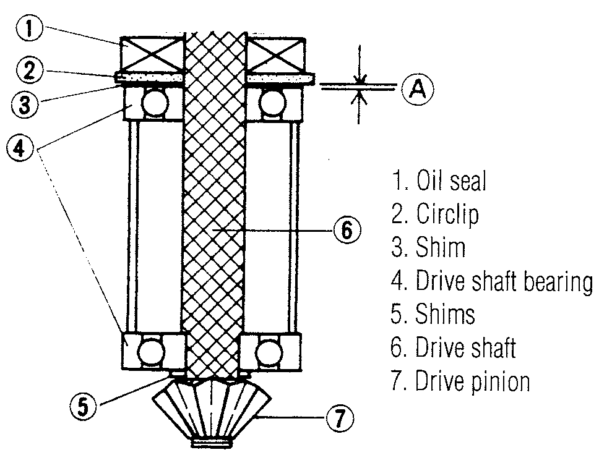

Fig. 3 Temporarily install the driveshaft with the pinion gear and shims. Pull upward on driveshaft. It should not move more than 0.004in. (0.1mm)

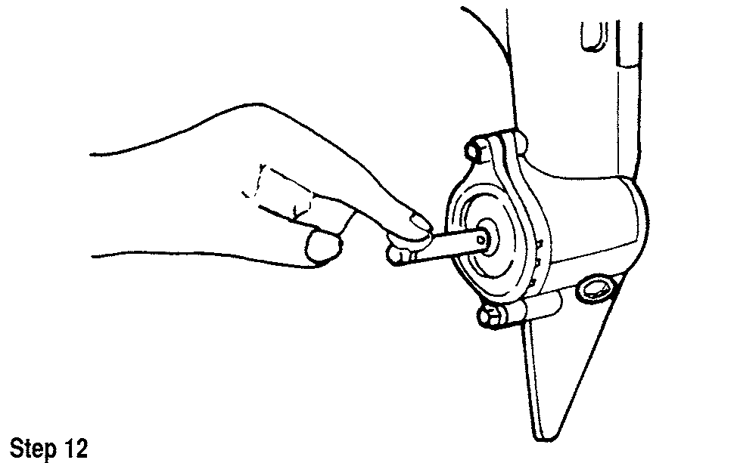

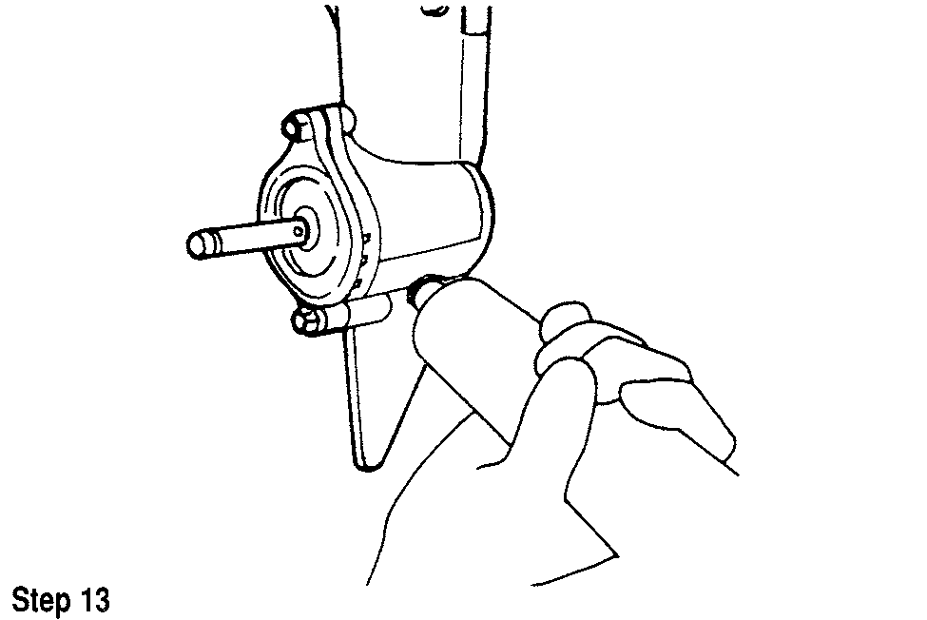

1 1

**HAND REWIND**

**STARTER**

**HAND REWIND STARTER 11-2**

**OVERHEAD TYPE STARTER 11-2 BENDIX TYPE STARTER 11-10**

**HAND REWIND STARTER 11-2** DESCRIPTION AND OPERATION 11-2 TROUBLESHOOTING THE HAND REWIND STARTER 11-2

**OVERHEAD TYPE STARTER 11-2**

DT2, DT2.2, DT4 AND DT5Y 11-2 REMOVAL & INSTALLATION 11-2 DISASSEMBLY 11-2

CLEANING AND INSPECTION 11-3 ASSEMBLY 11-3

DT5, DT6 AND DT8 11-4

REMOVAL & INSTALLATION 11-4 DISASSEMBLY 11-4

CLEANING AND INSPECTION 11-4 ASSEMBLY 11-6

DT9.9 AND DT15 11-6

REMOVAL & INSTALLATION 11-6 ADJUSTMENT 11-6 DISASSEMBLY 11-7

CLEANING AND INSPECTION 11-7 ASSEMBLY 11-7

DT20, DT25 AND DT28 11-8

REMOVAL & INSTALLATION 11-8 DISASSEMBLY 11-8

CLEANING AND INSPECTION 11-8 ASSEMBLY 11-9

DT25C, DT30C, DT35C AND DT40C 11-9 REMOVAL & INSTALLATION 11-9 ADJUSTMENT 11-9

DISASSEMBLY 11-9

CLEANING AND INSPECTION 11-10 ASSEMBLY 11-10

**BENDIX TYPE STARTER 11-10**

DT5, DT6 AND DT8 11-10

REMOVAL & INSTALLATION 11-10 DISASSEMBLY 11-10

CLEANING AND INSPECTION 11-11 ASSEMBLY 11-11

DT20, DT25 AND DT28 11-11

REMOVAL & INSTALLATION 11-11 DISASSEMBLY 11-11

CLEANING AND INSPECTION 11-12 ASSEMBLY 11-12

**11-2** HAND REWIND STARTER

**HAND REWIND STARTER**

**Description and Operation**

II See Figures 2, 3 and 4

The main components of a hand rewind starter (recoil starter) are the cover, rewind spring and pawl arrangement. Pulling the rope rotates the pulley, winds the spring and activates the pawl into engagement with the starter hub at the top of the flywheel. Once the pawl engages the hub, the powerhead is spun as the rope unwinds from the pulley.

Releasing the rope on rewind starter moves the pawl out of mesh with the hub. The powerful clock-type spring recoils the pulley in the reverse direction to rewind the rope to the original position.

Some starters may use a Neutral Start Interlock (NSI) system. The hand rewind starter should not function when the shift handle is in any other position than NEUTRAL. This prevents starting in gear and possibly throwing the occupants overboard. Always check for the proper function of this system after any repairs.

**Troubleshooting The Hand Rewind Starter**

Repair on hand rewind starter units is generally confined to rope, pawl and occasionally spring replacement.

**\*\*CAUTION**

When replacing the recoil starter spring extreme caution must be used. The spring is under tension and can be dangerous if not released properly.

Starters which use friction springs to assist pawl action may suffer from bent springs. This will cause the amount of friction exerted to not be correct and the pawl will not be moved into engagement.

Models equipped with a neutral start interlock system may experience a no-start condition due to a misadjusted interlock cable. The hand rewind starter should only function when the shift handle is in the NEUTRAL position.

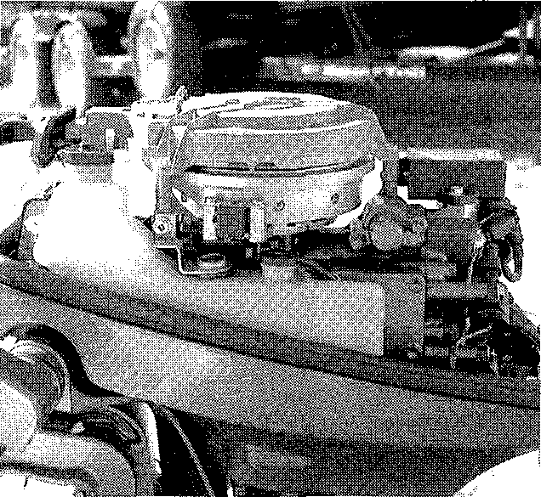

Fig. 2 A typical hand rewind starter assembly sits atop the outboard's flywheel

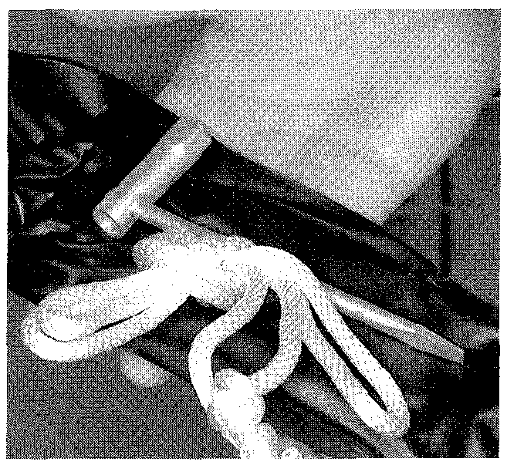

Fig. 2 On larger outboards with electric starters, an emergency hand-pull rope ...

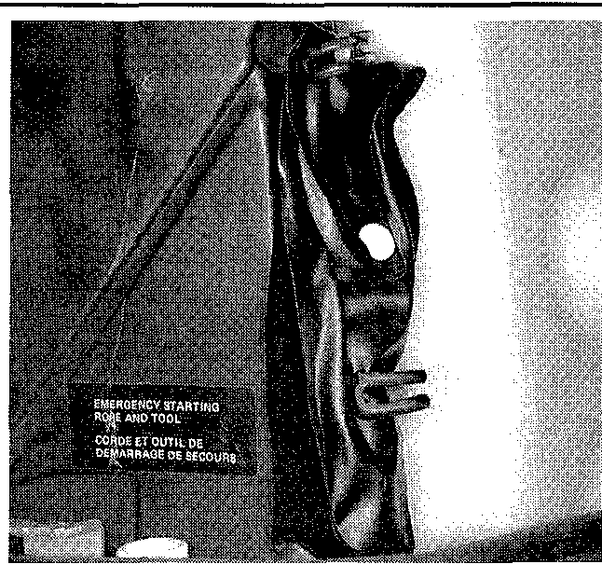

Fig. 3 ... is usually mounted under the cowl

**OVERHEAD TYPE STARTER**

**DT2, DT2.2, DT4 and DT5Y**

REMOVAL & INSTALLATION

1. Remove the engine cover fasteners and lift off the engine covers.
2. Remove the recoil starter assembly attaching bolts and lift the assembly from the powerhead.-

To install:

1. Place the recoil starter assembly on the powerhead and tighten the attaching nuts securely.
2. Install the engine covers and secure them with the cover fasteners.
3. Pull the starter knob several times and check for the proper operation of the ratcheting mechanism.

DISASSEMBLY

► See Figures 4, 5 and 6

1. Pull the starter rope out as far as it will come and hold the drum with your finger to prevent the rope from rewinding.
2. Hook the rope on the notch of the drum and gently rotate the drum clockwise to release spring tension.

a* The coil spring will be will attempt to turn the drum quickly. Using your finger, prevent the drum from spinning.

1. With the rope and spring fully stretched and the drum turned all the way, remove the drum securing bolt.
2. Remove the plate that covers the drum and the ratcheting pawl.

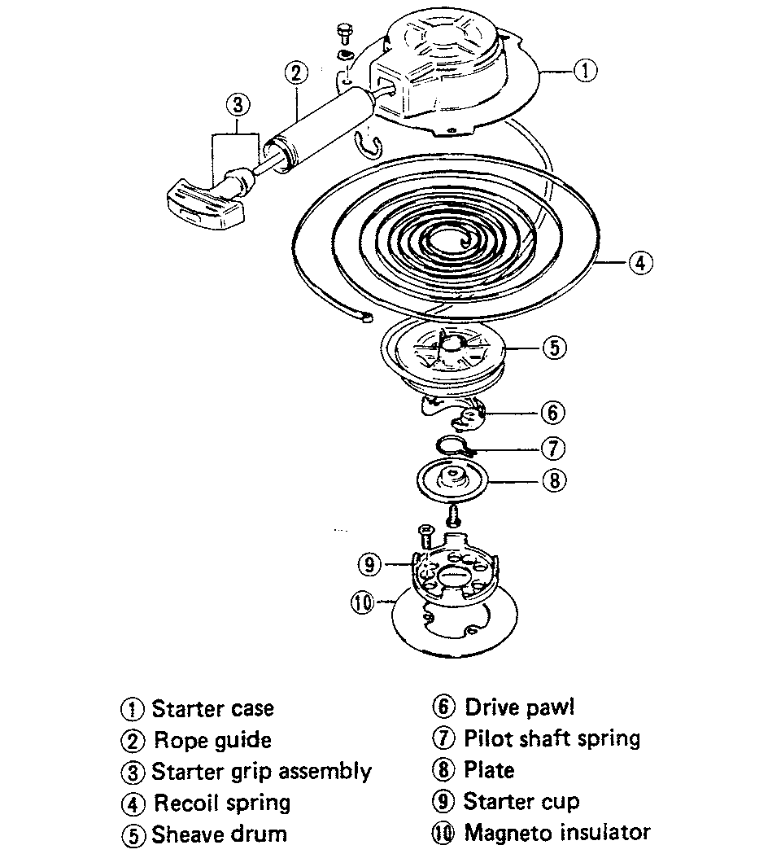

Fig. 4 Exploded view of the starter assembly - DT2 and DT2.2

HAND REWIND STARTER **11-3**

Fig. 6 If the drum will not lift out smoothly, disengage the spring from the drum using screwdriver inserted into the hole on drum

Fig. 5 Removing the plate that covers the drum and the ratcheting pawl

► See Figures 8, 9 and 10

1. Position the coil spring in the starter case, feeding the outer portion of the spring into the case first and positioning the remainder in the case gradually.

ASSEMBLY

Fig. 7 Lubricate the starter assembly at the following locations -DT2, DT2.2, DT4 and DT5Y

**CAUTION**

1. Remove the drum by lifting it gently from the housing. If the drum will not lift out smoothly, disengage the spring from the drum using screwdriver inserted into the hole on drum .

It is advisable to wear heavy gloves while removing the spring to prevent your hands from being cut by the sharp spring steel.

**\*\*CAUTION**

The starter drum spring is under high tension. If the spring should come loose, it may cause serious damage or personal injury. Take all applicable cautions when working with this spring.

1. Carefully remove the coil spring from the starter case. CLEANING AND INSPECTION

**I** See Figure 7

Clean all components and then blow them dry using compressed air. Remove any trace of corrosion and wipe all metal parts with an oil dampened cloth to prevent future corrosion.

Inspect the rope. Replace the rope if it appears to be weak or frayed. If the rope is frayed, check the holes through which the rope passes for rough edges or burrs. Remove the rough edges or burrs with a file and polish the surface until it is smooth.

Inspect the starter return spring end hooks. Replace the spring if it is weak, corroded or cracked. Inspect the inside surface of the starter case and drum for grooves or roughness. Grooves may cause erratic rewinding of the starter rope.

Inspect and lubricate the ratchet mechanism with waterproof grease. Check the mechanism for freedom of movement.

During installation, the spring will be placed under high tension. Take all applicable cautions when working with this spring.

2. Place the bent end of the spring into the groove on the drum.

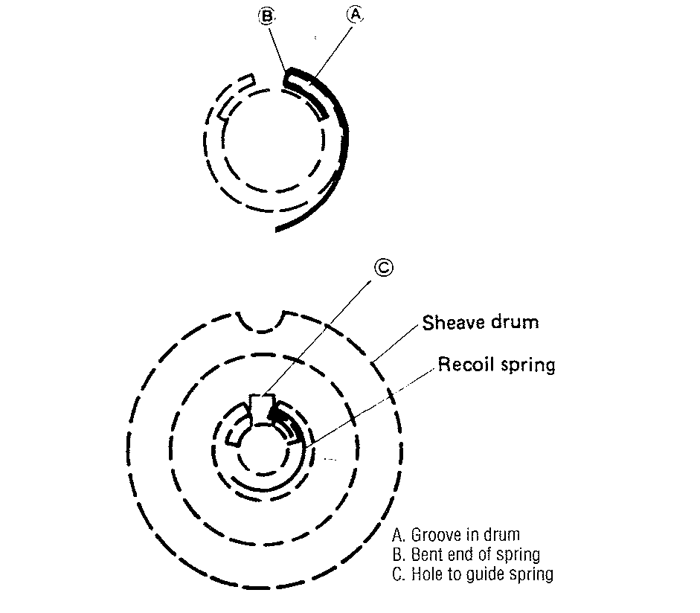

Fig. 8 If the spring is not engaged properly during assembly, insert a rod into the hole on the drum and guide the spring end into engagement with the drum

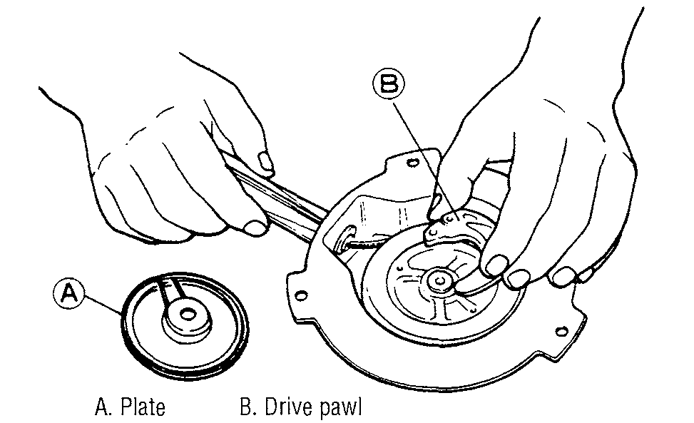

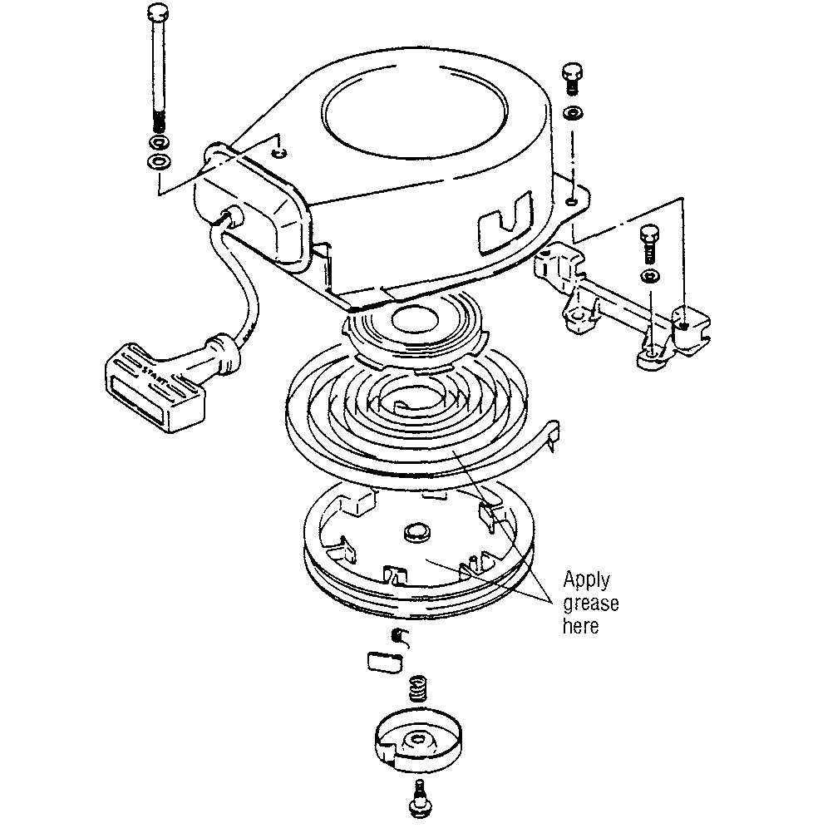

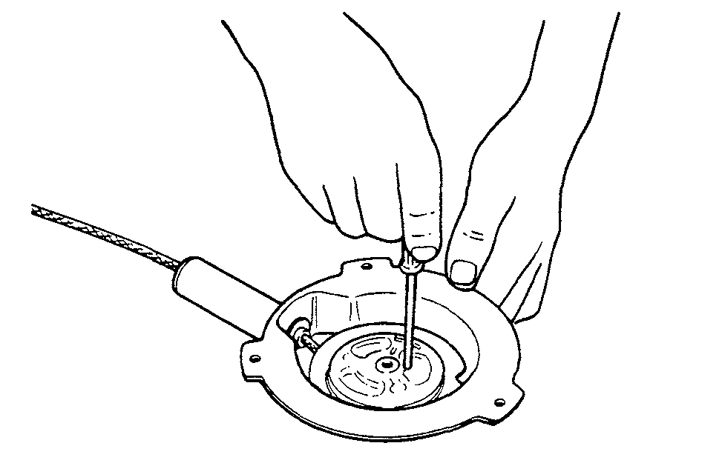

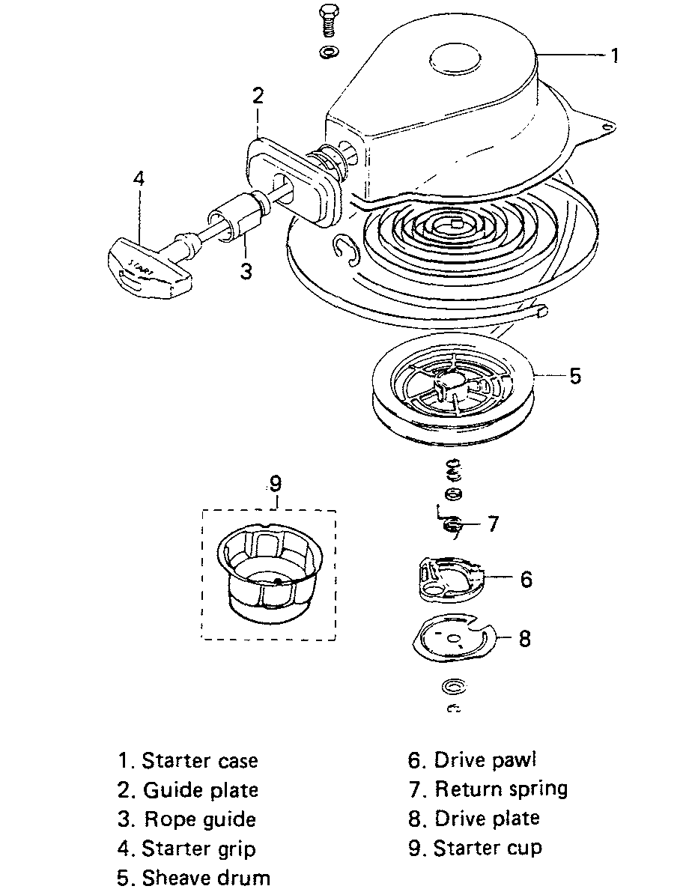

**11-4** HAND REWIND STARTER

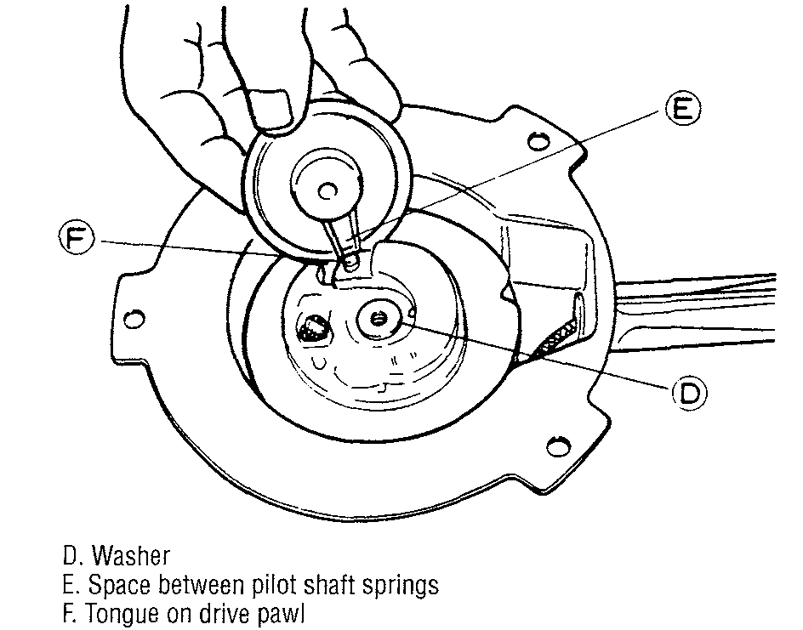

**Fig. 9 Ensure the tongue on the drive pawl is properly positioned into the space between the pilot shaft springs on the plate**

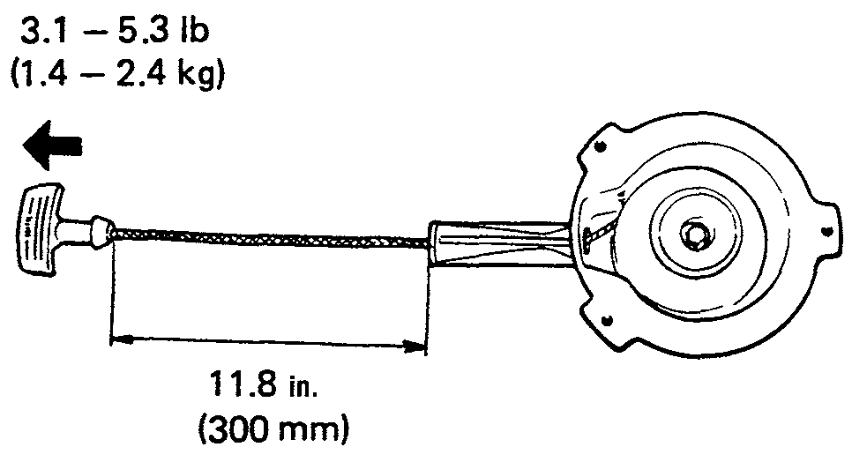

**Fig. 10 Rope length should be 11.8 in. (300mm) between the pull handle and the starter case**

1. Twist the drum counterclockwise to make sure the spring is positively engaged. If resistance is not felt, the spring may not be engaged properly. If this is the case, insert a rod into the hole on the drum and guide the spring end into engagement with the drum.
2. Install the washer, drive pawl and plate. Ensure the tongue on the drive pawl is properly positioned into the space between the pilot shaft springs on the plate.
3. Secure the drum in place by tightening the bolt securely.
4. Attach the pull rope in to the notch on the drum and turn the drum counterclockwise 6 rotations.
5. Remove the rope from the notch and gently wind it in under the force of the spring to take it up into the drum.
6. Measure the spring resistance using a fish scale. If should be 3.1-5.3 lbs. of pulling force.
7. If resistance is not within specification, adjust the amount of counter­clockwise rotations made prior to allowing rope to rewind into the drum.
8. Measure the length of the rope at full extension. Rope length should be 11.8 in. (300mm) between the pull handle and the starter case.

**DT6 and DT8**

REMOVAL & INSTALLATION

1. Remove the engine cover fasteners and lift off the engine covers.
2. Remove the recoil starter assembly attaching bolts and lift the assembly from the powerhead.

**To install:**

1. Place the recoil starter assembly on the powerhead and tighten the attaching nuts securely.
2. Install the engine covers and secure them with the cover fasteners.
3. Pull the starter knob several times and check for the proper operation of the ratcheting mechanism.

DISASSEMBLY

**See Figure 11**

1. Hook the rope on the notch of the drum and gently rotate the drum clock­wise to release spring tension.
2. Remove the E-clip and drive plate that covers the drive pawl.
3. Remove the return spring and spacer, then remove the drive pawl.
4. Remove the drum.

It **is advisable to wear heavy gloves while removing the spring to pre­vent your hands from being cut by the sharp spring steel.**

**\*\* CAUTION**

**The starter drum spring is under high tension. If the spring should come loose, it may cause serious damage or personal injury. Take all applicable cautions when working with this spring.**

1. Carefully remove the coil spring from the starter case.

CLEANING & INSPECTION

**See Figure 12**

Clean all components and then blow them dry using compressed air. Remove any trace of corrosion and wipe all metal parts with an oil dampened cloth to prevent future corrosion.

Inspect the rope. Replace the rope if it appears to be weak or frayed. If the
  
rope is frayed, check the holes through which the rope passes for rough edges

**Fig. 11 Exploded view of the starter assembly—DT6 and DT8**

ADDITIONAL INPUTS 4-48 AIR/OIL MIXING VALVE 6-7

REMOVAL & INSTALLATION 6-7

AIR TEMPERATURE SENSOR 4-39 DESCRIPTION & OPERATION 4-39

REMOVAL & INSTALLATION 4-39

TESTING 4-39

ALL OTHER MODELS 4-25 INSPECTION & CLEANING 4-26

REED & REED STOP REPLACEMENT 4-26

REMOVAL & INSTALLATION 4-26

ALTERNATOR (STATOR) 5-40 TESTING 5-40

ATMOSPHERIC PRESSURE SENSOR 4-39

DESCRIPTION & OPERATION 4-39

REMOVAL & INSTALLATION 4-39

TESTING 4-39

AVOIDING THE MOST COMMON MISTAKES 1-3

AVOIDING TROUBLE 1-2

BASIC ELECTRICAL THEORY 5-2

HOW ELECTRICITY WORKS: THE WATER ANALOGY 5-2

OHM'S LAW 5-2

BATTERY (BOAT MAINTENANCE) 3-9

BATTERY & CHARGING SAFETY PRECAUTIONS 3-11 BATTERY CHARGERS 3-11

BATTERY TERMINALS 3-11 CHECKING SPECIFIC GRAVITY 3-10

CLEANING 3-10

REPLACING BATTERY CABLES 3-12

BATTERY (CHARGING CIRCUIT) 5-41

BATTERY CABLES 5-45 BATTERY CHARGERS 5-44 BATTERY CONSTRUCTION 5-41

BATTERY LOCATION 5-42 BATTERY RATINGS 5-42 BATTERY SERVICE 5-42 BATTERY STORAGE 5-45 BATTERY TERMINALS 5-44 MARINE BATTERIES 5-41 SAFETY PRECAUTIONS 5-44

BEARINGS 7-44

GENERAL INFORMATION 7-44 INSPECTION 7-45

**BENDIX TYPE STARTER 11-10** BLEEDING THE OIL INJECTION SYSTEM 6-3

PROCEDURE 6-3

**BOAT MAINTENANCE 3-8 BOATING SAFETY 1-4**

BOLTS, NUTS AND OTHER THREADED RETAINERS 2-14 BREAKER POINTS 5-8

POINT GAP ADJUSTMENT 5-8 REMOVAL & INSTALLATION 5-9

TESTING 5-9

**BREAKER POINTS IGNITION (MAGNETO IGNITION) 5-7** BUY OR REBUILD? 7-33

CAN YOU DO IT? 1-2

CAPACITIES 3-2

**CAPACITOR DISCHARGE IGNITION (CDI) SYSTEM 5-11** CARBURETION 4-3

BASIC FUNCTIONS 4-5 CARBURETOR CIRCUITS 4-4 DUAL-THROAT CARBURETORS 4-6

GENERAL INFORMATION 4-3

REMOVING FUEL FROM THE SYSTEM 4-6

CARBURETOR IDLE AIR SCREW SPECIFICATION 3-33 **CARBURETOR SERVICE 4-11**

CDI UNIT 5-28

DESCRIPTION & OPERATION 5-28

REMOVAL & INSTALLATION 5-34

TESTING 5-28

**CHARGING CIRCUIT 5-39**

VASTER

I\DEX

**11-18** MASTER INDEX

DT9.9 AND DT15 (LOWER UNIT OVERHAUL) 8-14

ASSEMBLY 8-16

CLEANING & INSPECTION 8-15

DISSASSEMBLY 8-14

SHIMMING PROCEDURE 8-17

DT9.9 AND DT15 (OVERHEAD TYPE STARTER) 11-6

ADJUSTMENT 11-6 ASSEMBLY 11-7

CLEANING & INSPECTION 11-7

DISASSEMBLY 11-7

REMOVAL & INSTALLATION 11-6

DT9.9 AND DT15 (TUNE-UP) 3-21

IDLE SPEED 3-21 IGNITION TIMING 3-21

DT9.9, DT15 AND 1989-97 DT8 (CARBURETOR SERVICE) 4-15 ASSEMBLY 4-17

CLEANING & INSPECTION 4-16

DISASSEMBLY 4-16

REMOVAL & INSTALLATION 4-15

DT20 AND DT25 (BENDIX TYPE STARTER) 11-11

ASSEMBLY 11-12

CLEANING &INSPECTION 11-12

DISASSEMBLY 11-11

REMOVAL & INSTALLATION 11-11

DT20 AND DT25 (OVERHEAD TYPE STARTER) 11-8

ASSEMBLY 11-9

CLEANING & INSPECTION 11-8

DISASSEMBLY 11-8

REMOVAL & INSTALLATION 11-8

DT20, DT25 AND DT30 (LOWER UNIT OVERHAUL) 8-19

ASSEMBLY 8-20

CLEANING & INSPECTION 8-20

DISASSEMBLY 8-19 SHIMMING PROCEDURE 8-22

DT20, DT25 AND DT30 (TUNE-UP) 3-22

IDLE SPEED 3-22 IGNITION TIMING 3-22

THROTTLE LINKAGE ADJUSTMENT 3-22

DT20 TO DT85, DT115 AND DT140 (CARBURETOR SERVICE) 4-17 ASSEMBLY 4-21

CLEANING & INSPECTION 4-21

DISASSEMBLY 4-20

REMOVAL & INSTALLATION 4-19

DT25C, DT30C, DT35C AND DT40C (OVERHEAD TYPE STARTER) 11-9 ADJUSTMENT 11-9

ASSEMBLY 11-10

CLEANING & INSPECTION 11-10

DISASSEMBLY 11-9

REMOVAL & INSTALLATION 11-9

DT35 AND DT40 (LOWER UNIT OVERHAUL) 8-24

ASSEMBLY 8-24

CLEANING & INSPECTION 8-24

DISASSEMBLY 8-24 SHIMMING PROCEDURE 8-26

DT35 AND DT40 (TUNE-UP) 3-23

IDLE SPEED 3-25 IGNITION TIMING 3-23

THROTTLE LINKAGE 3-26

DT55 AND DT65 (LOWER UNIT OVERHAUL) 8-28

ASSEMBLY 8-31

CLEANING & INSPECTION 8-30

DISASSEMBLY 8-28 SHIMMING PROCEDURE 8-32

DT55 AND DT65 (TUNE-UP) 3-26

IDLE SPEED 3-26 IGNITION TIMING 3-26

THROTTLE LINKAGE 3-27

DT75 AND DT85 (LOWER UNIT OVERHAUL) 8-35

ASSEMBLY 8-38

CLEANING & INSPECTION 8-36 DISASSEMBLY 8-35

SHIMMING PROCEDURE 8-39 DT75 AND DT85 (TUNE-UP) 3-29

CARBURETOR LINKAGE ADJUSTMENT 3-29

IDLE SPEED 3-29

IGNITION TIMING 3-29

DT90 AND DT100 (TUNE-UP) 3-30 CARBURETOR LINKAGE ADJUSTMENT 3-30

IDLE SPEED 3-30

IGNITION TIMING 3-30

DT115 AND DT140 (LOWER UNIT OVERHAUL) 8-44 ASSEMBLY 8-45

CLEANING & INSPECTION 8-44 DISASSEMBLY 8-44

SHIMMING PROCEDURE 8-45

DT115 AND DT140 (TUNE-UP) 3-30 CARBURETOR LINKAGE 3-31 IDLE SPEED 3-32

IGNITION TIMING 3-30

DT150, DT175, DT200 3-32

CARBURETOR LINKAGE 3-32 IDLE SPEED 3-32

IGNITION TIMING 3-32

ELECTRICAL COMPONENTS 5-2 CONNECTORS 5-4

GROUND 5-3

LOAD 5-3

POWER SOURCE 5-2

PROTECTIVE DEVICES 5-3 SWITCHES & RELAYS 5-3

WIRING & HARNESSES 5-4 ELECTRICAL SYSTEM PRECAUTIONS 5-7 **ELECTRONIC FUEL INJECTION 4-32 ELECTRONIC IGNITION 5-38**

EMERGENCY STOP SWITCH (REMOTE CONTROL BOX) 10-5

REMOVAL & INSTALLATION 10-5

TESTING 10-5

EMERGENCY STOP SWITCH (TILLER HANDLE) 10-10 REMOVAL & INSTALLATION 10-10

TESTING 10-10

**ENGINE MAINTENANCE 3-2 ENGINE MECHANICAL 7-2**

ENGINE REBUILDING SPECIFICATIONS 7-49 ENGINE START SWITCH 10-10

REMOVAL & INSTALLATION 10-10

TESTING 10-10

ENGINE STOP SWITCH (REMOTE CONTROL BOX) 10-5 REMOVAL & INSTALLATION 10-5

TESTING 10-5

ENGINE STOP SWITCH (TILLER HANDLE) 10-10

REMOVAL & INSTALLATION 10-10 TESTING 10-10

EQUIPMENT NOT REQUIRED BUT RECOMMENDED 1-10 ANCHORS 1-10

BAILING DEVICES 1-10

FIRST AID KIT 1-10

SECOND MEANS OF PROPULSION 1-10 TOOLS AND SPARE PARTS 1-11 VHF-FM RADIO 1-11

**FASTENERS, MEASUREMENTS AND CONVERSIONS 2-14** FIBERGLASS HULLS 3-8

FLYWHEEL 7-2

INSPECTION 7-5

REMOVAL & INSTALLATION 7-2 FUEL 4-2

ALCOHOL-BLENDED FUELS 4-2

MASTER INDEX **11-19**

HIGH ALTITUDE OPERATION 4-2

OCTANE RATING 4-2

RECOMMENDATIONS 4-2

THE BOTTOM LINE WITH FUELS 4-2

VAPOR PRESSURE AND ADDITIVES 4-2

**FUEL AND COMBUSTION 4-2**

FUEL FILTER 3-4

RELIEVING FUEL SYSTEM PRESSURE 3-5

REMOVAL & INSTALLATION 3-5

FUEL INJECTORS 4-45

DESCRIPTION & OPERATION 4-45

TESTING 4-45 FUEL LINE 4-9

COMMON PROBLEMS 4-10

FUEL PRESSURE REGULATOR 4-46

REMOVAL & INSTALLATION 4-47

TESTING 4-46

FUEL PUMP (FUEL SYSTEM) 4-6

FUEL PUMP (TROUBLESHOOTING) 4-8

**FUEL PUMP SERVICE 4-27**

**FUEL SYSTEM 4-3**

FUEL SYSTEM (TROUBLESHOOTING) 4-7

COMMON PROBLEMS 4-8

LOGICAL TROUBLESHOOTING 4-7

FUEL/WATER SEPARATOR 3-6

GAS ASSIST DAMPER 9-2

REMOVAL & INSTALLATION 9-2

TESTING 9-2

**GAS ASSISTED TILT 9-2**

GEAR COUNTER COIL (ENGINE SPEED SENSOR) 4-45 DESCRIPTION & OPERATION 4-45

TESTING 4-45

GENERAL ENGINE SPECIFICATIONS 3-38

GENERAL INFORMATION (LOWER UNIT) 8-2

**HAND REWIND STARTER 11-2**

HAND TOOLS 2-5 ELECTRONIC TOOLS 2-10

GAUGES 2-11 HAMMERS 2-9 OTHER COMMON TOOLS 2-10

PLIERS 2-9

SCREWDRIVERS 2-9

SOCKET SETS 2-5 SPECIAL TOOLS 2-10

WRENCHES 2-8

HIGH PRESSURE FUEL PUMP 4-47

TESTING 4-48

**HOW TO USE THIS MANUAL 1-2**

**IGNITION AND ELECTRICAL WIRING DIAGRAMS 5-52** IGNITION COIL (BREAKER POINTS IGNITION) 5-10 DESCRIPTION & OPERATION 5-10

REMOVAL & INSTALLATION 5-11

TESTING 5-11

IGNITION COILS (CAPACITOR DISCHARGE IGNITION SYSTEM) 5-25

DESCRIPTION & OPERATION 5-25

REMOVAL & INSTALLATION 5-26

TESTING 5-25
  
IGNITION SWITCH 10-6

REMOVAL & INSTALLATION 10-6

TESTING 10-6
  
IGNITION SYSTEM 3-17

INSIDE THE BOAT 3-8 INTRODUCTION 3-12 **JET DRIVE 8-51**

JET DRIVE ASSEMBLY 8-51

ADJUSTMENT 8-54

ASSEMBLING 8-57

CLEANING & INSPECTING 8-56 DISASSEMBLY 8-56

REMOVAL & INSTALLATION 8-51 **LOWER UNIT 8-2**

LOWER UNIT (ENGINE MAINTENANCE) 3-3 DRAINING & FILLING 3-3

OIL RECOMMENDATIONS 3-3 **LOWER UNIT OVERHAUL 8-6** LOWER UNIT-NO REVERSE GEAR 8-3

REMOVAL & INSTALLATION 8-3
  
LOWER UNIT-WITH REVERSE GEAR 8-3

REMOVAL & INSTALLATION 8-3 MAINTENANCE OR REPAIR? 1-2 **MANUAL TILT 9-2**

MEASURING TOOLS 2-12

DEPTH GAUGES 2-13

DIAL INDICATORS 2-13

MICROMETERS & CALIPERS 2-12 TELESCOPING GAUGES 2-13

MODEL IDENTIFICATION AND SERIAL NUMBERS 8-51

NEUTRAL START SWITCH 10-2 REMOVAL & INSTALLATION 10-2 TESTING 10-2

OIL FLOW SENSOR 6-17

CLEANING & INSPECTION 6-17 REMOVAL & INSTALLATION 6-17 TESTING 6-17

**OIL INJECTION SYSTEM 6-2**

OIL INJECTION WARNING SYSTEM 6-15

**OIL INJECTION WARNING SYSTEMS 6-14**

OIL LEVEL SENSOR 6-16

REMOVAL & INSTALLATION 6-16 TESTING 6-16

OIL LINES 6-6

OIL LINE CAUTIONS 6-6

REMOVAL & INSTALLATION 6-6 OIL PUMP 6-5

REMOVAL & INSTALLATION 6-5 OIL PUMP CONTROL ROD 6-8 ADJUSTMENT 6-8

OIL PUMP DISCHARGE RATE (OIL INJECTION) 6-8

OIL PUMP DISCHARGE RATE (OIL INJECTION SYSTEM) 6-7 ADJUSTMENT 6-8

TESTING 6-7

OIL TANK 6-3

CLEANING & INSPECTION 6-4

REMOVAL & INSTALLATION 6-3 **OVERHEAD TYPE STARTER 11-2** OVERHEAT SENSOR 6-19

REMOVAL & INSTALLATION 6-19 TESTING 6-19

**OVERHEAT WARNING SYSTEM 6-17**

OVERHEAT WARNING SYSTEM (OIL INJECTION) 6-18 PISTON PINS 7-39

GENERAL INFORMATION 7-39 INSPECTION 7-39

PISTON RINGS 7-40

GENERAL INFORMATION 7-40 INSPECTION 7-41

PISTONS 7-37

GENERAL INFORMATION 7-37 INSPECTION 7-38

**POWER TILT 9-3**

**POWER TRIM/TILT 9-6**

POWERHEAD 7-5

DISASSEMBLY & ASSEMBLY 7-15 REMOVAL & INSTALLATION 7-5 POWERHEAD OVERHAUL TIPS 7-33

**11-20** MASTER INDEX

CAUTIONS 7-34

CLEANING 7-34

REPAIRING DAMAGED THREADS 7-34 TOOLS 7-34

POWERHEAD PREPARATION 7-35 **POWERHEAD RECONDITIONING 7-32** PROFESSIONAL HELP 1-2

PROPELLER (ENGINE MAINTENANCE) 3-7 PROPELLER (LOWER UNIT) 8-2

REMOVAL & INSTALLATION 8-2

PULSAR/CHARGING/GEAR COUNTER COILS 5-14 DESCRIPTION & OPERATION 5-14

REMOVAL & INSTALLATION 5-20 TESTING 5-15

PULSER COIL 4-45

DESCRIPTION & OPERATION 4-45 TESTING 4-45

PURCHASING PARTS 1-3

RECTIFIER 5-37

DESCRIPTION & OPERATION 5-37 REMOVAL & INSTALLATION 5-38 TESTING 5-37

**REED VALVE SERVICE 4-25**

REGULATIONS FOR YOUR BOAT 1-4 CAPACITY INFORMATION 1-4 CERTIFICATE OF COMPLIANCE 1-4 DOCUMENTING OF VESSELS 1-4 HULL IDENTIFICATION NUMBER 1-4 LENGTH OF BOATS 1-4

NUMBERING OF VESSELS 1-4 REGISTRATION OF BOATS 1-4 SALES AND TRANSFERS 1-4 VENTILATION 1-5

VENTILATION SYSTEMS 1-5

REGULATOR 5-38

DESCRIPTION & OPERATION 5-38 REMOVAL & INSTALLATION 5-38 TESTING 5-38

**REMOTE CONTROL BOX 10-2**

REMOTE CONTROL BOX (REMOTE CONTROL BOX) 10-2

REMOVAL & INSTALLATION 10-2 REMOTE CONTROL CABLES 10-2

ADJUSTMENT 10-2

REMOVAL & INSTALLATION 10-2 REQUIRED SAFETY EQUIPMENT 1-5 FIRE EXTINGUISHERS 1-5

PERSONAL FLOTATION DEVICES 1-7 SOUND PRODUCING DEVICES 1-9 TYPES OF FIRES 1-5

VISUAL DISTRESS SIGNALS 1-9 WARNING SYSTEM 1-7

**SAFETY IN SERVICE 1-12**

SAFETY TOOLS 2-2

EYE AND EAR PROTECTION 2-2 WORK CLOTHES 2-3

WORK GLOVES 2-2

SELF DIAGNOSTIC SYSTEM 4-48

DESCRIPTION & OPERATION 4-48

DIAGNOSIS PROCEDURE 4-49

FAIL SAFE EMERGENCY BACKUP 4-49

SERIAL NUMBER IDENTIFICATION (ENGINE MAINTENANCE) SERIAL NUMBER IDENTIFICATION (MAINTENANCE) 3-43 SHIFTING PRINCIPLES 8-2

COUNTERROTATING UNIT 8-2 STANDARD ROTATING UNIT 8-2 SPARK PLUG WIRES 3-17

REMOVAL & INSTALLATION 3-17 TESTING 3-17

SPARK PLUGS 3-13

INSPECTION & GAPPING 3-15 READING SPARK PLUGS 3-14 REMOVAL & INSTALLATION 3-14 SPARK PLUG HEAT RANGE 3-13 SPARK PLUG SERVICE 3-14

**SPECIFICATION CHARTS**

CAPACITIES 3-2

CARBURETOR IDLE AIR SCREW SPECIFICATION 3-33 CIRCUIT/POSITION 4-7

CONVERSION FACTORS 2-17

ENGINE REBUILDING SPECIFICATIONS 7-49 GENERAL ENGINE SPECIFICATIONS 3-38

OIL PUMP DISCHARGE RATE 6-8 SERIAL NUMBER IDENTIFICATION 3-43

TORQUE SPECIFICATIONS 7-46

TUNE UP SPECIFICATIONS CHARTS 3-34 **SPRING COMMISSIONING CHECKLIST 3-35** STANDARD AND METRIC MEASUREMENTS 2-15 STARTER MOTOR 5-46

DESCRIPTION & OPERATION 5-46 OVERHAUL 5-49

REMOVAL & INSTALLATION 5-48 TESTING 5-48

STARTER MOTOR RELAY SWITCH 5-50 DESCRIPTION & OPERATION 5-50 REMOVAL & INSTALLATION 5-51 TESTING 5-51

**STARTING CIRCUIT 5-45**

SYSTEM TESTING (BREAKER POINTS IGNITION) 5-8 SYSTEM TESTING (CAPACITOR DISCHARGE IGNITION SYSTEM) 5-14

PROCEDURE 5-14

TEST EQUIPMENT 5-4

JUMPER WIRES 5-4

MULTIMETERS 5-5

TEST LIGHTS 5-5

TESTING 5-6

OPEN CIRCUITS 5-7

RESISTANCE 5-6

SHORT CIRCUITS 5-7

VOLTAGE 5-6

VOLTAGE DROP 5-6

THERMOSTAT 6-13

CLEANING & INSPECTION 6-14 REMOVAL & INSTALLATION 6-13 THROTTLE CABLE 10-10

ADJUSTMENT 10-10

REMOVAL & INSTALLATION 10-10 THROTTLE VALVE SENSOR 4-40 ADJUSTMENT 4-42

DESCRIPTION & OPERATION 4-40 REMOVAL & INSTALLATION 4-45 TESTING 4-40

**TILLER HANDLE 10-7**

TILLER HANDLE (TILLER HANDLE) 10-8 REMOVAL & INSTALLATION 10-8 TILT CYLINDER 9-5

OVERHAUL 9-5

REMOVAL & INSTALLATION 9-5

3-2 TILT MOTOR AND PUMP 9-4

BLEEDING THE SYSTEM 9-4 CHECKING FLUID LEVEL 9-4 OVERHAUL 9-5

REMOVAL & INSTALLATION 9-5 TESTING 9-5

TILT SWITCH 9-6

TIMING AND SYNCHRONIZATION 3-17

MASTER INDEX **11-21**

PREPARATION 3-17

SYNCHRONIZATION 3-17

TIMING 3-17 **TOOLS 2-5**

**TOOLS AND EQUIPMENT 2-2**

TORQUE 2-15

TORQUE SPECIFICATIONS 7-46

TRIM TABS, ANODES AND LEAD WIRES 3-8

TRIM/TILT & PIVOT POINTS 3-6

INSPECTION & LUBRICATION 3-6

TRIM/TILT CYLINDER 9-14

ASSEMBLY 9-15

CLEANING & INSPECTION 9-15

DISASSEMBLY 9-15

REMOVAL & INSTALLATION 9-14

TESTING 9-14
  
TRIM/TILT MOTOR 9-9

ASSEMBLY 9-13

CLEANING &INSPECTION 9-12

DISASSEMBLY 9-11

REMOVAL & INSTALLATION 9-10

TESTING 9-9
  
TRIM/TILT PUMP 9-8

REMOVAL & INSTALLATION 9-9

TESTING 9-8
  
TRIM/TILT RELAY 9-15

REMOVAL & INSTALLATION 9-15

TESTING 9-15

TRIM/TILT SWITCH (POWER TRIM/TILT) 9-15

TRIM/TILT SWITCH (REMOTE CONTROL BOX) 10-6 REMOVAL & INSTALLATION 10-6

TESTING 10-6 **TROUBLESHOOTING 4-7**

**TROUBLESHOOTING CHARTS**

OIL INJECTION WARNING SYSTEM 6-15

OVERHEAT WARNING SYSTEM 6-18 TROUBLESHOOTING THE CHARGING SYSTEM 5-40 OVERCHARGING 5-40

UNDERCHARGING 5-40

TROUBLESHOOTING THE COOLING SYSTEM 6-12 TROUBLESHOOTING THE ELECTRICAL SYSTEM 5-6 TROUBLESHOOTING THE HAND REWIND STARTER 11-2 TROUBLESHOOTING THE LOWER UNIT 8-2

TROUBLESHOOTING THE OIL INJECTION SYSTEM 6-2 TROUBLESHOOTING THE OIL INJECTION WARNING SYSTEM 6-15 TROUBLESHOOTING THE OVERHEAT WARNING SYSTEM 6-17 TROUBLESHOOTING THE POWER TILT SYSTEM 9-4 TROUBLESHOOTING THE POWER TRIM/TILT SYSTEM 9-7 TROUBLESHOOTING THE REMOTE CONTROLS 10-2 TROUBLESHOOTING THE STARTING SYSTEM 5-46 TROUBLESHOOTING THE TILLER HANDLE 10-8

TUNE UP SPECIFICATIONS CHARTS 3-34 **TUNE-UP 3-12**

TUNE-UP SEQUENCE 3-12

TWO-STROKE CYCLE 7-2

2-STROKE OIL 3-2

FILLING 3-2

OIL RECOMMENDATIONS 3-2

**UNDERSTANDING AND TROUBLESHOOTING ELECTRICAL SYSTEMS 5-2**

V4 & V6 POWERHEADS 4-22

ASSEMBLY 4-25

CLEANING & INSPECTION 4-25 DISASSEMBLY 4-24

FUEL LEVEL TEST 4-24

REMOVAL & INSTALLATION 4-23 V4 AND V6 8-46

ASSEMBLY 8-47

CLEANING & INSPECTING 8-47 DISASSEMBLY 8-46

SHIMMING PROCEDURE 8-50 WARNING BUZZER 10-7

REMOVAL & INSTALLATION 10-7 TESTING 10-7

WARNING SYSTEMS 5-38

BATTERY VOLTAGE 5-39

OIL FLOW 5-38

OIL LEVEL 5-38

OVER REVOLUTION 5-38

OVERHEAT 5-38

WATER PUMP 6-12

CLEANING & INSPECTION 6-13 REMOVAL & INSTALLATION 6-12 WHERE TO BEGIN 1-2

**WINTER STORAGE CHECKLIST 3-35** WIRE AND CONNECTOR REPAIR 5-7



**SUPPLEMENT-**

**1999 & LATER**

**MODELS**

ADDITIONAL SERVICE DATA

FOR 1999 & LATER MODELS 12-2

CARBURETOR & IGNITION

COIL SPECIFICATIONS 12-5

O

**SUPPLEMENT - ADDITIONAL SERVICE DATA FOR 1999 & LATER MODELS 12-2** INTRODUCTION TO SUPPLEMENTAL DATA 12-2

DT4 AND DT5Y MODEL SUPPLEMENTAL DATA 12-2

DT5/6/8 MODEL SUPPLEMENTAL DATA 12-2 DT25C/DT30C MODEL SUPPLEMENTAL DATA 12-3

DT75 AND DT85 MODEL SUPPLEMENTAL DATA 12-4

DT100TC MODEL SUPPLEMENTAL DATA 12-4

DT115STC/DT140TC MODEL SUPPLEMENTAL DATA 12-4

DT150/175/200 MODEL SUPPLEMENTAL DATA 12-4

DT225 "M" MODEL SUPPLEMENTAL DATA 12-4

INTRODUCTION TO SUPPLEMENTAL DATA 12-2

DT4 AND DT5Y MODEL SUPPLEMENTAL DATA 12-2

CARBURETOR ASSEMBLY 12-2 CYLINDER & CYLINDER HEAD 12-2 PISTON & CRANKSHAFT 12-2 RECOIL STARTER ASSEMBLY 12-2

DT5/6/8 MODEL SUPPLEMENTAL DATA 12-2 DT25C/DT30C MODEL SUPPLEMENTAL DATA 12-3

CARBURETOR 12-3

FLOAT ADJUSTMENT 12-3

DT75 AND DT85 MODEL SUPPLEMENTAL DATA4

OIL INJECTION SYSTEM 12-4 POWER TRIM & TILT SYSTEM 12-4

DT100TC MODEL SUPPLEMENTAL DATA 12-4 CHANGE SUMMARY 12-4

DT115STC/DT140TC MODEL SUPPLEMENTAL DATA 12-4

ELECTRONIC FUEL INJECTION (EFI) 12-4 IGNITION CONTROL SYSTEM 12-4 DT150/175/200 MODEL SUPPLEMENTAL DATA 12-4

DT225 "M" MODEL SUPPLEMENTAL DATA 12-4

**CARBURETOR & IGNITION COIL SPECIFICATIONS 12-5**

ADDITIONAL CARBURETOR SPECIFICATIONS (DT4 THRU DT85) 12-5 ADDITIONAL CARBURETOR SPECIFICATIONS (DT90 THRU DT200) 12-6 IGNITION COIL SPECIFICATIONS (DT2 THRU DT85) 12-7

IGNITION COIL SPECIFICATIONS (DT90 THRU DT225) 12-8

**12-2** SUPPLEMENT

**SUPPLEMENT - ADDITIONAL SERVICE DATA FOR 1999 & LATER MODELS**

**Introduction to Supplemental Data**

Most of the data and practically all the procedures contained within the original manuscript are current and applicable to engines and models as indicated. However, engineering updates and additions to the product line has resulted in minor changes to some data and modification of a few procedures. It appears that the largest single impact of this manufacturing progress was the addition of the DT5Y Series in 1999.

While the similarities of the DT2 & DT2.2 are well known and the procedures clearly documented and completely interchangeable; this doesn't always apply in the discussions of engines that are larger and newer. The following data will discuss noted dissimilarity within specific family groupings. The DT4 and the DT5Y are similar enough for treatment as an "engine family." The significant differences discussed next will be followed by discussions of minor dissimilarity in other engine groups in a general chronological order. Many of the differences are related to both the fuel and ignition components. The details of these differences are listed in the supplemental data of this Section as Carburetor and Ignition Specifications.

**DT4 and DT5Y Model Supplemental Data**

There are four main differences between the DT4 and the DT5Y These are as follows:

* Displacement was increased to 109 cubic centimeters using a larger cylinder bore.
* Minor differences in the cylinder/cylinder head design were incorporated along with a change in nomenclature from Cylinder Head Cover to Cylinder Head.
* There are minor changes to the Carburetor Assembly.
* Due to the addition of a Neutral Start Interlock (NSI) system, recoil starter assembly is changed.

With the exception of these differences, all procedures listed for the DT4 also apply to the DT5Y.

PISTON & CRANKSHAFT

See Figure 1

Along with the larger cylinder bore, minor changes have been made to parts of the Piston and Crankshaft assembly. These changes include unique pistons, rings, piston pin, upper crankshaft and lower crankshaft.

CYLINDER & CYLINDER HEAD

0 See Figure 2

The DT5Y uses a slightly different cylinder and cylinder head assembly (along with related components) as shown in the accompanying illustration. Suzuki factory information also seems to change the nomenclature for the

"cylinder head cover" to simply "cylinder head" on the DT5Y, although no obvious change of function or design can be seen for that minor change in designation. Service procedures for the two motors otherwise remain unchanged.

CARBURETOR ASSEMBLY

See Figure 3

The slightly larger cylinder bore and related increase in power output of the DT5Y required a change in carburetor, specifically in the size and jetting system. In addition, an insulator was added between the carburetor gasket and crankcase.

RECOIL STARTER ASSEMBLY

0 See Figure 4

Whereas no starter interlock or neutral start system was originally incorporated into the DT4, the recoil starter was been changed for the DT5Y to include a Neutral Start Interlock (NSI) system for additional safety. After servicing the starter on these models, make sure the interlock system is working correctly and the starter rope can only be pulled while the shifter is in neutral. Otherwise, adjust the cable assembly until the rope cannot be pulled in gear, but can be freely operated when the gearcase is in neutral.

**DT5/6/8 Model Supplemental Data**

During the early 1980(s), three engines were the bellwether of Suzuki's small engine Product Line. These were the DT5/DT5W/DT8. Since the

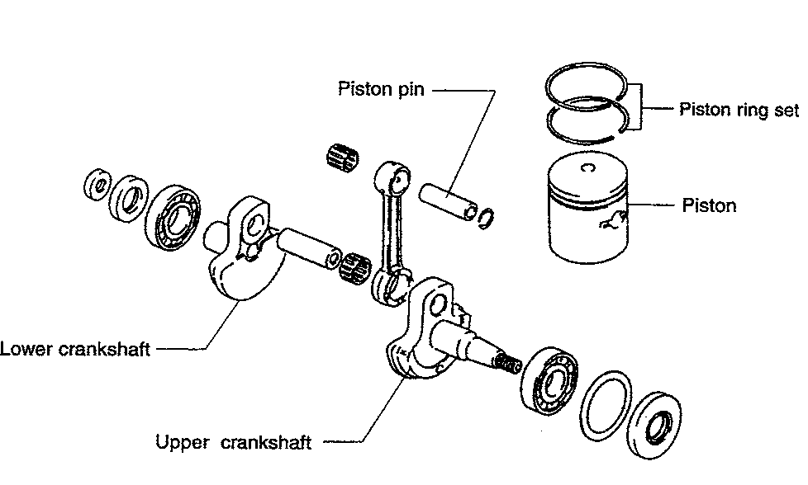

Fig. 1 Along with the larger cylinder bore, items indicated by name in the illustration have been changed on the DT5Y

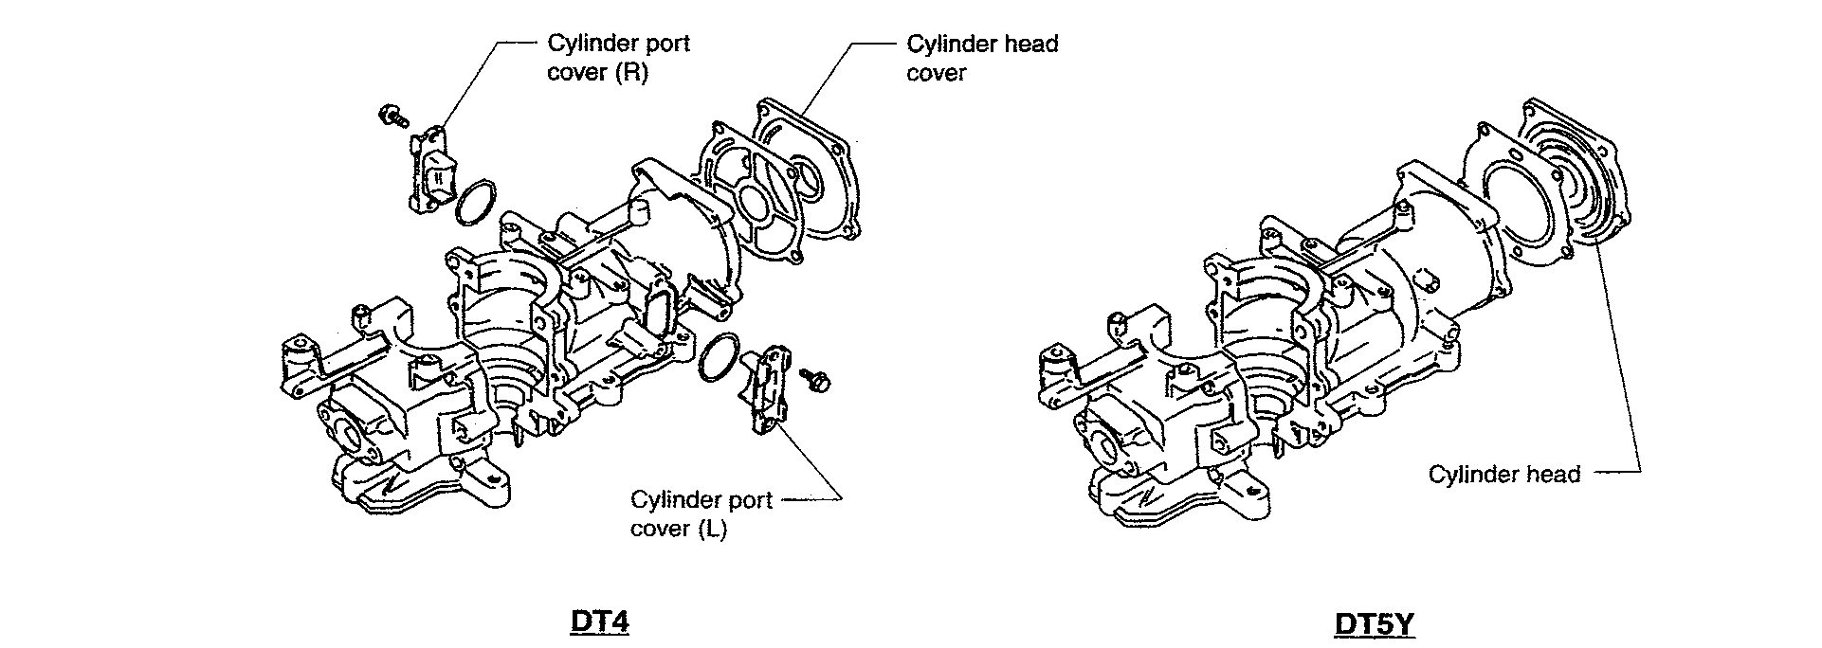

Fig. 2 Minor changes in shape and size occurred to the DT5Y (right) from he previous DT4 (shown at the left

SUPPLEMENT **12-7**

IGNITION COIL SPECIFICATIONS

Ignition coil testing may be accomplished using either an analog or digital volt/ohmmeter.
  
You will obtain the best results using a DVOM which includes a capacitor checker.
  
Resistance is measured in ohms (identified with the Greek letter Omega, which appears as a
  
small hump-backed caterpillar). All resistance specs were derived at a temp of 70F (20C)

|  |  |  |  |
| --- | --- | --- | --- |
|  | DT2 & DT2.2 | |  |
| Item |  | I Unit I | Data |
| Ignition Coil  Condenser Charge Coil Res Condenser | Primary Secondary | Ohm kOhm Ohm Ohm | 96-144  1.7-2.5  100  lo to hi |
|  |  |  |  |